**JOB DESCRIPTION**

**Providing Clarity; building Trust. A job that matters.**

**TITLE:** Investigation Support Unit Team Member

**DIRECTORATE:** Investigation Support Unit

**REPORTS TO:** ISU Manager

**LOCATION:**  Cardiff

**CONTRACT:** Permanent

**GRADE:** Grade 7

**SALARY:** £23,060

**PURPOSE**

To act as a member of the Operations Directorate, providing a full administrative support service to Operations Managers, Operations Team Leaders and Investigators inCardiffwhilst also providing administrative support nationally as and when required.

The post will be responsible for carrying out the document management function of updating and maintaining the case management system in independent investigations. The postholder will maintain local and national spreadsheets as directed. They will also draft correspondence, monitor witness appeal mailboxes and maintain performance management records. Acting as first point of contact to callers for Investigations when appropriate, they will liaise with outside agencies and aggrieved parties whether by telephone, e-mail or post and ensure they are dealt with promptly, efficiently and courteously.

The postholder will provide administrative support on a national and regional basis with the main responsibility being support to Investigations.

In completing some of these tasks the post holder may view some distressing or sensitive material.

# ORGANISATIONAL CONTEXT

# 

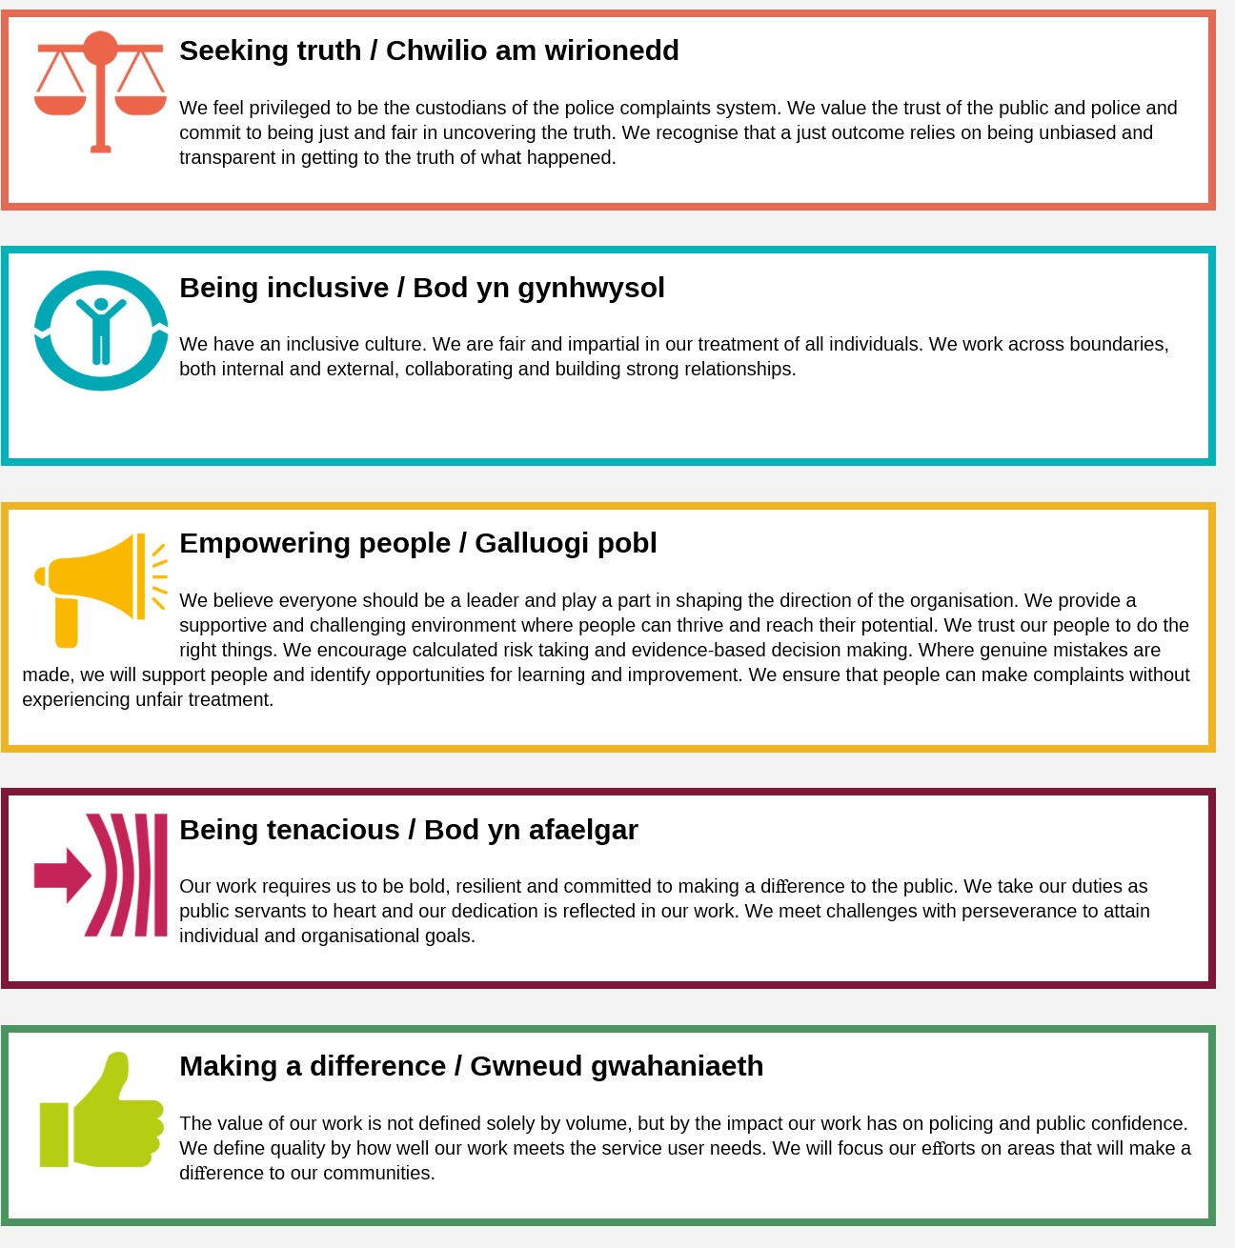We work in the context of our agreed values which inform the way we do things at the IOPC. The ISU Team Member will need to be commited to managing in the context of these values.

**MAIN DUTIES AND RESPONSIBILITIES**

* As an ISU Team member perform the following role with regard to Independent and Managed investigations.
* To ensure that the Operations directorate receive support in relation to the management of all investigations by means of maintaining tasks on Perito.
* In conjunction with the Lead Investigator ensure that all ISU functions, in respect of Independent and Managed cases, are completed within the statutory time frames on Perito in accordance with the IOPC’s legislative requirements, whilst maintaining ongoing liaison with the Lead Investigator in relation to each allocated case throughout its duration.
* The ensure Independent Investigations case files are kept up to date in accordance with guidelines.
* Acting as a team member whilst also using initiative in order to build files for Court, Inquests and Disciplinary Hearings, forwarding CPS/Court requests for information, dealing with case queries, disclosing evidence as and when directed by the Lead Investigator to interested parties.
* Preparing evidential documentation relating to court files for submission to the Crown Prosecution Service within the specified guidelines, in accordance with required standards, and on the direction of the Lead Investigator.
* In all cases, as deemed appropriate, maintain and update the Document Management Record (DMR) on Perito and securely store such documentation in compliance with IOPC policies.
* Responsible for archiving investigation material in liaison with the Lead Investigator in closed cases. Ensuring material and exhibits submitted are catalogued prior to submission to off-site Archive.
* Maintaining databases to service organisational performance management.
* Attend initial meetings as required at the commencement of new investigations, also attend briefings on more complex cases being run on the HOLMES system
* In relation to Independent investigations copy type statements, proofread and register other documentation as and when required.
* Assist the Operation Directorate with raising purchase orders, using the online requisition system on Business World (in accordance with IOPC procurement processes) and liaising with the Budget Holder when reconciling invoices.
* Maintain fleet vehicle support duties, including the organisation of internal fleet vehicles via the booking system. Ensure vehicles are available for MOT appointments and services, whilst ensuring business needs are met.
* Assist with the arrangement of meetings and other events (both internally and externally), including the booking of video conference facilities and other equipment required. Send out invitations at the request of investigators.
* Book travel arrangements for Operational staff.
* Manage the equipment booking system in respect of the portable audio equipment used for interviews and PPE on call kits.
* Responsibility for ordering stationery for the Operations Directorate on a pro rata basis within the agreed budget.
* Take responsibility and maintain an auditable register for all CDs, DVDs and bluebooks in respect of investigations.

The post holder will also perform the following customer service and relationship management duties:

* Issue witness warnings as and when directed and monitor (on a rotational basis) the National Witness Appeal lines.
* Send out update letters on the direction of the Lead Investigator to external parties.
* Dealing with enquiries from, and providing assistance to, members of the public, police officers, and any other external agencies when the investigator in the case is not available by taking and passing on the information.
* Assist and liaise with staff members to maintain good communication and relationships, with colleagues in other regional offices and interested parties.
* Act as a point of contact for support to investigation staff e.g. media transfer or sending material to external parties. Acting as a point of contact in advising external parties in relation to material sent and received.

These key duties and responsibilities are intended only as a guide to the main responsibilities of the post and are not intended to restrict the scope of the post holder to perform other duties. Additional responsibilities for the post holder may be agreed on an individual basis and recorded as part of the annual performance review role requirement.

**PERSON SPECIFICATION**

**Experience**

The **essential** requirements are:

* Good level of education
* Ability to work under pressure and prioritise tasks, working to strict and conflicting deadlines
* Demonstrates high level of attention to detail and an ability to work accurately
* Proven experience of working effectively in a team environment
* Experience with dealing with internal parties to complete tasks successfully
* Proficiency in the use of IT, including Microsoft (specifically word and excel)

The **desirable** requirements are:

* Familiarisation with the HOLMES 2 computer application.
* Experience or understanding of police forces and criminal justice system
* Typing experience – minimum of 40 to 50 words a minute.

**Skills and Abilities**

* Sound administrative skills, able to organise and prioritise when under pressure and meet or negotiate deadlines.
* Skills appropriate to the role, with the capacity to absorb/organise new information to ensure well briefed on new topics.
* Strong interpersonal communication skills (written and oral).
* Prioritising to ensure key objectives of the role are consistently achieved.
* Comfortable taking decisions within a clear framework of delegation.

**Any move to the IOPC from another employer will mean you can no longer access childcare vouchers. This includes moves between government departments. You may however be eligible for other government schemes, including Tax-Free Childcare. Determine your eligibility at [https://www.childcarechoices.gov.uk/.**](https://www.childcarechoices.gov.uk/.**)

**Selection process**

This vacancy is using [**Success Profiles**](https://www.gov.uk/government/publications/success-profiles?_ga=2.156185915.1692943174.1578577916-319911383.1576576754). As part of the application process you will be asked to complete 4 sift stage questions based on the essential criteria.

The Behaviours being assessed are:

* Changing and improving
* Working together
* Delivering at pace
* Communicating and influencing

For successful candidates who reach the assessment stage, we will provide further details of what will be assessed.

**What is Success Profiles?**

Success Profiles moves us to a tailored way of assessing, dependent on the requirements of the job. For each role we advertise, we consider what you will need to demonstrate in order to be successful. This gives us the best possible chance of finding the right person for the job, drives up performance and improves diversity and inclusivity so that we can truly reflect the communities that we serve.

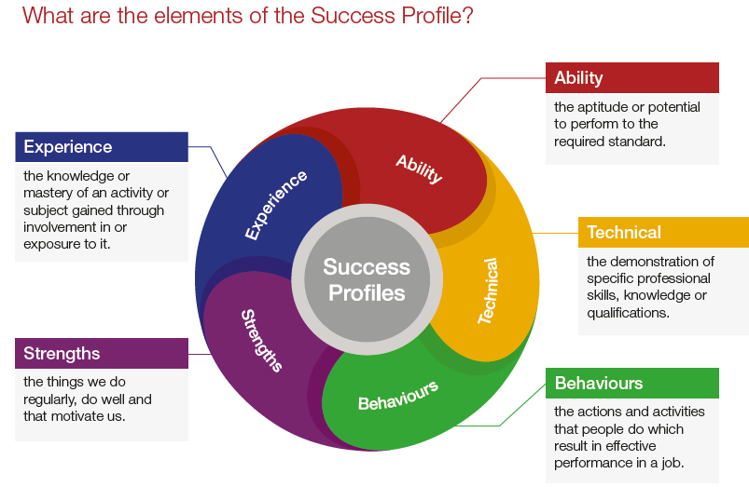Not all of the elements are relevant to every role, and will vary depending on the level and type of role. You should ensure you read the job description carefully to see what elements are required for the specific job you are applying for. There are separate guides to each of the elements, which will give you more information about what and how you can demonstrate specific requirements.

**How the elements are assessed**

You could be assessed in a number of different ways, depending on the type of role and level you are applying for. Using a range of assessment methods helps us to more accurately match people to the essential requirements of the job. For example, you may be asked to complete an application form; provide a CV and supporting statement; attend an assessment centre; or complete an online test. Often a combination of these approaches will be used and more than one element may be tested within the same assessment method.

Details of which elements will be assessed and how we will assess you against these, are included in the job description.

**Reasonable adjustments**

The IOPC is a diverse and inclusive workplace and we want to help you demonstrate your full potential whatever type of assessment is used. If you require any reasonable adjustments to our recruitment process please let the recruiting manager know.

**Preparation checklist**

Review the full job description ☐

Review the behaviours and the descriptors for each behaviour☐

Review the Strengths dictionary ☐

Review the IOPC values ☐

Consider your Strengths (if applicable) ☐

Consider drafting example answers that cover the specific elements ☐

Prepare some questions to ask the interviewers ☐