Job description
Title: Archive Manager
Reports to: Record Manager Lead
Location: Warrington
Grade: 12
Salary: £41,878
Contract: Permanent

Purpose
As the IOPC Archive Manager, you will be welcomed into a dynamic and inclusive team leading the archiving of the materials relating to the Hillsborough Stadium Disaster of 1989 and our wider information and data archiving requirements. You will be part of the Data and Information function within our DDaT services.
You will lead the delivery of the IOPC archiving requirements supported by the Archivist team. You will lead all aspects of your team’s effectiveness through delivery planning and scheduling of work and undertaking quality assurance, as well overseeing cataloguing and sensitivity review work

As a Public Records Act Officer within the IOPC you can expect to work in a progressive and dynamic organisation with declared and strong core values. These values influence our plans, service delivery and engagement with complainants, the police and all our stakeholders.
Role Description
To work within IOPC Data and Information function to enable the effective data management for archiving of;
- Material relating to the Hillsborough Stadium Disaster of 1989
- IOPC investigations and materials in relation to our role overseeing the Police complaints process.

Role Description
To work within IOPC investigation team managing the data lifecycle and archiving of materials, including the Hillsborough Stadium Disaster of 1989. The post holder be the general manager of archive material, conducting and delegating research into the archive material (where required) and also be a key player in the ongoing PRA investigation and Hillsborough legacy activity.

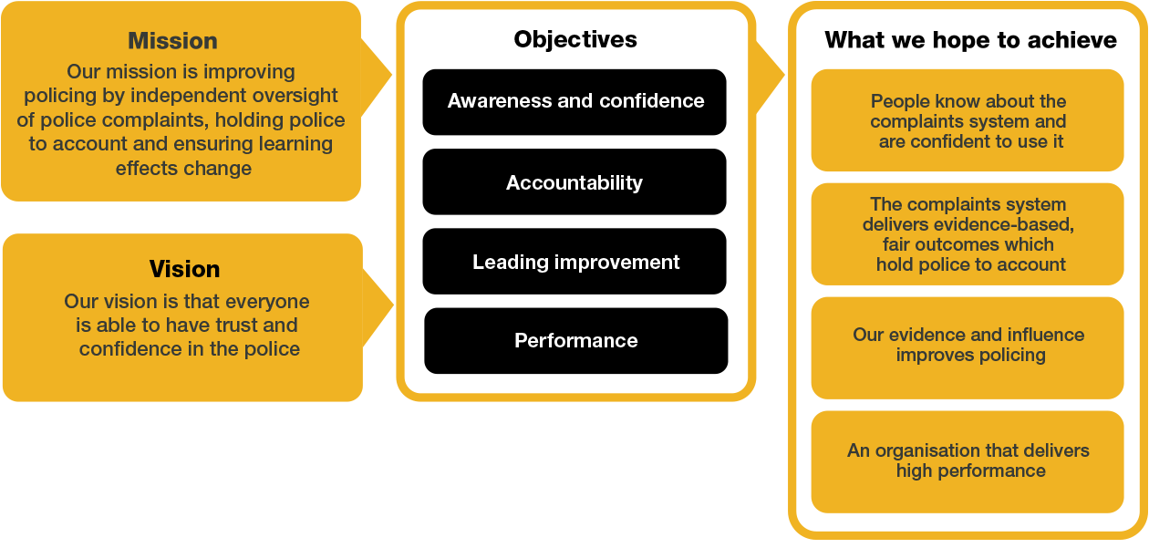
Organisational context

We work in the context of our agreed values which inform the way we do things at the IOPC. The Archive Manager will need to be commited to managing in the context of these values.

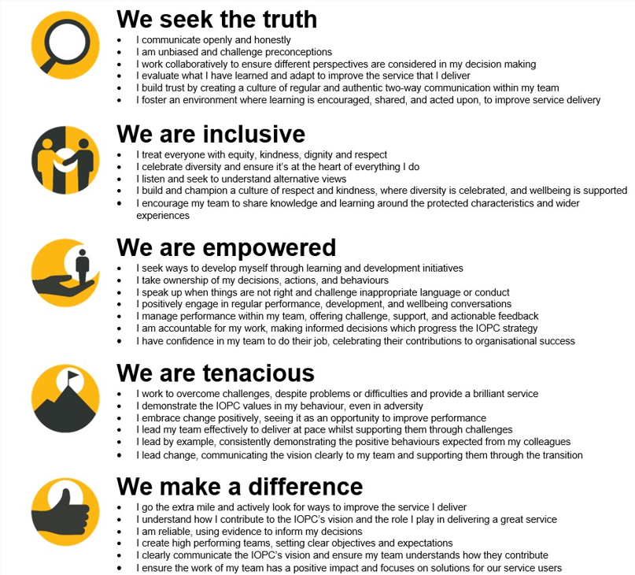

The IOPC is committed to promoting equality and valuing diversity in everything we do. Our vision is to be, and to be seen as, a leader in inclusive employment and services, demonstrating this ethos in everything that we do.
- As a silver standard Stonewall employer, we continue to commit ourselves to being a LGBTQ+ employer through the work of our Pride LGBTQ+ Staff Network, creating welcoming environments for lesbian, gay, bi, trans and queer people.
- We are pleased to share we are a signatory of the Business in the Community Race at Work Charter. The Charter is composed of five calls to action for leaders and organisations across all sectors.
- Being a Disability Confident employer, the IOPC is dedicated to removing the barrier for disabled people to thrive in the workplace.
- Our Staff Networks are constantly working to make the IOPC the leaders of inclusive employment, from our Allyship Programme to Operation Hotton, to Welsh Language Standards and Know the Line Policy, we are constantly seeking new ways to create an environment for all to develop and thrive.




Main duties and responsibilities
- To lead the Archiving team to deliver cataloguing, sensitivity review, redaction processes for physical and digital files, file preparation and transfer processes following IOPC cataloguing procedures, according to ISAD(G) standards and the Public Records Act. Set against delivery schedules and strategy set by the IOPC

- Lead in the development of policies relating to the archiving management of records in addition to internal policies such as Salvage Recovery Plans and Business Continuity plans.

- To support and advise on items for digitisation, not solely within the Archive but also material for PRA consideration held by Investigators, Exhibits and wider IOPC generated material.

- To oversee archiving resources including allocating and quality assuring their work

- To deliver the IOPC requirements for preservation of digital and physical materials requirements within archiving including specialist advice on preservation and digitisation where appropriate

- To assist in training staff in relevant processes related to the Public Records Act

- To ensure a wide range of stakeholders can easily navigate the IOPC generated archives by developing detailed indexes and descriptions against agreed naming conventions, with clear glossary and taxonomy.

- To ensure at all times that information contained within the collection is managed lawfully under the terms of the Data Protection 2018 and Freedom of Information Acts.

- To work cooperatively, communicate and consult with appropriate colleagues within the IOPC investigations directorate and build effective working relationships.

- Any other relevant duties appropriate to the grade as may be required.

- All duties and responsibilities should be carried out in accordance with agreed IOPC policies and procedures.

Person specification

Essential Experience
- Extensive experience and understanding in archive cataloguing including developing catalogues and archive cataloguing standards and principles.
- Experience of working towards compliance to Public Records Act, including cataloguing standards, developing or leading sensitivity reviews, redaction, file preparation and preservation
- Supervisory experience of developing and embedding data lifecycle management including retention schedules
- Experience of driving compliance of Data Protection and Freedom of Information requirements.
- Experience of managing archival collections to recognised environmental standards and managing and performing tasks to ensure the preservation of collections
- Experience of project management including archive digitisation projects.
- Experience of working with discretion, confidentiality and sensitivity.
- Experience of working to tight deadlines and adjusting working practices accordingly.
- Knowledge of relevant legislation, standards and procedures in relation to collections management, including the Public Records Act, and Copyright Act
- Experienced user of HOLMES 2
- Experienced user of Relativity Database
- Postgraduate degree level, in Archive and Records Management or equivalent experience.

Desirable Experience
- Experience of working in an investigation and inquiry archiving environment
- Experience of working in a public sector archiving environment
- Experienced user of HOLMES

Reasonable adjustments
The IOPC is a diverse and inclusive workplace and we want to help you demonstrate your full potential whatever type of assessment is used. We are open to providing you with the tools you need to succeed, from extra time to formatting changes, to name a mere few. If you require any reasonable adjustments to our recruitment process, please email recruitment@policeconduct.gov.uk

Working conditions
The IOPC are currently consulting with our consultative bodies about proposed changes to our hybrid working policy which will require all staff to work 20% of their contractual hours at their office base (or another office for business reasons) from 1 September 2024 and will be increased to 40% from April 2025. Office attendance time includes in-person training, meetings with stakeholders and families, and attending events.

Preparation checklist
☐ Review the full job description
☐ Review the behaviours and the descriptors for each behaviour
☐ Review the Strengths dictionary
☐ Review the IOPC values
☐ Consider your Strengths (if applicable)
☐ Consider drafting example answers that cover the specific elements
☐ Prepare some questions to ask the interviewers

