Job description
Title: Facilities Officer
Reports to: Facilities Co-ordinator
Location: Wakefield
Grade: 9
Salary: £30,870 – 24 hrs per week pro rata salary £19,515 per annum
Contract: Permanent

Purpose
As a Facilities Officer, you will be welcomed into a dynamic and inclusive Finance and Corporate Services team who are primarily responsible for everyday delivery of Facilities Management services including security and health & safety to ensure that the regional office facility runs effectively, securely and safely. The IOPC is on a journey to develop its culture, perspectives and ethos to support the organisation’s core outcomes and this is your opportunity to enter into the varied world of IOPC Finance and Corporate Services, allowing you to develop your mindset and approaches to contribute to improving the police complaints system in England and Wales.

The role also undertakes some other Finance and Corporate Resources Directorate (F&CRD) support including HR admin support, some IT support and other ad hoc F&CRD support as required. Alongside the Facilities Co-ordinator and other posts, this post will provide a regional presence and support service delivery on behalf of the F&CRD in a regional office.

The role is tasked with day to delivery of a range of services and contacts including maintenance, cleaning, office equipment, catering and other contracts. This will involve supervising a range of external contractors including engineers and dealing with staff at all levels verbally and in writing, exercising persuasion and influencing skills with assertion, sometimes dealing with challenging situations.
The role will also include the recording of building defects, maintenance register/schedules of engineering visits and statutory servicing.
The role undertakes a range of other administrative tasks as required by the Facilities Co-ordinator.

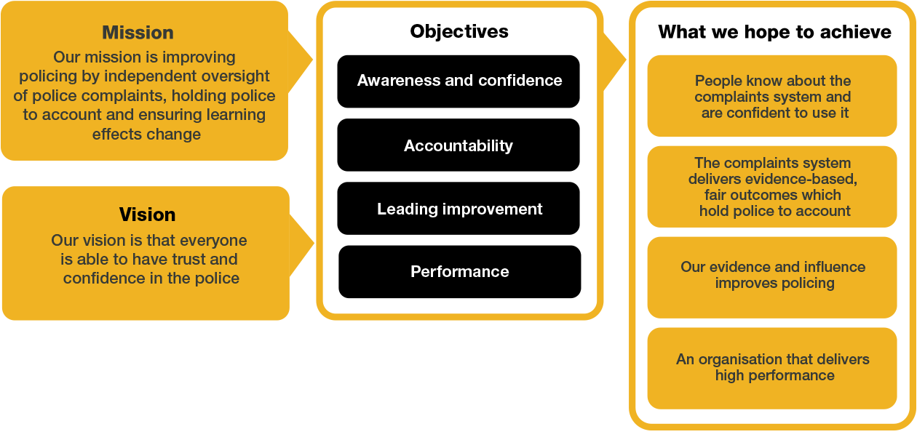
Organisational context

We work in the context of our agreed values which inform the way we do things at the IOPC. The Facilities Officer will need to be commited to managing in the context of these values.

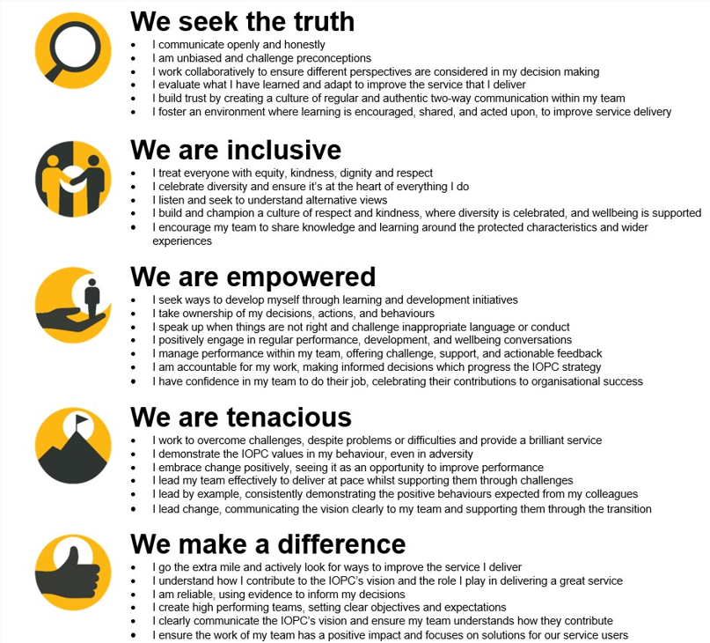
The IOPC is committed to promoting equality and valuing diversity in everything we do. Our vision is to be, and to be seen as, a leader in inclusive employment and services, demonstrating this ethos in everything that we do.
- As a silver standard Stonewall employer, we continue to commit ourselves to being a LGBTQ+ employer through the work of our Pride LGBTQ+ Staff Network, creating welcoming environments for lesbian, gay, bi and queer people.
- We are pleased to share we are a signatory of the Business in the Community Race at Work Charter. The Charter is composed of five calls to action for leaders and organisations across all sectors.
- Being a Disability Confident employer, the IOPC is dedicated to removing the barrier for disabled people to thrive in the workplace.
- Our Staff Networks are constantly working to make the IOPC the leaders of inclusive employment, from our Allyship Programme to Operation Hotton, to Welsh Language Standards and Know the Line Policy, we are constantly seeking new ways to create an environment for all to develop and thrive.




Main duties and responsibilities
- Deputise for the Facilities Co-ordinator in his/her/their absence. This will include:

- Taking overall responsibility for the delivery of Facilities Management (FM) services
- Prioritising day to day FM work activities
- Ensuring all FM Helpdesk calls are processed satisfactorily
- Dealing with incidents as and when they occur ie loss of power/gas, leaks etc. These may require occasional out of hours working.
- Overseeing the management of contractors and works on site
- Respond to out of hours incidents if required

- Provide staff cover to other IOPC offices during periods of short staffing. This may involve frequent travel and/or overnight stays away from home.

- Resolve day to day problems and issues relating to office/facilities management; equipment and supplies; IT support and Security matters. Troubleshoot equipment failures and supplier difficulties. Supervise contractors. Undertake routine H&S assessments and rectify everyday hazards, advising staff in relation to health and safety matters. Act as first point of contact for staff, visitors and suppliers in relation to all FM issues.

- Daily administration of supplier contracts in the office including cleaning, maintenance and security.

- Assist with HR related matters including regional recruitment and test administration.

- Management of stationery supplies including making decisions on appropriateness of stationery requests from staff, reconciliation of invoices and purchase orders; manage equipment inventories; liaison with suppliers. Manage general storage and filing arrangements. Includes obtaining quotations and decisions on best value in relation to special and routine supplies.

- Co-ordinate post and courier services in the region, training others in relation to safety procedures and booking arrangements. Advise others on the best method of despatch and packing.

- Book travel and accommodation.

- Liaise with landlord and building security, supervise security guards and handymen/contractors, notifying and initiating repairs and alterations to the building and equipment.

- Co-ordinate changes to staff and visitor access, issuing and altering permissions on security passes and providing access reports and internal audits as appropriate in line with security requirements and security policy.

- Visitor and Reception Management – including the provision of refreshments and meeting room facilitation.

- Provide a visitor management response to unplanned for visitors

- Maintain details of key holders and alarm system including details of security breaches and actions, working closely with colleagues in other offices as required. This will include occasionally responding to out of hours incidents.

- Provide technical assistance to staff using video conferencing and other equipment.

- Provide admin support to other teams within the F&CR Directorate as required.

- Co-ordinate requests sent via the FM Helpdesk and ensure high levels of customer service through early resolution of calls.

- Maintain open communications and relationships with colleagues, suppliers and stakeholders in organisations outside of the IOPC.

- Undertake any duties that may be reasonable as defined by the Facilities Co-ordinator.

- Facilitate all meeting room requests including provision of catering, telephone and surface hub requests.

Note: Some out of hours working and manual handling will be required

Person specification
Essential

- Experience of working in a busy office
- Evidence of complex problem-solving abilities in a busy environment
- Excellent knowledge of Microsoft Office; Word, PowerPoint, Excel
- Experience in working with different service providers and contractors
- Experience in dealing with visitors and internal/external parties at all levels
- Familiarity with online booking systems
- Flexible approach and ability to travel where necessary between IOPC offices

Desirable
- Experience of Facilities Management and Health & Safety responsibilities
- Qualifications relating to either of the above
- Good typing speeds and accuracy

Reasonable adjustments
The IOPC is a diverse and inclusive workplace and we want to help you demonstrate your full potential whatever type of assessment is used. We are open to providing you with the tools you need to succeed, from extra time to formatting changes, to name a mere few. If you require any reasonable adjustments to our recruitment process, please email recruitment@policeconduct.gov.uk

Working conditions

You will be contracted to work 24 hours per week. In line with our Hybrid Working policy and dependant on business need, you will be able to work 20% of your contractual hours from home with 80% office based. The shifts are as follows:

Monday 09:00 – 16:30

Tuesday 09:00 – 12:30

Wednesday non-working day

Thursday 09:00 – 16:30

Friday 09:00 - 16:00

Preparation checklist
☐ Review the full job description
☐ Review the behaviours and the descriptors for each behaviour
☐ Review the Strengths dictionary
☐ Review the IOPC values
☐ Consider your Strengths (if applicable)
☐ Consider drafting example answers that cover the specific elements
☐ Prepare some questions to ask the interviewers

