Job description
Title: Business Improvement Lead
Reports to: Head of Business Development
Location: Any IOPC Office
Grade: Grade 14
Salary: £56, 179 (plus London Weighting Allowance of £4731 if applicable)
Contract: Permanent

Purpose
As a Business Improvement Lead, you will be welcomed into a dynamic and inclusive Business Development Team. The IOPC is on a journey to develop its culture, perspectives and ethos to support the organisation’s core outcomes and this is your opportunity to enter into the varied world of IOPC Business Development, allowing you to develop your mindset and approaches to contribute to improving the police complaints system in England and Wales.
The purpose of the role is to:
- Lead elements of the development and delivery of a strategy that enable the IOPC to become recognised as excellent at delivering its mission (Operational Excellence)
- Lead staff across the IOPC to engage in improvement and innovation in pursuit of organisational excellence
- Lead a transfer of innovation and improvement skills and behaviours to all
- Lead cross cutting, organisational wide improvement activity that contributes to the achievement of organisational excellence

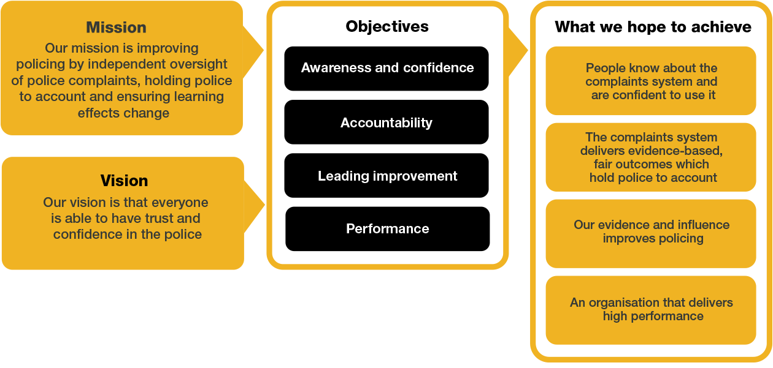
Organisational context

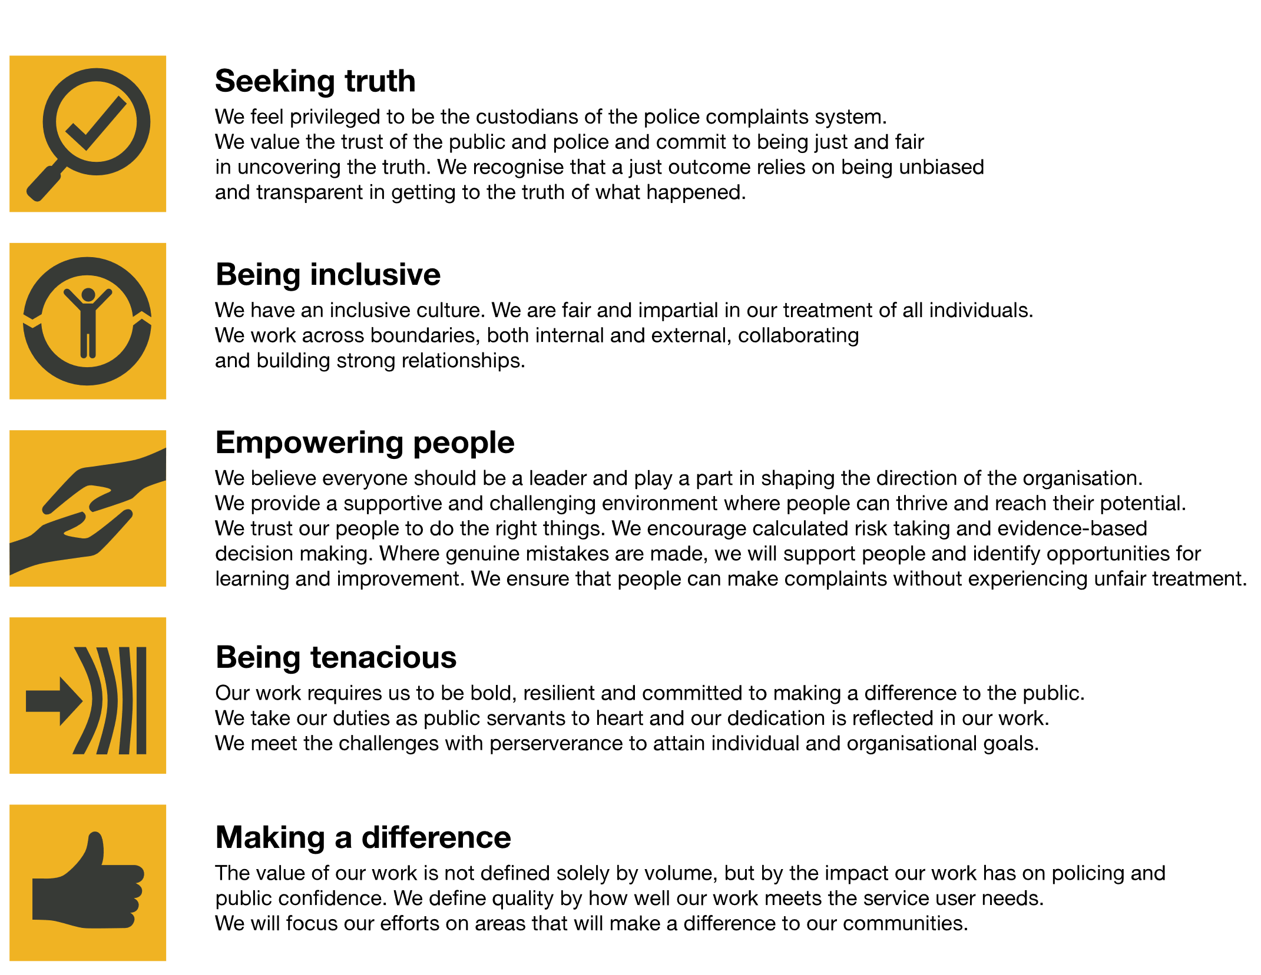
We work in the context of our agreed values which inform the way we do things at the IOPC. The Business Improvement Lead will need to be commited to managing in the context of these values.

The IOPC is committed to promoting equality and valuing diversity in everything we do. Our vision is to be, and to be seen as, a leader in inclusive employment and services, demonstrating this ethos in everything that we do.
- As a silver standard Stonewall employer, we continue to commit ourselves to being a LGBTQ+ employer through the work of our Pride LGBTQ+ Staff Network, creating welcoming environments for lesbian, gay, bi and queer people.
- We are pleased to share we are a signatory of the Business in the Community Race at Work Charter. The Charter is composed of five calls to action for leaders and organisations across all sectors.
- Being a Disability Confident employer, the IOPC is dedicated to removing the barrier for disabled people to thrive in the workplace.
- Our Staff Networks are constantly working to make the IOPC the leaders of inclusive employment, from our Allyship Programme, to Welsh Language Standards and Know the Line Policy, we are constantly seeking new ways to create an environment for all to develop and thrive.

Main duties and responsibilities
Main responsibility and activities will include:
- Research, design, implement and evolve an innovation and improvement methodology tailored to the IOPC and its Strategic Plan
- Train and coach staff in the IOPC improvement culture, methodology and tools and techniques so that skills, knowledge and culture are embedded into how staff work
- Work with internal and external stakeholders to design new policies, processes and organisational structures that enable sustainable efficiency improvements
- Lead cross-cutting work that improves how we deliver key processes working with staff from across IOPC in order to deliver a balanced set of benefits to the Service User, IOPC and its staff
- Lead improvement work using appropriate tools and techniques that enable effective Definition, Measurement, Analysis, Improvement and Control of business problems and end to end process improvements
- Train, coach and mentor leaders and staff across the organisation to drive innovation and improvement
- Share learning and provide support to staff across the public sector

Person specification

Essential

Experience
- Proven experience of implementing practical improvements in a complex environment
- Excellent problem solving skills and experience of using and teaching structured problem solving techniques
- Experience of complex data analysis to help solve problems

Skills and Abilities
- The post holder must have attained a Six Sigma black belt, an equivalent Lean or other Continuous Improvement qualification
- Exceptional communicator, with ability to engage and influence staff at all levels
- Good IT Skills in particular – Visio / PowerPoint / Excel
- Commitment to excellence, integrity and valuing diversity in all that they do

Desirable
Experience
- Experience of working with Customer Service Excellence model
- Experience of working in major Change Programmes including management system wide improvement/design
- Experience of using design thinking

Skills and Abilities
- Attained or working towards MSc or equivalent in Continuous Improvement
- ICIPS fellow or accreditation to Practitioner level
- A professional qualification in Organisational Design and Development
- Good IT skills in specialist IT packages – Power BI, SharePoint

l

Positive Action
At the IOPC, we are committed to building a workforce which reflects the diversity of the communities in which we serve. A more inclusive workforce enables us to be a more effective and efficient organisation, better understand and respond to the needs of our communities.
Positive action as detailed in the Equality Act 2010, allows us to use measures designed to help improve equality in the workplace, and create a level playing field for all, whilst still employing everyone based on merit. Our workforce profile data shows that people who identify as black, Asian and minority ethnic are under-represented at the IOPC.
For this role – should we have a situation where multiple candidates have achieved the highest score and one identifies as black, Asian or minority ethnic, by using positive action, we can select that candidate for the role, therefore improving this area of under-representation at the IOPC. We will only use positive action in this way where the highest scoring candidates have all scored equally, at the final assessment stage, and above our required threshold.

Emotional Consideration
In performing this role, you may have occassional exposure to distressing material which will likely be impactful, traumatic and challenging. Given the nature of the work, it is also possible that you will have contact with individuals who are experiencing extreme distress. The IOPC recognises this and offers all staff a range of wellbeing provisions, including TRiM (Trauma Risk Management) peer-to-peer support, a dedicated Wellbeing Advisor, and access to free confidential counselling. All staff are strongly encouraged to proactively access and engage with the support available. If you would like to speak about this element of the role with somebody already doing similar work at the IOPC, please contact campaigns@policeconduct.gov.uk and this can be arranged.

Reasonable adjustments
The IOPC is a diverse and inclusive workplace and we want to help you demonstrate your full potential whatever type of assessment is used. We are open to providing you with the tools you need to succeed. Whilst this list is not exhaustive, please see potential reasonable adjustments below that we can provide:
- Extra time for presentations or interview questions
- Formatting changes such as colours for text or background on written assignments
- Questions presented in writing during interviews
If you require any reasonable adjustments to our recruitment process, please email campaigns@policeconduct.gov.uk

Working conditions
Making the IOPC a great place to work is one of our key priorities. We are pleased to offer a unique hybrid working model based on business needs, balanced with the needs of our colleagues. Our business need framework guides our decisions about when it is best to work onsite (in our offices or other appropriate locations) to complete tasks most effectively or when to work remotely, offering colleagues flexibility to work where they feel most productive and supporting work-life balance. The model also encourages staff to feel welcome at the IOPC by ensuring we have opportunities to work face-to-face as teams.
Here at the IOPC, maintaining a culture that is accessible and inclusive of gender identity, sexuality, age, disability, race, sex, belief and caring responsibilities is deeply important to us. We believe that a rich, diverse workforce enables us a better understanding of each others needs, and produces more meaningful and trusting relationships, which in turn create more inclusive spaces where we all feel that we can contribute and belong. We value our diversity, as we believe that our diversity is our strength. It allows us to identify with our communities through shared lived experiences producing better understanding and higher quality results in our work.

What we offer
- 27.5 days paid annual leave (increasing with service to 32.5 days)
- Options to carry over, buy or sell annual leave
- Civil Service pension
- Civil Service maternity leave package
- PAM employee assistance programme
- Access to Civil Service Sports Council (CSSC) membership
- Cycle to work scheme
- Opportunity to enjoy the latest home and electronics in a more affordable way provided by Vivup
- Car Leasing Scheme
- Staff networks focused on each of the protected characteristics – run for staff, by staff:
- Age Network
- Enable Network
- Welsh Network
- Pride and LGBTQI+ Network
- Sex and Family Network
- Race, Religion and Belief Network
- Learning and development tailored to your role
- An environment with flexible working options
- A culture encouraging inclusion and diversity behaviours

Preparation checklist
☐ Review the full job description
☐ Review the behaviours and the descriptors for each behaviour
☐ Review the Strengths dictionary
☐ Review the IOPC values
☐ Consider your Strengths (if applicable)
☐ Consider drafting example answers that cover the specific elements
☐ Prepare some questions to ask the interviewers

