Job description
Title: Quality and Service Improvement Manager
Reports to: Deputy Director General Strategy & Corporate Services (temporary)
Location: This role can be based at any IOPC office, except Warrington
Grade: 15
Salary: £59,740 per annum (London Weighting Allowance £4,438, applicable to Canary Wharf and Croydon)
Contract: Permanent

Purpose
As the IOPC’s Quality and Service Improvement (QSI) Manager, you will be welcomed into a dynamic and inclusive Quality and Service Improvement team working to develop and implement our Quality Strategy and working with our service users.
We have just launched our new five year strategy and in it we are ambitious to improve Quality Assurance and are launching a new Quality Committee, chaired by a Non Executive Director to oversee our work.
This is your opportunity to enter into the varied world of IOPC Quality and Service Improvement, allowing you to develop your mindset and approaches to contribute to improving the police complaints system in England and Wales and therefore helping us to improve confidence in policing.
Reporting temporarily to the Deputy Director General Strategy & Corporate Services, the QSI Manager will lead a team of approximately 4/5 managers and 15 team members responsible for leading the development, and delivery of an organisational Quality Strategy. This includes:
- Acting as the lead manager to support the development and work of the new Quality Committee
- Defining operational quality standards and a quality assurance framework to support the first line of defence
- Being responsible for the delivery of the second line of defence in the quality assurance model for Operations. This includes a range of dip sample, thematic reviews, triggered reviews and tasked review activity
- Collecting, investigating and responding to complaints and feedback from service users
- Ensuring we have an effective process for learning and improving our delivery in response to the identification of best practice, mistakes and service user and stakeholder feedback
- Designing and supporting additional governance in the third line of defence – including reporting and engaging with Management Board, Unitary Board and external stakeholders

As part of the role, you will also take a lead in key work with our service users. This will include:
- Leading the work to gain and maintain customer service excellence
- Lead work in restorative practice with our service users
- Encourage and drive a customer focus throughout the organisations people, polices and processes

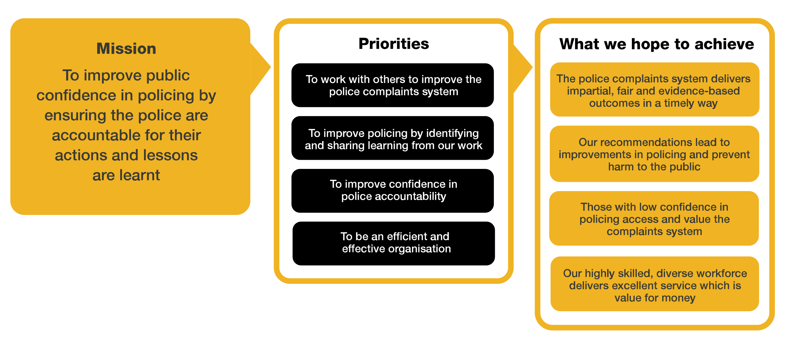
Organisational context

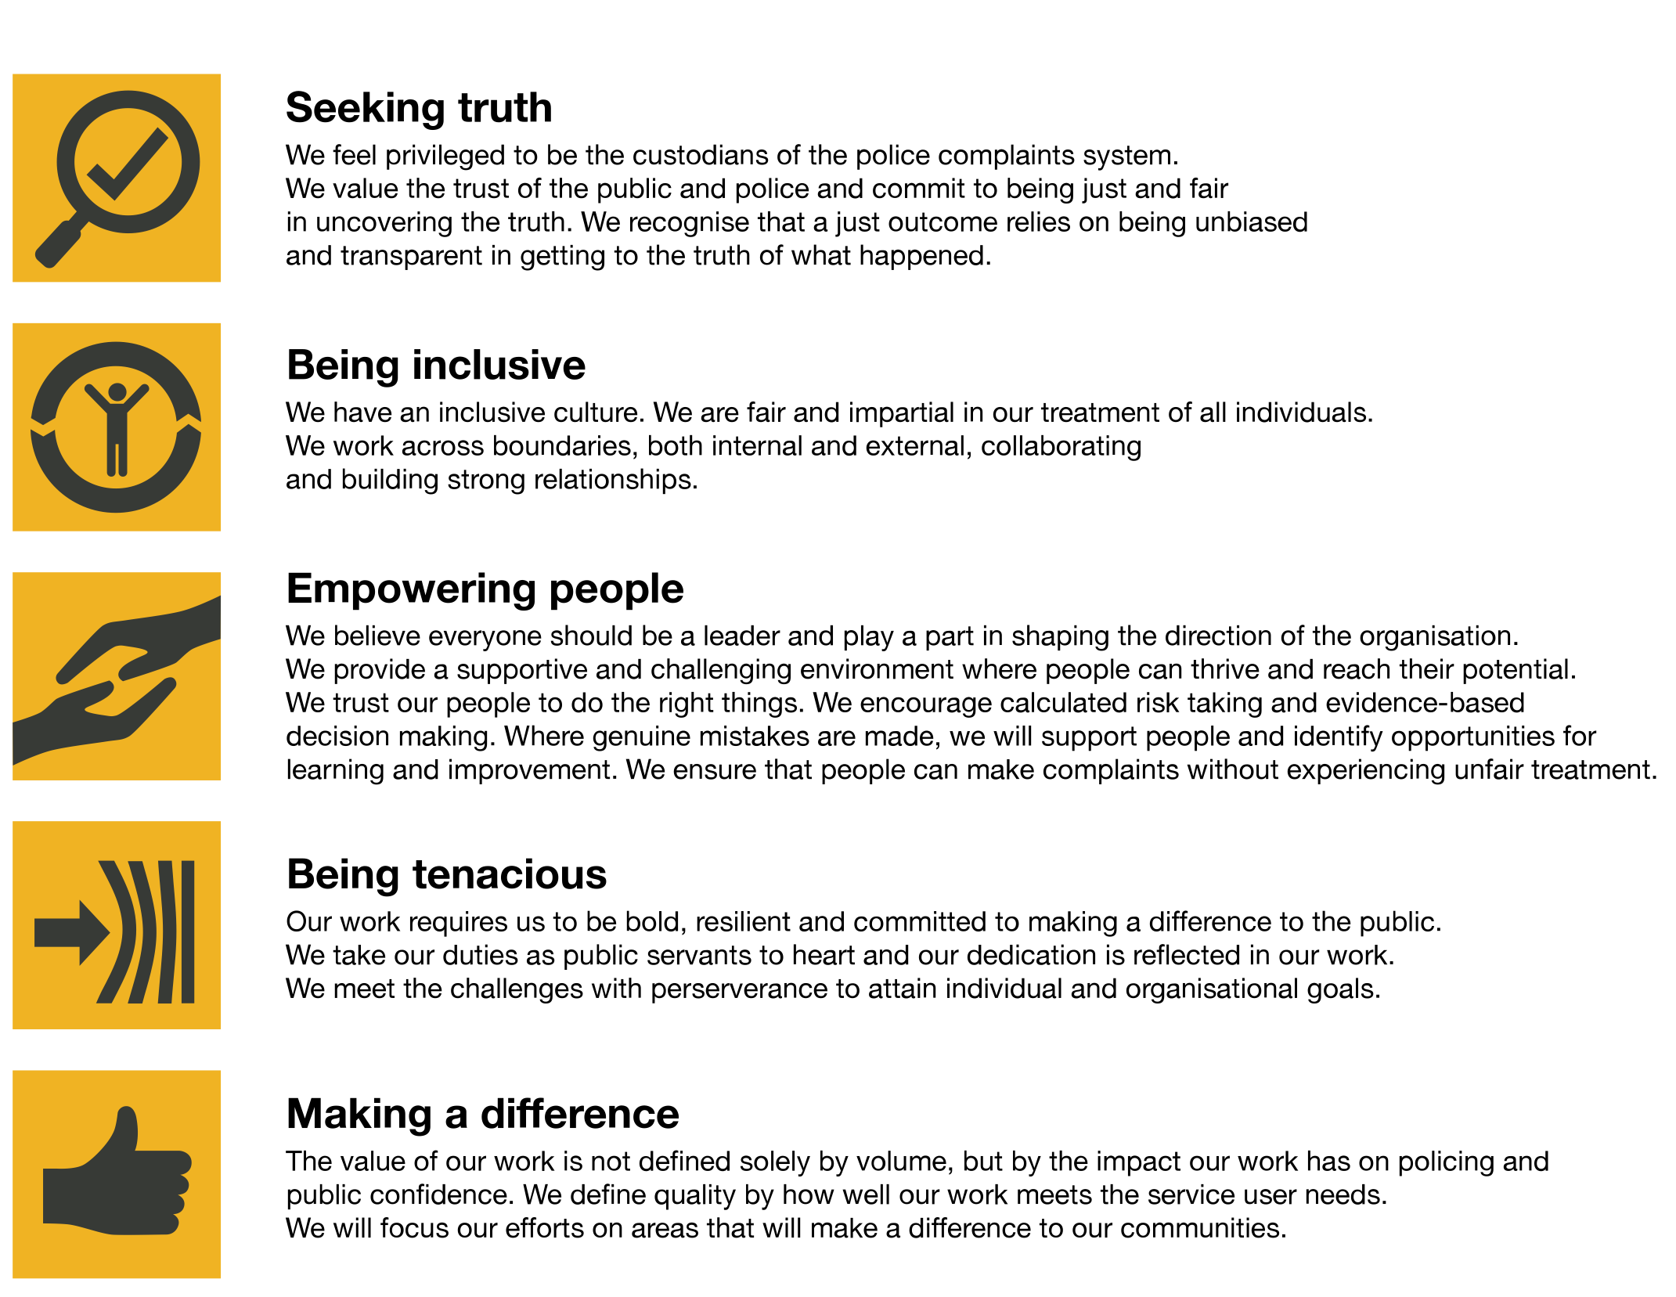
We work in the context of our agreed values which inform the way we do things at the IOPC. The QSI Manager will need to be commited to managing in the context of these values.

The IOPC is committed to promoting equality and valuing diversity in everything we do. Our vision is to be, and to be seen as, a leader in inclusive employment and services, demonstrating this ethos in everything that we do.
- As a silver standard Stonewall employer, we continue to commit ourselves to being a LGBTQ+ employer through the work of our Pride LGBTQ+ Staff Network, creating welcoming environments for lesbian, gay, bi and queer people.
- We are pleased to share we are a signatory of the Business in the Community Race at Work Charter. The Charter is composed of five calls to action for leaders and organisations across all sectors.
- Being a Disability Confident employer, the IOPC is dedicated to removing the barrier for disabled people to thrive in the workplace.
- Our Staff Networks are constantly working to make the IOPC the leaders of inclusive employment, from our Allyship Programme to Operation Hotton, to Welsh Language Standards and Know the Line Policy, we are constantly seeking new ways to create an environment for all to develop and thrive.

Main duties and responsibilities
- Ensure a proactive, continuous improvement approach to delivery of quality assurance and the review of operational work that identifies issues and problems at an early stage
- To oversee and build relationships with stakeholders, managing how the input of external voices are used to improve services
- Identify and set strategic direction for a series of thematic quality reviews, addressing ongoing issues and evaluating processes
- Build systems and processes to deliver business intelligence, identifying broader trends and overseeing targets and measures in partnership with the leadership team in Strategy & Corporate Services, Regional Directors, Head of National Operations and Director of Major Investigations.
- Lead development of organisational approach to quality – and assurance processes to support different parts of the organisation
- Investigate complaints from service users and identify learning required
- Develop solutions in partnership with colleagues to address issues and improve quality
- Lead and manage direct reports to provide a high quality assurance function that assists the IOPC operations function in the provision of consistently high quality work
- Champion the voice of the service user and be an ambassador for service user focus within the organisation
- Manage the budget for the quality and service improvement function ensuring efficient and effective use of resources, value for money and compliance with financial instructions
- Be responsible for the forward business planning of the QSI team including identifying key areas of work, and feeding these in through the annual business planning cycle
- Deputise for the Deputy Director General or Director as required
- Line manage the Operational Standards and Procedures Manager on a temporary basis, to be reviewed

Person specification

Essential Experience
- Experience of undertaking of reviews of operational work against quality standards and the development, implementation and operation of compliance and quality assurance systems in a regulatory environment
- Strong communication and interpersonal skills with a positive approach to collaborative working and stakeholder engagement, including influencing and negotiating
- The capacity to be resilient and reliable under pressure, acting with discretion to deal appropriately with confidential matters
- Demonstrated ability to quickly grasp new/complex concepts and assimilate information quickly
- Experience in building, leading and developing a team to achieve stretching goals
- Experience in running assurance programmes
- Experience of developing service improvement
- Experience in handling complaints

Technical
- Educational qualification at undergraduate/bachelor's level or equivalent

Desirable Experience
- Experience of working in the public sector and/or in a regulatory environment
- Understanding of the wider issues impacting on the police complaints system
- Prior experience of handling a budget and exercising financial discipline
- Knowledge of the legal framework in which the IOPC carries out its operational work and recognised quality management and accreditation models and their application

Reasonable adjustments
The IOPC is a diverse and inclusive workplace and we want to help you demonstrate your full potential whatever type of assessment is used. We are open to providing you with the tools you need to succeed, from extra time to formatting changes, to name a mere few. If you require any reasonable adjustments to our recruitment process, please email humanresources@policeconduct.gov.uk

Working conditions
Making the IOPC a great place to work is one of our key priorities. We are pleased to offer a unique hybrid working model based on business needs, balanced with the needs of our colleagues. Our business need framework guides our decisions about when it is best to work onsite (in our offices or other appropriate locations) to complete tasks most effectively or when to work remotely, offering colleagues flexibility to work where they feel most productive and supporting work-life balance. The model also encourages staff to feel welcome at the IOPC by ensuring we have opportunities to work face-to-face as teams.

Preparation checklist
☐ Review the full job description
☐ Review the behaviours and the descriptors for each behaviour
☐ Review the Strengths dictionary
☐ Review the IOPC values
☐ Consider your Strengths (if applicable)
☐ Consider drafting example answers that cover the specific elements
☐ Prepare some questions to ask the interviewers

