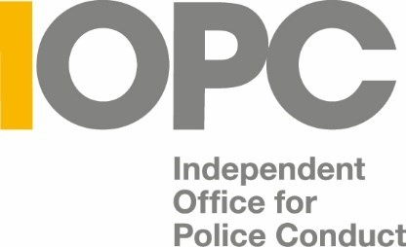

Job description

TITLE: Aspiring Professional

REPORTS TO: Equalities Delivery Manager

CONTRACT TYPE: Fixed-term contract for four weeks
Four weeks 18th September 2023 – 13th October 2023. All Aspiring Professionals must be available to start on 18th September 2023.

LOCATION: Birmingham, Canary Wharf, Croydon, Sale (South Manchester) & Wakefield.

As this is a hybrid role, some of your time will be spent working in one of our offices and the rest you will be able to work from home.

SALARY: £20,048.08 (per annum, pro rata). Plus London Weighting Allowance of £4527 (per annum, pro rata) if based in Canary Wharf or Croydon.

For the 4 week period of the placement, this will equate to
£1594.74 for non-London offices and £1906.07 for Canary Wharf or Croydon

JOB PURPOSE

The IOPC Aspiring Professionals Programme is offered as a development opportunity for passionate individuals interested in working in the public sector. Successful candidates will be offered the chance to work on an allocated project, develop workplace skills and gain professional experience.

We strongly encourage applications from diverse candidates who can bring a variety of life experience, unique skills and cultural knowledge into our organisation. We particularly invite applications from ethnic minority candidates, those on career breaks and care leavers.

The Aspiring Professionals Programme is a four-week work placement. Although it will not offer permanent employment at the end of the programme, it will help enhance your skills and confidence to apply for job opportunities, including those at the IOPC.

You will gain experience of working in a high-profile, public sector organisation, and be given lots of opportunity to work with colleagues across the organisation, allowing you to flourish in a supportive environment. The programme will also offer work-skills training sessions, a dedicated team project and coaching support. All activities will contribute to career development and inclusive work practices.

As an IOPC employee, we will be able to offer you flexible working patterns and remote working options. In addition, you will have access to our staff networks, which are run by staff, for staff, and work towards ensuring an inclusive workplace for all.

All successful applicants will be subject to security checks. However, an existing criminal record will not necessarily prevent participation on the programme.

IOPC Aspiring Professionals will report to our Equalities Delivery Manager and will be expected to meet our standards of equality, diversity and inclusion. While no prior experience will be needed for the role, we will be looking for individuals who understand and live by the IOPC values, detailed below.

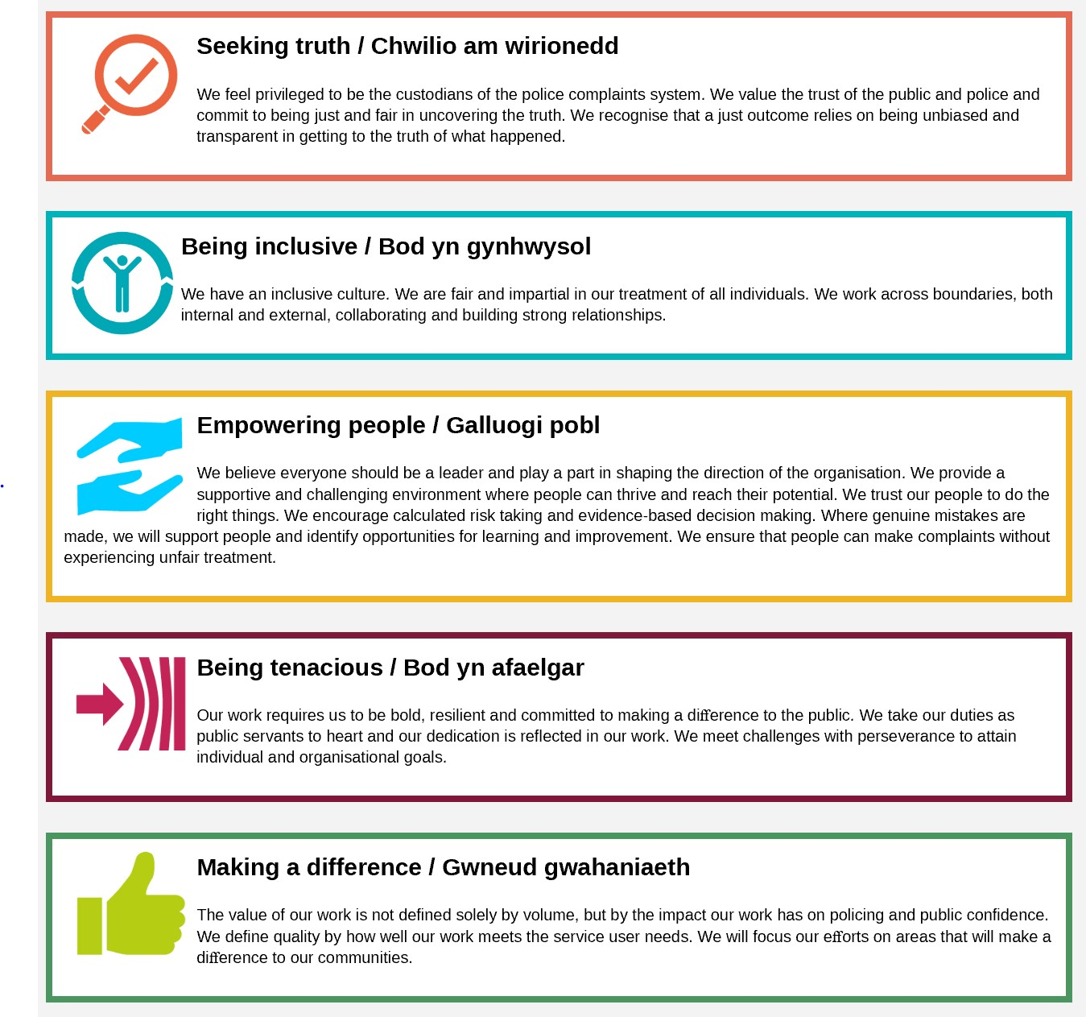

ORGANISATIONAL CONTEXT
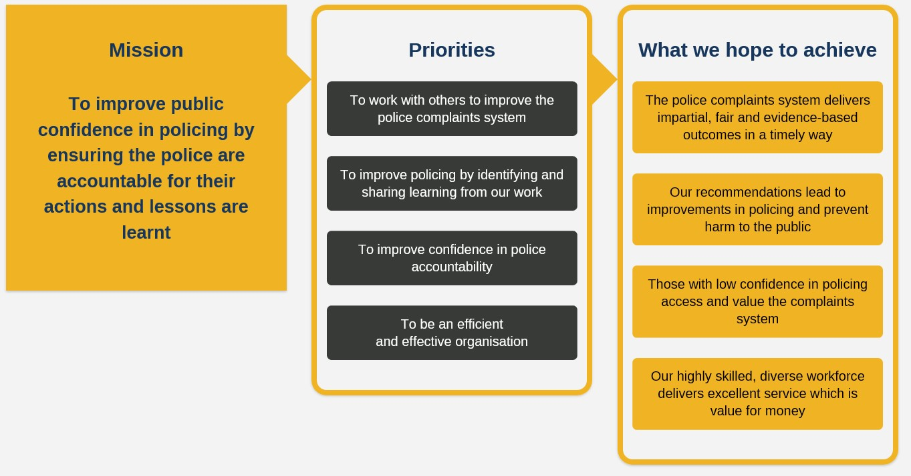
ROLE DESCRIPTION

CORE DUTIES

- Attend the IOPC Aspiring Professional induction
- Attend weekly work-skills sessions and workshops
- Contribute to the completion of an allocated group project

PERSON SPECIFICATION

Essential
- Able to work as part of a team
- Able to work with people from backgrounds different from your own
- An understanding of the IOPC values
- Good communication skills
- Willing to share ideas
- Able to use a computer

Selection Process
This vacancy is using Success Profiles, to find out more, please click here. As part of the application process you will be asked to complete three sift questions One of these will be based on the Level 1 Behaviour, Communicating and Influencing, whilst the other 2 are based on the IOPC Values (contained in the Job Description).

** If we receive a high number of applications for this role, we will mark Question 1 as the lead question. You will need to score well on Question 1 for the remainder of your application to be assessed.

If you are invited for interview for this role, we will send you many of the interview questions in advance.

THINGS TO CONSIDER BEFORE APPLYING

To take part in the IOPC Aspiring Professional Programme you should ideally be able to:
- Work full time; Monday – Friday
- Work 37 hours each week
- Work during core Aspiring Professional hours; 10am – 3pm each day
- Be available between 18 September – 13 October
- You must be aged 18 or over by 18 September 2023

We do not want any of the above requirements to prevent passionate and talented people from applying for a position on the programme, so if you feel that you may not be able to meet any of the above requirements, please contact us at campaigns@policeconduct.gov.uk and we can discuss your specific needs.

At the IOPC, we are committed to building a workforce which reflects the diversity of the communities in which we serve. A more inclusive workforce enables us to be a more effective and efficient organisation, better understand and respond to the needs of our communities.
Positive action as detailed in the Equality Act 2010, allows us to use measures designed to help improve equality in the workplace, and create a level playing field for all, whilst still employing everyone based on merit. Our workforce profile data shows that people who identify as black, Asian and minority ethnic are under-represented at the IOPC.
For this role – should we have a situation where multiple candidates have achieved the highest score and one identifies as black, Asian or minority ethnic, by using positive action, we can select that candidate for the role, therefore improving this area of under-representation at the IOPC. We will only use positive action in this way where the highest scoring candidates have all scored equally, at the final assessment stage, and above our required threshold.
If you would like any further guidance or support on our recruitment processes, or would like to speak to an IOPC colleague about the work that we do, please also contact us at campaigns@policeconduct.gov.uk

