Job description
Title: Data Engineer - Hybrid working
Reports to: Business Intelligence Manager
Location: Birmingham, Canary Wharf, Cardiff, Croydon, Sale or Wakefield
Grade: 13
Salary: £44,340 (including London Weighting)
Contract: Permanent

Purpose
As a Data Engineer you will be welcomed into a dynamic and inclusive team working to improve and maintain the IOPC’s BI reporting capacity. The IOPC is on a journey to develop its culture, perspectives and ethos to support the organisation’s core outcomes and this is your opportunity to enter into the varied world of IOPC Business Intelligence, allowing you to develop your mindset and approaches to contribute to improving the police complaints system in England and Wales.
The post holder will report to the Business Intelligence Manager and will join the Business Intelligence Team. The team bring Business Intelligence and Data Warehouse expertise in-house, as part of the continuous development of the Enterprise Data Warehouse (EDW).
They will be responsible for enabling these stakeholders to better report on the performance of the IOPC and the complaints system and make better use of the information it holds or will hold by providing a focussed, hands-on approach to maintaining and improving upon the IOPC’s BI and reporting systems.
The post holder will have the opportunity to learn on-the-job about data warehousing and database administration. This role would suit a professional with experience in Business Intelligence and understanding of Data Warehousing.
We are looking for a team player, with experience of EDW methodologies, SQL, Power BI, who is eager to be part of a reciprocal learning environment.
Given the sensitive nature of the data, the role requires that the successful candidate is prepared to undergo and receive SC clearance.
Due to high volume of applicants we reserve the right to close the application early. Applicants are encouraged to submit their application as soon as possible.

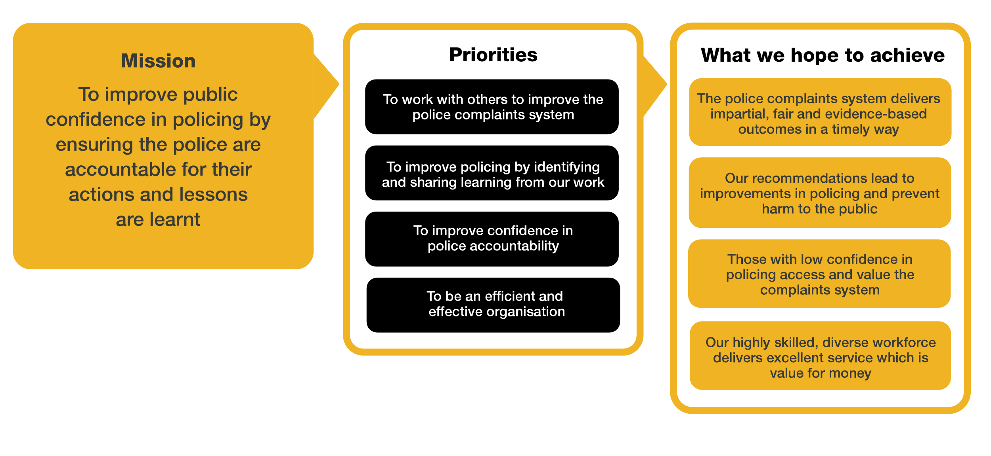
Organisational context

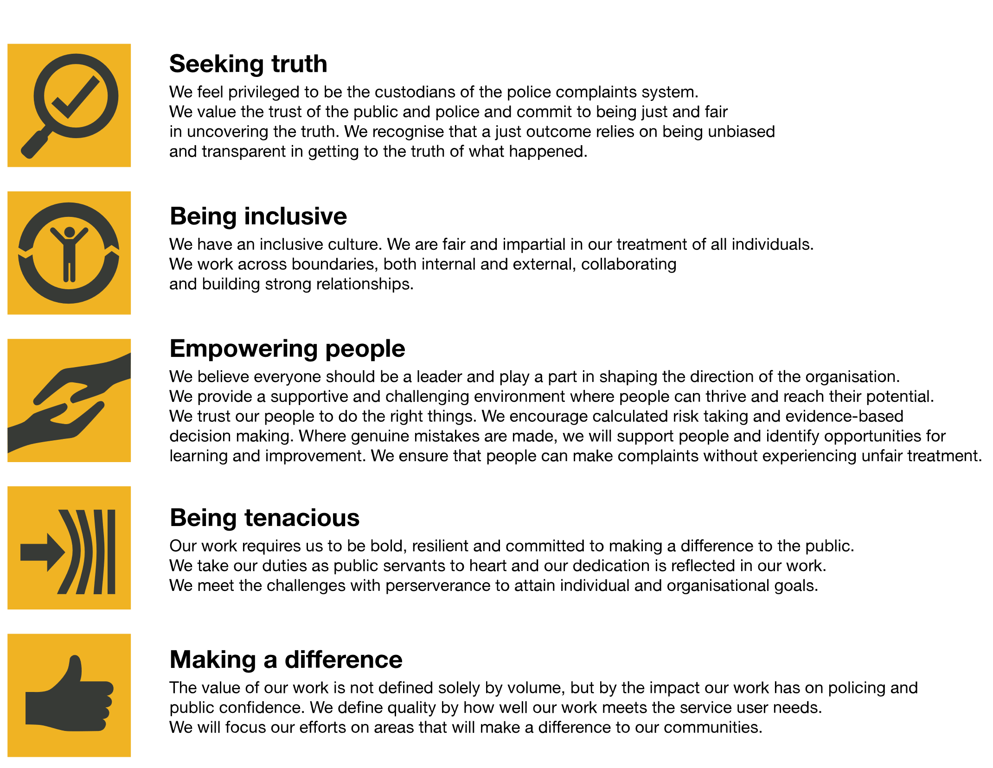
We work in the context of our agreed values which inform the way we do things at the IOPC. The Data Engineer will need to be commited to managing in the context of these values.

The IOPC is committed to promoting equality and valuing diversity in everything we do. Our vision is to be, and to be seen as, a leader in inclusive employment and services, demonstrating this ethos in everything that we do.
- As a silver standard Stonewall employer, we continue to commit ourselves to being a LGBTQ+ employer through the work of our Pride LGBTQ+ Staff Network, creating welcoming environments for lesbian, gay, bi and queer people.
- We are pleased to share we are a signatory of the Business in the Community Race at Work Charter. The Charter is composed of five calls to action for leaders and organisations across all sectors.
- Being a Disability Confident employer, the IOPC is dedicated to removing the barrier for disabled people to thrive in the workplace.
- Our Staff Networks are constantly working to make the IOPC the leaders of inclusive employment, from our Allyship Programme to Operation Hotton, to Welsh Language Standards and Know the Line Policy, we are constantly seeking new ways to create an environment for all to develop and thrive.

Main duties and responsibilities
- Maintain and develop close and collaborative relationships with colleagues, engage with and lead them in constructive communication to discern, negotiate, and prioritise requirements, and translate them into technical code (e.g. SQL, Power BI, SSRS)

- Identify, recommend and implement BI and Data Warehouse (DW) initiatives resulting from the impact of changes to business/counting rules, or existing ETL processes from various data sources.

- write ELT (extract, load, transform) scripts and code to ensure the ELT process performs optimally.

- re-engineer manual data flows to enable scaling and repeatable use.

- Maintain and improve the IOPC’s BI reporting systems capacity and capability by developing and deploying software (code) in support of business requirements and best practice.

- Maintain the document library (version control etc.) and produce the appropriate support and guidance materials.

- Ability to influence key stakeholders on how to make the most of BI tools to better report on IOPC organisational performance, providing them with expert guidance regarding data, processes, and best practice, and enhancing their user experience.

- Supporting administration of Power BI apps and the resolution of problems and incidents relating to the BI platform and EDW

- Managing UAT of changes and additions to BI objects

Person specification
- Experience in BI and system analysis and understanding of data warehousing methodologies, such as Data Vault, Snowflake and Star Schemas, and ability to translate technical BI concepts into business terms for user and super-users
- Hands-on experience of BI platforms, such as Power BI, SSRS and Report Builder, of writing languages such as SQL and Python, and familiarity with the Azure platform
- Familiarity and awareness of case management systems and working knowledge of one or more of the IOPC’s corporate applications such as SharePoint or Trim
- Experience of working with outsourced IT service delivery teams and awareness of ITIL incident and problem management principles
- Excellent listener, with the ability to elicit requirements from key stakeholders, analysing and translating these into new production code according to time and quality factors. Strong customer focus and experience of building strong working relationships with stakeholders and end users
- Experience of working in a secure environment
- Awareness of the legal issues relating to IS/IT e.g. Data Protection, Freedom of Information and Computer Misuse Acts, copyright, intellectual property rights
- Ability to undertake BI systems administration
- Ability to work as part of a team but under their own steam
- Communication skills
- Positive can-do attitude and flexibility of approach.

Reasonable adjustments
The IOPC is a diverse and inclusive workplace and we want to help you demonstrate your full potential whatever type of assessment is used. We are open to providing you with the tools you need to succeed, from extra time to formatting changes, to name a mere few. If you require any reasonable adjustments to our recruitment process, please email humanresources@policeconduct.gov.uk

Working conditions
Making the IOPC a great place to work is one of our key priorities. We are pleased to offer a unique hybrid working model based on business needs, balanced with the needs of our colleagues. Our business need framework guides our decisions about when it is best to work onsite (in our offices or other appropriate locations) to complete tasks most effectively or when to work remotely, offering colleagues flexibility to work where they feel most productive and supporting work-life balance. The model also encourages staff to feel welcome at the IOPC by ensuring we have opportunities to work face-to-face as teams.
Hybrid Working
This role offers flexible locations, however, there is an expectation to attend your chosen office. Details can be discussed at the interview with the hiring manager.

Preparation checklist
☐ Review the full job description
☐ Review the behaviours and the descriptors for each behaviour
☐ Review the Strengths dictionary
☐ Review the IOPC values
☐ Consider your Strengths (if applicable)
☐ Consider drafting example answers that cover the specific elements
☐ Prepare some questions to ask the interviewers

