**Job description**

**Title:** Communications Officer (Hillsborough)

**Reports to:** Communications Manager (Hillsborough)

**Location:** Warrington

**Grade:** 10

**Salary:** £30,032 per annum

**Contract:** 6 months Fixed Term Contract / Secondment

# Purpose

As a Communications Officer, you will be welcomed into a dynamic and inclusive Communications team working on supporting the IOPC’s Hillsborough investigation. The IOPC is on a journey to develop its culture, perspectives and ethos to support the organisation’s core outcomes and this is your opportunity to enter into the varied world of IOPC Strategy and Impact allowing you to develop your mindset and approaches to contribute to improving the police complaints system in England and Wales.

The Communications Officer is responsible for providing internal and external communications support to the IOPC’s Hillsborough investigation, based out of Warrington.

The role will contribute to and support delivery of a programme of planned proactive activity to ensure effective communication and engagement with staff, the media and other key stakeholders.

The role will work with colleagues across all aspects of communications – from planning and executing multi-channel campaigns, social media activity, internal communications, media relations, and publications production.

# Organisational context

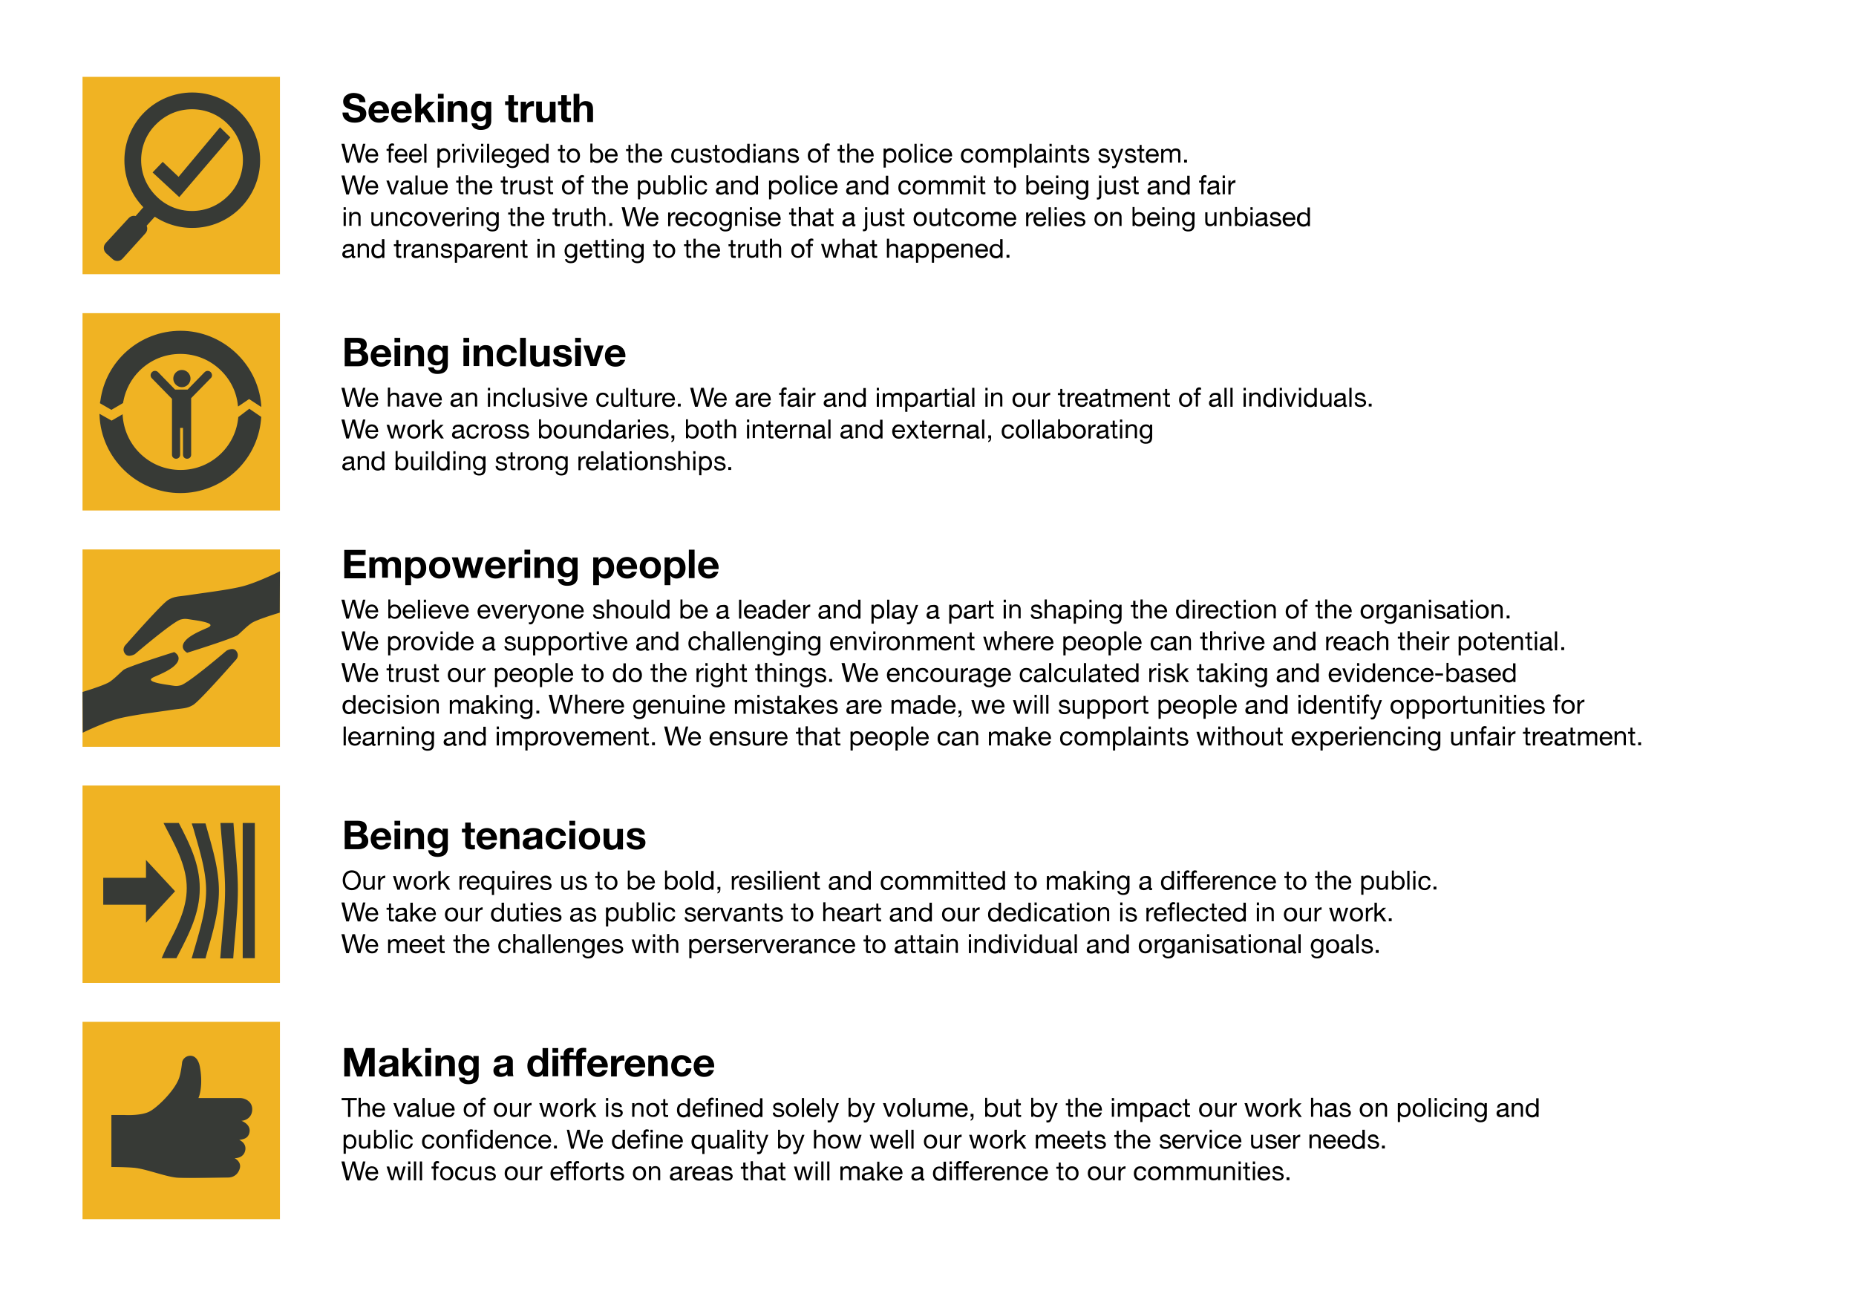We work in the context of our agreed values which inform the way we do things at the IOPC. The Communications Officer will need to be commited to managing in the context of these values.

The IOPC is committed to **promoting equality and valuing diversity** in everything we do. Our vision is to be, and to be seen as, a leader in inclusive employment and services, demonstrating this ethos in everything that we do.

* As a silver standard Stonewall employer, we continue to commit ourselves to being a LGBTQ+ employer through the work of our Pride LGBTQ+ Staff Network, creating welcoming environments for lesbian, gay, bi and queer people.
* We are pleased to share we are a signatory of the Business in the Community Race at Work Charter. The Charter is composed of five [calls to action](https://race.bitc.org.uk/issues/racecharter) for leaders and organisations across all sectors.
* Being a Disability Confident employer, the IOPC is dedicated to removing the barrier for disabled people to thrive in the workplace.
* Our Staff Networks are constantly working to make the IOPC the leaders of inclusive employment, from our Allyship Programme to [Operation Hotton](https://www.policeconduct.gov.uk/recommendations/operation-hotton-recommendations-metropolitan-police-service-september-2021), to [Welsh Language Standards](https://www.policeconduct.gov.uk/who-we-are/equality-and-diversity/welsh-language-standards) and Know the Line Policy, we are constantly seeking new ways to create an environment for all to develop and thrive.

# Main duties and responsibilities

* Assist in the delivery of effective media, internal and external communications for the Hillsborough investigation
* Support and assist in delivery of the communications and engagement strategy for the Hillsborough Investigation including:
* Monitoring and supporting the Hillsborough investigation’s online presence across digital and print channels
* Providing and supporting effective media engagement, including media liaison, draft releases and monitoring media coverage of the investigation
* Managing the regular update of Hillsborough website pages in coordination with investigation and legal colleagues
* Drafting web, social media and editorial content to prepare announcements and promote the delivery of the programme
* Assisting with production of key publications and reports
* Supporting and delivering effective internal communications to the Hillsborough investigation team and the broader organisation
* Provide administrative and project management support to the Communications Team, using planning tools to keep track of upcoming communications opportunities and deliverables
* Assist with communications planning for the broader corporate communications team
* Any other duties as required by the post

# Person specification

**KNOWLEDGE, EXPERIENCE AND QUALIFICATIONS**

* Experience of working in a communications role in a high-profile organisation
* Experience of drafting clear, consistent, targeted information for internal and external audiences
* Strong editing and proofreading skills
* Excellent written and verbal communication skills and the ability to present complex information to a range of audiences
* Excellent project management skills and experience of managing communications projects, including publications and events
* Experience of working under pressure to tight deadlines and competing priorities
* Experience of working both independently and as part of a team
* A flexible, proactive and creative approach to problem solving
* Good interpersonal skills and the ability to deal confidently with people at all levels with tact and diplomacy

## Reasonable adjustments

The IOPC is a diverse and inclusive workplace and we want to help you demonstrate your full potential whatever type of assessment is used. We are open to providing you with the tools you need to succeed, from extra time to formatting changes, to name a mere few. If you require any reasonable adjustments to our recruitment process, please email [humanresources@policeconduct.gov.uk](mailto:humanresources@policeconduct.gov.uk)

## Working conditions

Making the IOPC a great place to work is one of our key priorities. We are pleased to offer a unique hybrid working model based on business needs, balanced with the needs of our colleagues. Our business need framework guides our decisions about when it is best to work onsite (in our offices or other appropriate locations) to complete tasks most effectively or when to work remotely, offering colleagues flexibility to work where they feel most productive and supporting work-life balance. The model also encourages staff to feel welcome at the IOPC by ensuring we have opportunities to work face-to-face as teams.

## Preparation checklist

☐ Review the full job description

☐ Review the behaviours and the descriptors for each behaviour

☐ Review the Strengths dictionary

☐ Review the IOPC values

☐ Consider your Strengths (if applicable)

☐ Consider drafting example answers that cover the specific elements

☐ Prepare some questions to ask the interviewers