

**Job role profile**

**Title:** Investigations Manager – Complex

**Reports to**: Deputy Director of Investigations

**Location:** Birmingham, Sale, Wakefield, Cardiff, Croydon or Canary Wharf

**Grade:** 15

**Salary:** £64,301 (Plus London weighting of £4,968 if located at Croydon s or Canary Wharf)

**Contract:** Permanent

**Additional information:** The IOPC is recruiting for Investigation Managers in 3 areas: Performance and Resourcing, Core Business and Complex. Candidates should apply for the role they believe they would align with best rather than submitting multiple applications. During the application process you will be asked if you would also like to be considered for any other Investigation Manager positions. If you select ‘yes’ to any of these then you may be asked additional questions at interview to consider your suitability for these roles.

# Purpose

As an Investigations Manager – Complex, you will be a part of a dynamic investigations team working locally and nationally on a wide range of investigations in the Investigation, Oversight and Casework directorate. You will direct and be the decision maker in relation to critical, contentious and high-risk cases.

Alongside the Investigations Manager – Performance and Resourcing and Investigations Manager – Core Business, you will be responsible for providing strategic leadership to teams of investigators, ensuring delivery of high quality, robust and independent investigations and demonstrating our core values in all aspects of your role.

You will have accountability for the quality of investigations, timeliness and efficiency.

You will play a key role within the Operational Practitioner Group for Decision Making; you will set standards, embed good practice in decision making, act as a topic leads, conduct quality assurance and provide peer support to decision makers across the organisation.

You will lead on Victim’s Right of Review, be the decision maker on re-investigations and revisit previous investigation decisions.

**O**

**rganisational**

**C**

**ontext**

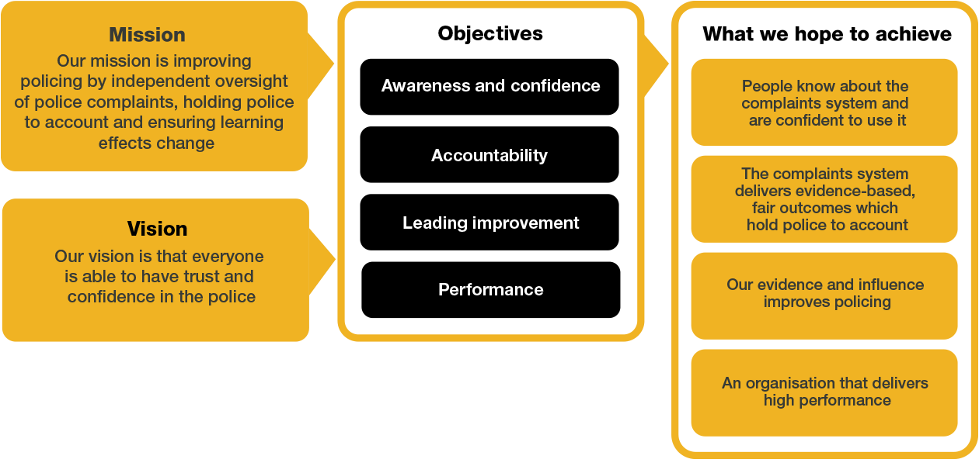

We work in the context of our agreed values which inform the way we do things at the IOPC. As the Investigations Manager – Complex, you will need to be committed to managing in the context of these values.

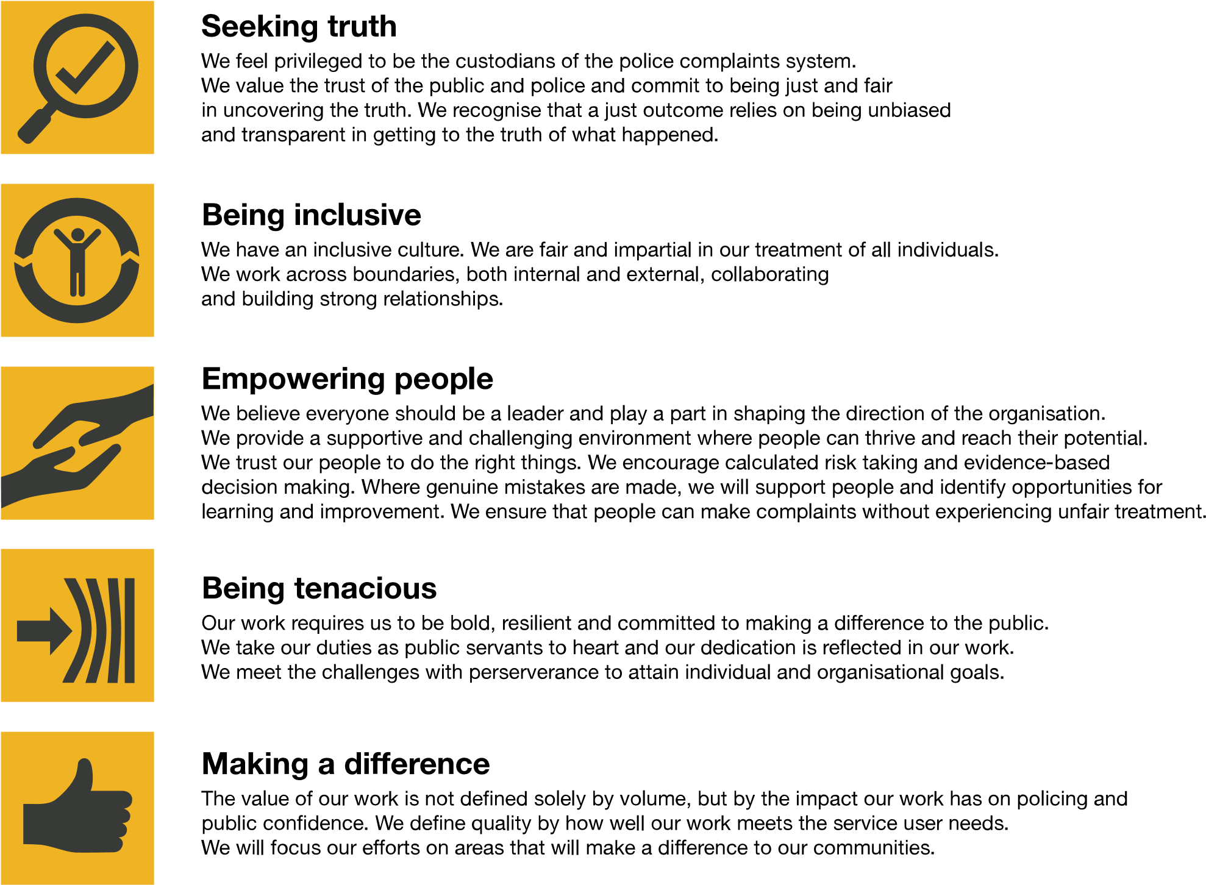

The IOPC is committed to **promoting equality and valuing diversity** in everything we do. Our vision is to be, and to be seen as, a leader in inclusive employment and services, demonstrating this ethos in everything that we do.

* As a silver standard Stonewall employer, we continue to commit ourselves to being a LGBTQ+ employer through the work of our Pride LGBTQ+ Staff Network, creating welcoming environments for lesbian, gay, bi and queer people.
* We are pleased to share we are a signatory of the Business in the Community Race at Work Charter. The Charter is composed of five [calls to action](https://race.bitc.org.uk/issues/racecharter) for leaders and organisations across all sectors.
* Being a Disability Confident employer, the IOPC is dedicated to removing the barrier for disabled people to thrive in the workplace.
* Our Staff Networks are constantly working to make the IOPC the leaders of inclusive employment, from our Allyship Programme to [Operation Hotton,](https://www.policeconduct.gov.uk/recommendations/operation-hotton-recommendations-metropolitan-police-service-september-2021) to [Welsh Language Standards](https://www.policeconduct.gov.uk/who-we-are/equality-and-diversity/welsh-language-standards) and Know the Line Policy, we are constantly seeking new ways to create an environment for all to develop and thrive.



# Main duties and responsibilities

**Leadership and general:**

* Provide strategic direction and operational leadership to investigation teams to ensure the delivery of high-quality, robust investigations.
* Ensure consistent and high-quality investigations delivery against policy and performance targets.
* Work closely with internal stakeholders to ensure the IOPCs Strategic Objectives are met including; Stakeholder Engagement Team, Oversight and Directors of Engagement.
* Contribute as a member of the wider Investigations senior management team to the development of the strategic direction and management of the Investigations function.
* Participate in the on-call function – offering advice, guidance and direction to forces, HMRC and UKBA in matters relating to deaths, serious injuries and other referrals.
* Work with the Directors/Deputy Directors in Investigations, and other key stakeholders to ensure a coordinated and consistent Investigations function.
* Deputise for Deputy Directors of Investigations as and when requested / where appropriate to provide internal and external leadership across investigation delivery activities.
* Develop and implement effective collaborative working with all other directorates within the IOPC to continuously improve performance and drive culture change.

**Transformation:**

* Work collaboratively with colleagues to ensure that the ambitions of the IOPC are delivered.
* Actively participate in the IOPC Transformation programme to ensure that we do what only the IOPC can do and deliver effective, timely and high-quality investigations.
* Identify ways to improve the way in which investigations are completed and delivered.
* Ensure investigations colleagues are kept up to date with transformation progress.

**Role specific:**

Delivery:

* Develop and implement guidance, training and best practices for decision making within the Operational Practitioner Group for Decision Making, maintaining consistency and integrity across all cases.
* Re-visit decisions after criminal, inquest and disciplinary proceedings; providing peer review and support for other Decision Makers, and colleagues in the Investigations Case Direction team.
* Provide advice and guidance across the organisation on serious and sensitive operational matters including; managing risk, tactical decision making, critical incident management and specific technical areas of expertise in order to drive effective service deliver that withstands public scrutiny.
* Work closely with Investigations Team Leader to understand capacity requirements.
* Ensure that Case Supervisors and Investigators deliver efficient, well informed and timely actions for the delivery of proportionate investigation outcomes.
* Lead on Victims Right of Review as well as reinvestigation decisions.
* Attend and support at Critical Case Panel Meetings.
* Review and develop systems for ensuring decisions are robust, proportionate, consistent and fulfil the organisations public duties and objectives.
* Ensure that the legal team are involved at an early stage in investigations, where appropriate.
* Work with the Investigations Manager – Core Business and Investigations Manager - Performance and Resourcing to provide feedback on the performance of investigators.
* Help to ensure effective implementation of the Decision-Making Framework and will provide guidance and training to relevant stakeholders on the Framework.
* Carefully and considerately discharge your delegated regulatory duties and responsibilities.

Corporate Responsibility:

* Minimise risk to the IOPC through ensuring all decisions and actions are consistent and align with best practice.

Decision Making:

* Lead on providing expert decision making in complex and critical cases; ensuring all relevant legal, ethical and operational considerations are addressed.
* Support the Investigations Manager’s within Core Business, ACU and MI by making decisions on cases when capacity is not available.

Communication & Engagement:

* Implement a collaborative approach with key stakeholders who have decision-making responsibilities (Legal, Quality and Presenting Unit Teams) ensuring relevant input and perspectives.

Cultural Competence, Equality, Diversity & Inclusion:

* Demonstrate cultural awareness and sensitivity in decision making, recognising diverse backgrounds and perspectives.
* Promote an environment that values cultural competence and encourages open dialogue on diversity issues, both within the investigation teams and across the IOPC.
* Ensure that a culture of inclusion is embedded across the investigations team.

# Person specification

## **Experience**

* Proven experience in leading and managing teams in complex and high-profile investigations, ideally within a regulatory, oversight or public sector context.
* Proven experience of investigating or leading investigations.
* Experienced leader with a track record of working effectively with others.
* Experience in financial management.
* An understanding of the management and care of survivors and victims of criminality, specifically sexual abuse.
* Strong track record in providing strategic direction ensure the delivery of high-quality, independent and robust investigations.
* Experience of driving teams to deliver high levels of performance and continuous improvement.
* Demonstrated ability to oversee and direct teams, including workforce planning, resource allocation and the management of investigation priorities.
* Proven experience of investigations methodology and principles applied to complex, large and challenging investigations.
* Experience of working as part of a senior management team to develop and implement the strategic vision for a function or organisation.
* An experienced leader with a track record of building high performing operational teams in a complex environment.
* Experience of managing disclosure in complex investigations
* Experience of leading teams through significant change, engaging and motivating staff to embrace new ways of working.

**Desirable:**

* Experience of working in a matrix management structure.
* Experience of delivering/leading major investigations or protracted and large-scale investigations.
* Experience of HOLMES as a case management system, or a robust understanding of how the HOLMES case management system operates.
* Driving license valid in England and Wales.

## **Skills and Abilities**

* Excellent intellectual ability, and highly developed skillset to analyse complex legislation and apply it to appropriate cases.
* The ability to motivate and develop others.
* The ability to work efficiently and effectively in a challenging environment with competing priorities.
* High levels of credibility as well as the ability to justify decisions made, including in a legal setting.
* Good judgement and ability to make high profile decisions.
* Highly developed decision-making skills.
* Evidence of excellent analytical and report writing skills; ability to reach and document clear, rational, evidence-based and independent decisions based on analysis of existing and emerging information.
* Highly developed oral, written and presentation skills.
* Excellent influencing and negotiation skills and the ability to persuade through personal credibility.
* Strong interpersonal skills, including the ability to negotiate and maintain good relationships with senior officials in all areas of public life.
* Experience of supporting staff who are working in an environment with significant scrutiny, challenge and potentially emotive material.
* Analytical thinker with the skills and ability to assess complex cases, identify key issues and develop solutions that address needs.
* Proven experience in mentoring, coaching and developing team members, fostering a culture of continuous improvement and professional growth.

**Desirable:**

* An understanding of Policing in the UK.

# Positive Action

**Positive action** as detailed in the Equality Act 2010, allows us to use measures designed to help improve equality in the workplace, and create a level playing field for all, whilst still employing everyone based on merit. Our workforce profile data shows that people who identify as black, Asian and minority ethnic are under-represented at the IOPC.

For this role – should we have a situation where multiple candidates have achieved the highest score and one identifies as black, Asian or minority ethnic, by using positive action, we can select that candidate for the role, therefore improving this area of under-representation at the IOPC. We will only use positive action in this way where the highest scoring candidates have all scored equally, at the final assessment stage, and above our required threshold.

## Reasonable adjustments

The IOPC is a diverse and inclusive workplace, and we want to help you demonstrate your full potential whatever type of assessment is used. We are open to providing you with the tools you need to succeed, from extra time to formatting changes, to name a mere few. If you require any reasonable adjustments to our recruitment process, please email recruitment@policeconduct.gov.uk

## Working conditions

Making the IOPC a great place to work is one of our key priorities. We are pleased to offer a unique hybrid working model based on business needs, balanced with the needs of our colleagues.

The IOPC has a hybrid working policy which requires all staff to work 40% of their contractual hours at their office base (or another office for business reasons) from April 2025. Office attendance time includes in-person training, meetings with stakeholders and families, and attending events.

## Preparation checklist

|  |  |
| --- | --- |
|  |  |
| ☐ | Review the full job description |
| ☐ | Review the behaviours and the descriptors for each behaviour |
| ☐ | Review the Strengths dictionary |
| ☐ | Review the IOPC values |
| ☐ | Consider your Strengths (if applicable) |
| ☐ | Consider drafting example answers that cover the specific elements |
| ☐ | Prepare some questions to ask the interviewers |