**Job description**

**Title: Customer Contact Centre Advisor (Apprenticeship)**

**Reports to: Customer Contact Centre Manager**

**Location: Sale**

**Grade: 8**

**Salary: £18,453 rising to £24,605 on successful completion of apprenticeship**

**Contract: Apprenticeship - 18 months FTC including End Point Assessment. Potential to be made**

# Purpose

As a Customer Contact Centre Advisor (Apprentice) you will be welcomed into a dynamic and inclusive Customer Contact Centre team working to support the delivery of excellent customer service, providing the best possible experience with the approach of ‘getting it right first time’ to manage service user expectation and to reduce avoidable contact. The complexity of enquiry or complaint will vary as will the demand of work at any one time. The IOPC is on a journey to develop its culture, perspectives and ethos to support the organisation’s core outcomes and this is your opportunity to enter into the varied world of IOPC customer relations allowing you to develop your mindset and approaches to contribute to improving the police complaints system in England and Wales.

The Customer Contact Centre Advisor will represent the IOPC as the first point of contact to the organisation, presenting a professional image providing advice and information to a range of external service users and stakeholders.

Working as part of the Customer Contact Centre the Contact Centre Advisor will have a spectrum of responsibilities that encompass all elements of the contact centre. This will include providing a responsive telephone information service, responding to correspondence and complaints received from a range of external parties, including members of the public, police forces, MPs, solicitors and other agencies.

The complexity of enquiry or complaint will vary as will the demand of work at any one time. Contact Centre Advisor will work within a defined framework and fulfil individual targets to maximise contribution to team and directorate performance.

# Apprenticeship Information

This is a fully funded Customer Service Specialist Level 3 apprenticeship. If you hold an equivalent level qualification in a similar subject, then you may not be eligible to undertake this apprenticeship. Throughout the duration of the apprenticeship, you will receive support from an approved apprentice provider and your line manager.

As part of the apprenticeship, you must spend 20% of your time completing off the job learning. Functional Skills are a compulsory requirement for all apprentices who do not hold a level 2 qualification in GCSE Maths and English. If you are unable to prove your GCSE qualifications (i.e. produce a certificate) you may also be required to complete functional skills tests. This falls outside of the 20% off the job learning time.

You will only be permitted to change IOPC roles in the duration of the apprenticeship where the new role accommodates meeting the apprenticeship standard and the hiring manager agrees to accommodate the apprenticeship.

# Organisational context

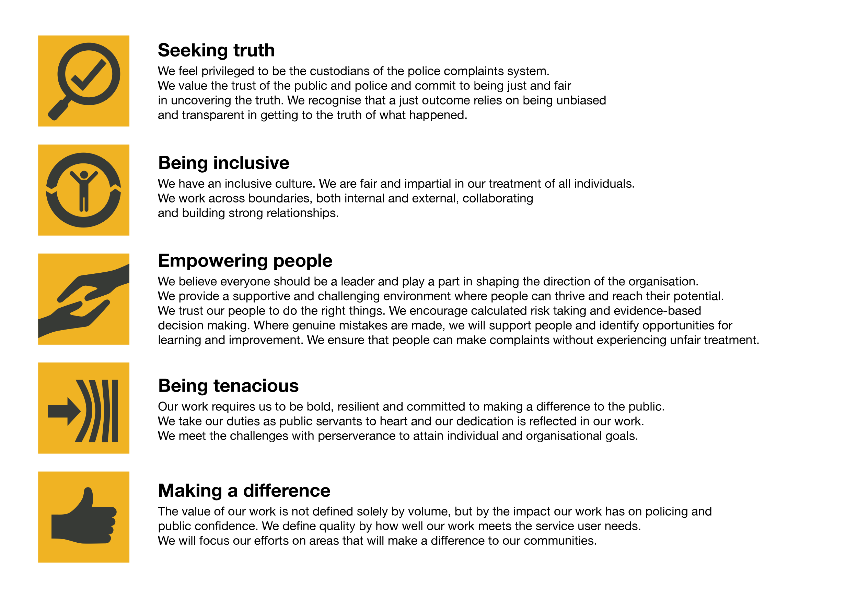We work in the context of our agreed values which inform the way we do things at the IOPC. The Customer Contact Centre Advisor (Apprentice) will need to be commited to managing in the context of these values.

The IOPC is committed to **promoting equality and valuing diversity** in everything we do. Our vision is to be, and to be seen as, a leader in inclusive employment and services, demonstrating this ethos in everything that we do.

* As a silver standard Stonewall employer, we continue to commit ourselves to being a LGBTQ+ employer through the work of our Pride LGBTQ+ Staff Network, creating welcoming environments for lesbian, gay, bi and queer people.
* We are pleased to share we are a signatory of the Business in the Community Race at Work Charter. The Charter is composed of five [calls to action](https://race.bitc.org.uk/issues/racecharter) for leaders and organisations across all sectors.
* Being a Disability Confident employer, the IOPC is dedicated to removing the barrier for disabled people to thrive in the workplace.
* Our Staff Networks are constantly working to make the IOPC the leaders of inclusive employment, from our Allyship Programme to [Operation Hotton](https://www.policeconduct.gov.uk/recommendations/operation-hotton-recommendations-metropolitan-police-service-september-2021), to [Welsh Language Standards](https://www.policeconduct.gov.uk/who-we-are/equality-and-diversity/welsh-language-standards) and Know the Line Policy, we are constantly seeking new ways to create an environment for all to develop and thrive.

# Main duties and responsibilities

* Process direct complaints received from members of the public to the appropriate police force or authority with minimal handling and representation.
* Be alert to and identify high profile matters and matters of public interest, and direct complaints that it may be appropriate not to forward to the force because of exceptional circumstances and draw these to the attention of the Customer Contact Centre Manager.
* Establish customer needs and provide appropriate information - which may range from advising on the role of the IOPC, the process for making a complaint or appeal to more general requests for information or signposting to other agencies
* Provide a responsive service to a range of service user queries and complaints ensuring prompt resolution of issues received by phone/email/letter/online form and fax.
* Respond to comebacks, complaints, MPs’ letters and other correspondence.
* Take ownership of calls, queries and complaints, seeking to resolve issues to reduce subsequent contact providing the best possible experience for the service user.
* Where appropriate, liaise with internal and external stakeholders regarding complaints and information received and recognising where information is significantly complex or sensitive and handling the information as appropriate.
* Identify and collate trends data information on potentially high profile issues
* Deal with service users that can often be angry, distressed, and sometimes challenging but remaining courteous and have the ability to see things from the service user point of view to ensure a consistent and fair service is provided to all
* Alongside signposting complainants to advocacy and advice services where they can receive assistance in making a complaint, the post holder may need to take down the details of complaints and appeals/reviews over the phone in accordance with the IOPC Reasonable Adjustment policy. This relates particularly to callers that may have an access or communication needs.
* Keep up to date with organisational issues and events, including press releases, report releases, changes to organisational practices to ensure knowledge is current in order to provide appropriate advice.
* Resolve queries first time to reduce subsequent contact providing the best possible experience for the service user.
* Record accurate enquiry and complaint information on relevant case and service user relationship management systems.
* Process and respond to Report Line contacts from serving Police Officers.
* Deal with whistleblowing allegations and liaise with the internal department regarding any whistleblowing
* Any other duties suitable to the grade, which may include administrative support, assisting more senior staff with face to face interactions with members of the public and post.
* Considering the validity of appeals/reviews received out of time and communicating the decision to the appellant and force, using clear guidance and standard template letters. Identifying any unusual, contentious or difficult cases and seeking appropriate advice to enable a sound decision to be taken.

# Person specification

* Good general education and proven relevant experience of working in a customer focused advice or information handling environment
* Experience or potential to develop experience of dealing with challenging people over the phone
* Experience or potential to develop experience of responding to customer queries and complaints in writing
* Ability to demonstrate strong oral and written communication skills
* Confidence and ability to communicate with people at all levels
* Good organisational skills and ability to manage own workload
* Ability to be patient, resilient, sensitive and diplomatic when dealing with the public and stakeholders
* A capacity to conduct enquiries, obtain information and to use sound judgement to reach conclusions
* Good IT skills, including Microsoft Office and database systems

The IOPC is a diverse and inclusive workplace and we want to help you demonstrate your full potential whatever type of assessment is used. We are open to providing you with the tools you need to succeed, from extra time to formatting changes, to name a mere few. If you require any reasonable adjustments to our recruitment process, please email [humanresources@policeconduct.gov.uk](mailto:humanresources@policeconduct.gov.uk)

## Working conditions

Making the IOPC a great place to work is one of our key priorities. We are pleased to offer a unique hybrid working model based on business needs, balanced with the needs of our colleagues. Our business need framework guides our decisions about when it is best to work onsite (in our offices or other appropriate locations) to complete tasks most effectively or when to work remotely, offering colleagues flexibility to work where they feel most productive and supporting work-life balance. The model also encourages staff to feel welcome at the IOPC by ensuring we have opportunities to work face-to-face as teams.

## Preparation checklist

☐ Review the full job description

☐ Review the behaviours and the descriptors for each behaviour

☐ Review the Strengths dictionary

☐ Review the IOPC values

☐ Consider your Strengths (if applicable)

☐ Consider drafting example answers that cover the specific elements

☐ Prepare some questions to ask the interviewers