**Job description**

**Title: Archive and Records Assistant**

**Reports to: Deputy Document and Records Manager**

**Location: Warrington (may be subject to change)**

**Grade: 7**

**Salary: £24,276 per annum**

**Contract: Fixed term until 31st December 2023 (with a view to go permanent)**

# Purpose

As an Archive and Records Assistant, you will be welcomed into a dynamic and inclusive Corporate Records Management team. The IOPC is on a journey to develop its culture, perspectives and ethos to support the organisation’s core outcomes and this is your opportunity to enter into the varied world of IOPC Data and Information, allowing you to develop your mindset and approaches to contribute to improving the police complaints system in England and Wales.

**Role Description**

To review, appraise and analyse the PCA/IPCC and IOPC hardcopy and electronic records and make recommendations as to whether records should be retained or destroyed in compliance with the IOPC Retention and Disposal Policy.

To determine the allegation and category a file relates to and be able to identify cases that have any links to identified government inquiries. Record details of findings and make a justifiable recommendation to retain or destroy.

To participate in the disposal processes by reviewing and analysing with a critical eye, the work of colleagues as part of the quality assurance process, by dip-sampling reviewed files to ensure the accuracy of recommendations.

To action service and supply requests, in line with the records lifecycle, for staff across the organisation and be a point of contact for document and records management queries.

# Organisational context

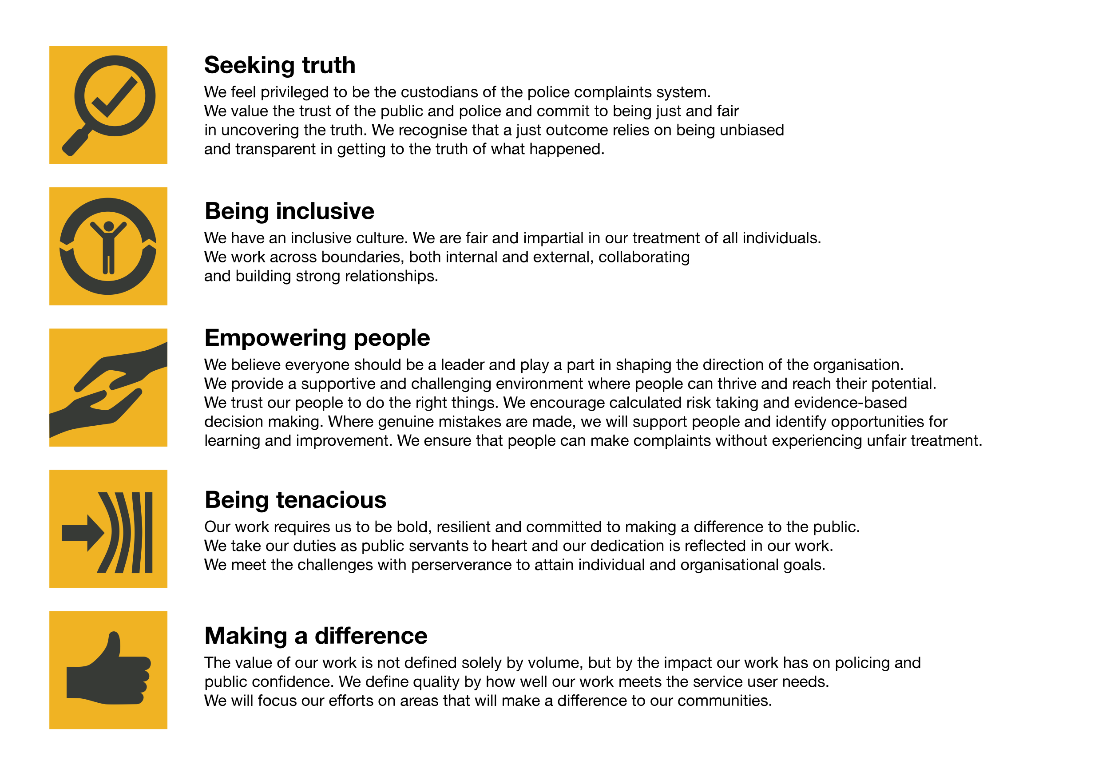We work in the context of our agreed values which inform the way we do things at the IOPC. The Archive and Records Assistant will need to be commited to managing in the context of these values.

The IOPC is committed to **promoting equality and valuing diversity** in everything we do. Our vision is to be, and to be seen as, a leader in inclusive employment and services, demonstrating this ethos in everything that we do.

* As a silver standard Stonewall employer, we continue to commit ourselves to being a LGBTQ+ employer through the work of our Pride LGBTQ+ Staff Network, creating welcoming environments for lesbian, gay, bi and queer people.
* We are pleased to share we are a signatory of the Business in the Community Race at Work Charter. The Charter is composed of five [calls to action](https://race.bitc.org.uk/issues/racecharter) for leaders and organisations across all sectors.
* Being a Disability Confident employer, the IOPC is dedicated to removing the barrier for disabled people to thrive in the workplace.
* Our Staff Networks are constantly working to make the IOPC the leaders of inclusive employment, from our Allyship Programme to [Welsh Language Standards](https://www.policeconduct.gov.uk/who-we-are/equality-and-diversity/welsh-language-standards) and Know the Line Policy, we are constantly seeking new ways to create an environment for all to develop and thrive.

# Main duties and responsibilities

* To review documents and records the IOPC holds in all formats and analyse content to make recommendations in line with the organisational Retention and Disposal Policy to ensure compliance across the organisation
* Provide written summaries and justifiable recommendations for records reviewed in line with retention criteria and guidance provided
* Update the relevant technical systems (e.g. case management system and archive catalogue), ensuring that any changes made to the location of records and other relevant metadata are accurately recorded to maintain integrity and accessibility of records
* Support the Corporate Records Management (cRM) team to retrieve material from the storage and external supplier in line with department priorities
* Ensure all material is handled in line with policies and allocated to the appropriate locations to facilitate correct disposal or accessibility in the future
* Please note: Assessing hardcopy legacy information involves moving boxes up to 15kg with the use of manual work positioner tool
* Participate in the destruction process by reviewing electronic inventories and analysing with a critical eye the work of colleagues as part of quality assurance and dip-sampling processes to ensure the accuracy of retention and disposal recommendations
* Action service and supply requests, in line with the records lifecycle, for staff across the organisation. This involves the use of e-forms, email mailbox maintenance, communicating to stakeholders across all offices and liaising with our external storage providers
* Provide an effective service to the wider business as part of this team, seeking to align processes with international Records Management standards and regulations whilst maintaining good communication and relationships with colleagues across the IOPC
* Support the cRM team with assessment work in line with Public Records Act 1958 responsibilities
* Help to promote the work of the team and good records management practice through involvement in learning sessions, knowledge sharing and providing support with updates to training and guidance material when required
* Meet with the Team Co-ordinator and Line Manager on a regular basis to discuss recommendations and alert management to any cases that may be of interest to government inquiries
* Support the cRM team completing other duties as required (e.g. minute taking and working group participation).

Recommendations made by the post holder may have an impact on the reputation of the IOPC and compliance with relevant legislation such as Freedom of Information and Data Protection. Therefore, a high level of accuracy is required both in the initial review of records and the quality assurance phase of the process. Final decisions to retain or destroy will be taken on the recommendations made by the post holder and the post holder must be able to justify their recommendations to retain or destroy both pre and post destruction.

# Person specification

## Essential

* Experience of analysing, appraising and evaluating physical and electronic material and documentation.
* Experience of working on own initiative, taking critical decisions within a framework of delegation and being able to justify those decisions.
* Experience of providing brief written summaries and guidance to others.
* Experience of working to tight deadlines whilst maintaining accuracy.
* Experience of dealing with internal and external stakeholders to complete tasks successfully.
* Proven experience of working effectively in a team environment.
* Experience in using relevant technology – Microsoft Office applications and information management systems.
* An understanding of the importance of legislation such as GDPR and Public Records Act as it relates to the work of the IOPC.

## Reasonable adjustments

The IOPC is a diverse and inclusive workplace and we want to help you demonstrate your full potential whatever type of assessment is used. We are open to providing you with the tools you need to succeed, from extra time to formatting changes, to name a mere few. If you require any reasonable adjustments to our recruitment process, please email [humanresources@policeconduct.gov.uk](mailto:humanresources@policeconduct.gov.uk)

## Working conditions

Making the IOPC a great place to work is one of our key priorities. We are pleased to offer a unique hybrid working model based on business needs, balanced with the needs of our colleagues. Our business need framework guides our decisions about when it is best to work onsite (in our offices or other appropriate locations) to complete tasks most effectively or when to work remotely, offering colleagues flexibility to work where they feel most productive and supporting work-life balance. The model also encourages staff to feel welcome at the IOPC by ensuring we have opportunities to work face-to-face as teams.

## Preparation checklist

☐ Review the full job description

☐ Review the behaviours and the descriptors for each behaviour

☐ Review the Strengths dictionary

☐ Review the IOPC values

☐ Consider your Strengths (if applicable)

☐ Consider drafting example answers that cover the specific elements

☐ Prepare some questions to ask the interviewers