Job description
Title: Archive and Records Assistant (ICO Audit support)
Reports to: Deputy Document and Records Manager
Location: London or Croydon (with travel to other offices)
Grade: 7
Salary: £23,060 per annum (plus £4,438 London Weighting Allowance)
Contract: Fixed term until 31st December 2023

Purpose
The Independent Office for Police Conduct (IOPC) exists to investigate complaints fairly and thoroughly. The IOPC has the power to initiate, carry out and oversee investigations. It is also responsible for monitoring the way complaints are handled by local police forces.
As an Archives and Records Assistant your role will be to carry out various tasks in order to aid the IOPC in legal and statutory compliance whilst promoting best practice records management.
As an Archive and Records Assistant within the IOPC, you can expect to work in a progressive and dynamic organisation with declared and strong core values. The work will be fulfilling and offer considerable opportunities for personal growth and satisfaction.

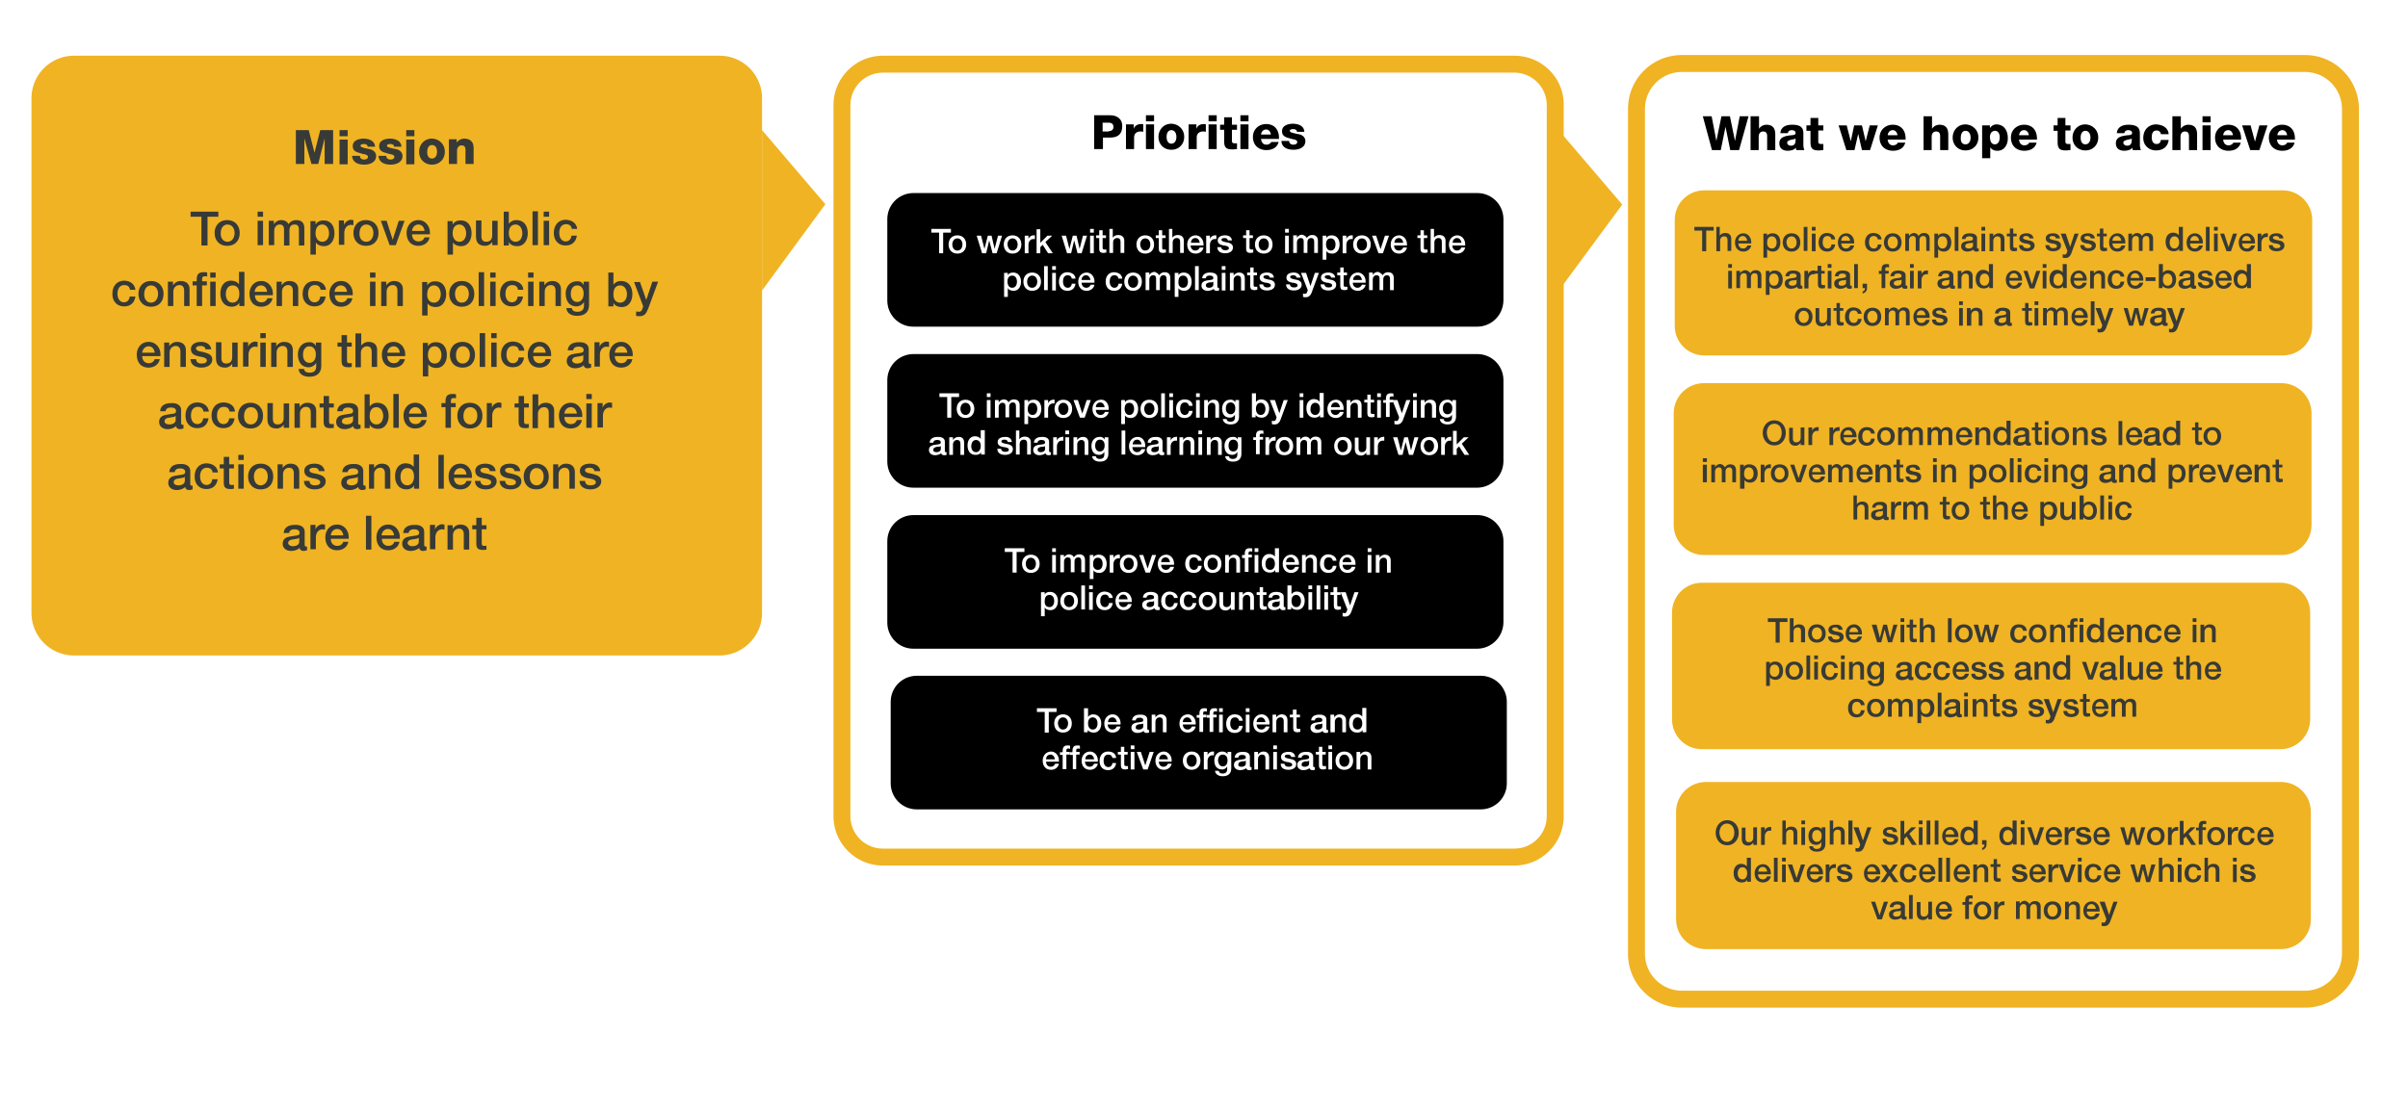
Organisational context

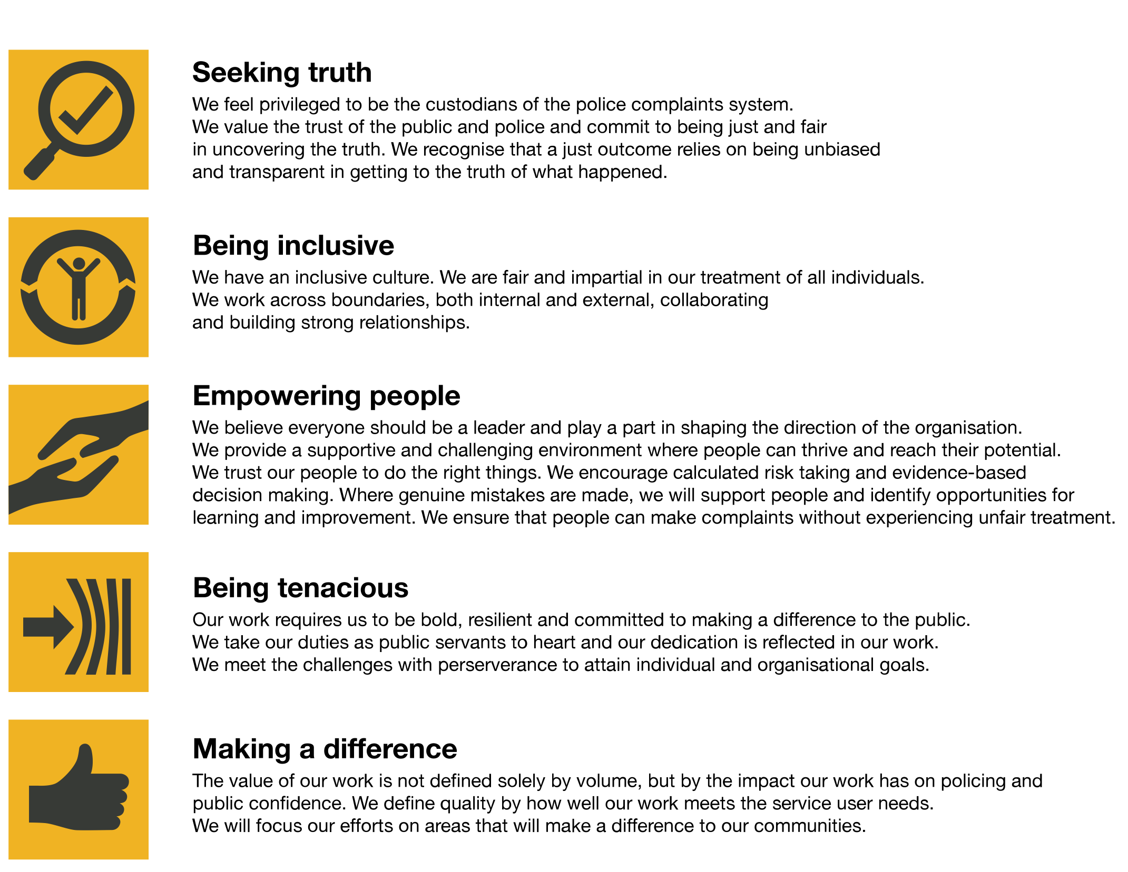
We work in the context of our agreed values which inform the way we do things at the IOPC. The Archive and Records Assistant will need to be commited to managing in the context of these values.
The IOPC is committed to promoting equality and valuing diversity in everything we do. Our vision is to be, and to be seen as, a leader in inclusive employment and services, demonstrating this ethos in everything that we do.
- As a silver standard Stonewall employer, we continue to commit ourselves to being a LGBTQ+ employer through the work of our Pride LGBTQ+ Staff Network, creating welcoming environments for lesbian, gay, bi and queer people.
- We are pleased to share we are a signatory of the Business in the Community Race at Work Charter. The Charter is composed of five calls to action for leaders and organisations across all sectors.
- Being a Disability Confident employer, the IOPC is dedicated to removing the barrier for disabled people to thrive in the workplace.
- Our Staff Networks are constantly working to make the IOPC the leaders of inclusive employment, from our Allyship Programme to Welsh Language Standards and Know the Line Policy, we are constantly seeking new ways to create an environment for all to develop and thrive.
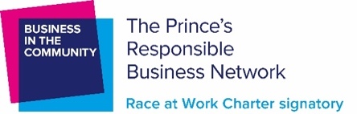

Main duties and responsibilities
- Carry out audits and analyse findings of records across IOPC, to determine whether they should be destroyed or retained in compliance with the organisation’s retention & disposal policy, the Data Protection Act 2018 and the Public Records Act Appraisal Policy. This role will therefore require travel around the sites of IOPC.

- Using a terms of reference and key policy, determine the allegation and category a file relates to and be able to identify cases that have any links to identified government inquiries. Record details of findings and make a justifiable recommendation to retain or destroy.
- To participate in the destruction process by reviewing and analysing with a critical eye, the work of colleagues as part of the quality assurance process by dip-sampling reviewed files to ensure the accuracy of recommendations to retain or destroy.

- Meet varying deadlines and prioritise high level tasks to help the IOPC deliver objectives set out under the external audit recommendation plan. Provide training to and closely liaise with teams who need to carry out their own audits and ensure the accurate recording of relevant data in SharePoint online.

- Support teams where records need to be transferred to offsite storage or destroyed.

- Closely liaise with the wider records management team and off-site storage providers to fulfil collection requests and log data.

- Arranging and leading meetings, logging actions and following up with various members of the business.

- To action service and supply requests, in line with the records lifecycle, for staff across the organisation.

- To assist in updating policies and guidance working closely with the Deputy Documents and Records manager.

- Carrying out post audit checks such as ensuring ICO recommendations have been followed through.

- Supporting teams with other audits which are part of the ICO recommendations such as shared drive audit under direction when required.
In relation to a high priority workstream initiated as part of IOPC compliance, the post holder will:

- Audit, review, appraise and analyse corporate and operational files across the organisation, make informed recommendations as to whether files should be retained or destroyed and record in accordance with the IOPC retention and disposal schedule and record all relevant details on a SharePoint list.

- Identify and segregate files as required:
  - those cases that relate to ongoing government inquiries
  - those cases that relate to case categories on the RED list contained in the Operational retention schedule
  - those cases that have reached their retention period limit
  - involves moving boxes up to 15kg with use of manual work positioner tool
  - Record details of findings onto the archiving catalogue, including a brief description of the allegations that gave rise to the complaint and make a justifiable recommendation to retain or destroy.

- Review and interrogate relevant systems, retrieving information to ascertain whether the hardcopy information is also available in electronic format.

- Assist where required in arranging record transportation to offsite storage or the timely destruction where appropriate, obtaining sign off for destruction from IAO’s and recording relevant destruction certificates as per IOPC processes.

- Train teams to carry out their own audits, ensuring colleagues are thoroughly briefed and remain easily contactable to discuss any queries or concerns and advise as necessary.

- Meet with the Documents and Records Compliance Officer, Deputy Record Manager, Corporate Document, Archive and Record Manager on a regular basis to discuss recommendations for disposal and highlight any risks or concerns concerned. Alert the Deputy Record Manager to any cases that may be of interest to government inquiries.

- Create frequent progress reports, ensuring that data is shown in a clear and coherent way to reflect the ongoing project. This data will also be included in the cRM team wide monthly dashboard, and other board dashboards, so consistency in reporting is key.

- Participate in the destruction process by reviewing and analysing with a critical eye the work of colleagues as part of the quality assurance process by dip-sampling archived files to ensure the accuracy of recommendations to retain or destroy.

- Recommendations made by the Archives and Records Assistant may have an impact on the reputation of the IOPC and directly impacts the status of compliance with relevant legislation such as Freedom of Information and Data Protection. Therefore, a high level of accuracy is required both in the initial review of the files and the quality assurance phase of the process. Final decisions to retain or destroy will be taken on the recommendations made by the post holder and the post holder must be able to justify their recommendations to retain or destroy both pre and post destruction.

In relation to general expectations of the post holder, as a member of the wider cRM team, the post holder will also work on other tasks and activities as required by the team from time to time. This includes:

- Liaise with key stakeholders to maintain good communication and relationships with colleagues in all regional offices and interested parties. This includes answering queries in the team mailbox, attending corporate events on behalf of the team and promoting the work of the team as and when required.

- Action service and supply requests on behalf of the cRM team for staff across the organisation. This includes destruction consent e-forms and communicating and liaising with our external storage providers.

- Provide an effective service to the wider business as part of the cRM team, seeking to align processes with international records management standards and regulations, such as ISO 15489.

- Develop processes and guidance that are consistent with policies developed by the cRM team and as part of this, consult impacted stakeholders for input and approval. From time to time, it may be necessary to report to boards and/or working groups on new processes to aid ongoing high-level workstreams.

- Support the Corporate Records Management (cRM) team completing any other duties as required, for example any new projects or initiatives.

- Assist in updating and maintaining I.T systems owned by the cRM team, such as aspects of the corporate EDRMS.

Person specification

Essential
- Experience of analysing, appraising and evaluating physical and electronic information and documentation to make an effective decision.
- Experience of working on own initiative, taking critical decisions within a framework of delegation and being able to justify those decisions.
- Experience of providing brief written summaries and guidance to others.
- Excellent interpersonal skills, with the ability to create and maintain key stakeholder relationships to complete tasks effectively.
- Ability to prioritise and manage a number of important tasks with varying deadlines whilst maintaining accuracy.
- Proven experience of working effectively in a team environment.
- Experience in using relevant technology – Microsoft Office applications and information management systems, with generic I.T. literacy.
- An awareness of the importance of legislation such as Public Records Act, Freedom of Information and Data Protection Act as it relates to the work of the IOPC.
- Be able to travel either by public transport or car.

Reasonable adjustments
The IOPC is a diverse and inclusive workplace and we want to help you demonstrate your full potential whatever type of assessment is used. We are open to providing you with the tools you need to succeed, from extra time to formatting changes, to name a mere few. If you require any reasonable adjustments to our recruitment process, please email humanresources@policeconduct.gov.uk

Working conditions
Making the IOPC a great place to work is one of our key priorities. We are pleased to offer a unique hybrid working model based on business needs, balanced with the needs of our colleagues. Our business need framework guides our decisions about when it is best to work onsite (in our offices or other appropriate locations) to complete tasks most effectively or when to work remotely, offering colleagues flexibility to work where they feel most productive and supporting work-life balance. The model also encourages staff to feel welcome at the IOPC by ensuring we have opportunities to work face-to-face as teams.

Preparation checklist
☐ Review the full job description
☐ Review the behaviours and the descriptors for each behaviour
☐ Review the Strengths dictionary
☐ Review the IOPC values
☐ Consider your Strengths (if applicable)
☐ Consider drafting example answers that cover the specific elements
☐ Prepare some questions to ask the interviewers

