**Job description**

**Title: ICT Service Desk Analyst**

**Reports to: Lead ICT Service Desk Analyst**

**Location: Any IOPC Office – Canary Wharf, Croydon, Birmingham, Wakefield, Warrington, Sale, Cardiff**

**Grade: 10**

**Salary: £31,110 (plus £4,527 London weighting if Canary Wharf or Croydon based) per annum**

**Contract: Fixed Term – Start Date 01 December 2023 – 31 July 2024**

# Purpose

The post holder will report to the Lead ICT Service Desk Analyst and be responsible for providing support for core ICT business activities.

* Support incident and problem resolution by undertaking first time fix and managing triage of tickets to other resolver groups.
* Support Service request fulfilment adhering to SLA’s, team OLA’s and prioritising tickets.
* Support users on the broad range of ICT deployed at the IOPC, along with helping to maintain infrastructure in the IOPC’s offices.

This will include: fixed and flexible working devices, WiFi networking, printing services, fixed and softphone telephony, mobile telephony and video conferencing as well as specialist equipment used by specific teams within the organisation.

* Work with in house and 3rd party ICT providers in delivering ICT services
* Deal with first line user enquiries and provide end user support for all departments within the IOPC onsite or remotely.
* Ensure incidents/service requests are closed within SLA.
* Administer the access and security of all ICT user accounts, system and file access requests and user profiles
* Deal with support requests appropriately via the Servicedesk workflow system

The post holder will be security cleared to SC level.

# Job Specific

The role involves close collaboration with the in-house ICT Business Relationship, Service Delivery, Security and Change managers and teams.

In addition, the post holder will work closely with internal and external stakeholders at all levels.

This will involve fostering good working relationships and liaison with end users, information asset owners, regional ICT staff and external suppliers, in particular all outsourced supplier services incident and problem management teams.

**All ICT staff must be SC cleared to begin employment with us. A requirement for this is to have been living in the UK continuously for the past 5 years.**

# Main duties and responsibilities

* To work with outsourced ICT service providers to ensure that incidents are resolved promptly, recurring problems are escalated and that ICT services are efficiently delivered.
* Ensure all support calls via phone/email/user walk-up are handled/triaged effectively.
* React to alerts from monitoring systems within SLA.
* Escalate/triage issues where necessary.
* Contribute to policies, processes and procedures.
* Reporting faults within the ITSM tool.
* Administer all ICT user account profiles, application and system access. Ensuring all users only have authorised access to the relevant information & systems according to their role and responsibility, supporting security and system integrity of the Starters and Leavers processes and security groups.
* Provide end user support for the ICT equipment & infrastructure in IOPC offices and key applications such as Outlook email & MS Office as well as line of business applications
* Maintain the CMDB and ICT asset registers are current, status accounted and fit for purpose, with reporting available when required
* Maintain and update a knowledge base, ensuring relevant information is available for all users when required
* Support refresh and change projects related to the ICT infrastructure and end user device portfolio, including user acceptance testing and cutover activities
* To undertake any other ICT administration duties as may be assigned from time to time commensurate with the level and responsibilities of the post.
* As an ICT Service Desk Analyst there is a requirement to cover the hours of:

08:00-16:00

09:00-17:00

10:00-18:00

This is rotated on a weekly basis or as and when needed.

# Person specification

## Desirable

* Knowledge of ITSM tools such as Freshservice/Service Now.
* Reporting and trending experience in ITSM tools.
* Experience of adding announcements for all staff with updates on maintenance/outages.
* Experience of creating and associating parent/child tickets in times of major outages.
* Experience/knowledge of automating tasks/processes
* ITIL Foundation Certification or willingness to work towards it.

## Experience

* Microsoft Office 365 cloud services
* Microsoft Azure cloud services
* Microsoft Outlook email
* Citrix XenApp thin client
* InTune/Endpoint management
* Strong customer focus and experience of building good working relationships with stakeholders and end users
* Experience supporting various end user devices utilising appropriate management tools such as Microsoft Active Directory & Mobile Device Management systems
* Experience of providing remote end user support across a range of desktop environments and office applications
* Knowledge of shared WiFi, VPN, LAN and WAN technologies
* Experience of working with outsourced IT service delivery teams and awareness of ITIL incident and asset management principles
* Experience of working in a secure environment
* Working knowledge of one or more of the IOPC’s corporate applications such as Sharepoint or HP Records Manager
* Awareness of the legal issues relating to IS/IT e.g. Data Protection, Freedom of Information and Computer Misuse Acts, copyright, intellectual property rights, GDPR
* Ability to undertake system administration and access control for the IOPC’s systems
* Good administration skills
* Ability to work as part of a team
* Excellent written and oral communication skills
* Positive can-do attitude and flexibility of approach.

## Working conditions

Making the IOPC a great place to work is one of our key priorities. We are pleased to offer a unique hybrid working model based on business needs, balanced with the needs of our colleagues. Our business need framework guides our decisions about when it is best to work onsite (in our offices or other appropriate locations) to complete tasks most effectively or when to work remotely, offering colleagues flexibility to work where they feel most productive and supporting work-life balance. The model also encourages staff to feel welcome at the IOPC by ensuring we have opportunities to work face-to-face as teams.

## Hybrid Working

Whereby an individual, or team, works part of their time in the office and part of their time working from home, or some other suitably secure agreed location.

The IOPC will provide the standard equipment needed to undertake your work. The equipment issued to you will vary dependent on your job role. The IOPC will provide Laptops which are Wi-Fi enabled and where colleagues opt to work remotely, they will be responsible for accessing a secure Wi-Fi or cabled internet connection.

Where it is not possible to access a secure internet connection, hybrid working will not be possible. The IOPC does not contribute to the cost of installing or maintaining a secure internet connection.

You will be able to work remotely throughout the UK, with a requirement to attend the office on a business needs basis.

See Hybrid Policy: <https://policeconduct.sharepoint.com/sites/thehub/news/news_stories/Pages/ns12082022_hybridpolicyandguidance.aspx>

# Organisational context

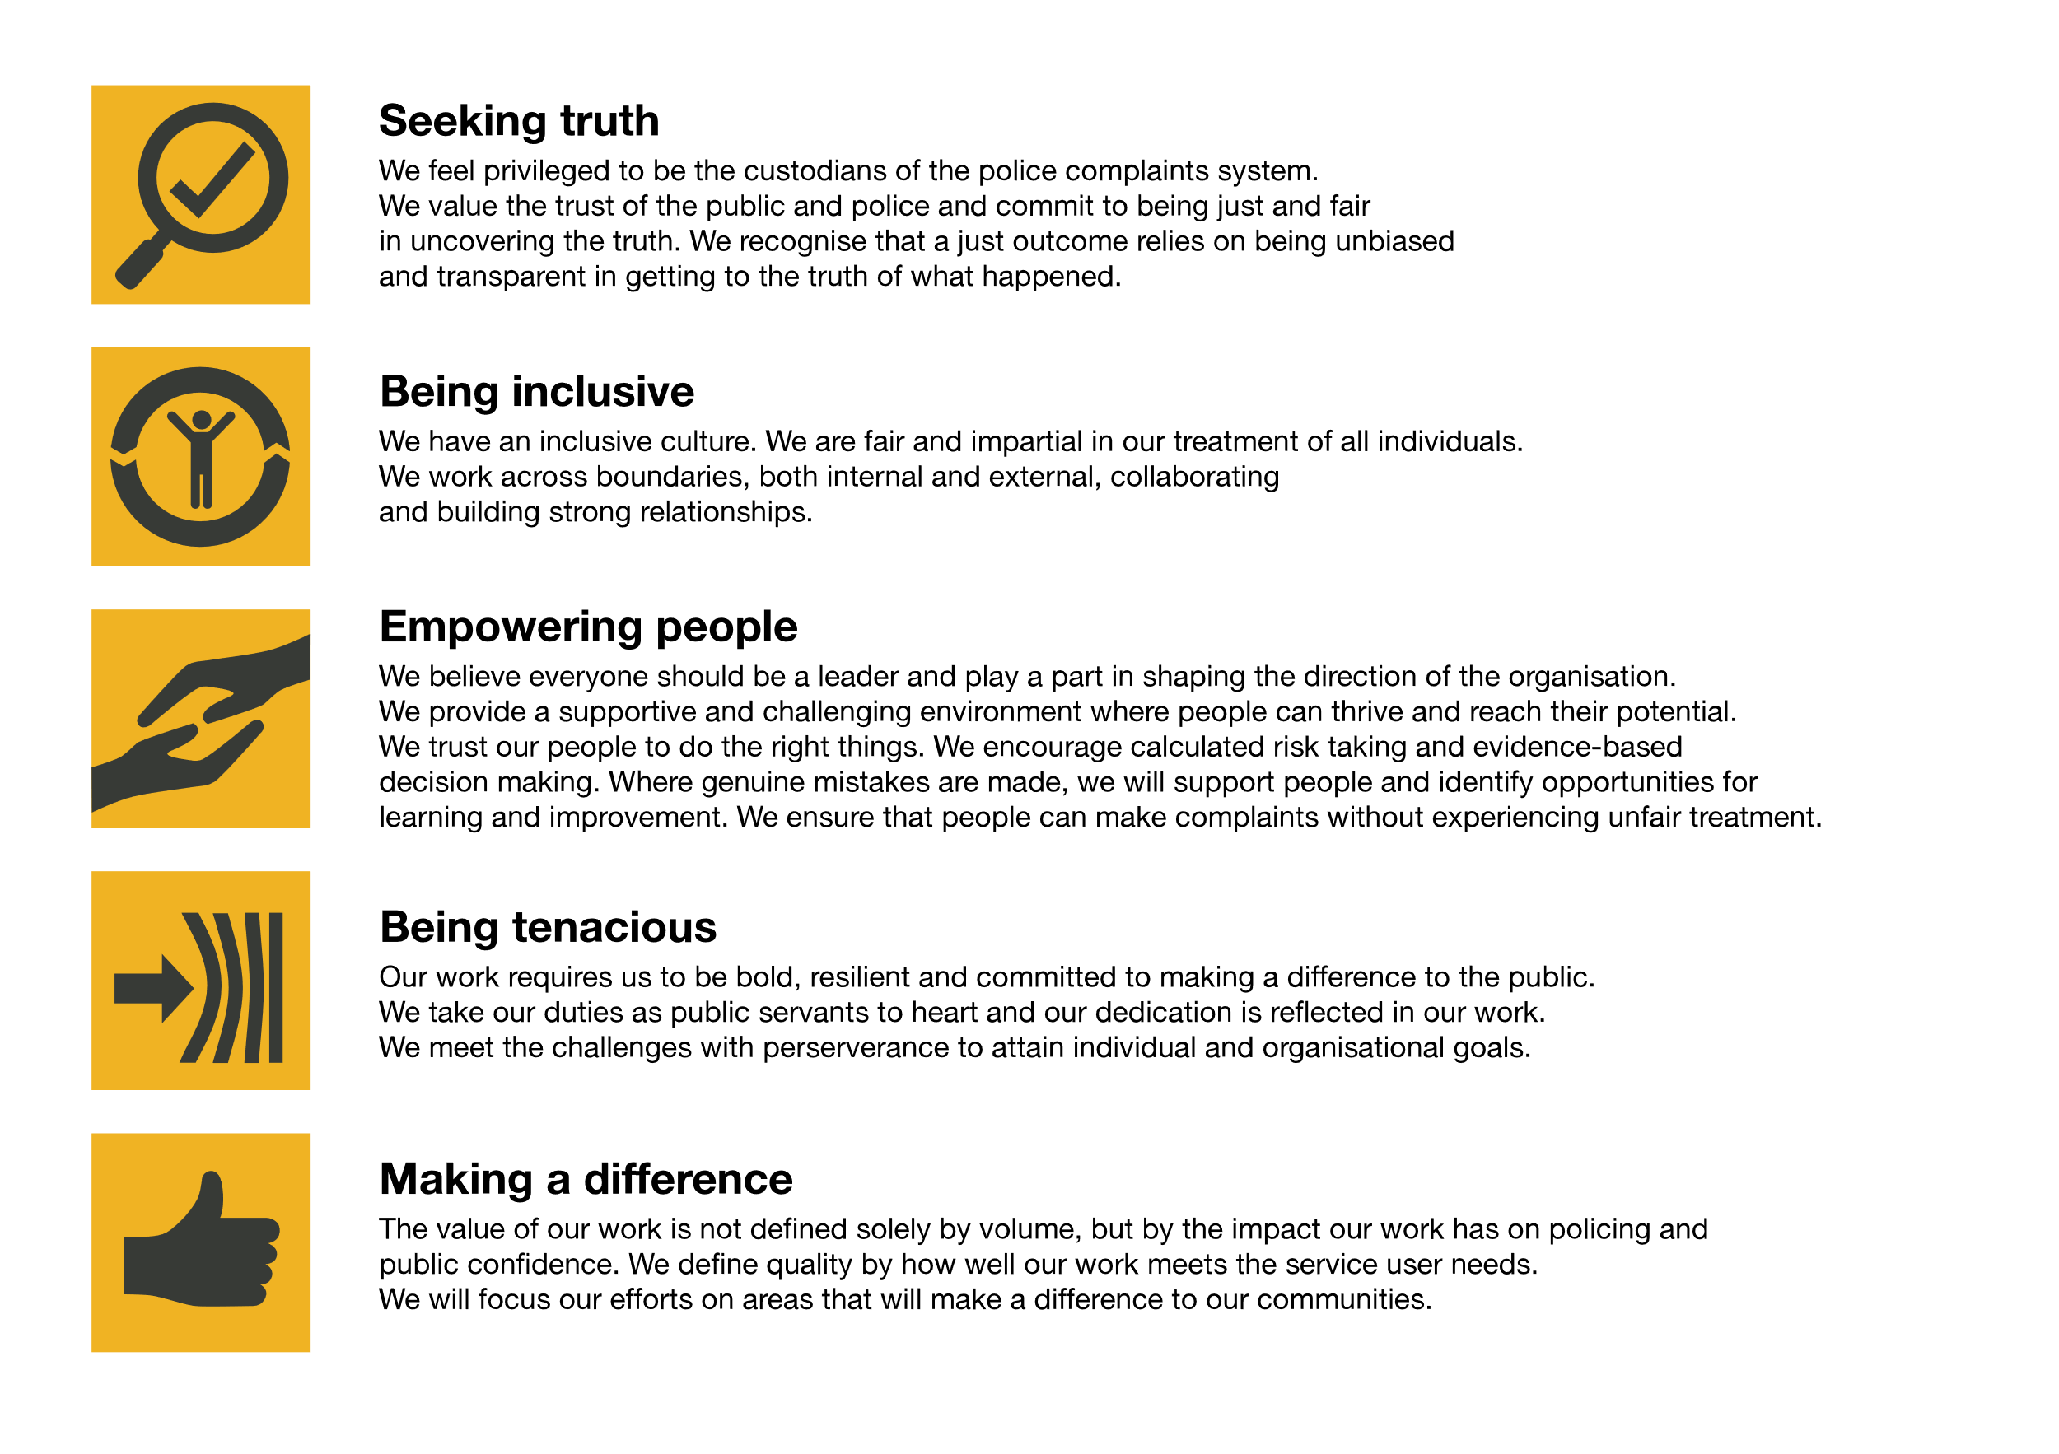We work in the context of our agreed values which inform the way we do things at the IOPC. The ICT Service Desk Analyst will need to be commited to managing in the context of these values.

The IOPC is committed to **promoting equality and valuing diversity** in everything we do. Our vision is to be, and to be seen as, a leader in inclusive employment and services, demonstrating this ethos in everything that we do.

* As a silver standard Stonewall employer, we continue to commit ourselves to being a LGBTQ+ employer through the work of our Pride LGBTQ+ Staff Network, creating welcoming environments for lesbian, gay, bi and queer people.
* We are pleased to share we are a signatory of the Business in the Community Race at Work Charter. The Charter is composed of five [calls to action](https://race.bitc.org.uk/issues/racecharter) for leaders and organisations across all sectors.
* Being a Disability Confident employer, the IOPC is dedicated to removing the barrier for disabled people to thrive in the workplace.
* Our Staff Networks are constantly working to make the IOPC the leaders of inclusive employment, from our Allyship Programme, to [Welsh Language Standards](https://www.policeconduct.gov.uk/who-we-are/equality-and-diversity/welsh-language-standards) and Know the Line Policy, we are constantly seeking new ways to create an environment for all to develop and thrive.

The IOPC is a diverse and inclusive workplace and we want to help you demonstrate your full potential whatever type of assessment is used. We are open to providing you with the tools you need to succeed, from extra time to formatting changes, to name a mere few. If you require any reasonable adjustments to our recruitment process, please email [campaigns@policeconduct.gov.uk](mailto:campaigns@policeconduct.gov.uk)

## Preparation checklist

☐ Review the full job description

☐ Review the behaviours and the descriptors for each behaviour

☐ Review the Strengths dictionary

☐ Review the IOPC values

☐ Consider your Strengths (if applicable)

☐ Consider drafting example answers that cover the specific elements

☐ Prepare some questions to ask the interviewers

**Selection process**

This vacancy is using [**Success Profiles**](https://www.gov.uk/government/publications/success-profiles?_ga=2.156185915.1692943174.1578577916-319911383.1576576754). As part of the application process you will be asked to complete 4 sift stage questions made up of an experience question and 3 Level 2 Behaviour questions.

The Level 2 Behaviours that are being assessed are:

* Managing a Quality Service
* Delivering at Pace
* Changing and Improving

For candidates who are successful at application stage, you will then be invited to a Success Profiles Interview.

The level 2 Behaviours that will be assessed are:

* Communicating and Influencing
* Delivering at Pace
* Changing and Improving

You will also be assessed on Strengths desirable for the role, as well as an IOPC Values question.