**Job description**

**Title: Application Solutions Analyst**

**Reports to: Application Solutions Architect**

**Location: Birmingham, Canary Wharf, Cardiff, Croydon, Sale, Wakefield**

**Grade: 12**

**Salary: £37,120 (plus £4,438 if London based)**

**Contract: Permanent**

# Purpose

As a ICT Solutions Analyst you will be welcomed into a dynamic and inclusive ICT team working to help develop the IOPC application strategy. The IOPC is on a journey to develop its culture, perspectives and ethos to support the organisation’s core outcomes and this is your opportunity to enter into the varied world of IOPC ICT, allowing you to develop your mindset and approaches to contribute to improving the police complaints system in England and Wales.

The ICT Application Solutions Analysts reside within the ICT team and have co-responsibility for the application architecture. They support the design and delivery of the application solutions that service the IOPC’s current and target operating needs.

Acting as the conduit and coordinator between the technical, information and business architecture layers of the IOPC, the role supports the ICT enterprise solution architect to ensure ICT capabilities align to the OnePlan.

Being part of a service orientation ICT, the ICT Application Solutions Analysts will use their technical expertise to Support the Enterprise Solution architect function by providing:

* Technology support for the development and maintenance of IOPC business applications;
* Requirements gathering and documentation to ensure the business needs are addressed appropriately as part of the application review;
* Technical support to ICT and business stakeholders where it concerns business applications
* Collaboration with internal stakeholders and partners within ICT and across the business, to interpret and refine business goals and drivers for the alignment of the future ICT strategy to the OnePlan.

We are in the exciting position to also offer this role as a development opportunity, for someone starting to enter the world of application solutions. If you do not currently have all of the essential experience, we would be able to offer the role starting at a Grade 11, with the aim to develop your knowledge skills and experience to a Grade 12 within 12 months.

Key Relationships:

The post holder will work closely with internal and external stakeholders at all levels, but with a focus on key business change stakeholders such as Project Management Office and Knowledge & Information Management. They will forge close working relationships with colleagues in ICT; business relationship managers, Service delivery managers, change managers, disaggregation and transformation project team and external supplier

This role requires security clearance to SC level.

# Organisational context

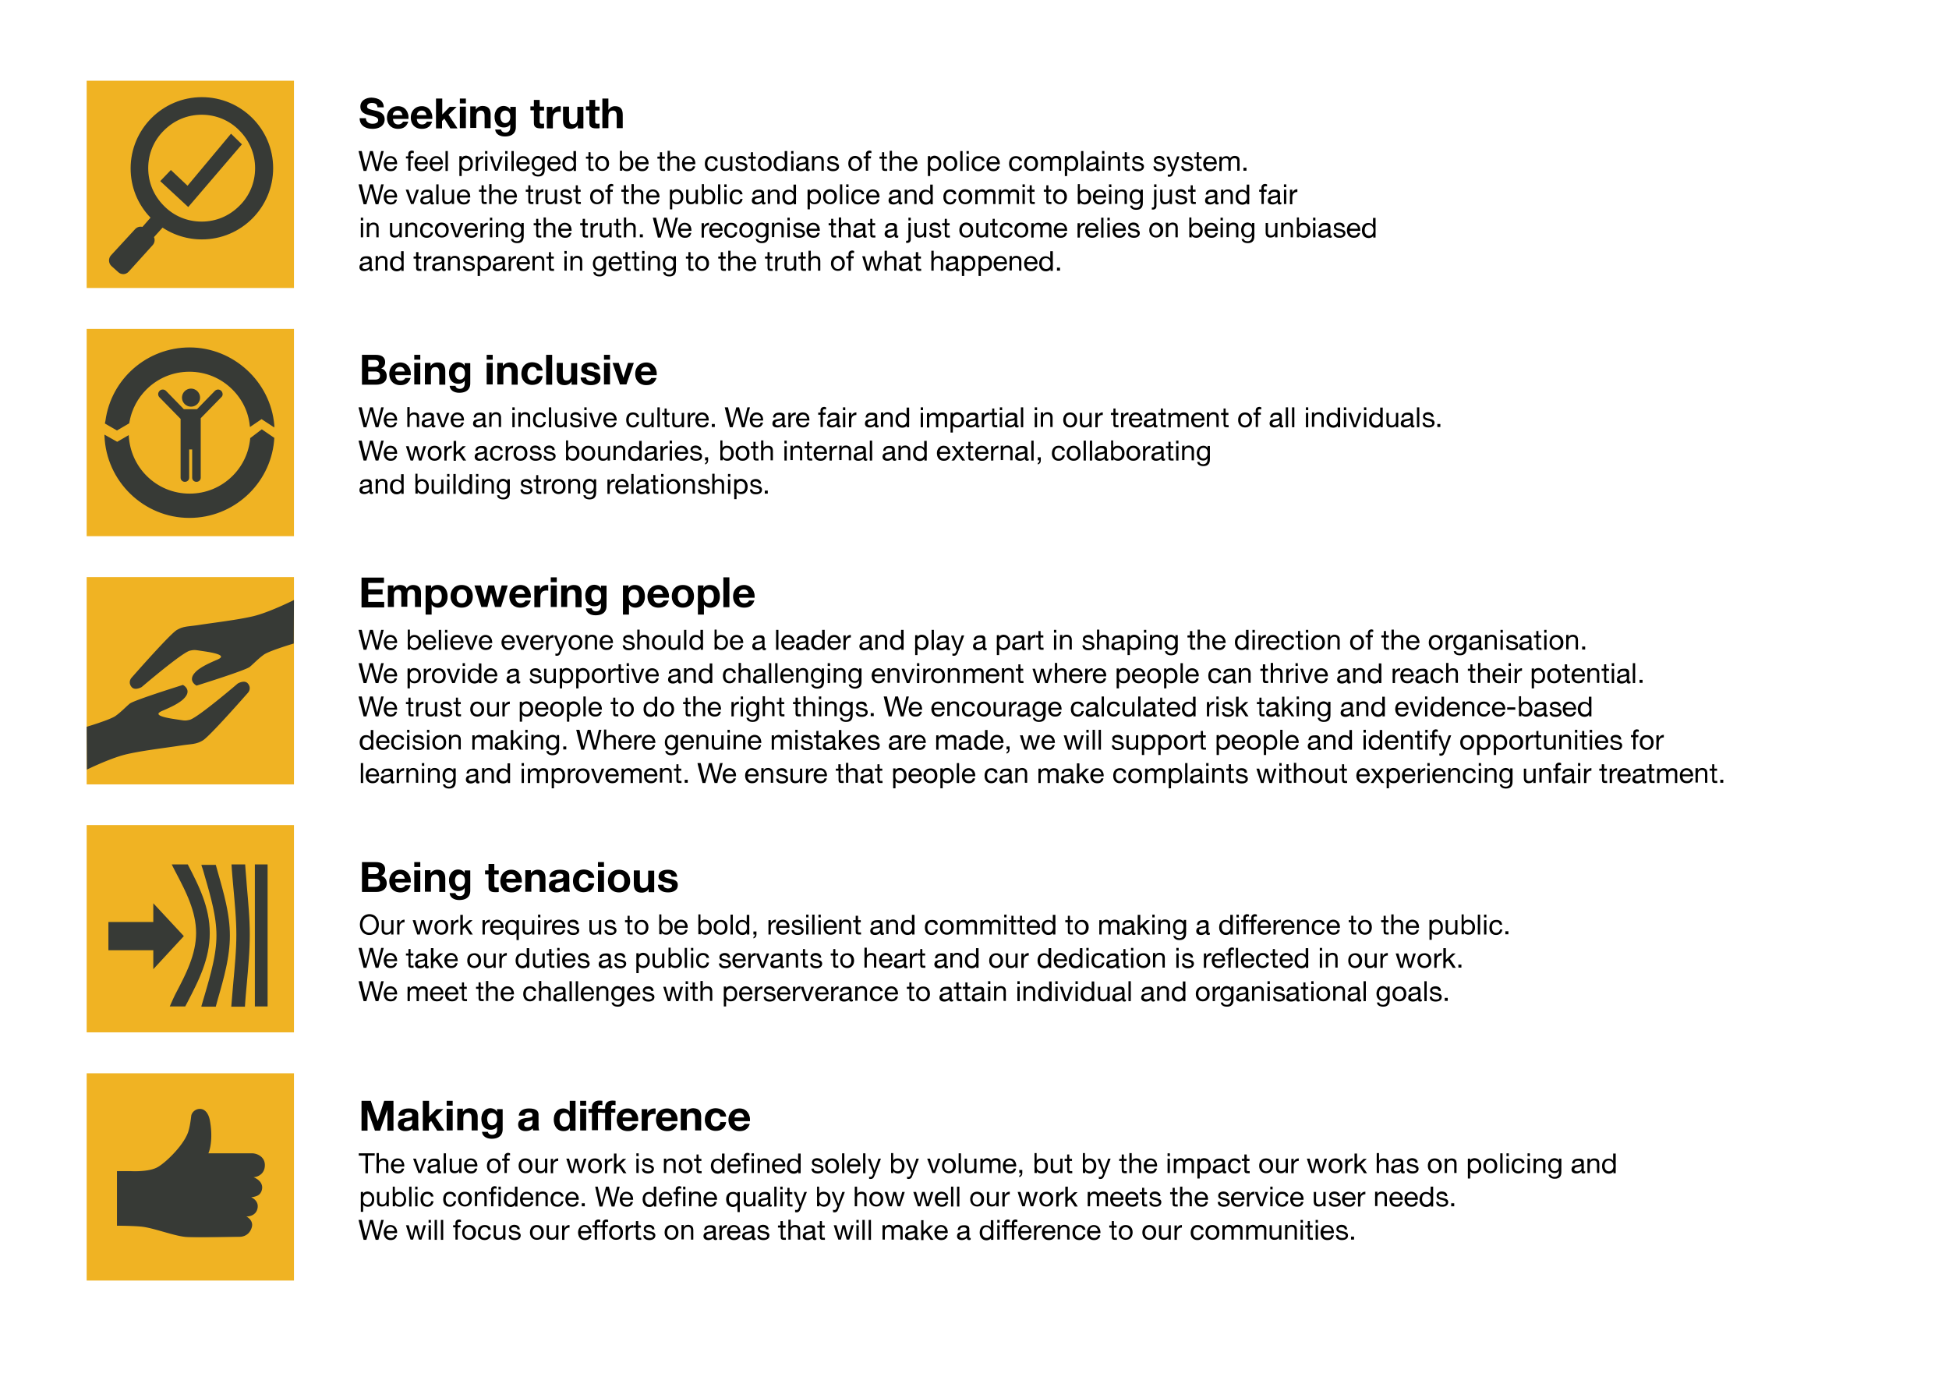We work in the context of our agreed values which inform the way we do things at the IOPC. The ICT Application Solutions Analyst will need to be commited to managing in the context of these values.

The IOPC is committed to **promoting equality and valuing diversity** in everything we do. Our vision is to be, and to be seen as, a leader in inclusive employment and services, demonstrating this ethos in everything that we do.

* As a silver standard Stonewall employer, we continue to commit ourselves to being a LGBTQ+ employer through the work of our Pride LGBTQ+ Staff Network, creating welcoming environments for lesbian, gay, bi and queer people.
* We are pleased to share we are a signatory of the Business in the Community Race at Work Charter. The Charter is composed of five [calls to action](https://race.bitc.org.uk/issues/racecharter) for leaders and organisations across all sectors.
* Being a Disability Confident employer, the IOPC is dedicated to removing the barrier for disabled people to thrive in the workplace.
* Our Staff Networks are constantly working to make the IOPC the leaders of inclusive employment, from our Allyship Programme to [Welsh Language Standards](https://www.policeconduct.gov.uk/who-we-are/equality-and-diversity/welsh-language-standards) and Know the Line Policy, we are constantly seeking new ways to create an environment for all to develop and thrive.

# Main duties and responsibilities

Application architecture

· Evaluate application technologies and make recommendations for best uses for the IOPC, to develop the IOPC application strategy.

· Analyse data flows between IOPC application solutions and those of its partnering stakeholders, with the view to designing and developing new application solutions or improve existing ones

· Support the creation, via iterative development, of the application architecture, to support the maintenance of boundaryless Information flow across the business

· Administer the Application portfolio

Support Business applications

· Assess and develop solution applications and associating documentation (specifications)

· Collaborate with internal stakeholders and partners within ICT and across the business, to interpret and refine business goals and drivers for the alignment of the future ICT strategy to the OnePlan.

· Provide and share expertise with other team members in areas of application architecture and software development

· Support SDLC – Software Development Lifecycle - coordinate software tests, prototypes development and creating architectural technical documents relating to application development where required.

Lead and support colleagues on information management as far as it relates to Application solutions

· Deputise for the Enterprise solution architect and solution architects as required.

· Support activities related to the information architecture.

· Work with stakeholders within IOPC and externally to ensure the integrity and integration of data and information (where appropriate)

· Coordinate and service workshops and meetings as part of supporting the IOPC application architecture

· Undertake any other duties to support the IOPC wider ICT strategy and programmes as necessary

· Champion the tactical strategy for master data management, that supports the management of data and information in all its forms and structures (including logical analysis of taxonomies, data and metadata).

# Person specification

**Essential**

· Experience working within a technology environment supporting business users

· Experience analysing business needs and proposing technology solution to meet need

· Hands on experience working in an application developer capacity within an in-house development team.

· Knowledge and experience of developing application solutions on Cloud technology and common platforms such as Azure and O365, AWS and open source option

· Experience of developing and managing CMS, Workflow management solutions and EDRM’s in at least 2 of the following; o Appian, o SharePoint 2010 +, o CRM, o Tricostar, o Excel, o Powerapps & Flow.

The post holder will be expected to be able to obtain, or currently hold, security clearance to SC level.

**Desirable**

· Microsoft 365 certification.

· Experience of certification in Appian development.

· Experience in at least 2 of the following: SQL, XML, Java script, .Net.

· Experience working with data flow management system i.e. data warehouse, data lake, transaction database

· Knowledge of API, SOA and middleware technology

· Understanding of solution architecture and associating governance

· Understating of a Business and project methodologies and frameworks such as Prince2, PMP, Agile and ITIL

· Experience of requirements gathering and modelling techniques languages and tools; User stories, UML, ArchiMate etc

## Reasonable adjustments

The IOPC is a diverse and inclusive workplace and we want to help you demonstrate your full potential whatever type of assessment is used. We are open to providing you with the tools you need to succeed, from extra time to formatting changes, to name a mere few. If you require any reasonable adjustments to our recruitment process, please email [humanresources@policeconduct.gov.uk](mailto:humanresources@policeconduct.gov.uk)

## Working conditions

Making the IOPC a great place to work is one of our key priorities. We are pleased to offer a unique hybrid working model based on business needs, balanced with the needs of our colleagues. Our business need framework guides our decisions about when it is best to work onsite (in our offices or other appropriate locations) to complete tasks most effectively or when to work remotely, offering colleagues flexibility to work where they feel most productive and supporting work-life balance. The model also encourages staff to feel welcome at the IOPC by ensuring we have opportunities to work face-to-face as teams.

## Preparation checklist

☐ Review the full job description

☐ Review the behaviours and the descriptors for each behaviour

☐ Review the Strengths dictionary

☐ Review the IOPC values

☐ Consider your Strengths (if applicable)

☐ Consider drafting example answers that cover the specific elements

☐ Prepare some questions to ask the interviewers