**Job description**

**Title:** ICT Service Delivery Manager – Service Integration and Management

**Reports to:**  Deputy Head of ICT

**Location:** Any IOPC office with remote working flexibility

**Grade:** 14

**Salary:** £53,760 per annum (plus £4438 London weighting if applicable)

**Contract:** Permanent

# Purpose

As an ICT Service Delivery Manager (SIAM), you will be welcomed into a dynamic and inclusive ICT team. The IOPC is on a journey to develop its culture, perspectives and ethos to support the organisation’s core outcomes and this is your opportunity to enter into the varied world of IOPC Strategy and Impact, allowing you to develop your mindset and approaches to contribute to improving the police complaints system in England and Wales.

The ICT Service Delivery Manager (SIAM) is responsible for owning ICT service management commercial and governance processes, management of 3rd party suppliers, supporting ICT project delivery, as well as the line management, leadership and co-ordination of in-house teams supporting business as usual ICT services.

Including:

* Contributing to the corporate, strategic and tactical direction for ICT services
* Customer support, delivery of production ICT services (both application and infrastructure)
* Ownership of new or evolving business requirements, ensuring they are translated into new or revised services that align with the ICT Architectural Principles
* Lead or contribute to ICT infrastructure and strategic technology change projects
* Governance and compliance of software licencing arrangements
* Contribution to the development and implementation of ICT security processes and compliance requirements, especially in the supply-chain
* Deputising for the Deputy Head of ICT and representing the service as a whole
* Delegated operational and project procurement activities
* Oversight of operational & project budgets

The post holder will be expected to gain or hold security clearance to SC level.

**Key Relationships:**

The post holder will work closely with internal and external stakeholders at all levels, but with a focus on senior stakeholders and key business change drivers.

This will involve close working relationships with other senior managers, Information Asset Owners, Business Owners, ICT Business Relationship Managers, the ICT Security & Information Assurance Manager and with external supplier managers and their staff.

The post holder will advise and support the ICT senior management team in developing ICT strategy and governance in accordance with business requirements, responding to and providing strategic and tactical direction for business change.

As a primary operational client-side contact, the post holder will lead on resolving high profile issues and managing suppliers to ensure a high standard of service at all levels.

The post holder will contribute to the following best practice processes: Daily incident reporting, Change Advisory Board, change request, problem review, project boards, risk review, supplier management and Continual Improvement initiatives. Where required, report on BAU activities and change programmes.

# Organisational context

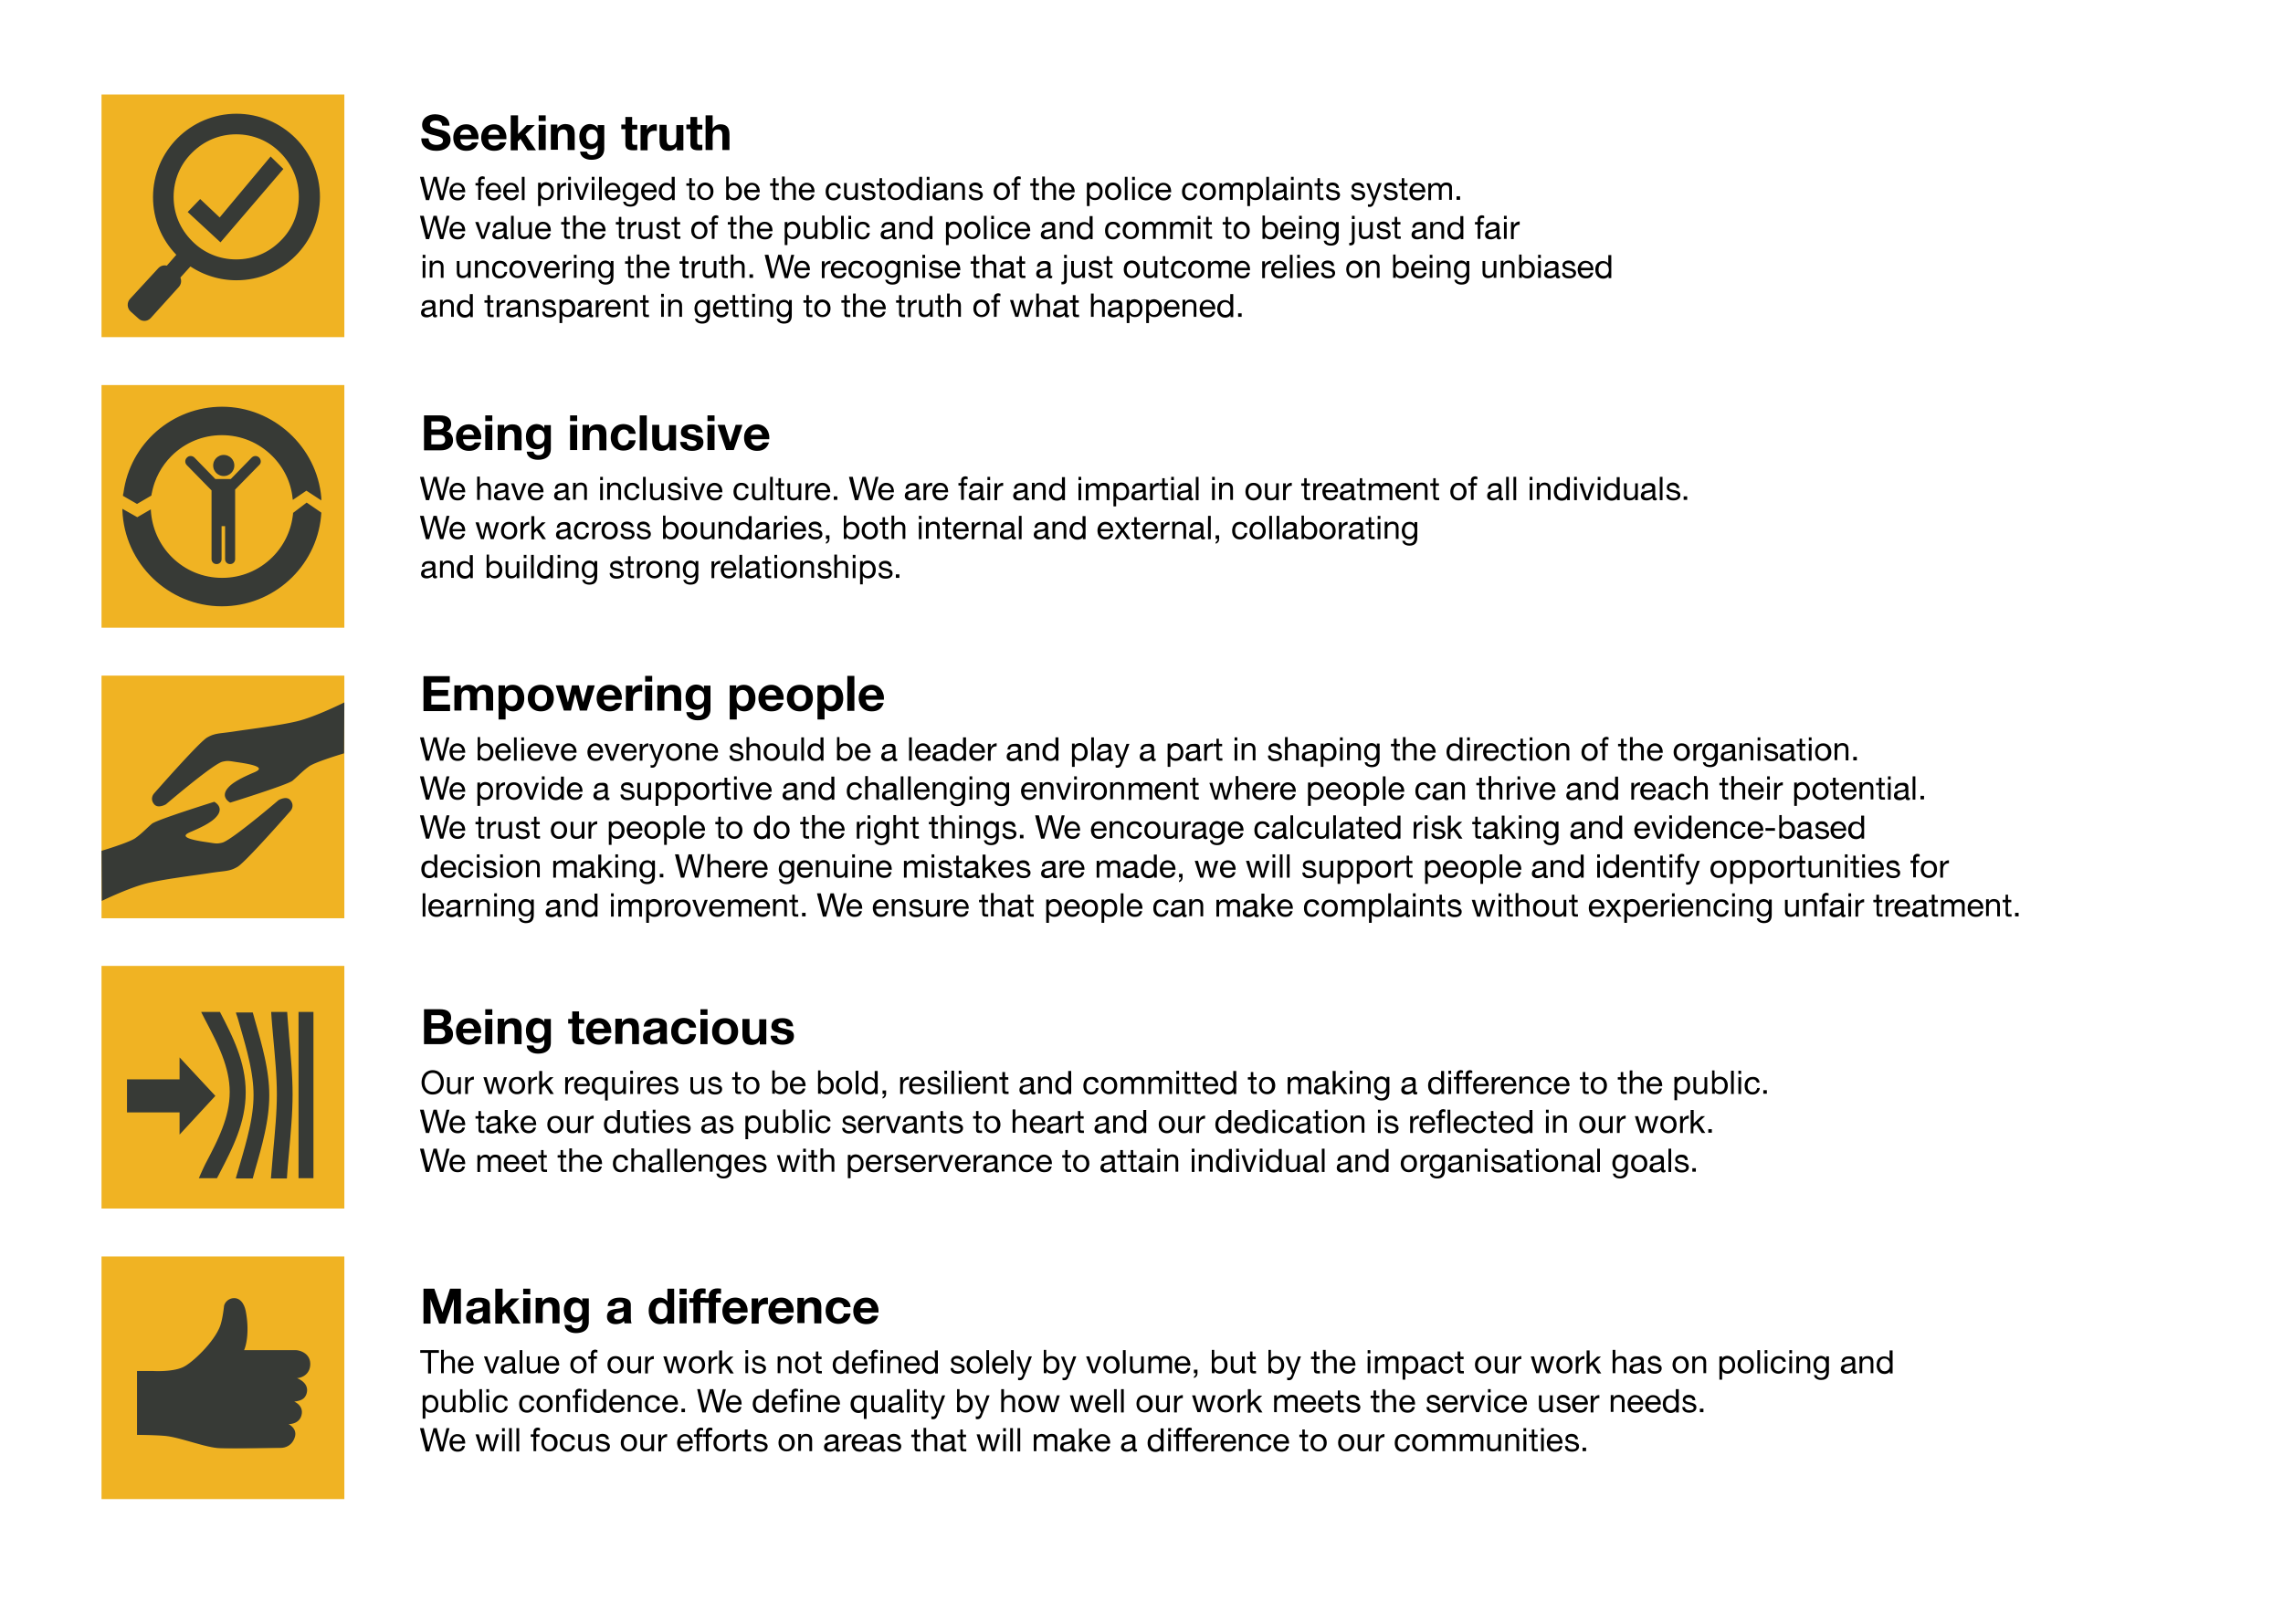We work in the context of our agreed values which inform the way we do things at the IOPC. The ICT Service Delivery Manager (SIAM) will need to be commited to managing in the context of these values.

The IOPC is committed to **promoting equality and valuing diversity** in everything we do. Our vision is to be, and to be seen as, a leader in inclusive employment and services, demonstrating this ethos in everything that we do.

* As a silver standard Stonewall employer, we continue to commit ourselves to being a LGBTQ+ employer through the work of our Pride LGBTQ+ Staff Network, creating welcoming environments for lesbian, gay, bi and queer people.
* We are pleased to share we are a signatory of the Business in the Community Race at Work Charter. The Charter is composed of five [calls to action](https://race.bitc.org.uk/issues/racecharter) for leaders and organisations across all sectors.
* Being a Disability Confident employer, the IOPC is dedicated to removing the barrier for disabled people to thrive in the workplace.
* Our Staff Networks are constantly working to make the IOPC the leaders of inclusive employment, from our Allyship Programme to [Welsh Language Standards](https://www.policeconduct.gov.uk/who-we-are/equality-and-diversity/welsh-language-standards) and Know the Line Policy, we are constantly seeking new ways to create an environment for all to develop and thrive.

# Main duties and responsibilities

**Service management**

The post-holder will ensure that all ITIL best practice processes for in house and 3rd party suppliers are implemented, relevant, and effective:

* Incident Management - customers have minimum service interruption and effective support
* Problem management - Effective root cause analysis and elimination of recurring or multiple incidents, with timely workarounds in place when necessary
* Change Management - BAU and project changes thoroughly assessed via the CAB process before implementation for business impact and scheduled appropriately.
* Configuration management - Maintain a reliable database for asset tracking and relationships between configuration items are valid and effective.
* Release Management - Effective forward schedule plan with standard changes and project rollouts incorporated.
* Capacity Management – Infrastructure resources monitored and remain within agreed tolerance for effective service delivery.
* Availability Management – Maintenance windows agreed with the business, key services remain available when required
* Continuity Management – Single points of failure risk assessed, key risks eliminated, Disaster Recovery plans fit for purpose and fully tested.
* Service Level Management – Suppliers fulfil their contracted SLA requirements and in-house teams support the agreed OLA targets.

**BAU service delivery:**

* Matrix management of in- house teams delivering end user, applications, access control, security process and project support.
* Responsibility for the management of ICT service requests, ensuring compliance with agreed governance processes and workflow.
* Review and advise on current capacity management reports.
* Maintain the ICT Operational Risk Register and input into BCP & DR plans.
* Contribute to the Service Improvement plan process.
* Ensure that infrastructure refresh plans are timely, appropriate and delivered without impacting system availability.
* Where appropriate, act as a key escalation contact for Directors for service delivery issues, ensuring they receive an appropriate level of customer care and support.
* Create an effective succession plan for team resilience and staff development opportunities.
* To deputise for other senior ICT managers, when required.
* To undertake any other duties as may be assigned from time to time commensurate with the level and responsibilities of the post.

**Project ownership and delivery**

* Responsible for reviewing and advising on technical strategy and tactical solutions.
* Contribution to the technical roadmap and forward schedules for project implementation.
* Assess and recommend new system implementations and any potential for cloud service offering alternatives.
* Oversight of infrastructure, system and platform projects- implementation of new and maintenance of existing tech platforms.
* Allocate appropriate resources to project implementations.
* Maintain close links to key business stakeholders, especially Business Relationship Managers, turning feedback into action plans to drive innovation wherever possible.

**Service specialism: ICT Service Integration and Management (SIAM)**

The IOPC’s multi-source approach to ICT requires that the SIAM SDM acts as the lead service integrator, ensuring necessary consistent governance, assurance, and management of multiple suppliers and services, whether these suppliers are external, internal, or a combination thereof.

This includes approaches for supplier co-ordination, integration, collaboration, interoperability and delivery.

The SIAM will focus on the end-to-end provision of service, ensuring control of all interfaces and outcomes from suppliers and facilitating collaboration between suppliers.

The SIAM creates an environment where all parties know their role, responsibilities, context and are empowered to deliver – and are then also held accountable for the outcomes.

The role assures that ICT services are effectively built and coordinated with internal and external suppliers.

This includes:

* Co-ordinating delivery, integration, and interoperability across multiple services and suppliers, including systems, applications and platforms
* Process integration across multiple suppliers
* Multi-supplier co-ordination (change/release/capacity/incident/problem, etc.)
* Service on-boarding of new and changed services and suppliers, and the related off-boarding of previous services and suppliers
* Procurement, commercial, financial and contract management, including software licencing compliance and audit
* Assuring supplier performance against SLAs and OLAs
* Providing other necessary governance and assurance of supplier performance on behalf of the business
* Line management of the ICT Commercial Manager and the ICT Quality Manager

The role requires excellent people skills, requiring the following capabilities:

* Relationship management
* Conflict management
* Persuasion
* Negotiation
* Stakeholder management

# Person specification

## Essential

* Experience of working client side in an outsourced ICT environment and supplier management against SLAs, monitoring performance against service level agreements, participating in effective working relationships to deliver continuous improvement
* Knowledge of and experience of working with procurement frameworks
* Experience of managing the performance of information / information technology and telecommunications systems services
* Experience of implementing ICT governance and change management processes
* Experience of working in a secure environment
* Significant knowledge of end user delivery and support
* Knowledge of case management systems
* Understanding of the legal issues relating to IS/IT e.g. GDPR, Freedom of Information and Computer Misuse Acts, copyright, intellectual property rights
* Experience of managing in house teams to deliver high quality services and outcomes
* Experience of building strong working relationships with a variety of stakeholders
* Strong customer focus
* Ability to manage technically diverse teams to deliver agreed outcomes
* Experience in delivering strategic and tactical technology change
* Project management experience
* Good communication and negotiation skills
* Positive can-do attitude and flexibility of approach

## Technical

* ITIL Foundation qualified
* Degree, professional qualification or equivalent experience in an Information technology related subject and project management

## Reasonable adjustments

The IOPC is a diverse and inclusive workplace and we want to help you demonstrate your full potential whatever type of assessment is used. We are open to providing you with the tools you need to succeed, from extra time to formatting changes, to name a mere few. If you require any reasonable adjustments to our recruitment process, please email [humanresources@policeconduct.gov.uk](mailto:humanresources@policeconduct.gov.uk)

## Working conditions

Making the IOPC a great place to work is one of our key priorities. We are pleased to offer a unique hybrid working model based on business needs, balanced with the needs of our colleagues. Our business need framework guides our decisions about when it is best to work onsite (in our offices or other appropriate locations) to complete tasks most effectively or when to work remotely, offering colleagues flexibility to work where they feel most productive and supporting work-life balance. The model also encourages staff to feel welcome at the IOPC by ensuring we have opportunities to work face-to-face as teams.

## Preparation checklist

☐ Review the full job description

☐ Review the behaviours and the descriptors for each behaviour

☐ Review the Strengths dictionary

☐ Review the IOPC values

☐ Consider your Strengths (if applicable)

☐ Consider drafting example answers that cover the specific elements

☐ Prepare some questions to ask the interviewers