**Job description**

**Title:** Deputy Data Protection Officer

**Reports to:** Data Protection Officer

**Location:** Birmingham, Cardiff, Sale or Wakefield

**Grade:** 13

**Salary:** £44,340 per annum

**Contract:** Permanent

# Purpose

As a Deputy Data Protection Officer (DPO), you will be welcomed into a dynamic and inclusive Data Protection and Freedom of Information team. The IOPC is on a journey to develop its culture, perspectives and ethos to support the organisation’s core outcomes and this is your opportunity to enter into the varied world of IOPC Strategy and Impact, allowing you to develop your mindset and approaches to contribute to improving the police complaints system in England and Wales.

The job holder will be responsible for helping to promote and embed a compliance culture which embraces the concept of ‘data protection by design and default’, by ensuring that the IOPC uses effective governance arrangements and documentation to achieve/maintain compliance with relevant legal, regulatory and policy requirements governing the processing of personal data.

The job holder will also be responsible for the periodic production/dissemination of management information associated with the processing of personal data across the IOPC.

They will also take the lead on the development of the internal data and information champions and establishing/maintaining positive working relationships between the FOI and DPA Team and a range of other relevant stakeholders (including Information Asset Owners; requesters, other government departments; privacy and data protection campaign/advocacy groups; etc.).

# Role Description

**UPHOLD IOPC CORE VALUES**

Foster continuous improvement by:

* Participating in examining and enhancing the IOPC’s work policies, procedures and systems.
* Identifying areas where performance can be improved.
* Driving to achieve excellence and continuously develop oneself and ones team.
* Openly sharing information and knowledge with others.
* Seeking to improves own performance by getting feedback from others.

Embrace diversity through:

* Demonstrating openness towards working with diverse ideas and people.
* Understanding the requirements associated with delivering the service to a culturally diverse society.
* Valuing and nurturing diversity within the organisation.

Fulfil the IOPC’s vision by:

* Understanding the IOPC’s vision and values and how these apply to employment and service delivery.
* Committing to ethical practices.
* Respecting human rights.
* Fostering openness and accountability.

# Organisational context

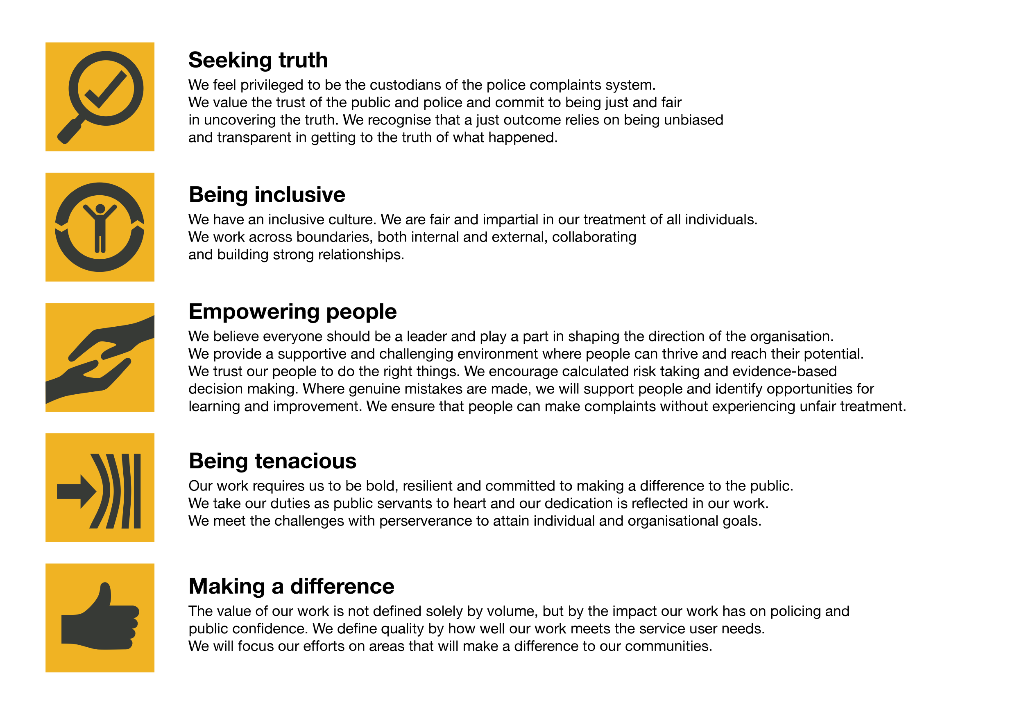We work in the context of our agreed values which inform the way we do things at the IOPC. The Deputy Data Protection Officer will need to be commited to managing in the context of these values.

The IOPC is committed to **promoting equality and valuing diversity** in everything we do. Our vision is to be, and to be seen as, a leader in inclusive employment and services, demonstrating this ethos in everything that we do.

* As a silver standard Stonewall employer, we continue to commit ourselves to being a LGBTQ+ employer through the work of our Pride LGBTQ+ Staff Network, creating welcoming environments for lesbian, gay, bi and queer people.
* We are pleased to share we are a signatory of the Business in the Community Race at Work Charter. The Charter is composed of five [calls to action](https://race.bitc.org.uk/issues/racecharter) for leaders and organisations across all sectors.
* Being a Disability Confident employer, the IOPC is dedicated to removing the barrier for disabled people to thrive in the workplace.
* Our Staff Networks are constantly working to make the IOPC the leaders of inclusive employment, from our Allyship Programme to [Welsh Language Standards](https://www.policeconduct.gov.uk/who-we-are/equality-and-diversity/welsh-language-standards) and Know the Line Policy, we are constantly seeking new ways to create an environment for all to develop and thrive.

# Main duties and responsibilities

* Supporting and helping to maintain a robust governance framework within the IOPC that will support compliance with privacy and data protection legislation;
* Working collaboratively with colleagues in the FOI and DP Team, Knowledge and Information Management Team, Archives and Records Management, Operations Management, IT and other areas of the organisation with policy and governance responsibilities, to ensure data privacy and protection compliance is integrated into IOPC policies, standards and procedures (whilst avoiding any duplication of effort);
* Leading on the completion and maintenance of personal data inventories, registers and maps required to support compliance with privacy and data protection recordkeeping, transparency and accountability requirements; overseeing the provision of associated specialist advice and guidance; and working with IOPC colleagues to integrate them (and the concepts of personal data processing ‘record-keeping’, ‘transparency’ and ‘accountability’) into the IOPC’s culture and ways of working;
* Co-ordinating and management of personal data inventories/maps, audits and Data Protection Impact Assessments (DPIAs);
* Managing the team’s stakeholder relationships in conjunction with internal comms and press team.
* Working with the Procurement Team to ensure appropriate data processor agreements are in place with any external service providers acting as a data processor for the IOPC;
* Working with the Stakeholder Engagement Team and other relevant colleagues, to ensure that appropriate overarching governance arrangements for the sharing of personal data (template Memoranda of Understanding etc.) are fit for purpose;
* Working proactively with internal teams to ensure that appropriate privacy and data protection training materials are being provided and promoted to staff;
* Overseeing the periodic collation and analysis of relevant statistics and management information covering: the volumes of personal data being processed by different areas of the organisation; the number, severity and causes of personal data breaches; the timescales associated with the completion of DPIAs, audits and associated and a risk analysis for each individual area of the business, the number of staff completing privacy and data protection training; the number of live privacy and data protection complaints and regulatory investigations; the timeliness of the Department’s responses to data subject rights requests.
* Advising and influencing colleagues up to the level of Director, who are responsible for: governance; business processes, systems and other technologies used to process personal data; personal data disclosure/sharing activities; the detection and resolution of information security incidents; the processing of requests for access to personal data held by the IOPC; procurement and contract management activities;
* Engaging and negotiating with: partner organisations; other government departments and agencies; regulatory bodies (including the Information Commissioner's Office (ICO);

# Person specification

## Essential Knowledge and Experience

* An in-depth knowledge of current UK and EU privacy and data protection legislation (including the Data Protection Act 2018, General Data Protection Regulation, Human Rights Act, Privacy and Electronic Communications Regulations, ePrivacy Directive)
* Experience of working in an auditing/compliance/governance context and good knowledge of compliance audit best practice.
* Experience and a foundation level knowledge of internal auditing.
* An in-depth knowledge of relevant statutory codes of practice, decisions and guidance issued by: the ICO; courts and tribunals; the Article 29 Working Party; and other relevant sources;
* The ability to anticipate/evaluate potential privacy and data protection compliance challenges (including changes to the law, organisational structures, business processes, etc.) and identify pragmatic solutions;
* Excellent communication, influencing, negotiation and stakeholder management skills; with the ability to articulate persuasive arguments both verbally and in writing;
* The ability to assimilate and interpret information quickly; and explain complex legal, regulatory and policy requirements to colleagues and external stakeholders at all levels;
* The ability to manage/prioritise a large and varied workload, take decisions under pressure on own initiative and meet challenging deadlines (setting and adjusting competing priorities in a rapidly changing environment);

## Technical

* Qualified as a Certified Internal Auditor Or a qualified data protection practitioner with 12 months experience and a foundation level knowledge of internal auditing, or,
* A qualified data protection practitioner

## Desirable

* Previous involvement in championing or supporting behaviour change within a large organisation (ideally focussed on establishing an effective privacy and data protection compliance culture);
* One or more relevant privacy and data protection or risk management practitioner certifications (e.g. CIPP/E, CIPM, BCS Practitioner Certificate in Data Protection, PC.dp, CFIRM, IRMCert, CISA, CRISC, etc.).

## Reasonable adjustments

The IOPC is a diverse and inclusive workplace and we want to help you demonstrate your full potential whatever type of assessment is used. We are open to providing you with the tools you need to succeed, from extra time to formatting changes, to name a mere few. If you require any reasonable adjustments to our recruitment process, please email [humanresources@policeconduct.gov.uk](mailto:humanresources@policeconduct.gov.uk)

## Working conditions

Making the IOPC a great place to work is one of our key priorities. We are pleased to offer a unique hybrid working model based on business needs, balanced with the needs of our colleagues. Our business need framework guides our decisions about when it is best to work onsite (in our offices or other appropriate locations) to complete tasks most effectively or when to work remotely, offering colleagues flexibility to work where they feel most productive and supporting work-life balance. The model also encourages staff to feel welcome at the IOPC by ensuring we have opportunities to work face-to-face as teams.

## Preparation checklist

☐ Review the full job description

☐ Review the behaviours and the descriptors for each behaviour

☐ Review the Strengths dictionary

☐ Review the IOPC values

☐ Consider your Strengths (if applicable)

☐ Consider drafting example answers that cover the specific elements

☐ Prepare some questions to ask the interviewers