Job description
Title: Analytical Support Officer – Performance Team
Reports to: Deputy Performance Manager
Location: Any IOPC office
Grade: Grade 9
Salary: £28,050 (plus London Weighting, if applicable)
Contract: Fixed term contract until 29th March 2024

Purpose
As an Analytical Support Officer, you will be welcomed into a dynamic and inclusive Knowledge and Performance team. The IOPC is on a journey to develop its culture, perspectives and ethos to support the organisation’s core outcomes and this is your opportunity to enter into the varied world of IOPC Strategy and Impact, allowing you to develop your mindset and approaches to contribute to improving the police complaints system in England and Wales.
The purpose of this role is to assist with and support colleagues in analytical tasks that contribute to the strategic aims of the IOPC.

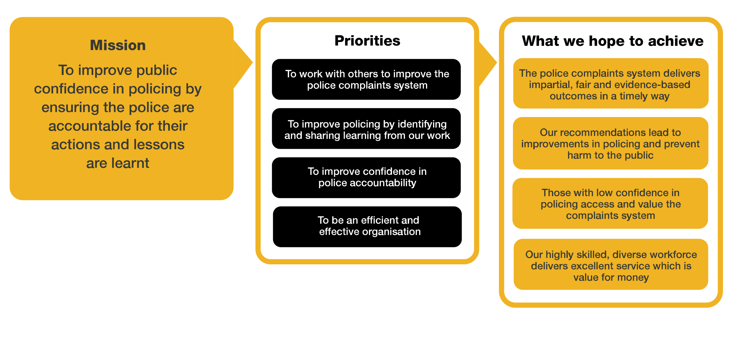
Organisational context

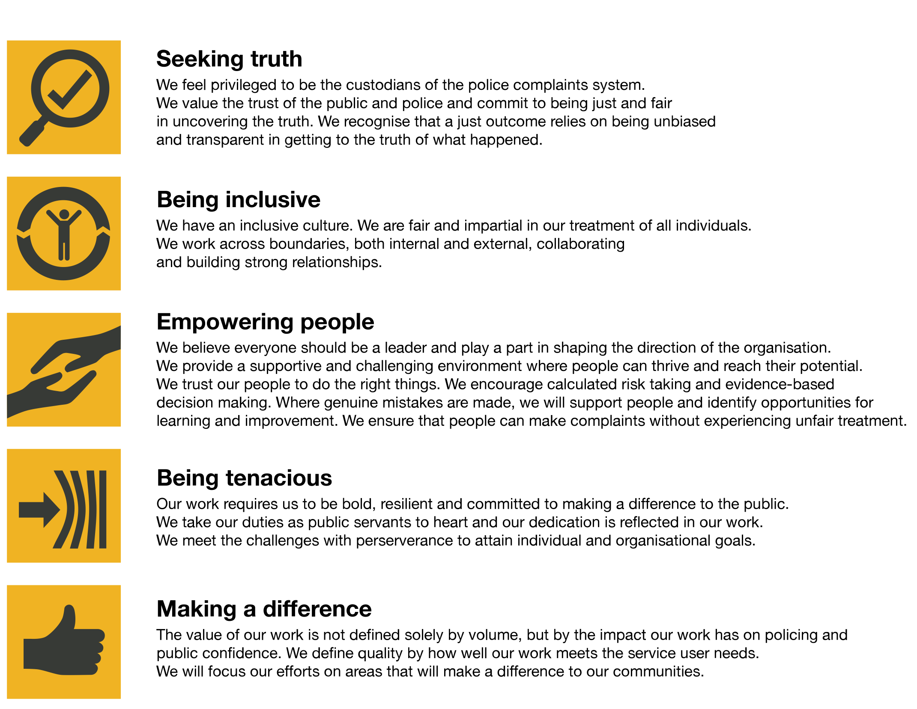
We work in the context of our agreed values which inform the way we do things at the IOPC. The Analytical Support Officer will need to be commited to managing in the context of these values.
The IOPC is committed to promoting equality and valuing diversity in everything we do. Our vision is to be, and to be seen as, a leader in inclusive employment and services, demonstrating this ethos in everything that we do.
- As a silver standard Stonewall employer, we continue to commit ourselves to being a LGBTQ+ employer through the work of our Pride LGBTQ+ Staff Network, creating welcoming environments for lesbian, gay, bi and queer people.
- We are pleased to share we are a signatory of the Business in the Community Race at Work Charter. The Charter is composed of five calls to action for leaders and organisations across all sectors.
- Being a Disability Confident employer, the IOPC is dedicated to removing the barrier for disabled people to thrive in the workplace.
- Our Staff Networks are constantly working to make the IOPC the leaders of inclusive employment, from our Allyship Programme to Welsh Language Standards and Know the Line Policy, we are constantly seeking new ways to create an environment for all to develop and thrive.

Main duties and responsibilities
- To undertake analysis, documentary appraisal and contribute to the production of summary reports for IOPC colleagues and key stakeholders. To assist with the collection and management of key data sources necessary to meet the information needs of the organisation
- To liaise with internal and external colleagues to improve the quality of the information collated by the IOPC analytical Services team
- To assist colleagues in the collation of accurate and relevant data for inclusion in standard reports and in response to FOI and other ad hoc requests
- To undertake analysis of data to support the development of new IT systems to generate information for reporting and analysis.
- To support members of the analytical services team in other tasks and duties that form part of the team’s work

Person specification

Essential
- Experience in a data analysis field
- Effective oral and written communication skills
- Good IT skills including some database experience, proficiency in analysing data in excel
- Understanding of diversity issues

Desirable
- Qualification in a social science subject (for example sociology, psychology, criminology), or a degree with a social research methods content
- An understanding of the strengths and weaknesses of qualitative and quantitative social research methodologies
- Practical experience of working in a working in a performance analysis team
- An understanding of some of the key issues surrounding police-public relations in the UK and the complexities of the IOPC remit and legislation.
- Experience of data management using a software package such as SPSS

Reasonable adjustments
The IOPC is a diverse and inclusive workplace and we want to help you demonstrate your full potential whatever type of assessment is used. We are open to providing you with the tools you need to succeed, from extra time to formatting changes, to name a mere few. If you require any reasonable adjustments to our recruitment process, please email humanresources@policeconduct.gov.uk

Working conditions
Making the IOPC a great place to work is one of our key priorities. We are pleased to offer a unique hybrid working model based on business needs, balanced with the needs of our colleagues. Our business need framework guides our decisions about when it is best to work onsite (in our offices or other appropriate locations) to complete tasks most effectively or when to work remotely, offering colleagues flexibility to work where they feel most productive and supporting work-life balance. The model also encourages staff to feel welcome at the IOPC by ensuring we have opportunities to work face-to-face as teams.

Preparation checklist
☐ Review the full job description
☐ Review the behaviours and the descriptors for each behaviour
☐ Review the Strengths dictionary
☐ Review the IOPC values
☐ Consider your Strengths (if applicable)
☐ Consider drafting example answers that cover the specific elements
☐ Prepare some questions to ask the interviewers

