**Job description**

**Title:** Disclosure Team Member

**Reports to:** Disclosure Team Leader

**Location:** Sale

**Grade:** 10

**Salary:** £32,600 per annum

**Contract:** Fixed term contract for 6 months. Although we are currently unable

to guarantee a longer or more permanent contract, if the role can be

extended or made permanent, the successful post holder may be

offered the role without further interview.

# Purpose

As a Disclosure Team Member, you will be welcomed into a dynamic and inclusive Operations Specialist Support Team (OSST) working within the Directorate of Major Investigations (DMI), providing high quality disclosure skills to support investigations in both the DMI and Core Business when capacity allows.

The Independent Office for Police Conduct (IOPC) exists to investigate complaints fairly and thoroughly. The IOPC has the power to initiate, carry out and oversee investigations. It is also responsible for monitoring the way complaints are handled by local police forces. The IOPC is on a journey to develop its culture, perspectives and ethos to support the organisation’s core outcomes, and this is your opportunity to enter into the varied world of IOPC’s DMI, allowing you to develop your mindset and approaches to contribute to improving the police complaints system in England and Wales.

The role of a Disclosure Team Member is challenging and interesting. You will be expected to make impartial and unbiased decisions when performing the role and ensure that our decisions can withstand scrutiny by being fair, balanced, and supported by legislation and appropriate guidelines. The IOPC Operations Directorate is overseen by the Deputy Director General (Operations), who is responsible for delivery of all operational work, including large and complex investigations undertaken by the DMI. Operational work and specialist teams will be managed by an Operations Manager who reports to the Deputy Director General.

The Home Office Large Major Enquiry System (HOLMES) is the principle case management system used within the DMI. The HOLMES team will support investigations using the HOLMES database or other Case management Systems if HOLMES is unsuitable or unavailable.

The Disclosure Team Member (DTM) role may provide advice and guidance to other staff that are fulfilling this role throughout the organisation.

# Organisational context

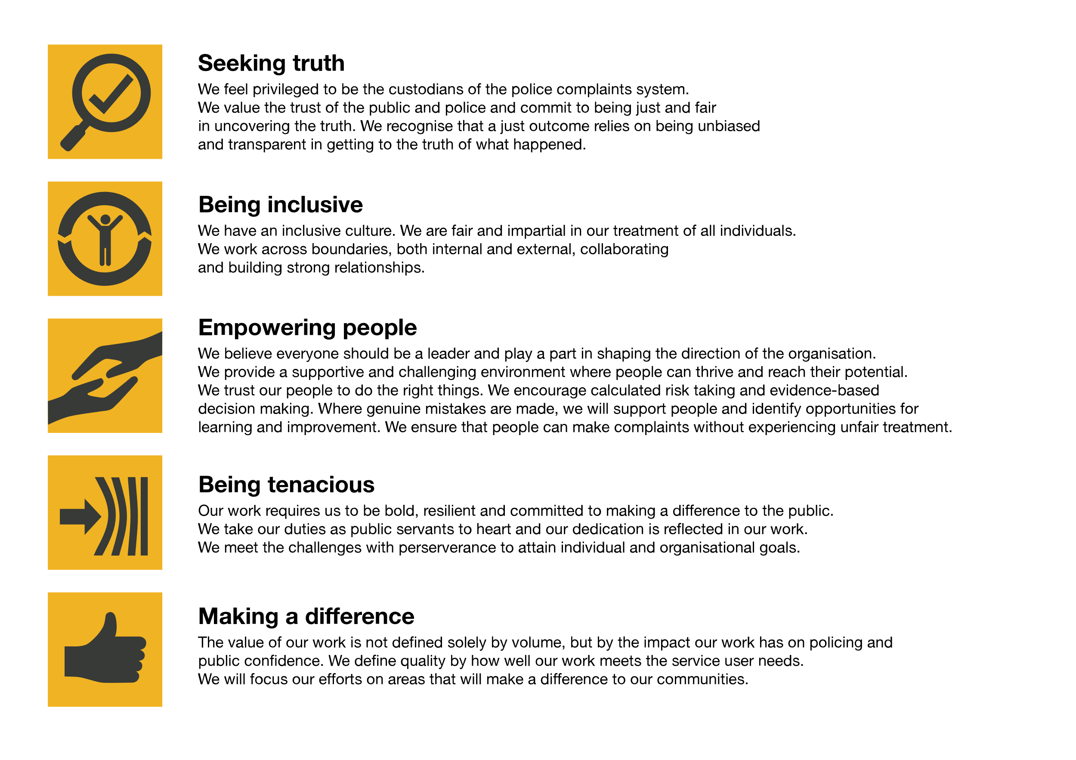We work in the context of our agreed values which inform the way we do things at the IOPC. The Disclosure Team Member will need to be commited to managing in the context of these values.

The IOPC is committed to **promoting equality and valuing diversity** in everything we do. Our vision is to be, and to be seen as, a leader in inclusive employment and services, demonstrating this ethos in everything that we do.

* As a silver standard Stonewall employer, we continue to commit ourselves to being a LGBTQ+ employer through the work of our Pride LGBTQ+ Staff Network, creating welcoming environments for lesbian, gay, bi and queer people.
* We are pleased to share we are a signatory of the Business in the Community Race at Work Charter. The Charter is composed of five [calls to action](https://race.bitc.org.uk/issues/racecharter) for leaders and organisations across all sectors.
* Being a Disability Confident employer, the IOPC is dedicated to removing the barrier for disabled people to thrive in the workplace.
* Our Staff Networks are constantly working to make the IOPC the leaders of inclusive employment, from our Allyship Programme to [Operation Hotton](https://www.policeconduct.gov.uk/recommendations/operation-hotton-recommendations-metropolitan-police-service-september-2021), to [Welsh Language Standards](https://www.policeconduct.gov.uk/who-we-are/equality-and-diversity/welsh-language-standards) and Know the Line Policy, we are constantly seeking new ways to create an environment for all to develop and thrive.

# Main duties and responsibilities

* To examine all material within a criminal investigation by applying the guidelines and the Code of Practice as set out in The Criminal Procedures and Investigation Act 1996 (as amended by the Criminal Justices Act 2003), the Disclosure Manual, The Disclosure Protocol and the Attorney General’s Guidelines’ on disclosure and in accordance with agreed IOPC policy and guidelines.
* To examine all material within a Misconduct investigation by applying the legislation as set out, but not restricted to, the Police Reform Act 2002 (as amended from time to time), The Police (Complaints and Misconduct) Regulations 2012 or 2020 as applicable and the Police (Conduct) Regulations 2012 or 2020.
* Assess all material retained within the investigation to ascertain its relevancy, evidential value, sensitivity and ability to undermine the prosecution case or assist the defence.
* Identify deficiencies and problems with continuity or other evidence related matters, inform the Disclosure Team Leader and ensure best evidence is obtained.
* Identify any material that is subject to Public Interest Immunity (PII), completing the relevant documentation.
* Liaise with the Crown Prosecution Service (CPS), Appropriate Authority, Coroner, other agencies, and counsel at case conferences and discuss disclosure, PII issues and possible defence arguments, as necessary.
* Monitor preparation of the disclosure schedules ensuring they are presented in the required format and submitted within statutory time limits.
* Liaise with Lead Investigator regarding existence, handling, and scheduling of sensitive material.
* Maintain security of all sensitive material, including source or surveillance material.
* Prepare reports and presentations to investigators, legal representatives and the judiciary as required.
* Produce MG disclosure schedules using the HOLMES database or manual schedules where material exists on other Case Management Systems
* This work may be completed whilst part of a disclosure team and each individual Disclosure Team Member is responsible for their assessment of the material and is accountable in proceedings.
* Contact identified third parties that hold material which may be relevant to the investigation and request them to hold the material for inspection or for its production to the court.
* Ongoing assessment of material as the case develops and / or on receipt of a defence statement.
* Ensure that necessary care for victims and witnesses is provided in an ethical and empathic manner and in accordance with legislation, policies, and procedures.
* Keep up to date with and understand and apply all changes to recent legislation and case law.
* Respond appropriately to any relevant authority and take appropriate action to address any issues that arise as a result of hearings.
* Attend Court or hearings as required.
* Identify actions taken, lessons learned and good practice, sharing details with appropriate personnel.
* In conjunction with the Lead Investigator manage the closure of the investigation to ensure that the judicial processes and continuity needs are met in accordance with relevant legislation and policies.
* The post holder may be requested to support operational requirements across the IOPC regional locations and as such a degree of flexibility is required.

# Person specification

## Essential Experience

* Proven experience of undertaking the role of Disclosure Team Member in a criminal investigation, experience of using the disclosure package on the HOLMES database after 2016.
* Experience of having been a case builder who has completed files of evidence for criminal trials at the Magistrates and Crown Courts.
* Proven experience of making appropriate and effective decisions based on assessment and analysis of existing and emerging information.
* Evidence of effective oral and written communication skills including report writing.
* Experience of engaging effectively with a diverse range of individuals and stakeholders.
* Delivering a high standard of work within demanding timescales.
* Working effectively in a changing environment.

## Essential Technical

* A sound knowledge and understanding of the Criminal Procedure & Investigations Act 1996 and relevant amendments to disclosure requirements.

## Desirable Technical

* Practical knowledge of CPIA, DPA, FOI, PRA and GPMS.
* Current UK DVLA Driving Licence.

## Working conditions

The IOPC are currently consulting with our consultative bodies about proposed changes to our hybrid working policy which will require all staff to work 20% of their contractual hours at their office base (or another office for business reasons) from 1 September and increased to 40% from April next year. Office attendance time includes in-person training, meetings with stakeholders and families, and attending events. Requirement to stay away from home to achieve operational requirements when deemed necessary.

## Reasonable adjustments

The IOPC is a diverse and inclusive workplace, and we want to help you demonstrate your full potential whatever type of assessment is used. We are open to providing you with the tools you need to succeed, from extra time to formatting changes, to name a mere few. If you require any reasonable adjustments to our recruitment process, please email [campaigns@policeconduct.gov.uk](mailto:campaigns@policeconduct.gov.uk)

## Preparation checklist

☐ Review the full job description

☐ Review the behaviours and the descriptors for each behaviour

☐ Review the Strengths dictionary

☐ Review the IOPC values

☐ Consider your Strengths (if applicable)

☐ Consider drafting example answers that cover the specific elements

☐ Prepare some questions to ask the interviewers