**Job description**

**Title:** Records Manager Lead

**Reports to:** Head of Data and Information

**Location:** Any IOPC Office – Croydon, Canary Wharf, Birmingham, Wakefield, Warrington, Cardiff, Sale

**Grade:** 13a

**Salary:** £50,970 plus London weighting allowance of £4,731 if based in Croydon or Canary Wharf

**Contract:** Permanent

# Purpose

As a Records Manager Lead, you will be welcomed into a dynamic and inclusive directorate team working towards delivering the Organisational Data Strategy. The IOPC is on a journey to develop its culture, perspectives and ethos to support the organisation’s core outcomes and this is your opportunity to enter into the varied world of IOPC records management, allowing you to develop your mindset and approaches to contribute to improving the police complaints system in England and Wales.

The post holder will report to the Head of Data and Information and lead the IOPC’s corporate Document & Records management function (including archive and records team). They will play a critical role in delivering the Organisational Data Strategy and lead the processes for master data management. The role will do this by being responsible for ensuring:

* the IOPC’s strategies and policies for archive and records and document management including those for archive and retention are fit for purpose, reflect best practice and comply with legislation and the IOPC’s information management, strategy and security policies.
* that processes and systems that support archive, records and document management are continually fit for purpose.
* supporting and enabling IOPC business functions to undertake efficiently and effectively archive, records and document management.
* work with external suppliers and bodies to fulfil the IOPC responsibilities with Document and record management produces and practices.
* Line management for the Records Managers, Hillsborough Archivist, and oversee the IOPC archive and records functions.
* Act as the Deputy Departmental Records Officer with responsibilities for managing the transfer of records to the National Archives, including early transfer, acting as a conduit with the National Archives

# Organisational context

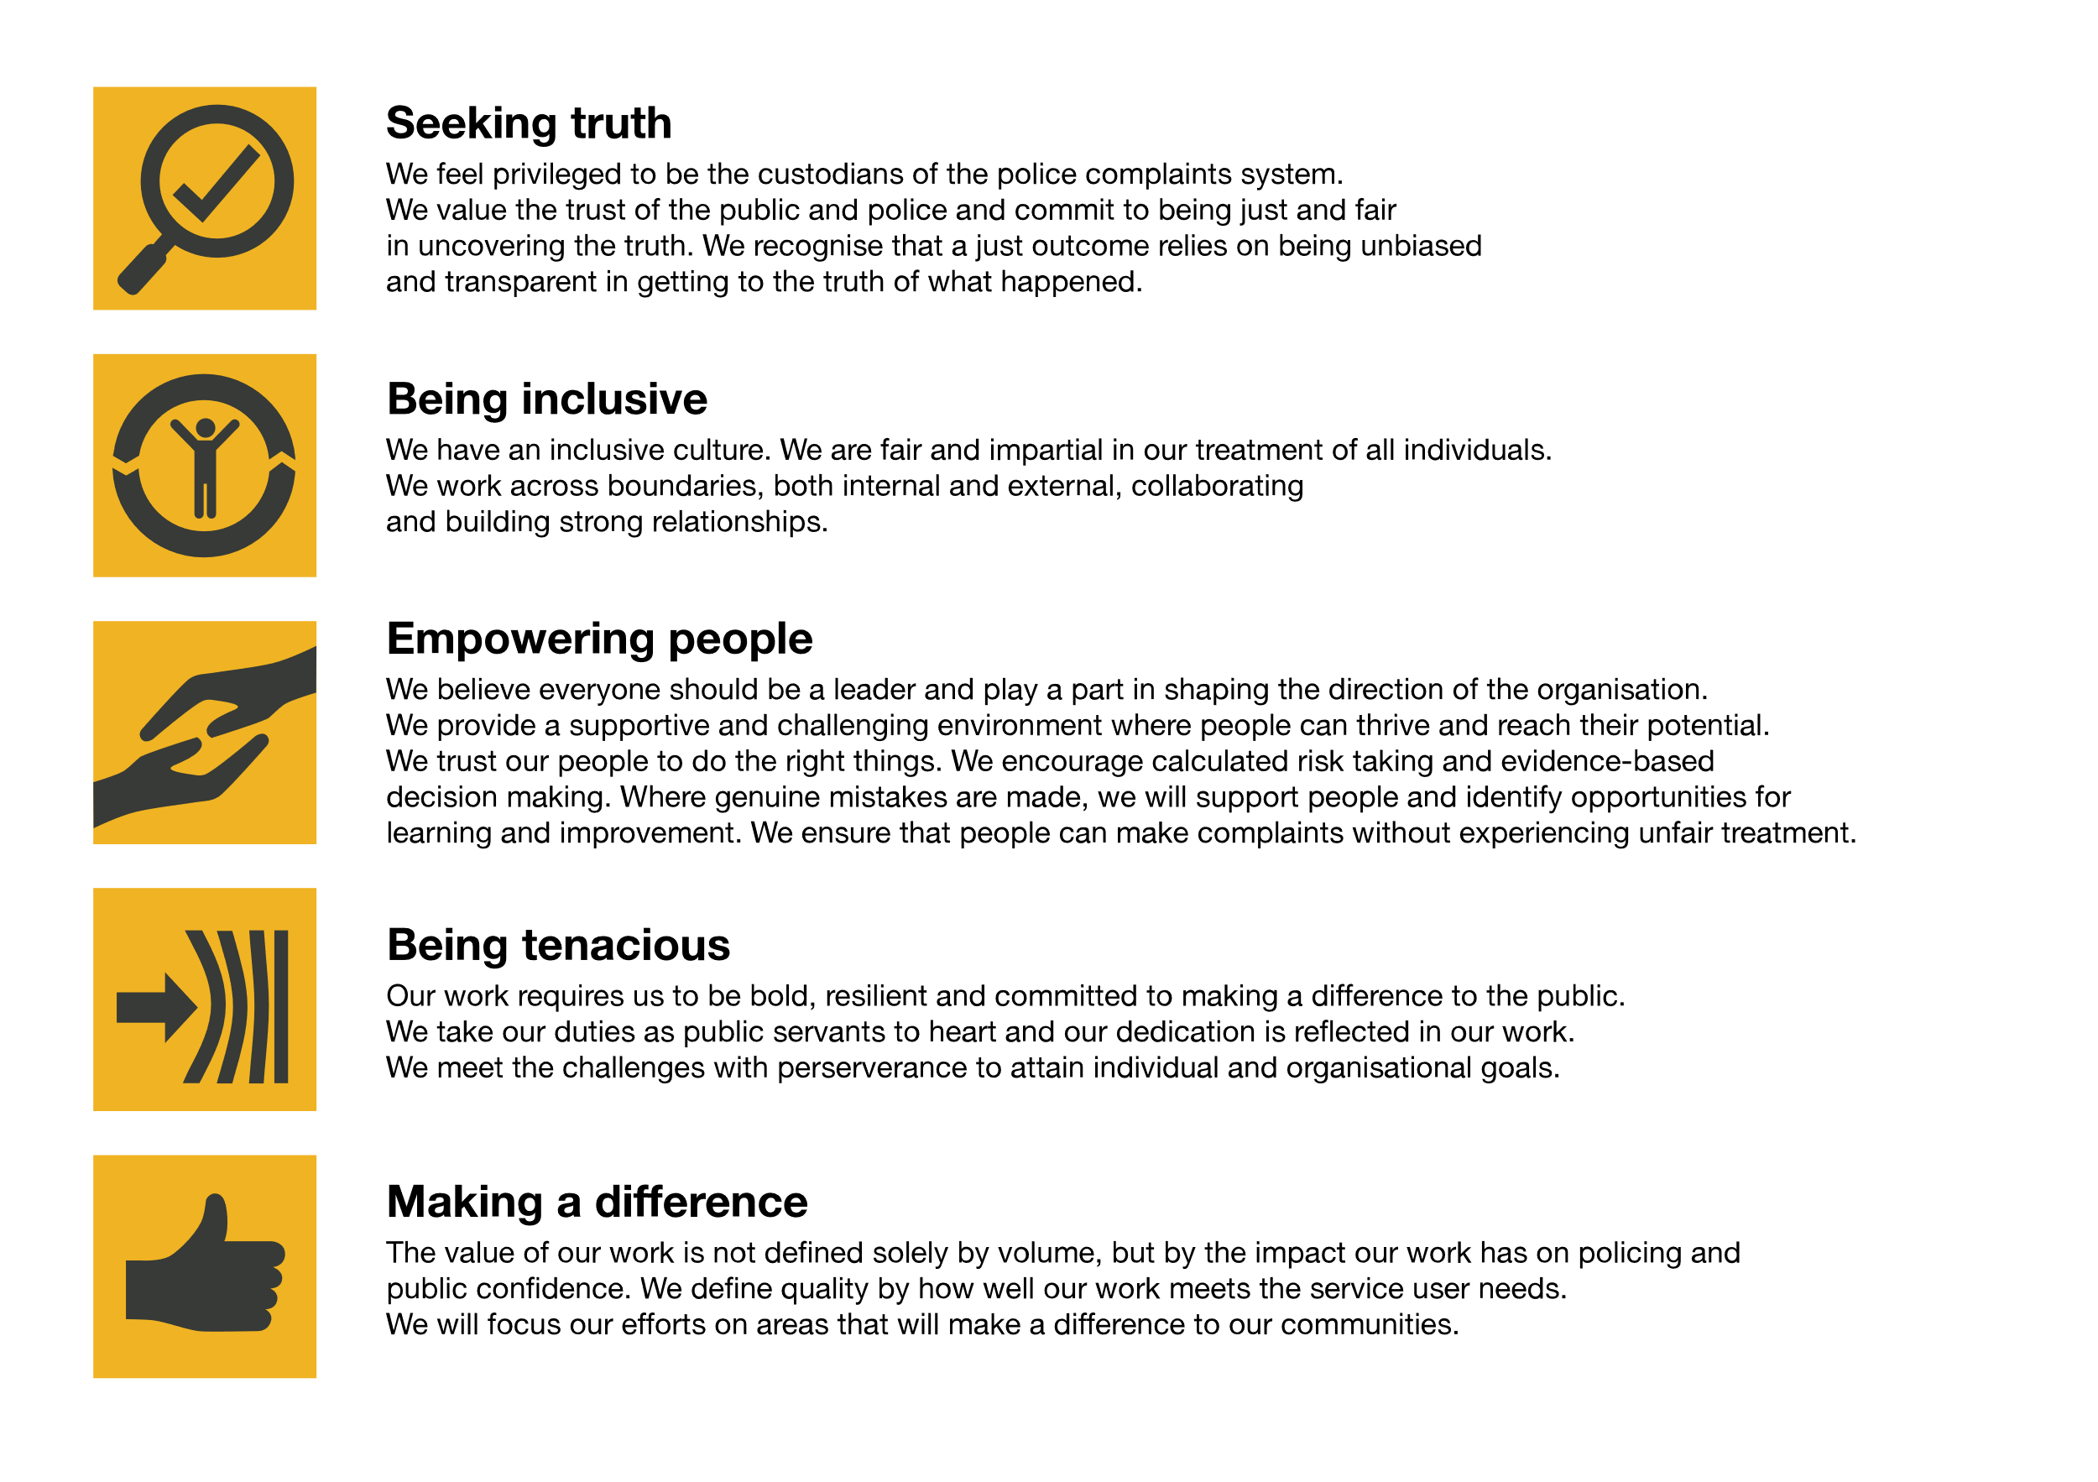We work in the context of our agreed values which inform the way we do things at the IOPC. The Records Manager Lead will need to be commited to managing in the context of these values.

The IOPC is committed to **promoting equality and valuing diversity** in everything we do. Our vision is to be, and to be seen as, a leader in inclusive employment and services, demonstrating this ethos in everything that we do.

* As a silver standard Stonewall employer, we continue to commit ourselves to being a LGBTQ+ employer through the work of our Pride LGBTQ+ Staff Network, creating welcoming environments for lesbian, gay, bi and queer people.
* We are pleased to share we are a signatory of the Business in the Community Race at Work Charter. The Charter is composed of five [calls to action](https://race.bitc.org.uk/issues/racecharter) for leaders and organisations across all sectors.
* Being a Disability Confident employer, the IOPC is dedicated to removing the barrier for disabled people to thrive in the workplace.
* Our Staff Networks are constantly working to make the IOPC the leaders of inclusive employment, from our Allyship Programme to [Operation Hotton](https://www.policeconduct.gov.uk/recommendations/operation-hotton-recommendations-metropolitan-police-service-september-2021), to [Welsh Language Standards](https://www.policeconduct.gov.uk/who-we-are/equality-and-diversity/welsh-language-standards) and Know the Line Policy, we are constantly seeking new ways to create an environment for all to develop and thrive.

# Main duties and responsibilities

* Strategic lead on development of policies and guidance documents as they relate to Records Management ensuring that they meet the IOPC’s needs and are compliant with relevant standards, best practice, and pan-government directives.
* Provide expert advice on records management to Senior Management, including scanning the horizon to engage the Senior Management on current and future developments to ensure legal compliance and adoption of best practice. Actively seek out relevant developments within the records management profession, e.g. developments in AI technology
* Responsible owner for the development of records management strategy, road map and business plan, identifying performance measurements requirements, and linking to overarching data strategy.
* Acting as SRO or business lead on programmes/projects in relation to records management activity, for example acting on external audits where appropriate.
* Act as the Deputy Departmental Records Officer taking the lead on Public Records Act compliance, providing expert advice, and associated liaising with the National Archives and Advisory Council where required, and lead on FOI 46 code of practice compliance.
* Deputise for the Head of Data and Information, when required, within their area of responsibility.
* Nominated individual within budget delegation able to sign off spend up to agreed limit.
* Develop and conduct initiatives to support the drive towards digital transformation when relevant for document and records.
* Lead on records management maturity assessment within the IOPC.
* Represent and chair record management at relevant internal and external boards and meetings.
* Maintain effective Records Management, systems and processes for managing paper and electronic archives.
* Draft and publish guidance documents to assist service users in understanding Records Management processes.
* Organise and execute the IOPC destruction and deletion process.
* Organise and manage governance for supporting and embedding Record management best practices; including naming convention; Taxonomy, business classification scheme, retention and disposal scheme, social network records etc.
* Participate in specifying, managing, and assuring the IOPC’s electronic and paper archive management processes and systems including Supporting devolved responsibilities in other IOPC directorates and functions.
* Manage the Deputy Documents and Record managers, Hillsborough Archivist, and oversee the archive team co-ordinator, archive team members, and cataloguing Archivists.
* The effective management of Documents, Records and Archive across all IOPC directorates and offices including management of file movements and their retention and destruction.
* To establish and manage a team to review the IOPC Archive to discover material that may be relevant to government inquiries and major investigations.
* To be the SME, providing advice, guidance and direction as required for queries to support Lawyers and Operational colleagues with regard to matters that arise from the records and documents management (archive review).
* Work cooperatively, communicate and consult with colleagues across the IOPC in order to maintain effective working relationships. Support IAO activities related to the information assets held by the IOPC’s corporate and local systems ensuring all assets are managed in accordance with the IOPC’s information management, information assurance and records management policies.
* Advise and support the devolved archive manager for the Hillsborough investigation, as necessary.
* Manage third party archive providers and associated contracts including their performance and costs.
* Liaise, as necessary, with relevant technical authority and government policy makers to ensure compliance.
* Support the work of colleagues in areas concerning information management such as ICT architects, FOI/DPA, KIM, Security, quality etc in particular assisting, as required, at specific training including IAO training day and annual security briefings as far as they relate to Archive and Records Management.
* Any duties and responsibilities should be carried out in accordance with agreed IOPC policies and procedures.
* Any other relevant duties appropriate to the grade as may be required.

# Person specification

## Essential Experience

* Managerial experience with leadership experience operating within the field of documents and records management.
* Knowledge and experience implementing ISO 15489 and document, record management best practice and the document lifecycle.
* Experience of managing electronic document and record management systems
* Experience writing and maintaining corporate record management polices and procedures.
* Experience of digital transformation at a corporate level
* Experience in writing reports.
* Experience and understanding of Public Records Act requirements, including sensitivity review, and cataloguing archive cataloguing standards and principles – and leading teams within this work.
* Experience of working to tight deadlines and adjusting working practices accordingly.
* Knowledge/experience of Information management and knowledge management practises
* Knowledge of relevant legislation, standards, and procedures in relation to collections management, and adapting to policies and guidance
  + Experience of working with information within a Data Protection and Freedom of Information environment.

## Desirable

* Experience of undertaking large scale destruction of records
* Working within a public organisation
* Experience of project management methods such as prince2
* Managing and working with external suppliers
* Relevant qualification in FOI
* Records management/archive qualification

## Reasonable adjustments

The IOPC is a diverse and inclusive workplace and we want to help you demonstrate your full potential whatever type of assessment is used. We are open to providing you with the tools you need to succeed, from extra time to formatting changes, to name a mere few. If you require any reasonable adjustments to our recruitment process, please email [campaigns@policeconduct.gov.uk](mailto:campaigns@policeconduct.gov.uk)

## Working conditions

The IOPC are currently consulting with our consultative bodies about proposed changes to our hybrid working policy which will require all staff to work 20% of their contractual hours at their office base (or another office for business reasons) from 1 September and increased to 40% from April next year. Office attendance time includes in-person training, meetings with stakeholders and families, and attending events.

## Preparation checklist

☐ Review the full job description

☐ Review the behaviours and the descriptors for each behaviour

☐ Review the Strengths dictionary

☐ Review the IOPC values

☐ Consider your Strengths (if applicable)

☐ Consider drafting example answers that cover the specific elements

☐ Prepare some questions to ask the interviewers