Job description
Title: ICT Service Delivery Manager (Application Design, Development and Support)
Reports to: Head of ICT
Location: Any IOPC office
Grade: 14
Salary: £53,760 per annum (plus London Weighting if applicable)
Contract: Permanent

Purpose
As an ICT Service Delivery Manager, you will be welcomed into a dynamic and inclusive Strategy and Corporate Services directorate. The IOPC is on a journey to develop its culture, perspectives and ethos to support the organisation’s core outcomes and this is your opportunity to enter into the varied world of IOPC Solutions and Records Management, allowing you to develop your mindset and approaches to contribute to improving the police complaints system in England and Wales.
The role resides within the ICT senior team and has overall responsibility for delivering corporate ICT applications and business solutions.
However, the role also coordinates design and build activities across the organisation at every level.
Acting as the conduit and coordinator between the technical, information and business architecture layers, the role supports the Head of ICT to ensure ICT capabilities align to the businesses mission statements and underpinning strategic direction.
Including:
- Contributing to the corporate, strategic and tactical direction for ICT services
- Customer support, delivery of production ICT services
- Senior Responsible Officer (SRO) and technical owner of relevant projects and enterprise application products.
- Ownership of new or evolving business requirements, ensuring they are translated into new or revised services that align with the ICT Architectural Principles
- Work with internal and external technical architects, ICT Business Relationship and the other ICT Service Delivery Managers to ensure that the disaggregating, decommissioning, and on-boarding of applications, services or platforms supports current and future architecture and business visions.
- Lead or contribute to ICT strategic technology change projects
- Governance and compliance of software licencing arrangements
- Contribution to the development and implementation of ICT security processes and compliance requirements, especially in the supply-chain
- Deputising for the Head of ICT and representing the service as a whole
- Delegated operational and project procurement activities
- Oversight of operational & project budgets

Key Relationships:

The post holder will work closely with internal and external stakeholders at all levels, but with a focus on senior stakeholders and key business change drivers.

This will involve close working relationships with other ICT Service Delivery Managers, Information Asset Owners, Business Owners, ICT Business Relationship Managers, the ICT Security & Information Assurance Manager and with external supplier managers and their staff.

The post holder will advise and support the ICT senior management team in developing ICT strategy and governance in accordance with business requirements, responding to and providing strategic and tactical direction for business change.

As a primary operational client-side contact, the post holder will lead on resolving high profile issues and managing suppliers to ensure a high standard of service at all levels.

The post holder will contribute to the following best practice processes: Daily incident reporting, Change Advisory Board, change request, problem review, project boards, risk review, supplier management and Continual Improvement initiatives. Where required, report on BAU activities and change programmes.

The post holder will be expected to gain or hold security clearance to SC level.

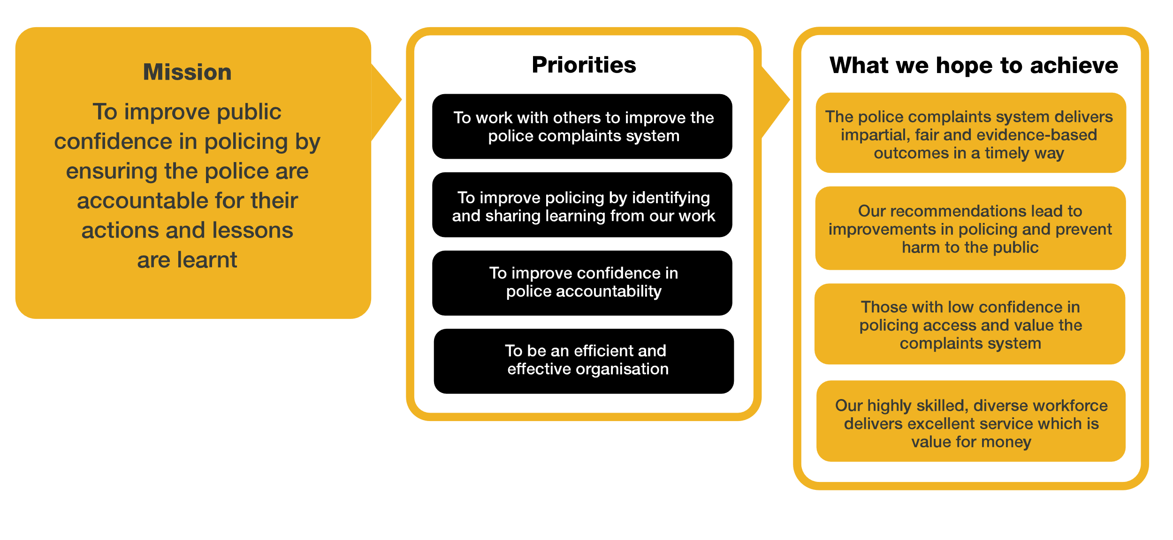
Organisational context

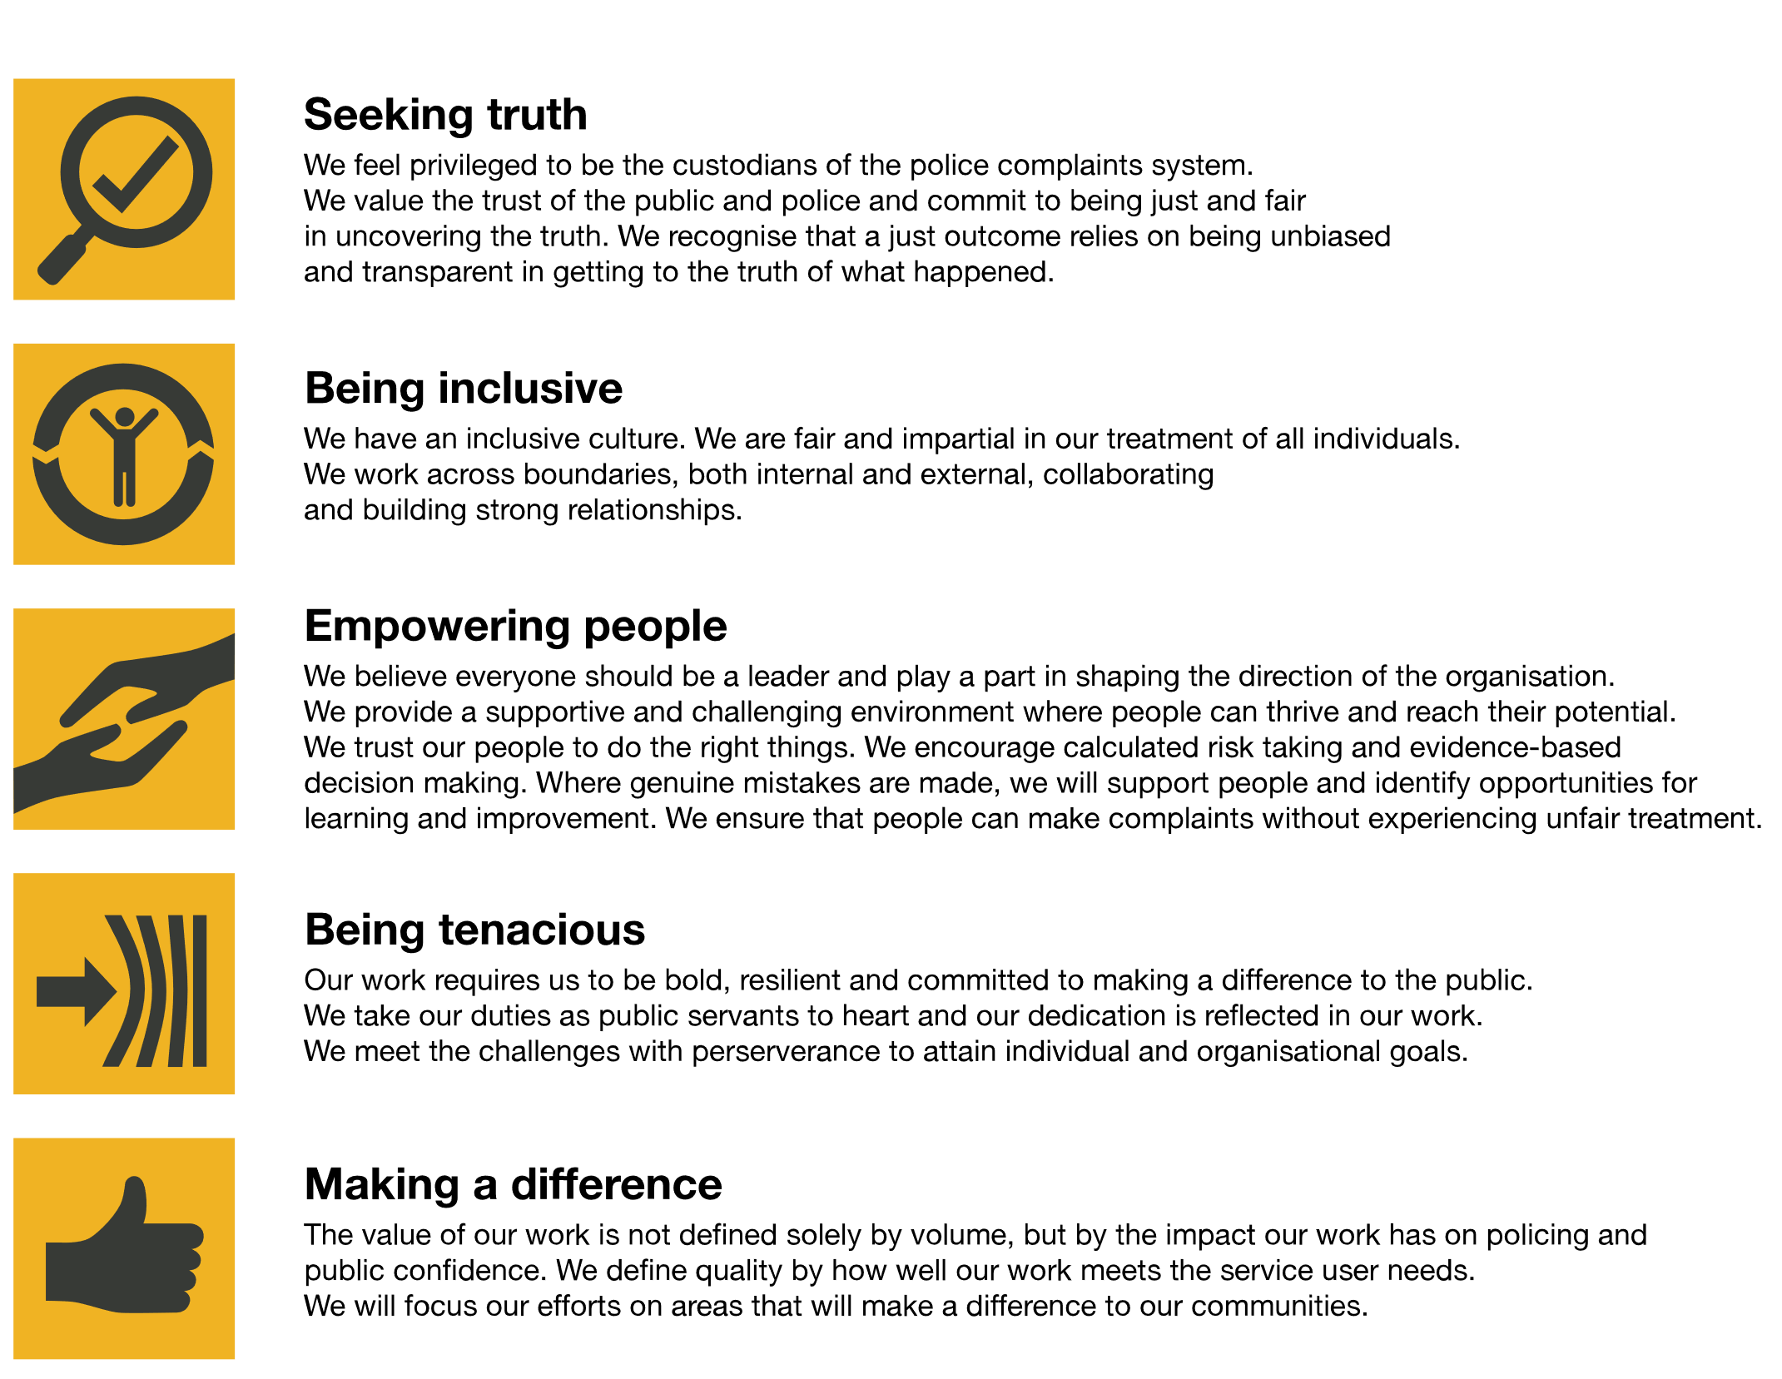
We work in the context of our agreed values which inform the way we do things at the IOPC. The ICT Service Delivery Manager will need to be commited to managing in the context of these values.
The IOPC is committed to promoting equality and valuing diversity in everything we do. Our vision is to be, and to be seen as, a leader in inclusive employment and services, demonstrating this ethos in everything that we do.
- As a silver standard Stonewall employer, we continue to commit ourselves to being a LGBTQ+ employer through the work of our Pride LGBTQ+ Staff Network, creating welcoming environments for lesbian, gay, bi and queer people.
- We are pleased to share we are a signatory of the Business in the Community Race at Work Charter. The Charter is composed of five calls to action for leaders and organisations across all sectors.
- Being a Disability Confident employer, the IOPC is dedicated to removing the barrier for disabled people to thrive in the workplace.
- Our Staff Networks are constantly working to make the IOPC the leaders of inclusive employment, from our Allyship Programme to Welsh Language Standards and Know the Line Policy, we are constantly seeking new ways to create an environment for all to develop and thrive.

Main duties and responsibilities
Service management

The post-holder will ensure that all ITIL best practice processes for in house and 3rd party suppliers are implemented, relevant, and effective:
- Incident Management - customers have minimum service interruption and effective support
- Problem management - Effective root cause analysis and elimination of recurring or multiple incidents, with timely workarounds in place when necessary
- Change Management - BAU and project changes thoroughly assessed via the CAB process before implementation for business impact and scheduled appropriately.
- Configuration management - Maintain a reliable database for asset tracking and relationships between configuration items are valid and effective.
- Release Management - Effective forward schedule plan with standard changes and project rollouts incorporated.
- Capacity Management – Resources monitored and remain within agreed tolerance for effective service delivery.
- Availability Management – Maintenance windows agreed with the business, key services remain available when required
- Continuity Management – Single points of failure risk assessed, key risks eliminated, Disaster Recovery plans fit for purpose and fully tested.
- Service Level Management – Suppliers fulfil their contracted SLA requirements and in-house teams support the agreed OLA targets.

BAU service delivery:

- Matrix management of in- house teams delivering end user, applications, access control, security process and project support.
- Responsibility for the management of ICT service requests, ensuring compliance with agreed governance processes and workflow.
- Review and advise on current capacity management reports.
- Maintain the ICT Operational Risk Register and input into BCP & DR plans.
- Contribute to the Service Improvement plan process.
- Ensure that application refresh plans are timely, appropriate and delivered without impacting system availability.
- Where appropriate, act as a key escalation contact for Directors for service delivery issues, ensuring they receive an appropriate level of customer care and support.
- Create an effective succession plan for team resilience and staff development opportunities.
- To deputise for other senior ICT managers, when required.
- To undertake any other duties as may be assigned from time to time commensurate with the level and responsibilities of the post.

Project ownership and delivery

- Responsible for reviewing and advising on technical strategy and tactical solutions.
- Contribution to the technical and application roadmap and forward schedules for project implementation.
- Assess and recommend new system implementations and any potential for cloud service offering alternatives.
- Oversight of application and platform projects- implementation of new and maintenance of existing tech platforms.
- Allocate appropriate resources to project implementations.
- Maintain close links to key business stakeholders, especially Business Relationship Managers, turning feedback into action plans to drive innovation wherever possible.

- Service specialism: Application Design, Development and SupportAssume the lead role supporting the Deputy Director to ensure alignment between business strategies, enterprise transformation activities and new technology directions, setting strategies, principles, policies, standards and practices that work within the constraints, standards and guiding principles of other frameworks in operation
- Define and maintain strategies for the development and delivery of digital products and services, while contributing to overall strategic and tactical direction of the DDaT service.
- Deliver and mature effective roadmaps for IOPC digital services that support its strategic goals.
- Lead, manage and coach the Application team in order to effect positive outcomes across the organisation, embedding required changes to service, process, business operating models and drive innovation.
- Conduct and present strategic assessments of current organisation capabilities to identify required or desired changes for enterprise-wide solutions.
- Manage the production of required artefacts to describe the inter-relationships between people, organisation, service, process, data, information, technology and the external environment.
- Direct the creation and review of enterprise capabilities to support the strategic requirements of the business, identifying the business benefits of alternative strategies necessary to define, assure and govern the required evolution.
- Use appropriate modelling, prioritisation and environmental trend techniques to identify and convey the business benefits of pursuing alternative strategies and approaches. Develop management papers to secure buy-in, approval and funding.
- Produce and approve models, matrixes and schematics that support the setting of strategies, implementation of standards and practices that ensure cohesion between business strategies, technology strategies, and enterprise transformation activities.
- Responsible for the designs of the high-level structures to enable and guide the development of integrated solutions that meet current and future business needs.
- Collaborate with stakeholders on practices and processes to ensure the security, compliance, quality, integrity, safety and availability of all forms of data and data structures which form the organisation’s information layer.
- Promote innovative ways for managing the organisation’s information assets online with embedded legal compliance and best practice.
Data modelling and design
- Facilitate decision makers in the organisation to understand the data assets and their relationships between real-world entities.
- Provide strategic advice, guidance and direction to data teams, application developers, solution architect and others to achieve the desired architecture target state.
Programme management
- Ensure that programme/project leads and service owners adhere to the agreed framework management approach.
- Produce reports as appropriate for architecture and project governance, including making recommendations for changes to the agreed scope.
Business change management
- Work with BRMs and colleagues across the business to develop plans and appropriate modelling activities for supporting significant change within ICT and across multiple business functions.
Budget and Contract management:
- Manage budget for application solution development
- Direct and provide advice in regard to the management of suppliers on key application contracts.

Person specification

Essential
- Experience of working in a secure environment.
- Experience of managing in house teams to deliver high quality digital services and outcomes.
- Experience of building strong working relationships with a variety of stakeholders.
- Strong customer focus ensuring user’s needs are met.
- Experience in delivering strategic and tactical technology change.
- Project and / or delivery management experience.
- Excellent communication and negotiation skills.
- Positive can-do attitude and flexibility of approach.
- Exposure to Architecture modelling languages and tools; e.g. UML, ArchiMate, Ardoq etc
- Experience developing conceptual, logical or physical models
- Knowledge of Cloud technology and common platforms e.g. Azure, Microsoft 365 and open-source options
- Experience of Case management, Document and Record management Applications and processes such as SharePoint, Case management solutions and CRM.
- Extensive knowledge and experience of Software Development Lifecycle Approaches (SDLC)
- Multi-level and matrix management experience
- Advance experience of common software service applications, especially but not limited to Microsoft 365 platform
Experience of supplier management
- Experience of succinct report writing and Budget management
- Knowledge and experience in relevant methodologies such as Scrum, AgilePM and ITIL
- Understanding of the legal issues relating to ICT e.g. Data Protection, Freedom of Information and Computer Misuse Acts, copyright, intellectual property rights.

Reasonable adjustments
The IOPC is a diverse and inclusive workplace and we want to help you demonstrate your full potential whatever type of assessment is used. We are open to providing you with the tools you need to succeed, from extra time to formatting changes, to name a mere few. If you require any reasonable adjustments to our recruitment process, please email humanresources@policeconduct.gov.uk

Working conditions
Making the IOPC a great place to work is one of our key priorities. We are pleased to offer a unique hybrid working model based on business needs, balanced with the needs of our colleagues. Our business need framework guides our decisions about when it is best to work onsite (in our offices or other appropriate locations) to complete tasks most effectively or when to work remotely, offering colleagues flexibility to work where they feel most productive and supporting work-life balance. The model also encourages staff to feel welcome at the IOPC by ensuring we have opportunities to work face-to-face as teams.

Preparation checklist
☐ Review the full job description
☐ Review the behaviours and the descriptors for each behaviour
☐ Review the Strengths dictionary
☐ Review the IOPC values
☐ Consider your Strengths (if applicable)
☐ Consider drafting example answers that cover the specific elements
☐ Prepare some questions to ask the interviewers

