**Job description**

**Title: Director of Operations (Wales, North, Midlands and DMI)**

**Reports to: Director General**

**Location: Canary Wharf, Croydon, Wakefield, Warrington, Sale, Birmingham, Cardiff**

**Grade: Director Level 2**

**Salary: £104,000 (Plus London Weighting allowance of £4,527 if based in Croydon or Canary Wharf)** Please note, that there is a senior Civil Service pay award pending.

**Contract: 12 Months Fixed Term Contract (pending a review of structure)**

# Purpose

The IOPC is undertaking a major programme of transformation, enabled by new IT systems and in support of an ambitious five-year strategy.  This in the context of rising demand and complexity of operational work and a challenging financial climate which means the IOPC must deliver more with fewer resources.

This role supports the delivery of operational work alongside a Director of Operations for London and the South East and National Functions; during a busy period of transformation which is likely to involve some restructuring (hence the temporary duration of the role at present).

This position is one of two posts already occupied in the organisation.

**The Director of Operations must be SC cleared to begin employment with us. A requirement for this is to have been living in the UK continuously for the past 5 years.**

# Funnel chart Description automatically generated with low confidenceOrganisational context

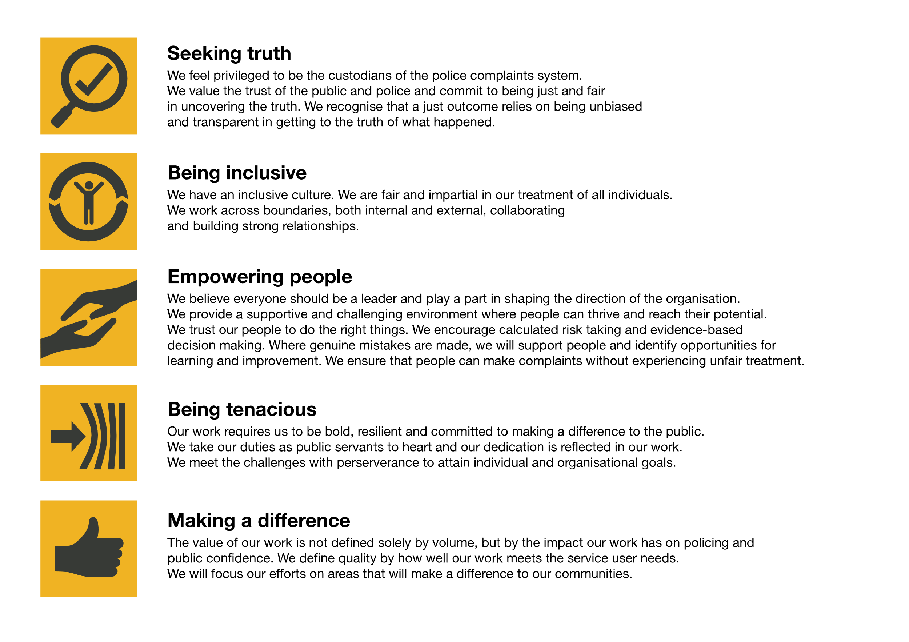We work in the context of our agreed values which inform the way we do things at the IOPC. The Director of Operations will need to be commited to managing in the context of these values.

The IOPC is committed to **promoting equality and valuing diversity** in everything we do. Our vision is to be, and to be seen as, a leader in inclusive employment and services, demonstrating this ethos in everything that we do.

* As a silver standard Stonewall employer, we continue to commit ourselves to being a LGBTQ+ employer through the work of our Pride LGBTQ+ Staff Network, creating welcoming environments for lesbian, gay, bi and queer people.
* We are pleased to share we are a signatory of the Business in the Community Race at Work Charter. The Charter is composed of five [calls to action](https://race.bitc.org.uk/issues/racecharter) for leaders and organisations across all sectors.
* Being a Disability Confident employer, the IOPC is dedicated to removing the barrier for disabled people to thrive in the workplace.
* Our Staff Networks are constantly working to make the IOPC the leaders of inclusive employment, from our Allyship Programme to [Welsh Language Standards](https://www.policeconduct.gov.uk/who-we-are/equality-and-diversity/welsh-language-standards) and Know the Line Policy, we are constantly seeking new ways to create an environment for all to develop and thrive.

# Main duties and responsibilities

The postholder will lead a team of around 300 colleagues responsible for Investigations.

The postholder is required to advise on complex and contentious technical decisions and assist in representing them publicly, including in the media, with key stakeholders and in communities.

An important focus of the role will be ensuring appropriate performance targets for timeliness and quality are set and achieved.

The postholder will lead a small team of senior colleagues and contribute to the overall management of the Operations function through Operations Management Board (OMB).

The appointed postholder will be able to work from any of the IOPC offices. The role will primarily focus on work within the North and therefore travel to other offices will be requires as part of the role.

**Key accountabilities**

*Corporate responsibilities*

* As a member of Management Board contribute to the development of the IOPC’s corporate strategy and plans
* Act as a role model for the IOPC’s values
* Work collaboratively with the Deputy Director General to ensure that the learning from Operations is used to improve public confidence in policing
* Work collaboratively with the Management Board, including the Director of Operations (London, South East and National Functions), to solve problems, lead change and represent the organisation internally and externally
* Participate in a “gold on call” rota to manage out of hours corporate business continuity incidents
* Act as a member of Unitary Board on a rotation basis with the Director of Operations (London, South East and National Functions)
* Act as SRO for major operational projects as required
* Lead the implementation of corporate initiatives in Operations

*Quality* and performance

* Monitor performance standards across Operations and take necessary actions if KPIs are not met
* Promote a culture of continuous improvement across Operations
* Lead improvement projects and ensure benefits are realised
* Ensure that there is broad consistency of work practices and decision making across regions and nations
* Support development of new Quality Management approaches in line with agreed plans
* Develop and action a resourcing and performance plan to ensure that Casework targets are met.
* Ensure that thematic case selection operates optimally
* Ensure that there are suitable arrangements in place to manage out of hours business continuity and critical incidents relating to Operations.

*Decision making*

* Review draft decisions relating to contentious or high-profile matters,
* Act as case decision maker if appropriate
* Ensure that the Director General is briefed about all high-profile/contentious cases and decisions in good time
* In collaboration with the General Counsel, provide operational advice and guidance to Communications colleagues producing public information related to investigations, reviews, appeals or other operational matters

*External influence and engagement*

* Present at public meetings, including to community groups, police forces and others
* Maintain an overview of all media strategies in the area of responsibility and take personal responsibility for ensuring appropriate sign off with Management Board the Director General or Unitary Board as necessary
* Approve and take responsibility for public messages relating to contentious or high-profile cases

*Operations leadership*

* Provide visible leadership to Operations, including chairing Operations Management Board
* Collaborate with the Director of Operations (London South East and National Functions) to ensure that Operations acts as a single Directorate
* Deputise for the Director of Operations (London, South East and National Functions) in their absence
* Ensure that excellent work is recognised and celebrated locally and nationally
* Ensure that safe systems of work are in place throughout Operations
* Listen to concerns and issues raised by staff and ensure necessary action is taken
* Maintain an overview of the budget to ensure that value for money is achieved across the Operations Budget
* Ensure that IOPC resources are used to their maximum effect

*Key contacts*

* Director General
* Deputy Director General and Management Board
* Senior leaders in the organisation, including Corporate Leadership Network
* Community, policing and political stakeholders

# Person specification

## Essential Knowledge, Experience, Skills and Abilities

Due to the statutory role of the IOPC, applications are not sought from those who have previously worked for the police in a capacity, or for a duration, that might compromise their perceived independence in the eyes of the public.

* Substantial experience of managing an investigations function
* Experience of working at board/strategic level
* Proven ability to make and defend complex or controversial case decisions
* Experience of risk assessing and where necessary challenging legal and procedural advice
* A track record of improving operational performance and driving change
* Proven ability to manage senior colleagues and achieve objectives through others
* Demonstrable ability to engage with a wide variety of audiences

***Personal attributes***

* + A collaborative working style
  + A strong, energetic and inspiring leader
  + Excellent attention to detail
  + Personal resilience and effective strategies for dealing with pressure
  + Role model of the IOPC values
  + Demonstrable commitment to Equality Diversity and Inclusion

# Positive Action

At the IOPC, we are committed to building a workforce which reflects the diversity of the communities in which we serve. A more inclusive workforce enables us to be a more effective and efficient organisation, better understand and respond to the needs of our communities.

Positive action as detailed in the Equality Act 2010, allows us to use measures designed to help improve equality in the workplace, and create a level playing field for all, whilst still employing everyone based on merit. Our workforce profile data shows that people who identify as black, Asian and minority ethnic are under-represented at the IOPC.

For this role – should we have a situation where multiple candidates have achieved the highest score and one identifies as black, Asian or minority ethnic, by using positive action, we can select that candidate for the role, therefore improving this area of under-representation at the IOPC. We will only use positive action in this way where the highest scoring candidates have all scored equally, at the final assessment stage, and above our required threshold.

# Emotional Consideration

In performing this role, you may have occasional exposure to distressing material which will likely be impactful, traumatic and challenging. Given the nature of the work, it is also possible that you will have contact with individuals who are experiencing extreme distress. The IOPC recognises this and offers all staff a range of wellbeing provisions, including TRiM (Trauma Risk Management) peer-to-peer support, a dedicated Wellbeing Advisor, and access to free confidential counselling. All staff are strongly encouraged to proactively access and engage with the support available. If you would like to speak about this element of the role with somebody already doing similar work at the IOPC, please contact [campaigns@policeconduct.gov.uk](mailto:campaigns@policeconduct.gov.uk) and this can be arranged.

## Reasonable adjustments

The IOPC is a diverse and inclusive workplace and we want to help you demonstrate your full potential whatever type of assessment is used. We are open to providing you with the tools you need to succeed, from extra time to formatting changes, to name a mere few. If you require any reasonable adjustments to our recruitment process, please email [campaigns@policeconduct.gov.uk](mailto:campaigns@policeconduct.gov.uk)

## Working conditions

Making the IOPC a great place to work is one of our key priorities. We are pleased to offer a unique hybrid working model based on business needs, balanced with the needs of our colleagues. Our business need framework guides our decisions about when it is best to work onsite (in our offices or other appropriate locations) to complete tasks most effectively or when to work remotely, offering colleagues flexibility to work where they feel most productive and supporting work-life balance. The model also encourages staff to feel welcome at the IOPC by ensuring we have opportunities to work face-to-face as teams.

## Preparation checklist

☐ Review the full job description

☐ Review the behaviours and the descriptors for each behaviour

☐ Review the Strengths dictionary

☐ Review the IOPC values

☐ Consider your Strengths (if applicable)

☐ Consider drafting example answers that cover the specific elements

☐ Prepare some questions to ask the interviewers