**Title: Lawyer**



**J**

**ob**

**d**

**escription**

**Location: Birmingham or Canary Wharf**

**Grade: 13a**

**Salary: £50,970 (plus £4731 London Weighting Allowance, if based in Canary Wharf)**

**Contract: 1 x Permanent**

**1 x Fixed Term until 30/06/2025**

# Purpose

As a Lawyer, you will be welcomed into a dynamic and inclusive Legal Services team working closely with clients across the IOPC including senior clients such as the Director General, Deputy DG Operations and Deputy DG Corporate Services, Regional and Executive Directors and Heads of Function.

The IOPC is on a journey to develop its culture, perspectives and ethos to support the organisation’s core outcomes and this is your opportunity to enter into the varied world of IOPC Legal Services, allowing you to develop your mindset and approaches to contribute to improving the police complaints system in England and Wales.

As a completely independent organisation, the IOPC seek to uphold the rights of the public and investigate the most [serious matters,](https://www.policeconduct.gov.uk/research-and-learning/key-areas-work) including deaths following police contact, to promote learning and influence change in policing. The IOPC is an organisation steeped in history, influenced by significant figures such as Stephen Lawrence and Sir William Macpherson. We are looking for people to uphold our core values, and in return we will give you a supportive and inclusive work environment to flourish in.

The IOPC’s Legal Services is headed by IOPC General Counsel and reports to the Deputy Director General Corporate Services. Our lawyers play an active and important role in all of the organisation’s work. They advise colleagues in our Operations Directorate in relation to the exercise of their powers and police misconduct decision-making. They also represent the IOPC in legal proceedings (e.g. judicial review, inquests and police misconduct proceedings). They advise colleagues in the Strategy and Impact Directorate contributing to the development of organisational policy. Much of our work is high profile and lawyers are often called upon for advice on extremely sensitive matters which are subject to intense media scrutiny.

As a Lawyer, you will be expected to develop professional working relationships with solicitors acting for complainants, police forces, legally qualified chairs and individual officers and members of police staff, internal and external stakeholders at all levels but particularly with the Senior Information Risk Owner (SIRO), the Information Asset Owners (IAO’s), the IOPC Facilities Management (FM) team, the external accreditor, staff of outsourced suppliers and Home Office and CESG representatives.

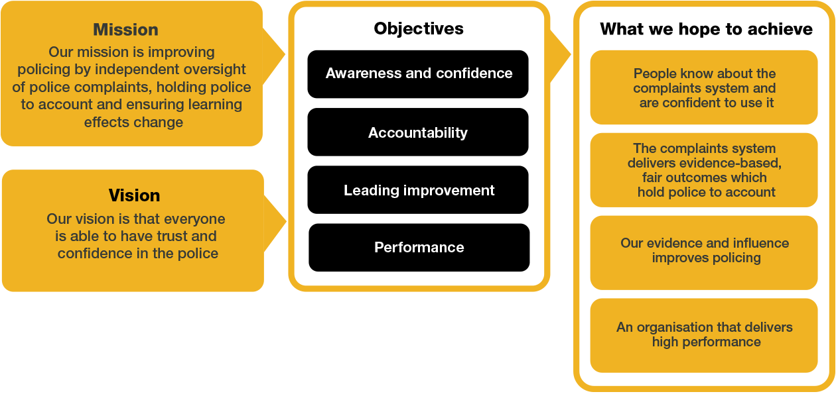

# Organisational context

We work in the context of our agreed values which inform the way we do things at the IOPC. The Lawyer will need to be committed to working in the context of these values.

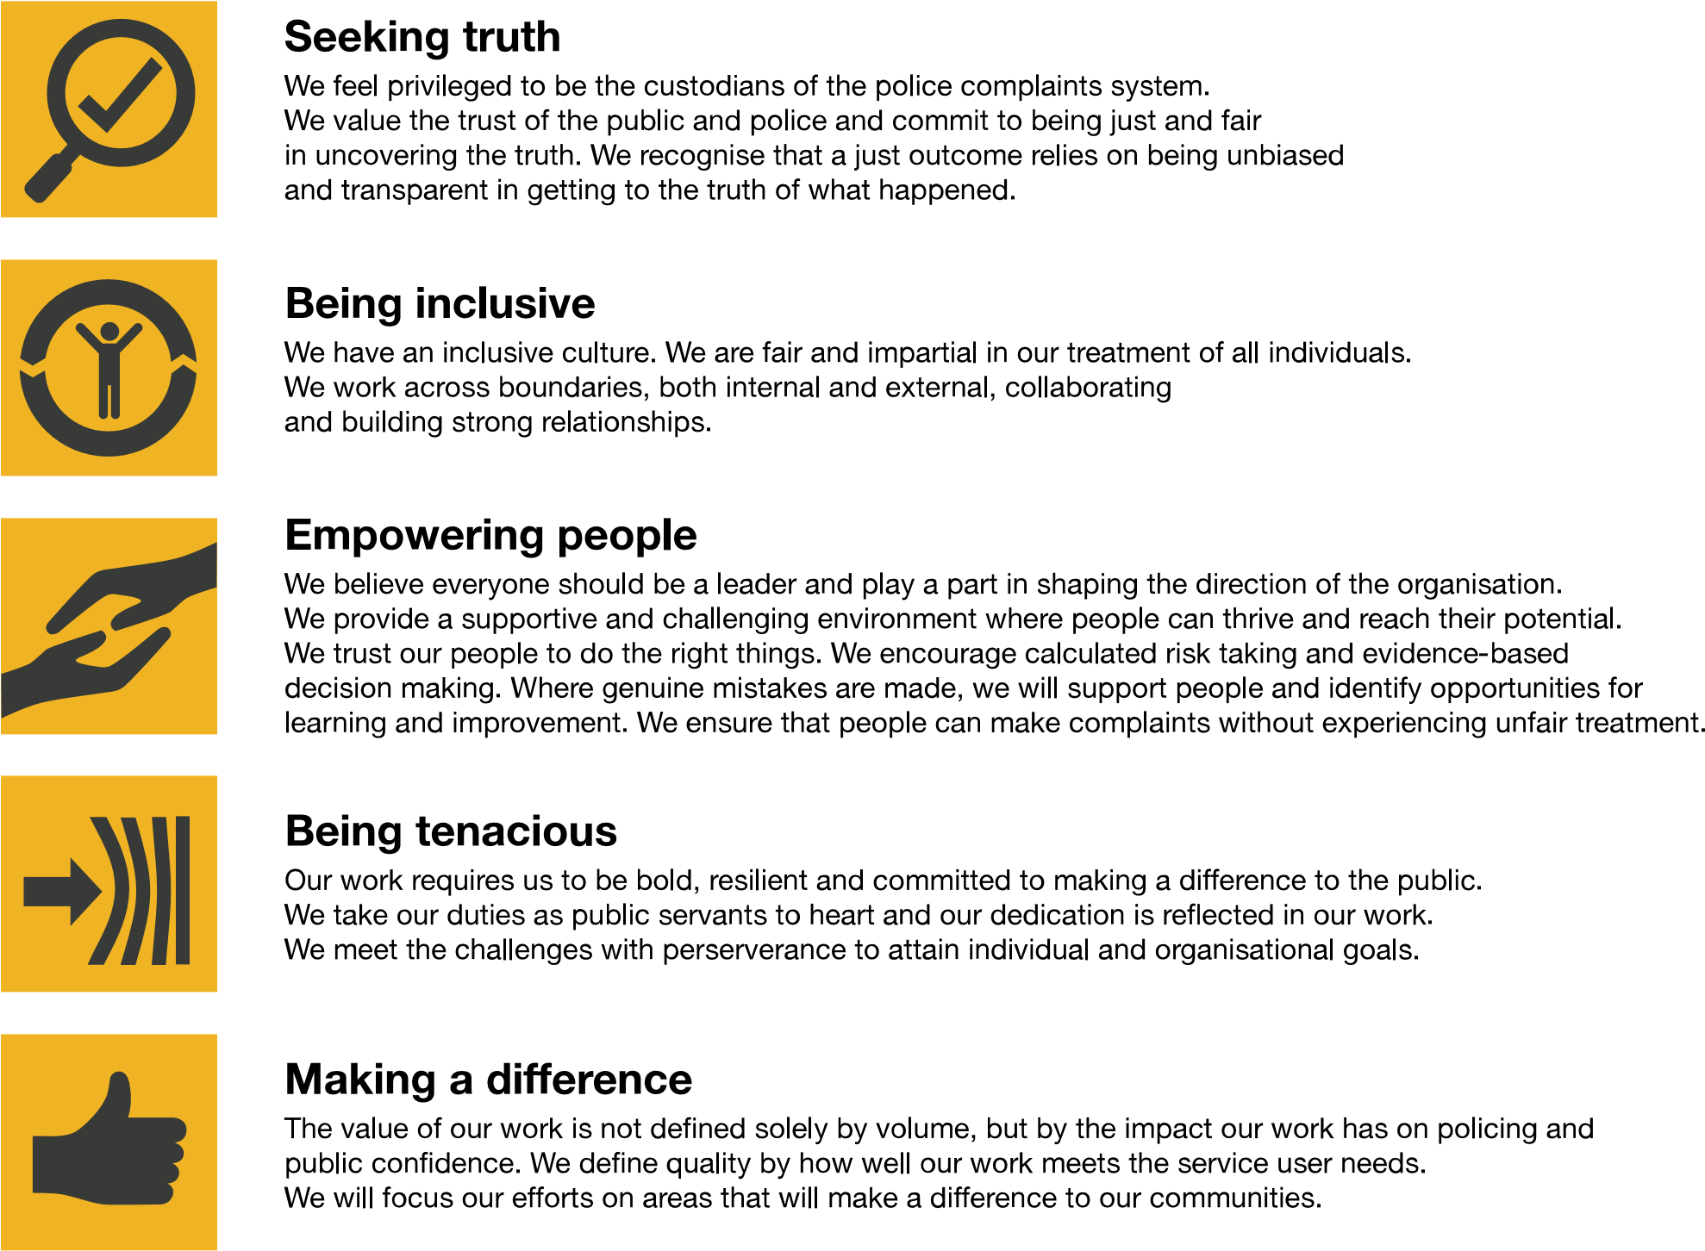

The IOPC is committed to **promoting equality and valuing diversity** in everything we do. Our vision is to be, and to be seen as, a leader in inclusive employment and services, demonstrating this ethos in everything that we do.

* As a silver standard Stonewall employer, we continue to commit ourselves to being a LGBTQ+ employer through the work of our Pride LGBTQ+ Staff Network, creating welcoming environments for lesbian, gay, bi and queer people.
* We are pleased to share we are a signatory of the Business in the Community Race at Work Charter. The Charter is composed of five [calls to action](https://race.bitc.org.uk/issues/racecharter) for leaders and organisations across all sectors.
* Being a Disability Confident employer, the IOPC is dedicated to removing the barrier for disabled people to thrive in the workplace.
* Our Staff Networks are constantly working to make the IOPC the leaders of inclusive employment, from our Allyship Programme to [Operation Hotton,](https://www.policeconduct.gov.uk/recommendations/operation-hotton-recommendations-metropolitan-police-service-september-2021) to [Welsh Language Standards](https://www.policeconduct.gov.uk/who-we-are/equality-and-diversity/welsh-language-standards) and Know the Line Policy, we are constantly seeking new ways to create an environment for all to develop and thrive.



# Main duties and responsibilities

* To provide advice to organisation staff on all areas of the organisation’s work including casework, investigations and policy.
* To handle a caseload of matters including litigation cases, inquests, judicial review cases and misconduct hearings.
* To undertake advocacy.
* Participate in the development and review of organisational policy.
* To participate in service wide initiatives and projects.
* To lead on certain allocated legal issues.
* Comply with the Legal Service’s policies and procedures.
* To comply with all relevant corporate policies and procedures.
* Must be prepared to travel to attend hearings or other IOPC offices if necessary, (additional travel costs will be paid for by the IOPC) in particular: i) if based in the South East – Canary Wharf and Croydon offices

ii) if based in Birmingham, then travel to Cardiff office iii) if based in Sale, then travel to the Wakefield office

* To undertake other duties commensurate with the level and remit of the post as may time to time be allocated by the General Counsel or another member of the Legal Services Senior Management Team.
* To take on work and/or provide support to other regional offices as required.
* After 6 months of employment to provide telephone based on-call cover. This is on a rota within the Legal Team and is approximately 2-3 weeks per year. Additional on-call allowances are payable.

# Person specification

## Essential Technical

• Qualified solicitor or barrister entitled to practice in England and Wales. A current practising certificate will need to be provided prior to the start of your employment.

## Experience

* Post qualification experience in at least one relevant areas of law – these include criminal law, police law, coronial law, professional disciplinary and regulatory law, public and administrative law and human rights law.
* Experience of advising on complex issues.
* Experience of handling substantial and complex cases.
* Strong analytical skills with the ability to master new material rapidly.
* Excellent oral and written communication skills.
* Problem solving skills.
* Approachable and constructive.
* A good team worker but also able to work independently**.**

This role is exempt from the Rehabilitation of Offenders Act 1974, therefore a basic Disclosure and Barring Service (DBS) check will be carried out for the successful candidate during the pre-employment process. Once in role, the postholder will be expected to undertake and obtain Home Office SC clearance – please note that this requires 5 years’ continuous residency in the UK.

## Desirable

* Experience of litigation
* Knowledge of FoI/DPA/GDPR matters
* Knowledge of complaints systems and handling

Reasonable adjustments

The IOPC is a diverse and inclusive workplace and we want to help you demonstrate your full potential whatever type of assessment is used. We are open to providing you with the tools you need to succeed, from extra time to formatting changes, to name a mere few. If you require any reasonable adjustments to our recruitment process, please email humanresources@policeconduct.gov.uk

## Working conditions

Making the IOPC a great place to work is one of our key priorities. We are pleased to offer a hybrid working model based on business needs, balanced with the needs of our colleagues

*The IOPC is currently consulting with its consultative bodies about proposed changes to our hybrid working policy which will require all staff to work 20% of their contractual hours at their office base (or another office for business reasons) from 1 September 2024 and increased to 40% from April 2025. Office attendance time includes in-person training, meetings with stakeholders and families, and attending events.*

Our business need framework guides our decisions about when it is best to work onsite (in our offices or other appropriate locations) to complete tasks most effectively or when to work remotely, offering colleagues flexibility to work where they feel most productive and supporting work-life balance. The model also encourages staff to feel welcome at the IOPC by ensuring we have opportunities to work face-to-face as teams.

## Preparation checklist

|  |  |
| --- | --- |
| ☐ | Review the full job description |
| ☐ | Review the behaviours and the descriptors for each behaviour |
| ☐ | Review the Strengths dictionary |
| ☐ | Review the IOPC values |
| ☐ | Consider your Strengths |
| ☐ | Consider drafting example answers that cover the specific elements |
| ☐ | Prepare some questions to ask the interviewers |