Job description
Title: People Systems Analyst
Reports to: People Systems Technical Lead
Location: Any IOPC Office Location
Grade: 10
Salary: £31,110 (Plus London Weighting allowance £4,527 if based in Croydon or Canary Wharf)
Contract: Permanent

Purpose
As a People Systems Analyst, you will be welcomed into a dynamic and inclusive team working to deliver effective technical solutions for our people management processes. The IOPC is on a journey to develop its culture, perspectives and ethos to support the organisation’s core outcomes and this is your opportunity to enter into the varied world of IOPC People Systems, allowing you to develop your mindset and approaches to contribute to improving the police complaints system in England and Wales.
The purpose of the People Systems Analyst is to provide system administration, configuration and workflow development expertise to ensure that the ResourceLink system is fully maintained, accurate and up to date to deliver an effective technical solution for our people management processes.
The role is responsible for the development of our people management reporting capability using reporting tools to automate Daily, Weekly and Monthly reports by utilising ResourceLink RRS, Power BI and other reporting tools as appropriate. Regular review and maintenance of existing reports/dashboards and developing new business reports to make data easily available to colleagues through ResourceLink self-service and other reporting tools such as Power BI.
The postholder will be responsible for raising faults and issues and ensuring these are investigated, resolved and or escalated as appropriate.
The role will provide support for managers at all levels across the organisation by designing ad hoc reports and analysing the outputs of those reports to support operational and strategic decision making.
Reporting to the People Systems Technical Lead, the requirement is for an experienced and proactive individual to provide day to day system support for the entire suite of ResourceLink modules as well as other people management systems. This is a varied and exciting role that will provide an opportunity to work within a confidential, professional, fast paced and developing systems and information management team.
This role will complement the delivery of the People Management Strategy and the IOPC Strategic Objectives to ensure excellent client service and satisfaction.

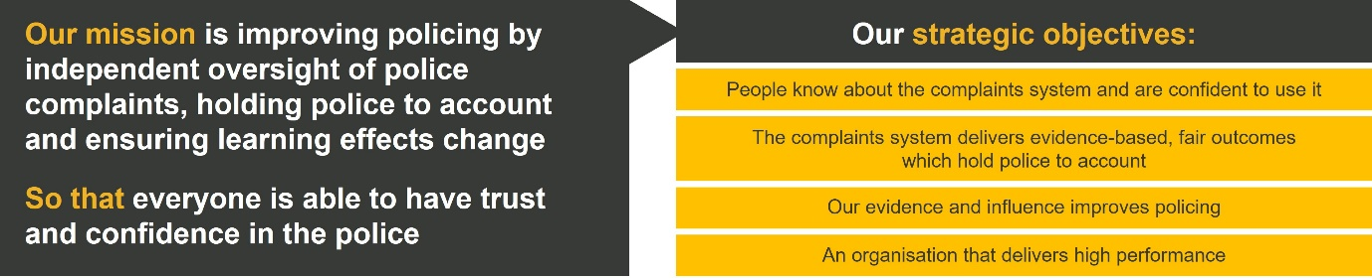
Organisational context

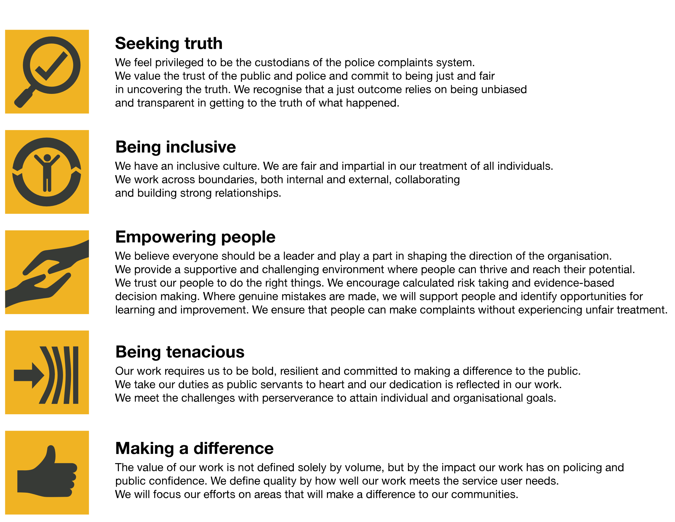
We work in the context of our agreed values which inform the way we do things at the IOPC. The People Systems Analyst will need to be commited to managing in the context of these values.
The IOPC is committed to promoting equality and valuing diversity in everything we do. Our vision is to be, and to be seen as, a leader in inclusive employment and services, demonstrating this ethos in everything that we do.
- As a silver standard Stonewall employer, we continue to commit ourselves to being a LGBTQ+ employer through the work of our Pride LGBTQ+ Staff Network, creating welcoming environments for lesbian, gay, bi and queer people.
- We are pleased to share we are a signatory of the Business in the Community Race at Work Charter. The Charter is composed of five calls to action for leaders and organisations across all sectors.
- Being a Disability Confident employer, the IOPC is dedicated to removing the barrier for disabled people to thrive in the workplace.
- Our Staff Networks are constantly working to make the IOPC the leaders of inclusive employment, from our Allyship Programme to Operation Hotton, to Welsh Language Standards and Know the Line Policy, we are constantly seeking new ways to create an environment for all to develop and thrive.

Main duties and responsibilities
System Administration
- Provide point of contact for colleagues across the entire organisation and deliver support, guidance and coaching in the effective use of our people management systems.
- Manage day-to-day maintenance of user accounts, including but not limited to, data security and log-in credentials, information queries, systems password reset, line management changes and re-instating employee accounts.
- Create and maintain organisational structures within ResourceLink including establishment to ensure that data and reporting is accurate, and that system workflow is optimised.
- Support the IOPC in delivering organisational change projects by managing and completing bulk updates to organisation structures, people record and other people management data.
- Work proactively to identify improvement opportunities to ensure that business processes and systems are aligned to policy and as effective as possible.
- Provide oversight of system(s) performance, quality, housekeeping, fault fixing and support day to day working relationships with ICT and suppliers to ensure effective issue resolution.
- Contribute to the design of lean and effective processes and develop ResourceLink functionality to maximise system automation, business notifications and workflow.
- Support the People Systems Technical Lead with system design and configuration activities in support of business process and continuous improvement.
- Escalate unresolved issues, faults or other system features as appropriate.

Business Reporting
- Develop the People Directorate performance reporting capability by creating a suite of automated user reports that are executed at an agreed frequency and can be viewed by appropriate colleagues using ResourceLink Management Information, Power BI or other reporting tools as appropriate.
- Deliver analytical capability to interrogate ResourceLink, LMS, PDR and Data Warehouse systems to extract people management data and report on issues, trends and outcomes across a range of People Management KPI’s.
- Lead on analysis of data in relation to Workforce Planning, Gender Pay Gap and other statistical analysis to produce monthly, quarterly and annual reports for internal and external bodies

Person specification

Essential
- Excellent customer service skills.
- Proven experience of maintaining an HR Information Management system including self service.
- Experience of developing and implementing changes to system workflow, configuration and system design.
- Experience of HR policy and business process.
- Proven skills of working with database reporting and business intelligence tools;
  - RRS
  - Power BI.
  - Advanced Microsoft office 365 suite skills including;
  - charting,
  - pivot tables,
  - V-look ups and
  - ‘if formulas’
  - MS Teams
  - Power Query
- Experience of developing customer focussed, automated business reporting.
- Proven experience of complex data analysis to inform decision making.
- Effective problem solving skills.
- Ability to prioritise changing work demands.
- Effective and clear communications using a range of media.
- Ability to multi task and work under pressure.
- Proficiency in the use of standard Microsoft IT packages.
- A strong eye for detail and accuracy.

Desirable
- Educated to degree level or equivalent
- Working knowledge and proven experience of the ResourceLink system and modules.
- An understanding of Microsoft Azure technologies
- Holds or is willing to work towards a Business Analysis qualification.
- Demonstrable commitment to ongoing self-development

Reasonable adjustments
The IOPC is a diverse and inclusive workplace and we want to help you demonstrate your full potential whatever type of assessment is used. We are open to providing you with the tools you need to succeed, from extra time to formatting changes, to name a mere few. If you require any reasonable adjustments to our recruitment process, please email humanresources@policeconduct.gov.uk

Working conditions
Making the IOPC a great place to work is one of our key priorities. We are pleased to offer a unique hybrid working model based on business needs, balanced with the needs of our colleagues. Our business need framework guides our decisions about when it is best to work onsite (in our offices or other appropriate locations) to complete tasks most effectively or when to work remotely, offering colleagues flexibility to work where they feel most productive and supporting work-life balance. The model also encourages staff to feel welcome at the IOPC by ensuring we have opportunities to work face-to-face as teams.

Preparation checklist
☐ Review the full job description
☐ Review the behaviours and the descriptors for each behaviour
☐ Review the Strengths dictionary
☐ Review the IOPC values
☐ Consider your Strengths (if applicable)
☐ Consider drafting example answers that cover the specific elements
☐ Prepare some questions to ask the interviewers

