**Job description**

**Title: Director of Finance and Change Delivery**

**Reports to: Deputy Director General**

**Location: Canary Wharf, Croydon, Sale, Wakefield, Birmingham, Warrington, Cardiff**

**Grade: Director, Level 3**

**Salary: £93,000 (Plus London Weighting allowance of £4,527 if located at Canary Wharf or Croydon)** Please note, that there is a senior Civil Service pay award pending.

**Contract: 18 months fixed term contract (with possible option to extend)**

# Purpose

The IOPC is undertaking a major programme of transformation, enabled by new IT systems and in support of an ambitious five-year strategy.  This in the context of rising demand and complexity of operational work and a challenging financial climate which means the IOPC must deliver more with fewer resources. The success of that programme will be fundamental to meeting stakeholder expectations, increasing public confidence in police accountability and the IOPC’s future.

The Director of Programmes and Resources is responsible for senior leadership of that programme and will chair the Change Delivery Board. The post holder will lead the Finance, Procurement, Estates and Business Development (strategy and business planning, innovation and improvement, programme management and project delivery) functions and be the lead for corporate business continuity.

The post holder has the following direct reports

* Head of Finance
* Head of Procurement and Contracts Management
* Head of Business Development
* Head of Estates and Facilities Management
* Risk and Audit Manager

# Organisational context

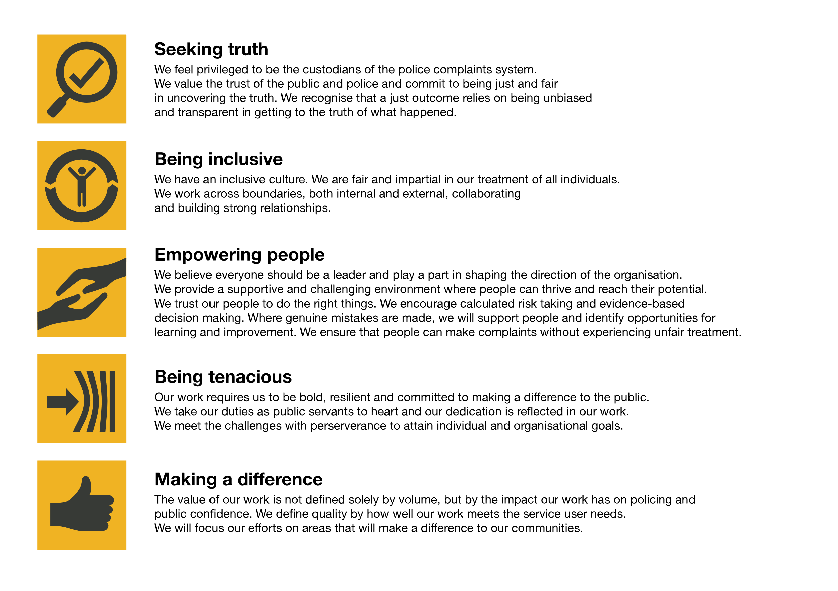We work in the context of our agreed values which inform the way we do things at the IOPC. The Director of Finance and Change Delivery will need to be committed to managing in the context of these values.

The IOPC is committed to **promoting equality and valuing diversity** in everything we do. Our vision is to be, and to be seen as, a leader in inclusive employment and services, demonstrating this ethos in everything that we do.

* As a silver standard Stonewall employer, we continue to commit ourselves to being a LGBTQ+ employer through the work of our Pride LGBTQ+ Staff Network, creating welcoming environments for lesbian, gay, bi and queer people.
* We are pleased to share we are a signatory of the Business in the Community Race at Work Charter. The Charter is composed of five [calls to action](https://race.bitc.org.uk/issues/racecharter) for leaders and organisations across all sectors.
* Being a Disability Confident employer, the IOPC is dedicated to removing the barrier for disabled people to thrive in the workplace.
* Our Staff Networks are constantly working to make the IOPC the leaders of inclusive employment, from our Allyship Programme to [Welsh Language Standards](https://www.policeconduct.gov.uk/who-we-are/equality-and-diversity/welsh-language-standards) and Know the Line Policy, we are constantly seeking new ways to create an environment for all to develop and thrive.

# Main duties and responsibilities

**Leadership and Corporate**

* Contribute to collective corporate decision making as a member of the Management Board and as a member of attendee of Unitary Board.
* Lead a skilled team of professionals to deliver high quality outcomes
* Act as a role model for the IOPC’s values and Leadership Charter
* Develop excellent relationships with Non-Executive Directors
* Review all activities within the group to identify potential savings and efficiencies
* Ensure the continued professionalisation of our corporate services including embedding Government Functional Standards
* Undertake “Gold on call” duties, for business continuity purposes approximately every 6-8 weeks

**Business Development**

* Chair the Change Delivery Board, ensuring that projects and programmes are on track to deliver objectives and benefits, within the agreed timescale, taking remedial action where necessary.
* Provide assurance to Management and Unitary Board that all programmes contributing to the Medium-Term Financial Plan (MTFP) are on track to deliver agreed benefits.
* Ensure that project and programme monitoring is effective, maintaining an overview of the whole portfolio of change and managing interdependencies
* Ensure that SROs are supported and coached as necessary to achieve their delegated responsibilities.
* Ensure that change is planned, managed, and communicated to colleagues and stakeholders in accordance with best practice
* Ensure that the IOPC runs an integrated and effective annual planning and budgeting process
* Ensure that the organisation has a proportionate means of reporting progress against high level plans
* Ensure that all business cases for programmes of work are robust, focus on benefits realisation and are properly costed

**Finance**

* Develop and report on the financial strategy for the period 2023-27
* Ensure that there are appropriate and secure systems to evaluate and pay invoices, including acting as a counter signatory for high value invoices
* Work closely with the Head of Finance to maintain excellent relationships with the Home Office Finance Group and other Home Office ALBs to understand likely financial allocations in future years
* Co-ordinate the response to requests from the Home Office and other central government departments where necessary
* Working closely with the Head of Finance, ensure that the statutory accounts are accurately prepared liaising with the Auditors as necessary
* Provide appropriate assurances to the Director General in their role as Accounting Officer.

**Audit and Risk**

* Maintain an overview of the strategic risk register and ensure risks are updated and mitigations actioned
* Liaise with the Government Internal Audit Agency to ensure that the programme of internal audit provides assurance against the organisations agreed risks
* Ensure that agreed audit recommendations are actioned within appropriate timescales
* Advise the Audit and Risk Assurance Committee as needed

**Procurement**

* Ensure that IOPC procurement processes meet government functional standards and are efficient and effective
* Develop the IOPC’s approach to Contracts Management to ensure that the organisation is conducting effective reviews of suppliers and achieving value for money
* Chair the Procurement Board

**Estates and FM**

* Ensure that the Estates strategy is operationalised, including the requirement to save money
* Manage the portfolio of leases, ensuring that the requirements of the Home Office, National Property Controls and Government Property Agency requirements are met
* Lead consultation with colleagues about changes to the estate
* Ensure that there are robust facilities management procedures in place and that all IOPC workplaces are safe and secure
* Lead the IOPC’s work on sustainability
* Ensure that the IOPC meets the requirements of the “places for growth” strategy mandating a partial move out of London
* Act as the lead commissioner for national procurement of travel and fleet

**Business Continuity**

* Ensure that the IOPC has suitable business continuity plans (BCPs) in place
* Ensure that BCPs are regularly tested
* Ensure that there is a suitable awareness of BCP issues in key teams across the IOPC

**KEY RELATIONSHIPS:**

* Director General and Management Board
* Unitary Board,
* Home Office Finance Group
* Head of internal audit and risk
* SROs responsible for major projects
* Colleagues across the organisation

Whilst remote working is permitted for this role and the postholder may be located in any of our regional office, there will be expectations for frequent travel to other offices. If you are not based in the region that will be travelled to, we may be able to consider travel expenses for this interim role.

# Person specification

## Qualifications

**Essential**

* An ACA or CIPFA qualified accountant

**Desirable**

* A Prince2 or MSP qualification

## Experience

* Significant experience in successfully leading programmes of change in complex organisations, ensuring benefits are realised
* Ability to develop and operationalise a 5-year financial strategy taking account of likely scenarios
* Sound understanding of public finance structures, preferably including relations between central government and Non-Departmental Public Bodies
* A sound understanding of public sector procurement
* Demonstrable experience of supporting equality diversity and inclusion

Due to the nature of this role, and the statutory role of the IOPC, ideally applications are not sought from those who have recently worked for the police in a capacity or for a duration that might compromise their impartiality in the eyes of the public.

## Skills and Abilities

* Ability to think and act strategically, developing practical, innovative, and creative solutions to the management of strategic and complex problems.
* Ability to work collaboratively
* Highly developed oral, written and presentation skills.
* Able to build effective relationships quickly and to influence and negotiate as needed

## Reasonable adjustments

The IOPC is a diverse and inclusive workplace and we want to help you demonstrate your full potential whatever type of assessment is used. We are open to providing you with the tools you need to succeed, from extra time to formatting changes, to name a mere few. If you require any reasonable adjustments to our recruitment process, please email [campaigns@policeconduct.gov.uk](mailto:campaigns@policeconduct.gov.uk)

# Political Restriction

Please note that this is a politically restricted role and will be subject to limitations set out in the IOPC code of conduct, a relevant extract from which is set out below. This post has been identified as politically restricted because:

* The post holder will act as “spokesperson” for the organisation, or have a significant degree of face-to-face contact with stakeholders, pressure groups, or other bodies or individuals who are seeking to influence the IOPC
* It would appear to the public that the post holder had some influence over the outcome of the organisation’s decisions.

If a post is politically restricted, this means that you should discuss with your line manager before taking on any political activities. Permissions will not be unreasonably withheld but consideration will need to be given to the scope and remit of the role and how this may be perceived in the context of your IOPC position. You should discuss with your line manager if you are considering becoming politically active, for example:

* Campaigning for a political party.
* Holding a political office.
* Occupying party political posts.
* Holding a particularly sensitive or high-profile unpaid roles in a political party.

# Positive Action

At the IOPC, we are committed to building a workforce which reflects the diversity of the communities in which we serve. A more inclusive workforce enables us to be a more effective and efficient organisation, better understand and respond to the needs of our communities.

Positive action as detailed in the Equality Act 2010, allows us to use measures designed to help improve equality in the workplace, and create a level playing field for all, whilst still employing everyone based on merit. Our workforce profile data shows that people who identify as black, Asian and minority ethnic are under-represented at the IOPC.

For this role – should we have a situation where multiple candidates have achieved the highest score and one identifies as black, Asian or minority ethnic, by using positive action, we can select that candidate for the role, therefore improving this area of under-representation at the IOPC. We will only use positive action in this way where the highest scoring candidates have all scored equally, at the final assessment stage, and above our required threshold.

# Emotional Consideration

In performing this role, you may have occasional exposure to distressing material which will likely be impactful, traumatic and challenging. Given the nature of the work, it is also possible that you will have contact with individuals who are experiencing extreme distress. The IOPC recognises this and offers all staff a range of wellbeing provisions, including TRiM (Trauma Risk Management) peer-to-peer support, a dedicated Wellbeing Advisor, and access to free confidential counselling. All staff are strongly encouraged to proactively access and engage with the support available. If you would like to speak about this element of the role with somebody already doing similar work at the IOPC, please contact [campaigns@policeconduct.gov.uk](mailto:campaigns@policeconduct.gov.uk) and this can be arranged.

## Working conditions

Making the IOPC a great place to work is one of our key priorities. We are pleased to offer a unique hybrid working model based on business needs, balanced with the needs of our colleagues. Our business need framework guides our decisions about when it is best to work onsite (in our offices or other appropriate locations) to complete tasks most effectively or when to work remotely, offering colleagues flexibility to work where they feel most productive and supporting work-life balance. The model also encourages staff to feel welcome at the IOPC by ensuring we have opportunities to work face-to-face as teams.

## Preparation checklist

☐ Review the full job description

☐ Review the behaviours and the descriptors for each behaviour

☐ Review the Strengths dictionary

☐ Review the IOPC values

☐ Consider your Strengths (if applicable)

☐ Consider drafting example answers that cover the specific elements

☐ Prepare some questions to ask the interviewers