**Job description**

**Title:** Assistant Publications Co-ordinator (Hillsborough)

**Reports to:**  Hillsborough Communications Manager

**Location:** Any IOPC office

**Grade:** 10

**Salary:** £30,032 per annum (plus London Weighting Allowance, if applicable)

**Contract:** Fixed term until 31 March 2024

# Purpose

As an Assistant Publications Co-ordinator, you will be welcomed into a dynamic and inclusive Strategy and Impact directorate. The IOPC is on a journey to develop its culture, perspectives and ethos to support the organisation’s core outcomes and this is your opportunity to enter into the varied world of IOPC Communications, allowing you to develop your mindset and approaches to contribute to improving the police complaints system in England and Wales.

The Assistant Publications Co-ordinator (Hillsborough) will help ensure all editorial material relating to the Hillsborough investigations is ready for publication in a timely manner, to a high standard, and in an accessible format. The post holder will work closely with the Editorial and Publishing Lead (Hillsborough) to ensure all reports, summaries and organisational learning meet our editorial standards.

They will also work closely with investigators and other staff across the IOPC, to commence the publishing process. This work will be carried out in accordance with the IOPC’s policies, guidelines and relevant legislative requirements.

# Organisational context

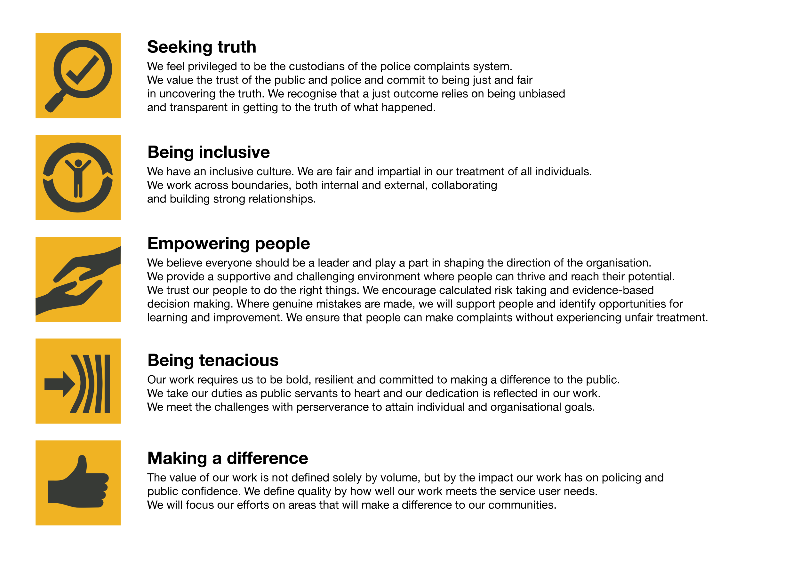We work in the context of our agreed values which inform the way we do things at the IOPC. The Assistant Publications Co-ordinator (Hillsborough) will need to be commited to managing in the context of these values.

The IOPC is committed to **promoting equality and valuing diversity** in everything we do. Our vision is to be, and to be seen as, a leader in inclusive employment and services, demonstrating this ethos in everything that we do.

* As a silver standard Stonewall employer, we continue to commit ourselves to being a LGBTQ+ employer through the work of our Pride LGBTQ+ Staff Network, creating welcoming environments for lesbian, gay, bi and queer people.
* We are pleased to share we are a signatory of the Business in the Community Race at Work Charter. The Charter is composed of five [calls to action](https://race.bitc.org.uk/issues/racecharter) for leaders and organisations across all sectors.
* Being a Disability Confident employer, the IOPC is dedicated to removing the barrier for disabled people to thrive in the workplace.
* Our Staff Networks are constantly working to make the IOPC the leaders of inclusive employment, from our Allyship Programme to [Welsh Language Standards](https://www.policeconduct.gov.uk/who-we-are/equality-and-diversity/welsh-language-standards) and Know the Line Policy, we are constantly seeking new ways to create an environment for all to develop and thrive.

# Main duties and responsibilities

* Work with investigators, the communications team and other internal stakeholders to ensure all Hillsborough material and reports meet our editorial standard.
* Proactively liaise with investigators and key stakeholders regarding publication decisions.
* Edit investigation summaries, based on the investigation report, the decision maker’s opinion document, the force’s response, and all other relevant correspondence, to provide an accurate summary of the facts, the investigation, and its outcomes.
* Review Paragraph 28A learning recommendations and responses from internal systems to ensure the content is ready for publication and meets legislative requirements.
* Promote Hillsborough related material, investigation summaries and learning recommendations via internal channels, and send monthly updates to various departments and subject matter networks.
* Ensure compliance with IOPC style guidelines and promote their use to others to ensure a consistent and professional look and feel.
* Assist with proofreading investigation reports and summaries of IOPC conclusions ready for publication.
* Promote good practice across the Hillsborough investigation and wider organisation around applying the Publication policy and writing investigation summaries, by sharing support materials and advising operational staff where necessary.
* Carry out additional writing and editing work in the Communications Department as necessary.

# Person specification

## Essential

* Experience of writing and editing complex, technical information where accuracy is vital.
* Ability to process, analyse and summarise information to produce clear, accurate and succinct copy.
* Excellent organisational skills and the ability to juggle multiple tasks while meeting deadlines.
* Experience of working with technical or operational staff and supporting them in understanding the importance of accurate and accessible written communication.
* Experience of using Word, Outlook and Excel.
* Ability to deal with sensitive information.
* Good interpersonal skills and the ability to deal confidently with people at all levels and use persuasive skills when necessary.
* A flexible, proactive and creative approach

## Reasonable adjustments

The IOPC is a diverse and inclusive workplace and we want to help you demonstrate your full potential whatever type of assessment is used. We are open to providing you with the tools you need to succeed, from extra time to formatting changes, to name a mere few. If you require any reasonable adjustments to our recruitment process, please email [humanresources@policeconduct.gov.uk](mailto:humanresources@policeconduct.gov.uk)

## Working conditions

Making the IOPC a great place to work is one of our key priorities. We are pleased to offer a unique hybrid working model based on business needs, balanced with the needs of our colleagues. Our business need framework guides our decisions about when it is best to work onsite (in our offices or other appropriate locations) to complete tasks most effectively or when to work remotely, offering colleagues flexibility to work where they feel most productive and supporting work-life balance. The model also encourages staff to feel welcome at the IOPC by ensuring we have opportunities to work face-to-face as teams.

## Preparation checklist

☐ Review the full job description

☐ Review the behaviours and the descriptors for each behaviour

☐ Review the Strengths dictionary

☐ Review the IOPC values

☐ Consider your Strengths (if applicable)

☐ Consider drafting example answers that cover the specific elements

☐ Prepare some questions to ask the interviewers