**Job description**

**Title:** Business Relationship Manager

**Reports to:** Lead Business Relationship Manager

**Location:** Any IOPC office – Sale, Wakefield, Warrington, Cardiff, Birmingham, Canary Wharf, Croydon

**Grade:** 13

**Salary:** £46,335 Plus London Weighting allowance of £4,731 if based in London or Canary Wharf

**Contract:** Permanent

# Purpose

As a Business Relationship Manager, you will be welcomed into a dynamic and inclusive Digital, Data and Technology (DDaT) function. The IOPC is on a journey to develop its culture, perspectives and ethos to support the organisation’s core outcomes and this is your opportunity to enter into the varied world of DDaT at the IOPC, allowing you to develop your mindset and approaches to contribute to improving the police complaints system in England and Wales.

A Business Relationship Manager (BRM) is the DDaT liaison for specific business areas within the IOPC. A BRM understands the business processes in use and provides guidance to ensure maximum return on investment for the DDaT and IOPC business strategies. The key to this role is reducing barriers between the business and DDaT.

The BRM understands and documents the desired business outcome of a service, working with DDaT technical teams and subject matter experts to establish if the business need can be achieved using an existing service offering or if a new or changed service must be created.

The BRM will maintain and develop regular contact with senior leaders and managers within the organisation who act as business owners plus service delivery and project managers across a customer and digital portfolio.

# Organisational context

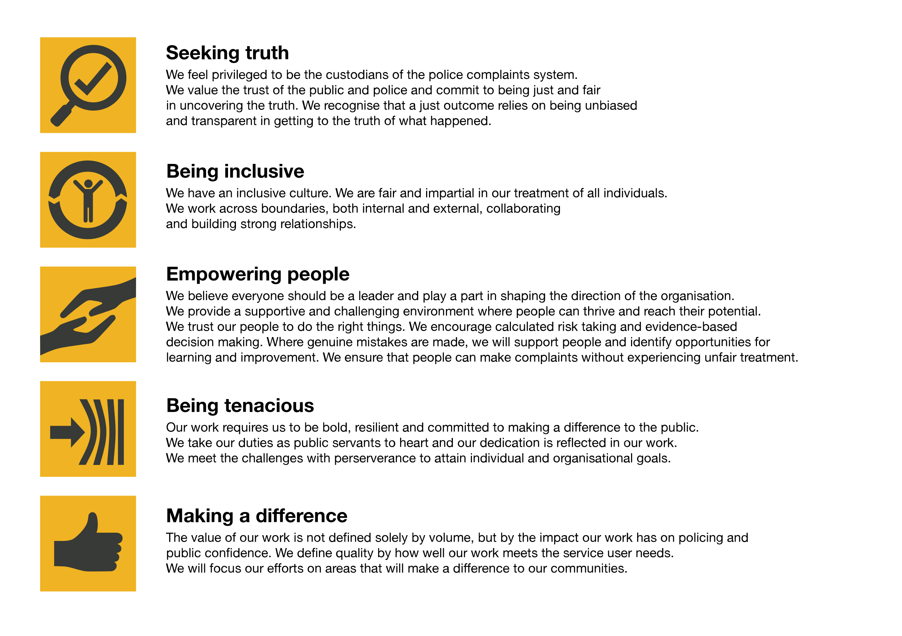We work in the context of our agreed values which inform the way we do things at the IOPC. The Business Relationship Manager will need to be commited to managing in the context of these values.

The IOPC is committed to **promoting equality and valuing diversity** in everything we do. Our vision is to be, and to be seen as, a leader in inclusive employment and services, demonstrating this ethos in everything that we do.

* As a silver standard Stonewall employer, we continue to commit ourselves to being a LGBTQ+ employer through the work of our Pride LGBTQ+ Staff Network, creating welcoming environments for lesbian, gay, bi and queer people.
* We are pleased to share we are a signatory of the Business in the Community Race at Work Charter. The Charter is composed of five [calls to action](https://race.bitc.org.uk/issues/racecharter) for leaders and organisations across all sectors.
* Being a Disability Confident employer, the IOPC is dedicated to removing the barrier for disabled people to thrive in the workplace.
* Our Staff Networks are constantly working to make the IOPC the leaders of inclusive employment, from our Allyship Programme to [Operation Hotton](https://www.policeconduct.gov.uk/recommendations/operation-hotton-recommendations-metropolitan-police-service-september-2021), to [Welsh Language Standards](https://www.policeconduct.gov.uk/who-we-are/equality-and-diversity/welsh-language-standards) and Know the Line Policy, we are constantly seeking new ways to create an environment for all to develop and thrive.

# Main duties and responsibilities

* Works with business and product owners and other stakeholders at all levels to understand how DDaT can support new business initiatives
* Oversee changes to their service catalogue and ensure that any such change is delivered on-time, on-budget and meets the business’ needs.
* Help define key strategies for the DDaT delivery model.
* Working closely with other BRMs and DDaT colleagues to understand concerns around the alignment of digital and data services across the business to develop and drive improvements.
* Understands DDaT trends and forecasts future demand and requirements through close liaison with Service Delivery Management, Infrastructure and Architecture, Data and Information teams.
* Work within ITIL practices and processes and IOPC policy to effectively deliver outcomes and change
* Undertake customer satisfaction surveys, stakeholder mapping and engagement activity.

# Person specification

## Essential

* Strong customer focus with experience of building effective working relationships with business stakeholders and end users to deliver service improvements
* Experience of developing and writing business cases, high-level requirements and succinct non-technical reports to business stakeholders
* Experience of working with in-house and outsourced IT service delivery teams
* Excellent communication skills
* Good knowledge of using Microsoft 365 products
* Practical experience of PRINCE2 and Agile project delivery
* Ability to work as part of a team but under their own steam
* Positive “can do” attitude and flexibility of approach

## Desirable

* ITIL v3 or v4 Foundation certificate
* BRM Institute Business Relationship Management Professional

## Reasonable adjustments

The IOPC is a diverse and inclusive workplace and we want to help you demonstrate your full potential whatever type of assessment is used. We are open to providing you with the tools you need to succeed, from extra time to formatting changes, to name a mere few. If you require any reasonable adjustments to our recruitment process, please email [humanresources@policeconduct.gov.uk](mailto:humanresources@policeconduct.gov.uk)

## Working conditions

Making the IOPC a great place to work is one of our key priorities. We are pleased to offer a unique hybrid working model based on business needs, balanced with the needs of our colleagues. Our business need framework guides our decisions about when it is best to work onsite (in our offices or other appropriate locations) to complete tasks most effectively or when to work remotely, offering colleagues flexibility to work where they feel most productive and supporting work-life balance. The model also encourages staff to feel welcome at the IOPC by ensuring we have opportunities to work face-to-face as teams.

## Preparation checklist

☐ Review the full job description

☐ Review the behaviours and the descriptors for each behaviour

☐ Review the Strengths dictionary

☐ Review the IOPC values

☐ Consider your Strengths (if applicable)

☐ Consider drafting example answers that cover the specific elements

☐ Prepare some questions to ask the interviewers