**Job description**

**Title: Quality and Service Improvement Officer (Service User Experience & Involvement)**

**Reports to: Quality and Service Improvement Team Leader (Complaints, Feedback and Service User Improvement)**

**Location: Birmingham, Canary Wharf, Cardiff, Croydon, Sale or Wakefield**

**Grade: 12**

**Salary: £40,075 plus £4,731 London Weighting Allowance if based in Croydon or Canary Wharf**

**Contract: Permanent**

# Purpose

As Quality and Service Improvement Officer, you will be welcomed into the dynamic and inclusive Quality and Service Improvement team working at the forefront of the IOPC’s drive to deliver exceptional quality and value for money in the services that we provide.

The IOPC is on a journey to develop its culture, perspectives and ethos to support the organisation’s core outcomes, and this is your opportunity to enter into the varied world of IOPC Quality and Service Improvement, allowing you to develop your mindset and approaches to contribute to improving the police complaints system in England and Wales.

The QSI team support our colleagues by working with them to set standards, quality assure these standards and drive positive changes in quality by identifying good practice and opportunities for improvement.

We act as a critical friend to other teams and functions, to provide assurance to both internal and external stakeholders that the IOPC’s work is of a high standard and maintains a focus on service user experience.

We carry out a wide range of assurance activities, manage complaints and feedback about IOPC and oversee and develop the Operations Manual and focus on quality improvement.

This is a new role and therefore it is important that you are adaptable and flexible as the role develops. You will also have the opportunity to shape the role over time.

You will work closely with the Quality & Service Improvement Team Leader to design, implement and embed service user engagement and involvement activities and processes for the IOPC. This will be something that you have completed successfully in another organisation. You will be someone who is passionate about ensuring that service users have a variety of ways to give their views and have their voices heard. You will bring skills and experience to address barriers to engagement with people using our service who may be hard to reach.

You will also ensure that this feedback and insight is used, proactively, to inform service development and organisational strategy and improvement projects. You will also ensure other data and feedback from across the organisation is fully utlilised and fed into improvement work.

There will also be opportunities to add value in areas such as improvement projects, thematic reviews, audit and compliance and service user engagement.

The postholder will be expected to work flexibly across all areas of delivery.

There will be a need to travel to other IOPC offices. There will also be a need to travel to other locations to meet with stakeholders and service users.

# Organisational Context

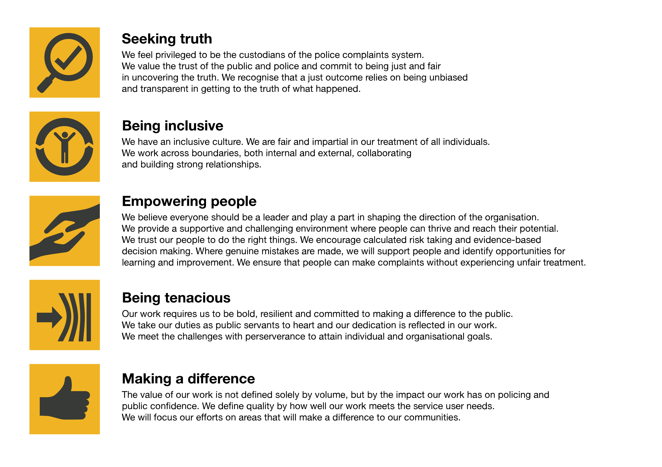We work in the context of our agreed values which inform the way we do things at the IOPC. The Quality and Service Improvement Officer will need to be commited to managing in the context of these values.

The IOPC is committed to **promoting equality and valuing diversity** in everything we do. Our vision is to be, and to be seen as, a leader in inclusive employment and services, demonstrating this ethos in everything that we do.

* As a silver standard Stonewall employer, we continue to commit ourselves to being a LGBTQ+ employer through the work of our Pride LGBTQ+ Staff Network, creating welcoming environments for lesbian, gay, bi and queer people.
* We are pleased to share we are a signatory of the Business in the Community Race at Work Charter. The Charter is composed of five [calls to action](https://race.bitc.org.uk/issues/racecharter) for leaders and organisations across all sectors.
* Being a Disability Confident employer, the IOPC is dedicated to removing the barrier for disabled people to thrive in the workplace.
* Our Staff Networks are constantly working to make the IOPC the leaders of inclusive employment, from our Allyship Programme to [Welsh Language Standards](https://www.policeconduct.gov.uk/who-we-are/equality-and-diversity/welsh-language-standards) and Know the Line Policy, we are constantly seeking new ways to create an environment for all to develop and thrive.

# Main duties and responsibilities

**PURPOSE**

* To design, implement and embed service user engagement and involvement processes and activities throughout the IOPC .
* To lead on the development of using service user experience to inform improvement activity, through the Quality Improvement Cycle.
* To lead on sharing and reporting on service user feedback and experience throughout the organisation
* To be responsible for identifying learning and/or areas of concern and providing recommendations to the appropriate colleagues (at all levels of the organisation).
* Input to all areas of Quality Management, including dip sample design, operational standards and support colleagues handling, and responding to complaints from service users.
* Contribute to improved organisational learning and disseminate learning and best practice across the IOPC.
* To support colleagues in driving and sustaining improvements in IOPC delivery
* To drive improvements in delivery through engagement and collaboration with service users and stakeholders, using feedback to improve. For example through the use of involvement panels
* Provide assurance that service user experience is accounted for in the organisational assessment of quality.

**MAIN DUTIES AND RESPONSIBILITIES**

*Our Organisation*

* Consider IOPC strategic intent when carrying out work, i.e. continuous improvement and accountability
* Identify and cycle learning and improvement from quality assurance activity into the wider organisation in order to embed a ‘learning culture’.
* Challenge work that doesn’t add value.
* Be the voice of the service user– actively promote and champion the IOPC’s service standards at all times.
* Represent the organisation as specified. This will include designing and delivering presentations for IOPC colleagues and could include representing the IOPC at external events and meetings.
* Attend and contribute to organisational improvement activities / change events that seek to embed organisational learning and drive improvements throughout the organisation, championing and promoting the voice of the service user.
* Attend and input into long term organisational projects, championing the voice of the service user, using data and analysis from service user experience.
* Champion and promote a service user focus across the IOPC

*Our People*

* Take responsibility for personal and professional learning and development
* Be part of the team – be flexible to adapt to the business need of the wider QSI team
* Be self motivated and able to work independently
* Be able to give constructive feedback to colleagues, including peers and managers. Seek feedback and be able to reflect on it
* Maintain your professional expertise and keep up to date with relevant legislation, policy and good practice in order to strive for operational improvement
* Work with teams across the IOPC to support them to embed the IOPC’s service standards

*Our Delivery*

* Plan and lead strands of the service user involvement & experience framework, including being responsible for:
  + Designing and embedding multiple ways for service users to provide their feedback to the IOPC. This will involve working closely with colleagues from across the organisation
* Working with service users to develop service user journey maps
* Establishing, embedding and facilitating a service user ‘sounding board’ and/or ‘involvement panel(s)’
* Establishing a process to analyse service user feedback and insight from across the organisation to inform improvement activity
* Further developing, and contributing to, a reporting framework – for all colleagues – in relation to feedback received to ensure that the voice of the service user is recognised throughout all teams
* Understand the IOPC complaints and feedback processes to enable identification and accurate reporting and recording of service user dissatisfaction
* Communicate with service users using their preferred method of contact. This will include speaking with service users on the phone, communicating in writing and in person to achieve a high quality of service, having regard to reasonable adjustments and safeguarding
* Liaise with colleagues and external partners to recover and improve service delivery, identify and implement organisational learning
* Convert raw data to useful management information, produce reports and present findings to senior managers as required
* Work collaboratively with colleagues across the QSI team to deliver the team’s objectives

The postholder may also be required to:

* Design and deliver presentations for colleagues, external stakeholders and service users as required
* Carry out debriefs and after action reviews with internal and external service users to identify learning for the IOPC and other organisations where necessary
* Support the collection, analysis, decision making in relation to service user feedback

# Person specification

## Essential

* Experience of designing, implementing, and embedding service user engagement / involvement processes and activities to develop understanding of service user experience. Ideally, this experience has been gained in the public / social housing / third sector
* Have a real understanding of how to gather service users’ needs and be keen and skilled at developing a positive rapport with multiple different service user groups
* Be experienced in working with service user to understand their ‘service user journey’ with an organisation – and be able to feed that insight into improvement activity
* Be able to demonstrate a 'can-do' attitude and be solutions-focussed
* A demonstrably high level of communication skills, both written and verbal
* Experience of gathering and analysing information, to inform decisions and recommendations and make improvements
* Experience or recognising insight which may pose reputational risk and escalate appropriately
* Strong persuasion and influencing skills
* Experience of service user complaint handling and resolution
* Experience off involving people whose voice is seldom heard
* Experience of engaging and involving harder to reach audiences, to bring improvements which impact organisational effectiveness
* Experience of working with colleagues, service users and stakeholders to drive service improvements
* Experience of communicating verbally or in writing with challenging service users
* Experience of using restorative practice with service users is highly desirable

## Skills and Abilities

* Motivated by working with service users, listening to their views and having the drive to use their voices to make a difference
* Tenacious and resilient in ‘doing the right thing’
* Skilled negotiator – must be able to work with others, often with competing needs and work, to ensure that projects succeed
* Self-motivated with the proven ability to plan and prioritise their own workload
* Confident and skilled communicator who is able to provide the highest quality of information in writing or other alternative, or via presentations in person, to a variety of audiences including those who are hard to reach
* Able to write in Plain English and for a variety of audiences.
* Able to work collaboratively, across teams and directorates to deliver results and be able to persuade and influence others
* Promotes a culture which values diversity of experience and background and embeds team behaviours
* Able to prioritise, plan and manage tasks effectively to deliver quality outcomes within challenging timescales
* Able to work flexibly and remotely, including national travel, working independently and as part of a national team based in separate locations

## Desirable

* Understanding of a complex legislative regulatory environment (or willingness to learn)

Understanding of the police complaints system and the statutory framework within which the IOPC operates

* Understanding of the relevance of the Human Rights Act 1998; IOPC obligations under the Equality Act 2010, including the Public Sector Equality Duty, and other relevant legislation to the work of the IOPC and reasonable adjustments
* Knowledge of safeguarding policy

# Values and Behaviours

Demonstrate the IOPC’s values: seeking the truth, being inclusive, being tenacious, making a difference, including by:

* Putting our service users at the heart of what we do - applying and championing the IOPC’s service user standards and considering the diverse needs of both our internal service users and external users of the IOPC’s services.
* Understanding and championing a learning culture and a commitment to continuous improvement, actively seeking and being open to feedback to learn and improve performance and processes.
* Promoting collaborative and inclusive team working - supporting team members and colleagues across the organisation, being open to challenge and valuing diverse ideas and backgrounds.
* Having the confidence to provide robust, honest, evidence-based feedback to individuals, teams and the organisation in a way that supports learning and improvement.

# Emotional Consideration

In performing this role, you will have regular exposure to distressing material which will likely be impactful, traumatic and challenging. Given the nature of the work, it is also possible that you will have contact with individuals who are experiencing extreme distress. The IOPC recognises this and offers all staff a range of wellbeing provisions, including TRiM (Trauma Risk Management) peer-to-peer support, a dedicated Wellbeing Advisor, and access to free confidential counselling. All staff are strongly encouraged to proactively access and engage with the support available. If you would like to speak about this element of the role with somebody already doing similar work at the IOPC, please contact [campaigns@policeconduct.gov.uk](mailto:campaigns@policeconduct.gov.uk) and this can be arranged.

## Reasonable adjustments

The IOPC is a diverse and inclusive workplace and we want to help you demonstrate your full potential whatever type of assessment is used. We are open to providing you with the tools you need to succeed, from extra time to formatting changes, to name a mere few. If you require any reasonable adjustments to our recruitment process, please email [campaigns@policeconduct.gov.uk](mailto:campaigns@policeconduct.gov.uk)

## Working conditions

The IOPC is currently consulting with its consultative bodies about proposed changes to our hybrid working policy which will require all staff to work 20% of their contractual hours at their office base (or another office for business reasons) from 1 September and increased to 40% from April next year. Office attendance time includes in-person training, meetings with stakeholders and families, and attending events. There will be a requirement to attend the one of our casework offices (Sale and Cardiff) when business needs dictate. This is likely to be quite infrequently, and travel expenses would be paid if this is not your normal local office.

Here at the IOPC, maintaining a culture that is accessible and inclusive of gender identity, sexuality, age, disability, race, sex, belief and caring responsibilities is deeply important to us. We believe that a rich, diverse workforce enables us a better understanding of each others needs, and produces more meaningful and trusting relationships, which in turn create more inclusive spaces where we all feel that we can contribute and belong.  We value our diversity, as we believe that our diversity is our strength. It allows us to identify with our communities through shared lived experiences producing better understanding and higher quality results in our work.

## Selection Process

This vacancy is using [**Success Profiles**](https://www.gov.uk/government/publications/success-profiles?_ga=2.156185915.1692943174.1578577916-319911383.1576576754).

Throughout the recruitment process we will assess your Experience, Behaviours, Strengths and Values. As part of the application process you will be asked to complete 3 sift stage questions based on the essential criteria.

For successful candidates who reach the assessment stage, we will provide further details of what will be assessed.

## What is Success Profiles?

Success Profiles moves us to a tailored way of assessing, dependent on the requirements of the job. For each role we advertise, we consider what you will need to demonstrate in order to be successful. This gives us the best possible chance of finding the right person for the job, drives up performance and improves diversity and inclusivity so that we can truly reflect the communities that we serve.

Not all of the elements are relevant to every role, and will vary depending on the level and type of role. You should ensure you read the job description carefully to see what elements are required for the specific job you are applying for. There are separate guides to each of the elements, which will give you more information about what and how you can demonstrate specific requirements.

## 

## Preparation checklist

☐ Review the full job description

☐ Review the behaviours and the descriptors for each behaviour

☐ Review the Strengths dictionary

☐ Review the IOPC values

☐ Consider your Strengths

☐ Consider drafting example answers that cover the specific elements

☐ Prepare some questions to ask the interviewers