**Title:** Trainee Investigator



**J**

**ob**

**d**

**escription**

Trainee Investigator

**Reports to:**  Operations Team Leader

**Location:** Birmingham, Canary Wharf, Cardiff, Croydon, Sale or Wakefield

**Please note that we are separately advertising roles for different locations. Please only apply for your first-choice location. Within that application, you can then specify your 2nd, 3rd, 4th etc. location preferences. Please do not submit applications for more than one location.

**Grade:** 9

**Salary:**  £30,870 per annum (increasing to £34,067 on promotion to Investigator, Grade 10)

London Weighting Allowance of £4,968 will be payable, in addition, for roles in Canary Wharf or Croydon

**Contract:** This is a training contract lasting up to 24 months. Continuing permanent employment is subject to successful completion of the Trainee Investigator Programme and appointment to a permanent Investigator role.

# Purpose

As a Trainee Investigator, you will be welcomed into a dynamic and inclusive Investigations team working locally and nationally on a wide range of IOPC investigations. The IOPC is on a journey to develop its culture, perspectives and ethos to support the organisation’s core outcomes, and this is your opportunity to enter into the varied world of IOPC Investigations, allowing you to develop your mindset and approaches to contribute to improving the police complaints system in England and Wales.

You will engage in a Professionalising Investigations Programme Level 1 (PIP1) programme that is designed to develop your skills and knowledge as an investigator whilst working to achieve a qualification. The PIP1 development programme includes formal and, on the job, learning as well as the support to build a portfolio of evidence which will provide you with the skills and knowledge to become a PIP1 investigator. The PIP1 programme is a mandatory part of your role and promotion to investigator requires the PIP1 programme to be completed in full.

You will be responsible for contributing to the delivery of high quality, robust and independent investigations, demonstrating our core values in all aspects of your role.

After completion of the PIP1 programme, you will be expected to engage in the revalidation programme. Revalidation ensures that your skills and knowledge are enhanced and maintained in line with the PIP requirements. Full engagement with the revalidation process is mandatory.

Security Level: Baseline Standard

# Organisational context

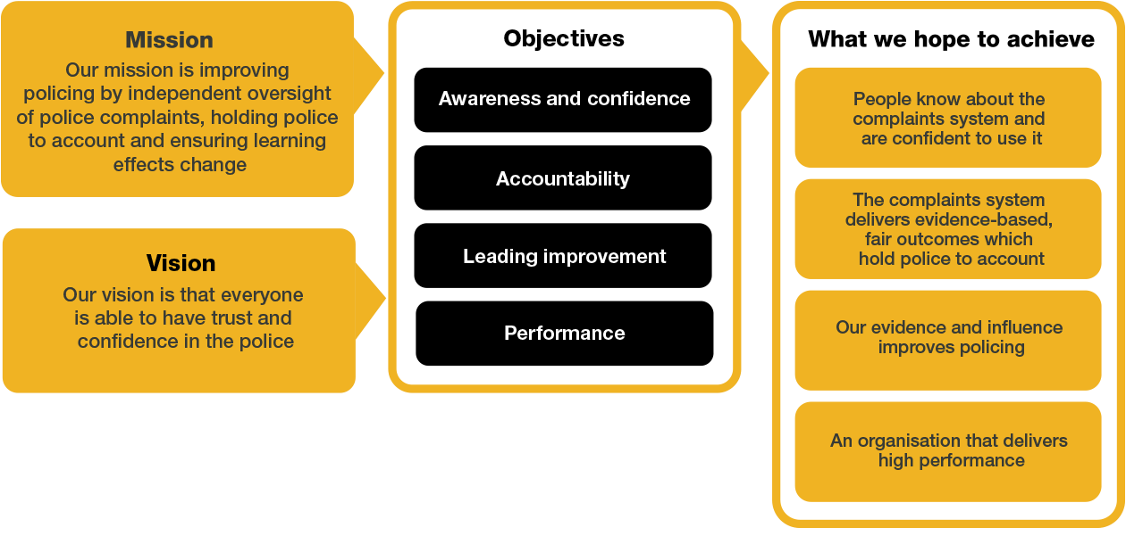

/

We work in the context of our agreed values which inform the way we do things at the IOPC. Trainee Investigators will need to be committed to working in the context of these values.

The IOPC is committed to **promoting equality and valuing diversity** in everything we do. Our vision is to be, and to be seen as, a leader in inclusive employment and services, demonstrating this ethos in everything that we do.

* As a silver standard Stonewall employer, we continue to commit ourselves to being a LGBTQ+ employer through the work of our Pride LGBTQ+ Staff Network, creating welcoming environments for lesbian, gay, bi and queer people.
* We are pleased to share we are a signatory of the Business in the Community Race at Work Charter. The Charter is composed of five [calls to action](https://race.bitc.org.uk/issues/racecharter) for leaders and organisations across all sectors.
* Being a Disability Confident employer, the IOPC is dedicated to removing the barrier for disabled people to thrive in the workplace.
* Our Staff Networks are constantly working to make the IOPC the leaders of inclusive employment, from our Allyship Programme to [Operation Hotton,](https://www.policeconduct.gov.uk/recommendations/operation-hotton-recommendations-metropolitan-police-service-september-2021) to [Welsh Language Standards](https://www.policeconduct.gov.uk/who-we-are/equality-and-diversity/welsh-language-standards) and Know the Line Policy, we are constantly seeking new ways to create an environment for all to develop and thrive.



# Main duties and responsibilities

During your employment within this role you will complete the Trainee Investigator training programme which includes formal and on the job training. This will provide you with the skills and knowledge to achieve PIP1. On the job training will be carried out within an operational investigations team and will consist of assisting with and, in due course, conducting, a broad range of investigative tasks including but not limited to:

* Investigative actions on independent investigations into criminal and misconduct allegations in accordance with agreed IOPC guidelines.
* Witness and subject investigative interviews.
* Evidence collection, analysis and presentation.
* Visit incident scenes where required and assist in action taken to preserve and recover evidence.
* Attend post-mortems.
* Take part in criminal, misconduct and inquest proceedings.
* Prepare disclosure schedules for court and inquest proceedings.
* Assist in writing final investigation reports, summarising and analysing evidence.
* Communicate effectively with complainants, bereaved families and other internal and external stakeholders.
* Work as part of a multi-disciplinary team with Commissioners, lawyers, press officers and others.
* Take responsibility for personal development and producing an accreditation portfolio.
* Shadow an investigator in the 24 hour on call facility and be prepared to work unsociable and extended hours.

Due to the nature of the IOPC’s work, there is a requirement for Investigators to provide a 24/7 on-call response when critical incidents occur involving the police.These may include road traffic, firearms and terrorist incidents and deaths or serious injury during or after police contact.

This will not be part of the expectations of your role while you are a Trainee Investigator (although you may participate in some shadowing of on-call responses). Once you progress from Trainee Investigator to Investigator, however, you will be expected to participate in the on-call rota, though requests for reasonable adjustments will be considered.

Please see the attached document for more information around current on-call arrangements. Please note that this is currently under review and may be subject to change.

* Assist the Directorate in achieving its key deliverables.

# Person specification

## Technical

Desirable

Driving licence valid in England & Wales. If not already held, employment will be conditional on passing the driving test within 12 months of starting employment. Once you are a qualified investigator, you will be expected to have the confidence to drive alone, in a fleet car, in all conditions including at night and on all road types such as motorways and country lanes. Reasonable adjustment requests around driving will be considered.

## Experience

Essential

* Analysing complex information and developing evidence-based conclusions, decisions or recommendations.
* Working with or assisting people from diverse backgrounds through active participation in community, voluntary or public-facing work.
* Working effectively in a team environment.
* Effective oral and written communication skills, including highly developed report writing skills.
* Evidence of excellent analytical and report writing skills; ability to reach and document clear, rational, evidence-based and independent decisions based on analysis of existing and emerging information.
* Experience of engaging effectively with a diverse range of people and stakeholders, and evidence of a commitment to equality and diversity within the workplace.
* Delivering a high standard of work within demanding timescales.
* Working effectively in a changing environment.

## Skills and Abilities

Essential

* Ability to show initiative and adapt in a changing environment.
* Ability to recognise your development needs and be proactive in addressing them.
* Ability to prioritise and manage tasks effectively to deliver quality outcomes within demanding timescales.
* Ability to work effectively in a team with diverse ideas and people.
* Ability to communicate effectively both verbally and in writing and adapt communication styles as appropriate.
* Ability to analyse information and identify the key issues.
* Demonstrates the confidence and ability to cope with challenging situations.
* Ability to respond appropriately to the diverse needs of individuals and stakeholder groups.

## Reasonable adjustments

The IOPC is a diverse and inclusive workplace, and we want to help you demonstrate your full potential whatever type of assessment is used. We are open to providing you with the tools you need to succeed, from extra time to formatting changes, to name a mere few. If you require any reasonable adjustments to our recruitment process, please email recruitment@policeconduct.gov.uk

## Working conditions

The IOPC are currently consulting with our consultative bodies about proposed changes to our hybrid working policy which will require all staff to work 20% of their contractual hours at their office base (or another office for business reasons) from 1 September 2024 and increased to 40% from April 2025. Office attendance time includes in-person training, meetings with stakeholders and families, and attending events.

Mandatory training for this role will be hybrid, via in-person sessions and e-learning. The in-person training may take place in locations that are not your usual office base and may require overnight stays of up to 4 consecutive nights. Further information regarding dates / locations will be provided later in the process.

### Selection process

This vacancy is using [**Success Profiles**.](https://www.gov.uk/government/publications/success-profiles?_ga=2.156185915.1692943174.1578577916-319911383.1576576754) As part of the application process, you will be asked to answer 3 questions around Experience, IOPC Values and the following Behaviour at Executive Officer (EO) level.

* Working together

Please note that your application for this role will be assessed purely against the answers you provide to these questions. Other information provided at application stage, such as work history, will not be considered as part of the marking criteria. We ask that your answers to the shortlisting questions provide sufficient detail to demonstrate your suitability for the role.

If you are successfully shortlisted, you will be invited to an assessment centre which will assess you in the following areas and we will provide further information at that stage regarding what these will involve:

* Interview
* Written exercise
* Roleplay exercise

Preparation checklist

☐ Review the full job description

☐ Review the behaviours and the descriptors for each behaviour

☐ Review the Strengths dictionary

☐ Review the IOPC values

☐ Consider your Strengths

☐ Consider drafting example answers that cover the specific elements

☐ Prepare some questions to ask the interviewers