

**Job role profile**

**Title:** Investigations Manager - Performance and Resourcing

**Reports to**: Deputy Director of Investigations

**Location:** Birmingham, Sale, Wakefield, Cardiff, Croydon or Canary Wharf

**Grade:** 15

**Salary:** £64,301 (Plus London weighting of £4,968 if located at Croydon s or Canary Wharf)

**Contract:** Permanent

**Additional information:** The IOPC is recruiting for Investigation Managers in 3 areas: Performance and Resourcing, Core Business and Complex. Candidates should apply for the role they believe they would align with best rather than submitting multiple applications. During the application process you will be asked if you would also like to be considered for any other Investigation Manager positions. If you select ‘yes’ to any of these then you may be asked additional questions at interview to consider your suitability for these roles.

# Purpose

As an Investigations Manager - Performance and Resourcing, you will be a part of a dynamic investigations team working locally and nationally on a wide range of investigations in the Investigation, Oversight and Casework directorate. You will oversee the recruitment, accreditation, performance, personal and professional development of teams of Investigators and Trainee Investigators.

Alongside the Investigations Manager – Complex and Investigations Manager – Core Business, you will be responsible for providing strategic leadership to teams of investigators, ensuring delivery of high quality, robust and independent investigations and demonstrating our core values in all aspects of your role.

You will have line management responsibilities of the Investigations Team Leader - Performance and Resourcing and accountability for investigation outcomes and performance. You will work closely together to identify trend areas for improvement and be a point of escalation for capacity, people management, wellbeing and pastoral matters.

You will work closely with the Demand Resourcing Directorate to identify investigator demand and supply for workforce planning and development purposes.

You will be the Operational Lead for Quality and Performance and will be senior sponsors for a number of topics, including leading on any associated SMN’s and OPG’s.

**O**

**rganisational**

**C**

**ontext**

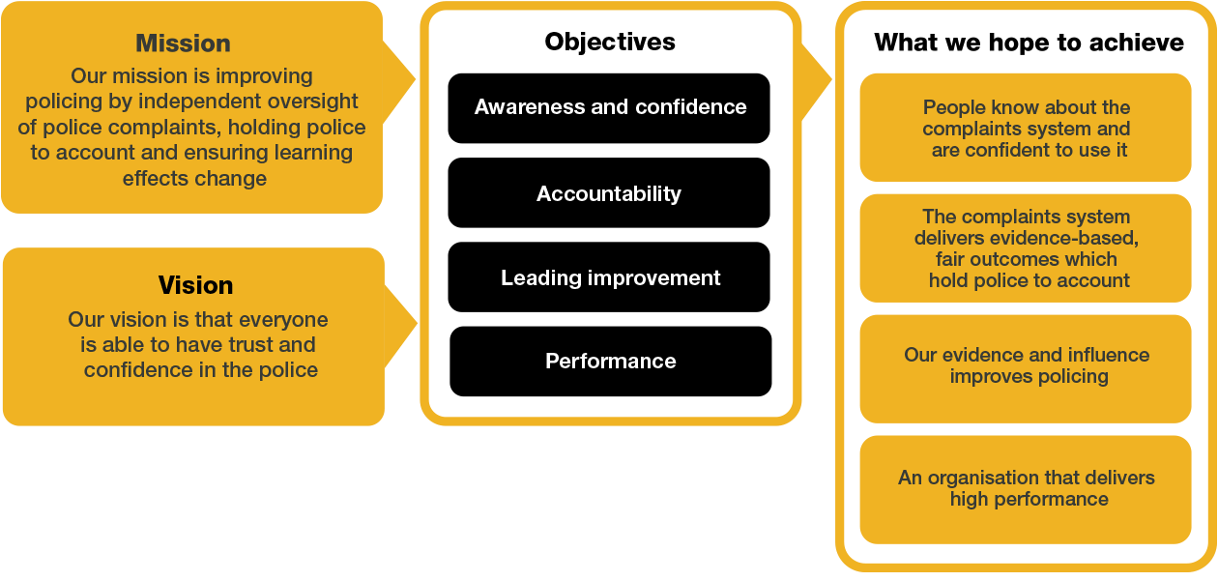

We work in the context of our agreed values which inform the way we do things at the IOPC. As the Investigations Manager - Performance and Resourcing, you will need to be committed to managing in the context of these values.

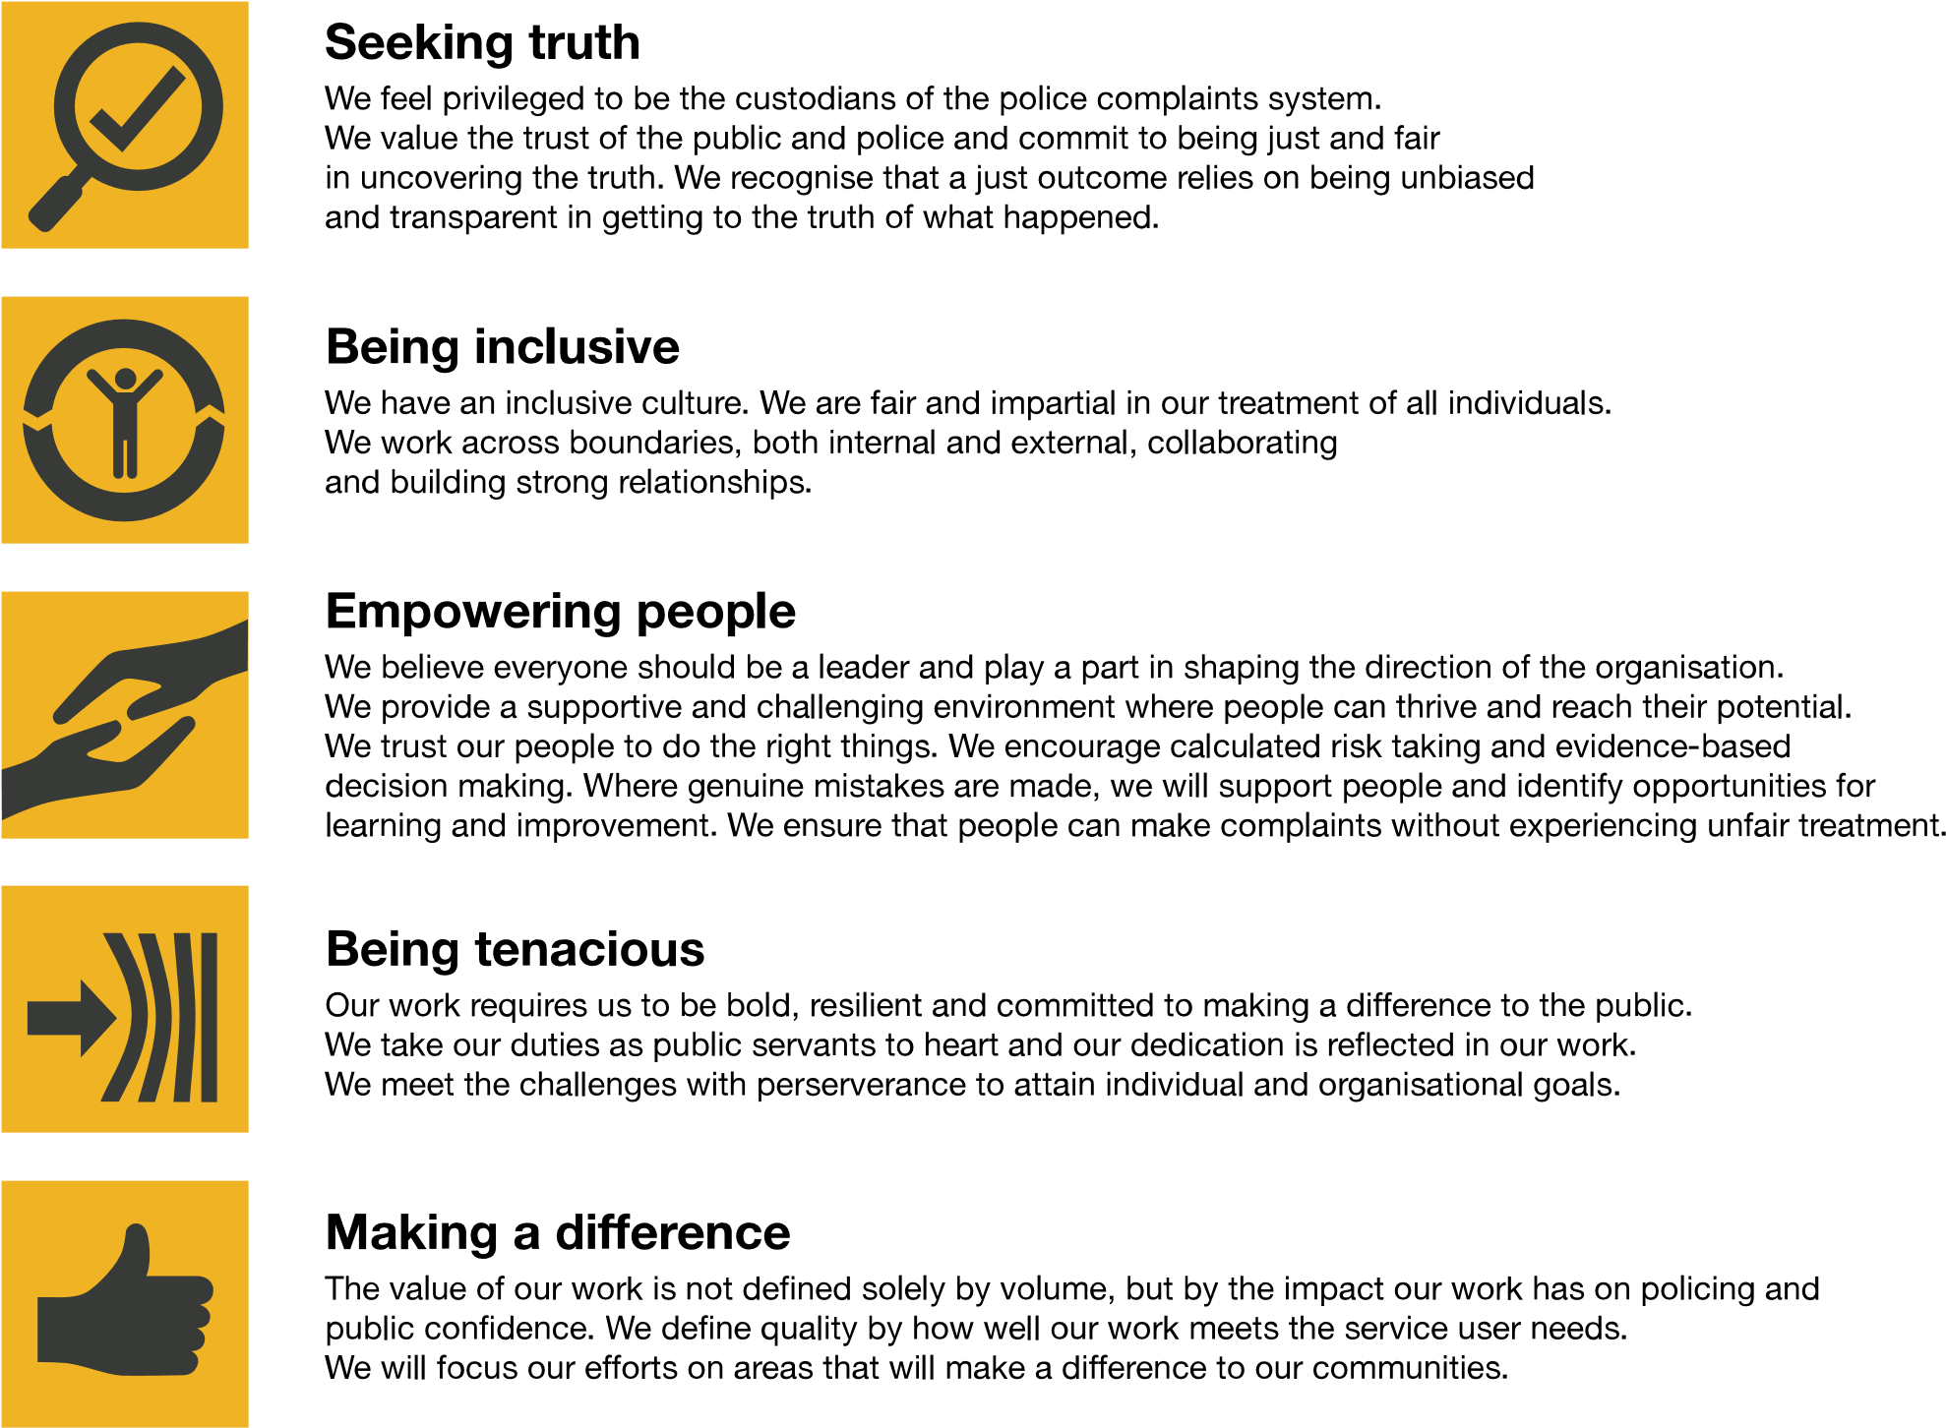

The IOPC is committed to **promoting equality and valuing diversity** in everything we do. Our vision is to be, and to be seen as, a leader in inclusive employment and services, demonstrating this ethos in everything that we do.

* As a silver standard Stonewall employer, we continue to commit ourselves to being a LGBTQ+ employer through the work of our Pride LGBTQ+ Staff Network, creating welcoming environments for lesbian, gay, bi and queer people.
* We are pleased to share we are a signatory of the Business in the Community Race at Work Charter. The Charter is composed of five [calls to action](https://race.bitc.org.uk/issues/racecharter) for leaders and organisations across all sectors.
* Being a Disability Confident employer, the IOPC is dedicated to removing the barrier for disabled people to thrive in the workplace.
* Our Staff Networks are constantly working to make the IOPC the leaders of inclusive employment, from our Allyship Programme to [Operation Hotton,](https://www.policeconduct.gov.uk/recommendations/operation-hotton-recommendations-metropolitan-police-service-september-2021) to [Welsh Language Standards](https://www.policeconduct.gov.uk/who-we-are/equality-and-diversity/welsh-language-standards) and Know the Line Policy, we are constantly seeking new ways to create an environment for all to develop and thrive.



# Main duties and responsibilities

**Leadership and general:**

* Provide strategic direction and operational leadership to investigation teams to ensure the delivery of high-quality, robust investigations.
* Ensure consistent investigations delivery against policy and performance targets.
* Work closely with internal stakeholders to ensure the IOPCs Strategic Objectives are met including; Stakeholder Engagement Team, Oversight and Directors of Engagement.
* Contribute as a member of the wider Investigations senior management team to the development of the strategic direction, management and recruitment of the Investigations function.
* Participate in the on-call function – offering advice, guidance and direction to forces, HMRC and UKBA in matters relating to deaths, serious injuries and other referrals.
* Work with the Directors/Deputy Directors in Investigations, and other key stakeholders to ensure a coordinated and consistent Investigations function.
* Deputise for Deputy Directors of Investigations as and when requested / where appropriate to provide internal and external leadership across investigation delivery activities.
* Develop and implement effective collaborative working with all other directorates within the IOPC to continuously improve performance and drive culture change.
* Contribute to the management of the investigations team finance including budget management.

**Transformation:**

* Work collaboratively with colleagues to ensure that the ambitions of the IOPC are delivered.
* Actively participate in the IOPC Transformation programme to ensure that we do what only the IOPC can do and deliver effective, timely and high-quality investigations.
* Identify ways to improve the way in which investigations are completed and delivered.
* Ensure investigations colleagues are kept up to date with transformation progress.

**Role specific:**

Delivery:

* Provide leadership and direct line management to the Investigations Team Leader - Performance and Resourcing and ISU Team Managers
* Set up processes to monitor and track the performance of investigators, identify trends, gaps and underperforming areas; ensuring appropriate people management policies and procedures are applied quickly and effectively. Support the Investigations Team Leader - Performance and Resourcing to find solutions.
* Ensure risk is managed through the undertaking of appropriate controls and checks at all stages of the investigation.
* Ensure the team operates, always, in compliance with the legislation, policies, processes and guidance that govern the work of the team.
* In conjunction with the Deputy Director of Demand, Resourcing and Performance, plan and determine the workload of the Investigations teams, ensuring effective use of available resources to meet business needs and identification of future resource requirements.
* Have relevant oversight of the quality and timeliness of case progression. Monitor and lead the performance of the team by ensuring sufficient support, guidance and direction is provided.
* Ensure that the team is sufficiently resilient to adapt effectively to changing priorities and direction and to absorb the introduction of new process and procedures.
* Be the operational owner for topics in agreed areas. Work closely with other teams within the IOPC to manage organisational approach to good practice and drive embedding of this within investigations teams.
* Create and maintain the relevant Operational Policies and Operations Manual guidance.
* Work closely with Quality to drive improvement and proportionality in investigations.
* Carefully and considerately discharge your delegated regulatory duties and responsibilities.

Corporate Responsibility:

* Minimise risk to the IOPC through ensuring all decisions and actions are consistent and align with best practice.

Performance:

* Lead on decision making regarding resource allocation; work closely with the

Investigations Manager – Core Business on the prioritisation of cases.

* Use data and insights from performance monitoring to inform strategic decisions.
* Analyse management information and other qualitative data to identify emerging issues and risks, taking a proactive and collaborative approach to solving cross-functional issues.
* Work collaboratively with the Investigations Manager – Core Business and Investigations Manager - Complex to obtain feedback on the performance of investigators and in conjunction with the Investigations Team Leader - Performance and Resourcing - create personalised development plans for direct reports.
* Lead on decision making in relation to professional development and training needs; ensuring investigations staff are equipped with the skills necessary to perform their roles to the highest standard.
* Lead data driven decision making on performance improvement initiatives and address areas of underperformance.
* Implement agile ways of working to anticipate and respond to developments in the investigatory landscape and be proactive in identifying and making a case for appropriate improvements to meet challenges head on.
* Work with other teams within the IOPC to drive quality improvement, proportionality and good practice in relation to investigations

Communication & Engagement:

* Ensure regular and transparent communication regarding organisational goals, expectations, objectives and any changes in processes or priorities.
* Design and implement communication strategies that promote team cohesion, encouraging knowledge sharing and keeping each other informed.

Cultural Competence, Equality, Diversity & Inclusion:

* Lead by example in promoting equality, diversity and inclusion within the investigative teams, ensuring all staff are treated fairly, with respect for their differences.
* Promote an environment that values cultural competence and encourages open dialogue on diversity issues, both within the investigation teams and across the IOPC.
* Ensure that a culture of inclusion is embedded across the investigations team.

# Person specification

## **Experience**

* Proven experience in leading and managing teams in complex and high-profile investigations, ideally within a regulatory, oversight or public sector context.
* Strong track record in providing strategic direction ensure the delivery of high-quality, independent and robust investigations.
* Extensive experience in people management; including objective setting, monitoring performance and wellbeing, providing feedback, conflict resolution, and staff development.
* Experience in workforce planning and managing demand and capacity.
* Proven experience of investigating, leading investigations, managing complex situations arising from these and how to support survivors and victims of criminality.
* Experienced leader with a track record of working effectively with others.
* Experience of working as part of a senior management team to develop and implement the strategic vision for a function or organisation.
* An experienced leader with a track record of building high performing operational teams in a complex environment.
* Experience of managing disclosure in complex investigations
* Experience of leading teams through significant change, engaging and motivating staff to embrace new ways of working.

**Desirable:**

* Experience of working in a matrix management structure.

## **Skills and Abilities**

* Excellent intellectual ability, and the ability to analyse complex legislation and apply it to appropriate cases.
* The ability to manage, motivate and develop people.
* The ability to work effectively in a challenging environment with competing priorities.
* Good judgement and ability to make decisions.
* Highly developed decision-making skills.
* Evidence of excellent analytical and report writing skills.
* Highly developed oral, written and presentation skills.
* Good influencing and negotiation skills and the ability to persuade through personal credibility.
* Strong interpersonal skills, including the ability to negotiate and maintain good relationships with senior officials in all areas of public life.
* Experience of supporting staff who are working in an environment with significant scrutiny, challenge and potentially emotive material.
* High emotional intelligence.
* Proven experience in mentoring, coaching and developing team members, fostering a culture of continuous improvement and professional growth.

**Desirable:**

* An understanding of Policing in the UK.
* Driving license valid in England and Wales.

# Positive Action

**Positive action** as detailed in the Equality Act 2010, allows us to use measures designed to help improve equality in the workplace, and create a level playing field for all, whilst still employing everyone based on merit. Our workforce profile data shows that people who identify as black, Asian and minority ethnic are under-represented at the IOPC.

For this role – should we have a situation where multiple candidates have achieved the highest score and one identifies as black, Asian or minority ethnic, by using positive action, we can select that candidate for the role, therefore improving this area of under-representation at the IOPC. We will only use positive action in this way where the highest scoring candidates have all scored equally, at the final assessment stage, and above our required threshold.

## Reasonable adjustments

The IOPC is a diverse and inclusive workplace, and we want to help you demonstrate your full potential whatever type of assessment is used. We are open to providing you with the tools you need to succeed, from extra time to formatting changes, to name a mere few. If you require any reasonable adjustments to our recruitment process, please email recruitment@policeconduct.gov.uk

## Working conditions

Making the IOPC a great place to work is one of our key priorities. We are pleased to offer a unique hybrid working model based on business needs, balanced with the needs of our colleagues.

The IOPC has a hybrid working policy which requires all staff to work 40% of their contractual hours at their office base (or another office for business reasons) from April 2025. Office attendance time includes in-person training, meetings with stakeholders and families, and attending events.

## Preparation checklist

|  |  |
| --- | --- |
|  |  |
| ☐ | Review the full job description |
| ☐ | Review the behaviours and the descriptors for each behaviour |
| ☐ | Review the Strengths dictionary |
| ☐ | Review the IOPC values |
| ☐ | Consider your Strengths (if applicable) |
| ☐ | Consider drafting example answers that cover the specific elements |
| ☐ | Prepare some questions to ask the interviewers |