**Title:** Casework Manager – Hybrid Working

**Reports to:** Senior Casework Manager

**Location:** Cardiff, Sale, Wakefield, Birmingham

**Grade:** 10

**Salary:** £32,600

**Contract:** Fixed term or secondment until end of March 2026

# Purpose

As a Casework Manager, you will be welcomed into a dynamic and inclusive Operations Team. The IOPC is on a journey to develop its culture, perspectives and ethos to support the organisation’s core outcomes, and this is your opportunity to enter into the varied world of IOPC Operations, allowing you to develop your mindset and approaches to contribute to improving the police complaints system in England and Wales.



**J**



**ob**



**d**



**escription**



Our Casework Managers assess, understand, evaluate and reach decisions on reviews regarding police investigations to serious complaints. In short, they evaluate the circumstances following complaints made by members of the public after interacting with the police; weighing the available evidence, considering the relevant legislation, reports and analysis to reach a conclusion, which can range from no fault, to learning recommendations for the force/officer training, or a recommendation that disciplinary proceedings should take place.

As a Casework Manager, you will be accountable for your decisions as they affect the lives of both members of the public and police officers; the decisions you reach have the potential to make a difference to the public’s confidence in the police and policing in the UK.

The role of Casework Manager is equally challenging as it is rewarding. It is important to remain impartial and unbiased when performing the role, and ensure that our decisions are fair, balanced and supported by the legislation and available evidence. The decisions made by IOPC Casework Managers are final and can only be challenged in the courts. Therefore, the cases you complete must be of a high quality and supported by a sound rationale.

As a Casework Manager, you will be provided with in-depth bespoke and tailored training about a variety of subjects which will be relevant to your role. We invest significantly in our Casework Managers; closely supporting them to improve their knowledge and experience to effectively perform their role. The organisation has a variety of other departments, including Legal, Subject Matter Networks and an Oversight Team, who offer specialist support and guidance to Casework Manager’s when they are reaching their decisions.

If you are looking for an unconventional ‘desk based’ role that offers you the opportunity to develop a strong and transferrable skill-set to build your career from be well-supported by the organisation, and have a tangible positive impact on policing and the public in the UK, please consider applying.

**Security Level: Baseline Standard**

## Hybrid Working

The IOPC is currently consulting with its consultative bodies about proposed changes to our hybrid working policy which will require all staff to work 20% of their contractual hours at their office base (or another office for business reasons) from 1 September and increased to 40% from April next year. Office attendance time includes in-person training, meetings with stakeholders and families, and attending events.

There will be a requirement to attend the one of our casework offices (Sale and Cardiff) when business needs dictate. This is likely to be quite infrequently, and travel expenses would be paid if this is not your normal local office.

# Emotional Consideration

In performing this role, you will have regular exposure to distressing material which will likely be impactful, traumatic and challenging. Given the nature of the work, you will have contact with individuals who are experiencing extreme distress. The IOPC recognises this and offers all staff a range of wellbeing provisions, including TRiM (Trauma Risk Management) peer-to-peer support, a dedicated Wellbeing Advisor, and access to free confidential counselling. All staff are strongly encouraged to proactively access and engage with the support available. If you would like to speak about this element of the role with somebody already doing similar work at the IOPC, please contact campaigns@policeconduct.gov.uk and this can be arranged.

# Positive Action

At the IOPC, we are committed to building a workforce which reflects the diversity of the communities in which we serve. A more inclusive workforce enables us to be a more effective and efficient organisation, better understand and respond to the needs of our communities.

Positive action as detailed in the Equality Act 2010, allows us to use measures designed to help improve equality in the workplace, and create a level playing field for all, whilst still employing everyone based on merit. Our workforce profile data shows that people who identify as black, Asian and minority ethnic are under-represented at the IOPC.

For this role – should we have a situation where multiple candidates have achieved the highest score and one identifies as black, Asian or minority ethnic, by using positive action, we can select that candidate for the role, therefore improving this area of under-representation at the IOPC. We will only use positive action in this way where the highest scoring candidates have all scored equally, and above our required threshold.



**Organisational context**

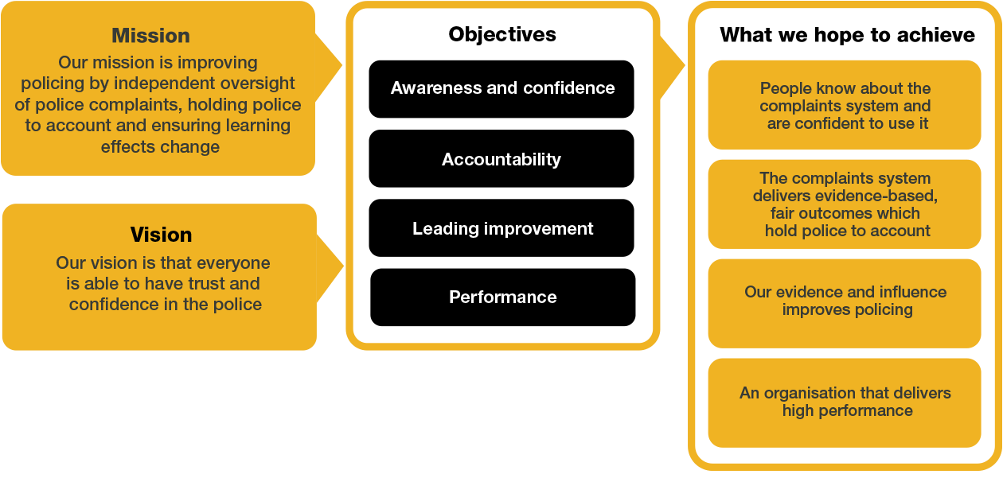

We work in the context of our agreed values which inform the way we do things at the IOPC. The Casework Manager will need to be committed to managing in the context of these values.

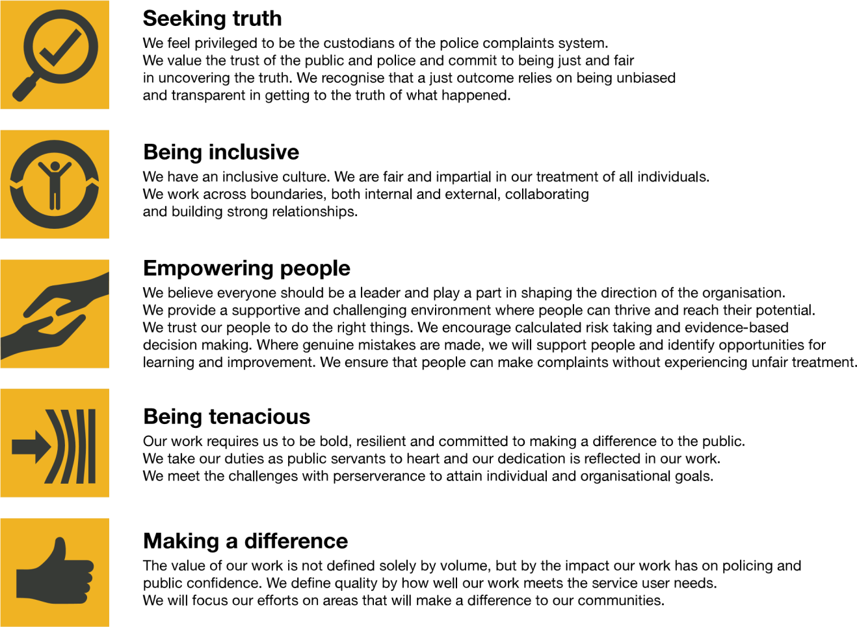

The IOPC is committed to **promoting equality and valuing diversity** in everything we do. Our vision is to be, and to be seen as, a leader in inclusive employment and services, demonstrating this ethos in everything that we do.

* As a silver standard Stonewall employer, we continue to commit ourselves to being a LGBTQ+ employer through the work of our Pride LGBTQ+ Staff Network, creating welcoming environments for lesbian, gay, bi and queer people.
* We are pleased to share we are a signatory of the Business in the Community Race at Work Charter. The Charter is composed of five [calls to action fo](https://race.bitc.org.uk/issues/racecharter)r leaders and organisations across all sectors.
* Being a Disability Confident employer, the IOPC is dedicated to removing the barrier for disabled people to thrive in the workplace.
* Our Staff Networks are constantly working to make the IOPC the leaders of inclusive employment, from our Allyship Programme to [Operation Hotton, t](https://www.policeconduct.gov.uk/recommendations/operation-hotton-recommendations-metropolitan-police-service-september-2021)o [Welsh Language Standards an](https://www.policeconduct.gov.uk/who-we-are/equality-and-diversity/welsh-language-standards)d Know the Line Policy, we are constantly seeking new ways to create an environment for all to develop and thrive.



# Main duties and responsibilities

This is a challenging, interesting position with a variety of work, which requires good judgement and an analytical, methodical mindset as well as the resilience to analyse the finer details of the circumstances of the complaint; which itself is often of a sensitive nature.

You will be expected to handle a wide variety of cases and subject matters, ranging from reviews following police complaint investigations, to reviewing Death and Serious Injury reports completed by the police, before communicating your assessment to a variety of interested parties and stakeholders, tailoring your communication to the audience appropriately. You may also be required to communicate your decision to other stakeholders, both internal and external.

**CUSTOMER SERVICE & RELATIONSHIP MANAGEMENT**

* Ensuring customer service principles are met when interacting with appellants, appropriate authorities and other interested parties and explaining the reasons for decisions taken by the organisation.
* Assess and make recommendations or decisions in accordance with the Scheme of Delegation on: investigation and other handling reviews, suspended complaint challenges, and death and serious injury local investigation reports.
* Conduct correspondence and communicate over the telephone, with members of the public and appropriate authorities.
* Ensure that each case is dealt with promptly, objectively, and in accordance with the relevant legislation.
* Critically analyse evidence and information provided to the organisation.
* Assess whether the level of information provided by Appropriate Authorities is adequate.
* Obtain further information as required to assist in analysis of the information.
* Exercise your considerable levels of discretion and autonomy in reaching clear decisions based on the evidence.
* Write clear concise reports containing analysis of the evidence, explain findings and conclusions, and recommend appropriate action.
* Make, or advise others to make, learning recommendations, recommendations for disciplinary action and directions to take disciplinary action.
* Prepare files for disclosure to the relevant parties when appropriate.
* Observe misconduct proceedings stemming from upheld reviews.
* Share learning acquired from your work with colleagues and stakeholders to improve the quality of decision making.
* Help the IOPC affect wider positive change by carrying out a range of activities such as training events and working with external stakeholders.

# Person specification

Essential Experience

* Relevant experience, of complaints handling or of dealing with a direct service to the public where contentious and difficult issues have to be dealt with sensitively.
* Evidence of well-developed critical thinking skills; able to gather and use information to carry out enquiries and form sound judgements.
* Evidence of strong oral and particularly written communication skills, backed up with good computer literacy.
* Proven ability to show initiative and contribute in a changing environment.

# Selection process

This vacancy is using [Success Profiles.](https://www.gov.uk/government/publications/success-profiles?_ga=2.156185915.1692943174.1578577916-319911383.1576576754) As part of the application process you will be asked to complete four sift stage questions at the shortlisting stage. The **level 2** Behaviours being assessed are:

* Making Effective Decisions

The other sift question relates to your experience.

We ask that you ensure you provide sufficient details to demonstrate your suitability for the role within your sift answers as this will be the only information visible to shortlisting panels.

For successful candidate who reach the assessment stage, we will provide further details about what areas will be assessed. Please note, it is likely the assessment centre will consist of a formal interview and written exercises.

**What is Success Profiles?**

Success Profiles moves us to a tailored way of assessing, dependent on the requirements of the job. For each role we advertise, we consider what you will need to demonstrate in order to be successful. This gives us the best possible chance of finding the right person for the job, drives up performance and improves diversity and inclusivity so that we can truly reflect the communities that we serve.

Not all of the elements are relevant to every role and will vary depending on the level and type of role. You should ensure you read the job description carefully to see what elements are required for the specific job you are applying for. There are separate guides to each of the elements, which will give you more information about what and how you can demonstrate specific requirements.

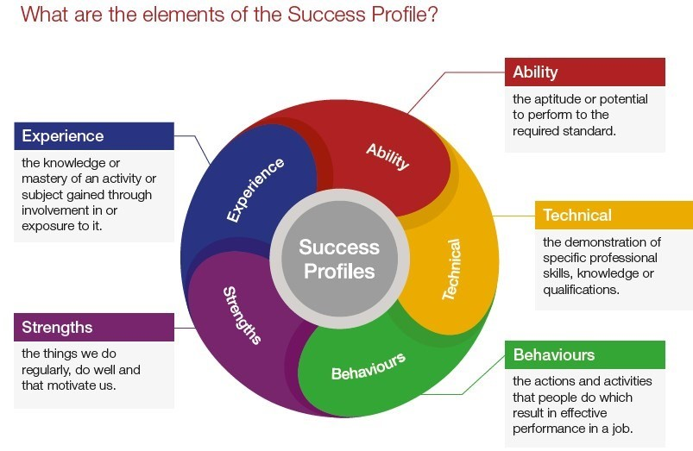

How the elements are assessed

You could be assessed in a number of different ways, depending on the type of role and level you are applying for. Using a range of assessment methods helps us to more accurately match people to the essential requirements of the job. For example, you may be asked to complete an application form; provide a CV and supporting statement; attend an assessment centre; or complete an online test. Often a combination of these approaches will be used and more than one element may be tested within the same assessment method.

Details of which elements will be assessed and how we will assess you against these, are included in the job description.

# Reasonable adjustments

The IOPC is a diverse and inclusive workplace, and we want to help you demonstrate your full potential whatever type of assessment is used. We are open to providing you with the tools you need to succeed, from extra time to formatting changes, to name a mere few. If you require any reasonable adjustments to our recruitment process, please email campaigns@policeconduct.gov.uk

# Preparation checklist

|  |  |
| --- | --- |
|  |  |
| ☐ | Review the full job description |
| ☐ | Review the behaviours and the descriptors for each behaviour |
| ☐ | Review the Strengths dictionary |
| ☐ | Review the IOPC values |
| ☐ | Consider your Strengths (if applicable) |
| ☐ | Consider drafting example answers that cover the specific elements |
| ☐ | Prepare some questions to ask the interviewers |