Job description
Title: ICT Application Solutions Architect - Hybrid
Reports to: ICT Enterprise Solution Architect
Location: Birmingham, Canary Wharf, Cardiff, Croydon, Sale, Wakefield
Grade: 13
Salary: £44,340 (plus £4,438 if London based)
Contract: Permanent

Purpose
As an ICT Application Solutions Architect, you will be welcomed into a dynamic and inclusive ICT team working to evaluate application technologies and make recommendations for best uses. The IOPC is on a journey to develop its culture, perspectives and ethos to support the organisation’s core outcomes and this is your opportunity to enter into the varied world of IOPC ICT, allowing you to develop your mindset and approaches to contribute to improving the police complaints system in England and Wales.
The ICT Solution Architects reside within the ICT team and have co-responsibility for the application architecture and maintaining of the Application portfolio. They will have responsibility for the designing and managing the delivery of application solutions that service the IOPC’s current and target operating needs.
As the IOPC are transitioning, the ICT Solution Architects will be pivotal to ensure the organisation has the technology which is agile, available and fit for purpose. The roles will act as the conduit and coordinator between the technical, information and business architecture layers of the IOPC, the roles support ICT enterprise solution architect to ensure ICT capabilities align to the OnePlan (the central, co-ordinated business strategy).
Being part of a Service orientated ICT Team, the ICT Solutions Architects will use their technical expertise to:
- Evaluate application technologies and make recommendations for best uses for the IOPC, to develop the IOPC application strategy.
- Analyse data flows between IOPC application solutions and those of its partnering stakeholders, with the view to design and create new applications solutions or improving existing solutions.
- Support the creation, via iterative development, of the application architecture, to support the maintenance of boundaryless Information flow across the business
- Ensure the IOPC architecture conforms to and actively exhibits the key principles, methods and models, shaping the organisation's current and future state.
- Manage the running of software tests, developing product prototypes and creating architectural technical documents relating to application development.
- Provide and share expertise with other team members in areas of application architecture and software development.
- Support programmes and projects that enable the evolution of the business to fulfil its strategic direction.
- Collaborate with internal stakeholders and partners within ICT and across the business, to interpret and refine business goals and drivers for the alignment of the future ICT strategy to the OnePlan.

This role requires security clearance to SC level.

Key Relationships:
The post holder will work closely with internal and external stakeholders at all levels, but with a focus on key business change stakeholder such as Project Management Office (PMO), Business Development(BD) and Knowledge and Information Management (KIM) Team.
The successful applicant will forge close working relationships with colleagues in ICT including the Business Relationship Managers, Service Delivery Managers, Change Manager, and those engaged with ICT disaggregation and transformation.

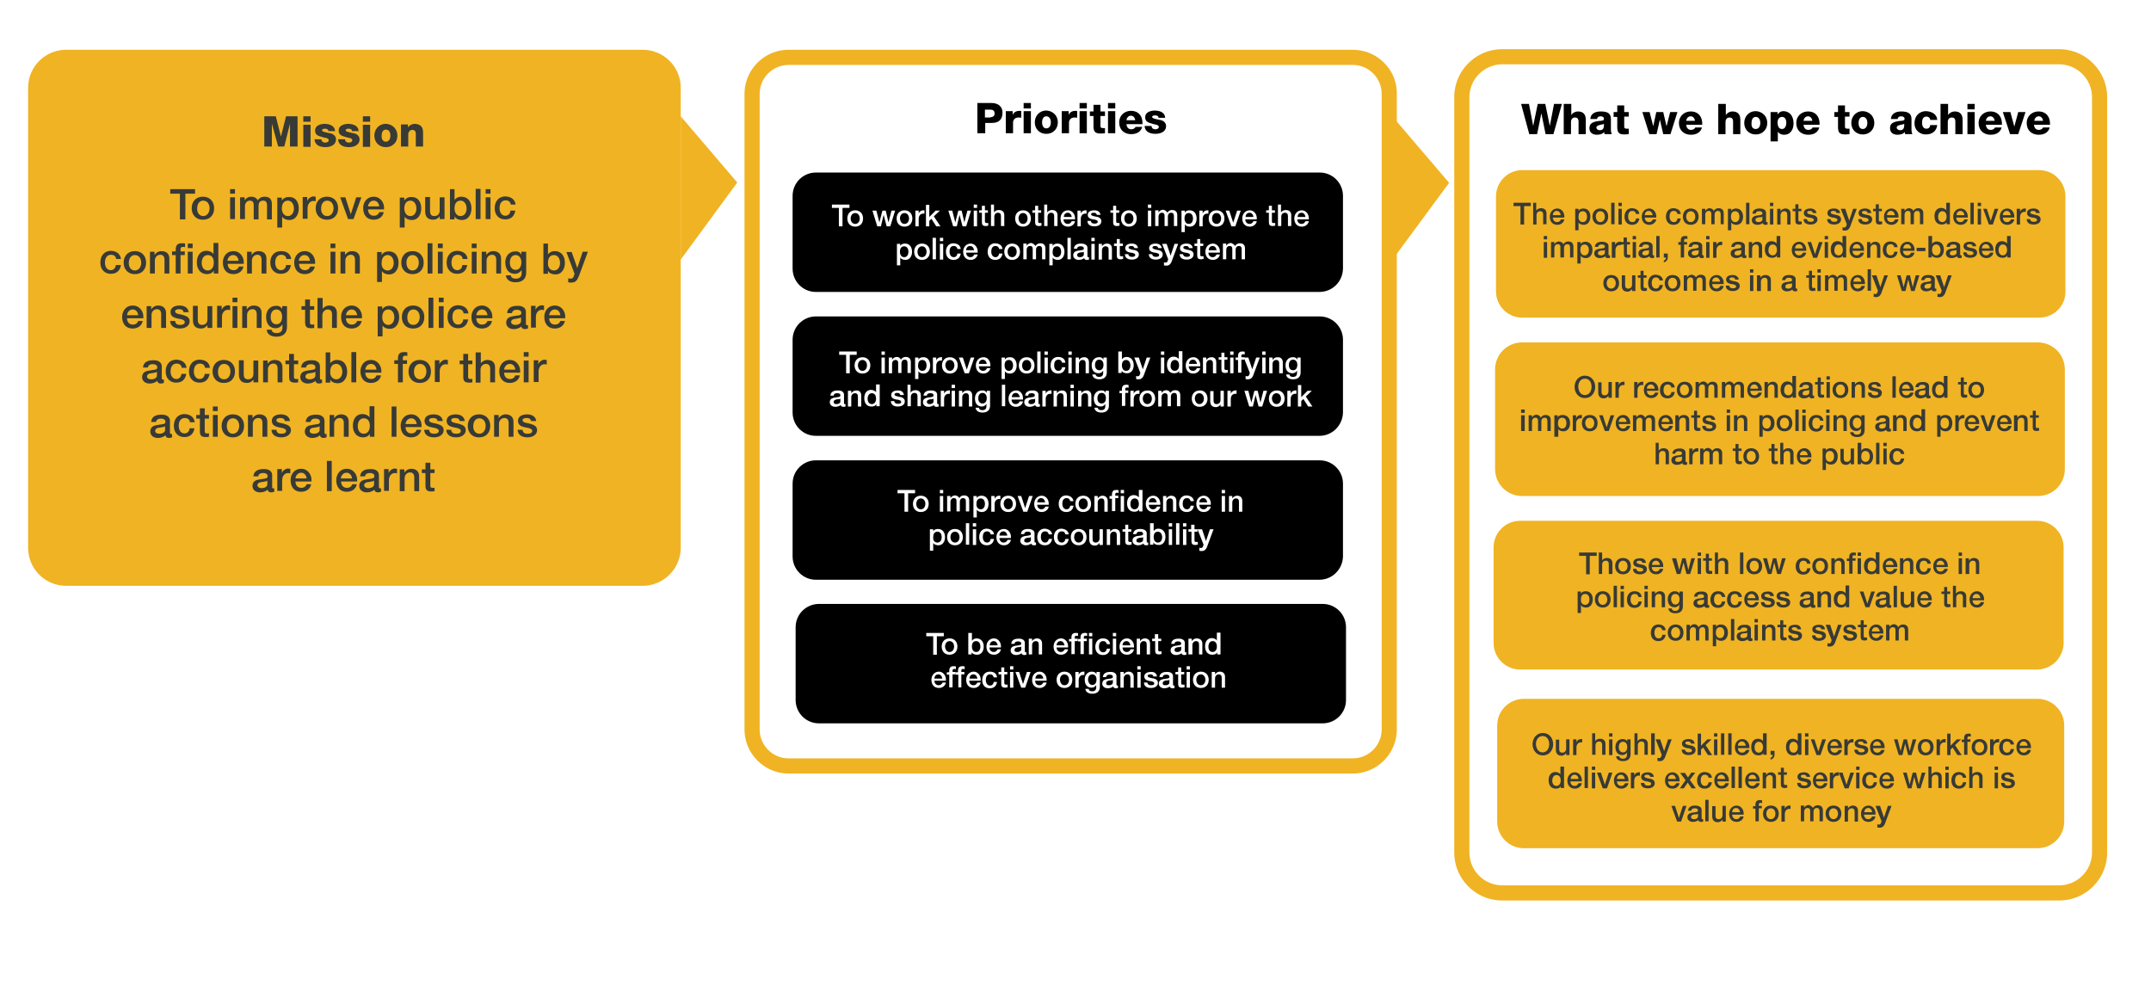
Organisational context

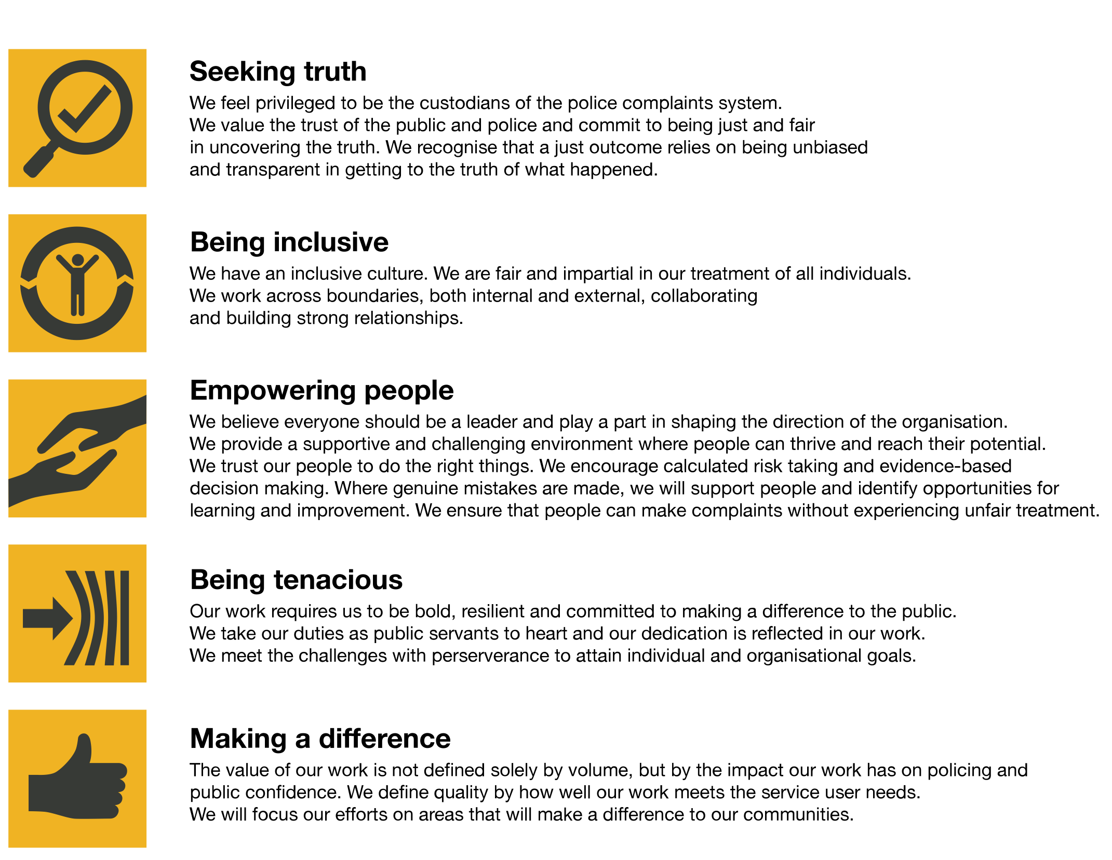
We work in the context of our agreed values which inform the way we do things at the IOPC. The ICT Application Solution Architect will need to be commited to managing in the context of these values.
The IOPC is committed to promoting equality and valuing diversity in everything we do. Our vision is to be, and to be seen as, a leader in inclusive employment and services, demonstrating this ethos in everything that we do.
- As a silver standard Stonewall employer, we continue to commit ourselves to being a LGBTQ+ employer through the work of our Pride LGBTQ+ Staff Network, creating welcoming environments for lesbian, gay, bi and queer people.
- We are pleased to share we are a signatory of the Business in the Community Race at Work Charter. The Charter is composed of five calls to action for leaders and organisations across all sectors.
- Being a Disability Confident employer, the IOPC is dedicated to removing the barrier for disabled people to thrive in the workplace.
- Our Staff Networks are constantly working to make the IOPC the leaders of inclusive employment, from our Allyship Programme to Welsh Language Standards and Know the Line Policy, we are constantly seeking new ways to create an environment for all to develop and thrive.

Main duties and responsibilities
- The post holder will be expected to hold or gain security clearance to SC level.
- Provide specialist technology expertise.
- Conduct and present strategic assessments of current organisation capabilities to identify required or desired changes for enterprise-wide application solutions.
- Encourage programme/project leads and service owners to adhere to agreed management frameworks and approaches.
- Support the transition of applications to suitable platforms and hosting arrangements in accordance with the ICT strategy and programme of works
- Produce reports as appropriate for architecture and project governance, including making recommendations for changes to the agreed scope.
- Provide strategic advice, guidance and direction to database designers, application developers, technical architects and others to achieve the desired architecture target state.
- Produce required artefacts to describe the inter-relationships between people, organisation, service, process, data, information, technology and the external environment.
- Collaborate with other architects, ICT suppliers, business and framework leads to develop and embed standard architecture processes, that promote the synchronised management of organisation wide and extended architecture programmes and projects.
- Use appropriate modelling, prioritisation and environmental trend techniques to identify and convey the business benefits of pursuing alternative strategies and approaches.
- Develop option, proposal and recommendation papers to secure buy-in, approval and funding for application development.
- Be responsible for the designs of the high-level structures to enable and guide the development of integrated solutions that meet current and future business needs.
- Lead application support and development resources to manage the Information layer (data & application) and coordinate the relationship with the technology layer and its components.
- Assist with embedding required changes to service, process, organisation to improve ICT, the businesses operating models and drive innovation.
- Work with internal and external technical architects, ICT Business Relationship and Service Delivery Managers to ensure that the disaggregating, decommissioning and on-boarding of applications, services or platforms supports current and future architecture and business visions.
- Collaborate with stakeholders on practices and processes to ensure the security, compliance, quality, integrity, safety and availability of all forms of data and data structures which form the organisation’s information layer.
- Champion the tactical strategy for master data management, that supports the management of data and information in all its forms and structures. (including logical analysis of taxonomies, data and metadata)
- Promote innovative ways for managing the organisations application architecture in line with legal compliance and best practice.
- Contribute to the ICT infrastructure and strategic technology change projects.
- Deputising for the ICT Enterprise solution Architect and represent the ICT service as a whole.
- Undertake any other duties as may be assigned from time to time.

Person specification
The post holder must be able to demonstrate:
- SC clearance
- Experience in at least 2 of the following: SQL, JQuery, SOAP, XML, Java script, .Net.
- Experience API and SOA technology
- Experience of working as a developer within house development teams
- Experience of developing and managing CMS, Workflow management solutions and EDRM’s using at least 2 of the following;
- Appian
- SharePoint 2010 +,
- CRM,
- Tricostar,
- Excel,
- Drupal,
- Powerapps & Flow.
- Experience managing and working with external suppliers to deliver high quality application solutions.
- Extensive knowledge and experience of Software Development Lifecycle and project management Approaches (SDLC) (agile, waterfall, iteration and SOA)
- Knowledge and experience of developing application solutions as IAAS, PAAS and SAAS, including; Azure, AWS, O365 and open source options
- Experience developing technical architecture governance documentation
- Exposure to Architecture modelling languages and tools; UML, ArchiMate
- Understanding of at least one enterprise and solution Architecture frameworks; TOGAF, ZACHMAN, DODAF etc.
- Knowledge and experience in business and project methodologies and frameworks such as Prince2, PMP, Agile and ITIL
- Experience developing conceptual, logical and physical architectural models
- Experience of building strong working relationships with a variety of stakeholders
- Experience of information and data management integration tools and techniques such as analysis of taxonomies, data warehouse approaches (KIMBALL) and metadata management
- Excellent communication and negotiation skills.
- Positive can-do attitude and flexibility of approach.
- Understanding of the legal issues relating to IS/IT e.g.
- Knowledge or awareness one of the following;
- Record management and archive practices in line with ISO 15489
- ISO 90001
- SIAM professional BOK.
- Data Protection,
- Freedom of Information and Computer Misuse Acts,
- copyright, intellectual property rights

Reasonable adjustments
The IOPC is a diverse and inclusive workplace and we want to help you demonstrate your full potential whatever type of assessment is used. We are open to providing you with the tools you need to succeed, from extra time to formatting changes, to name a mere few. If you require any reasonable adjustments to our recruitment process, please email humanresources@policeconduct.gov.uk

Working conditions
Making the IOPC a great place to work is one of our key priorities. We are pleased to offer a unique hybrid working model based on business needs, balanced with the needs of our colleagues. Our business need framework guides our decisions about when it is best to work onsite (in our offices or other appropriate locations) to complete tasks most effectively or when to work remotely, offering colleagues flexibility to work where they feel most productive and supporting work-life balance. The model also encourages staff to feel welcome at the IOPC by ensuring we have opportunities to work face-to-face as teams.

Preparation checklist
☐ Review the full job description
☐ Review the behaviours and the descriptors for each behaviour
☐ Review the Strengths dictionary
☐ Review the IOPC values
☐ Consider your Strengths (if applicable)
☐ Consider drafting example answers that cover the specific elements
☐ Prepare some questions to ask the interviewers

