# JOB DESCRIPTION



**Title: Chief of Staff**

**Reports to: Director General**

**Location: Canary Wharf**

**Grade: 16**

**Salary: £71,347, plus London Weighting Allowance of £4731**

**Direct Reports: 1 x Deputy Chief of Staff**

**1 x Executive Support to the Director General**

**Contract: Permanent**

|  |
| --- |
|  |

**Role Purpose**

* To be the principal adviser supporting the Office of the Director General and support the Director General in influencing across the IOPC and with key stakeholders. This will be facilitated by representing the views of the Director General at the highest level both internally and externally and ensuring consistency of messaging and strategic direction.
* Provide overall leadership to the work of the Director General’s Office, ensuring that it operates efficiently and efficient, including the provision of accurate and timely advice and support as and when required.
* The role will lead on external horizon scanning for the Director General to ensure any new or emerging high-level risks are identified as quickly as possible.
* The role will advise on executive decision making and in particular will be involved in the discussions that may have a political or reputational impact.
* To work collaboratively with management board, board and committee members, Police Chiefs, and a wide range of key stakeholders, representing the Director General to ensure that their expectations are met.
* Act as the Director Generals expert advisor on policing, service delivery, resources, including all financial and core business matters.
* Work collaboratively with directorate leads to support the one ‘IOPC’ approach.

**Role and responsibilities**

1. Provide high level policy, strategic, budgetary and performance delivery advice to the Director General as and when required, ensuring liaison with the relevant Directors and teams within the IOPC.
2. Lead, direct, and manage strategic projects commissioned by the Director General ensuring delivery on time and within allocated budget.
3. Lead and manage direct reports, including coaching and mentoring to ensure delivery of an effective and efficient Director General Office.
4. Ensure that the Director General is fully briefed for all meetings and events including background, potential conflicts as well as key information.
5. Occasionally draft presentations and speeches to be delivered by the Director General ensuring that information is accurate and in line with IOPC communication guidelines, and in collaboration with colleagues in the Policy, Communications, and other relevant teams.
6. Act as the de facto Executive Director for the Director General’s Office, leading the team to support the Director General to deliver their responsibilities across the IOPC.
7. Parliamentary and stakeholder contact in liaison with the Communications, Policy and other relevant IOPC teams.
8. Prepare board and committee reports on behalf of the Director General working closely with management board and Head of Governance, so that IOPC governance and decision making supports the effective development and delivery of organisational priorities.
9. Provide a day-to-day interface between the Director General and key stakeholders including Police Chiefs, community groups, local government, and their senior teams, to support the effective development and delivery of IOPC priorities.
10. Provide comprehensive and detailed responses to correspondence and emails on behalf of the Director General and signpost critical matters requiring further attention.
11. Act as the Director General’s spokesperson as and when necessary.
12. Act as counsel and advisor to the Director General and provide tactical support to in managing the highest-level risks to the organisation.
13. Realise the benefits of a flexible approach to work in undertaking the duties and responsibilities of this job role, and participating in multi-disciplinary, cross organisational and cross-organisational groups and project teams.
14. Always demonstrate high commitment to the equality, diversity and inclusion aims and strategy of the IOPC, as well as the values and behaviours.
15. To undertake any other duties and or responsibilities which are commensurate with the role of a Chief of Staff.

# PERSON SPECIFICATION

**Qualifications:**

* Educated to degree level or equivalent qualification or experience.
* A leadership or management degree level qualification or equivalent experience.
* Evidence of strong continuing personal and professional development.

**Knowledge**

* Understanding of the impact of regulatory frameworks and statutory regulations and how that affects the way an organisation functions.
* Sound knowledge of problem solving and improvement methodologies.
* Understanding of and ability to interpret national policing policy, decisions, and strategy, to assess risk and identify the impact on the organisation.
* Excellent understanding of the most significant issues facing policing and the complaints system, with underpinning knowledge about how these may be tackled.

Desirable:

* Understanding of policing in the UK, and the complaints system.

**Experience:**

* Significant senior management experience in a complex organisation with comparable scope, responsibilities, budget, and resources.
* Experience of liaising with government ministers, Council Leaders, senior community leaders and with the ability to influencing relevant outcomes.
* Experience of working with executive teams and Boards, although not necessarily as an executive.
* Experience of managing complex problems.

Desirable:

* Experience of working in policing or an investigative organisation.
* Experience of working as a Chief of Staff or Chief Advising to a Director General or Chief Executive Officer.

**Skills:**

* Committed people person; empowering, enabling, motivating, and developing others.
* Advanced analytical skills and an ability to think and plan strategically, tactically, and creatively focused on adding value to the organisation and making real lasting change.
* High energy levels, an innovative approach and ability to inspire and enthuse others.
* Evidence of holding to a clear strategy and set of values while responding appropriately to short term challenges and priorities.
* Proactive, versatile, and problem-solving approach.
* Ability to seek and exploit opportunities to advance objectives.
* Robust and persistent in the pursuit of objectives and maintaining personal credibility.
* A demonstrable commitment to ensuring equality, celebrating diversity, and promoting social inclusion within an organisation.
* Able to focus for long periods of time and prioritise and work under frequent pressure with tight and challenging deadlines.

**Additional information:**

* The postholder must be able to spend the majority (60 – 80%) of their contractual hours working in-person due to nature of the job role.
* The postholder must be able to work flexibly to meet the demands of the job role. This means at times longer days including early starts and late finish.
* The postholder must be able and willing to travel to all IOPC locations as and when required.
* This post is based in London.

# Organisational context

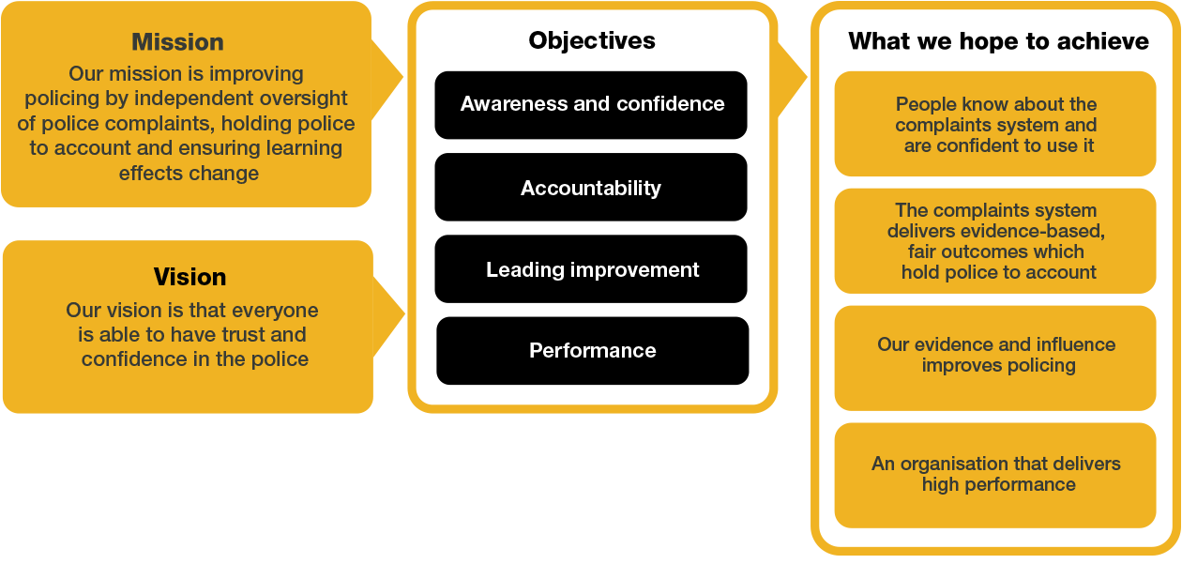

We work in the context of our agreed values which inform the way we do things at the IOPC. The Chief of Staff will need to be committed to managing in the context of these values.

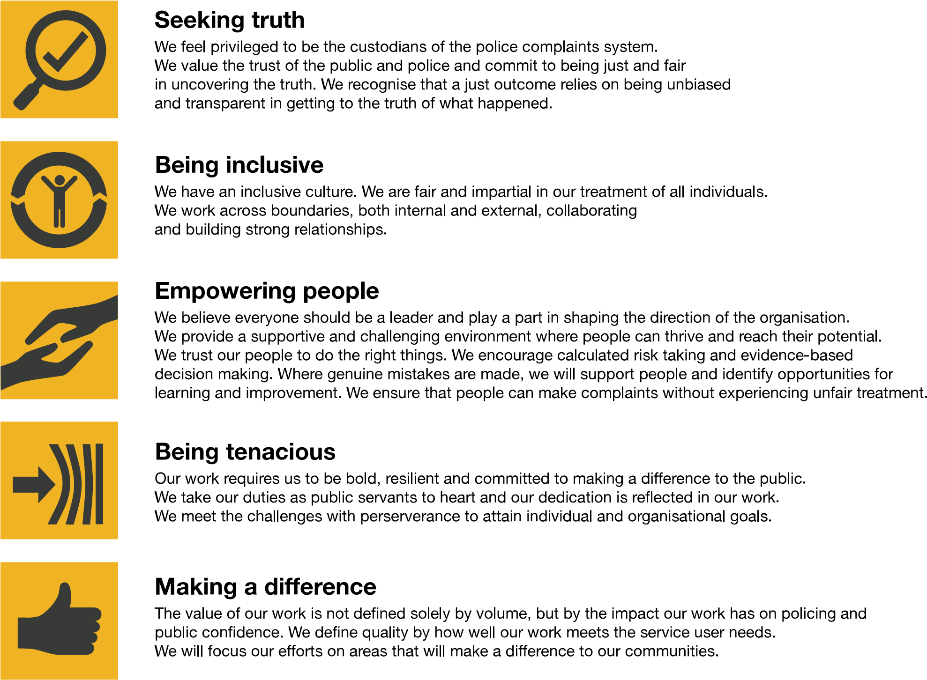

The IOPC is committed to **promoting equality and valuing diversity** in everything we do. Our vision is to be, and to be seen as, a leader in inclusive employment and services, demonstrating this ethos in everything that we do.

* As a silver standard Stonewall employer, we continue to commit ourselves to being a LGBTQ+ employer through the work of our Pride LGBTQ+ Staff Network, creating welcoming environments for lesbian, gay, bi and queer people.
* We are pleased to share we are a signatory of the Business in the Community Race at Work Charter. The Charter is composed of five [calls to action](https://race.bitc.org.uk/issues/racecharter) for leaders and organisations across all sectors.
* Being a Disability Confident employer, the IOPC is dedicated to removing the barrier for disabled people to thrive in the workplace.
* Our Staff Networks are constantly working to make the IOPC the leaders of inclusive employment, from our Allyship Programme to [Operation Hotton,](https://www.policeconduct.gov.uk/recommendations/operation-hotton-recommendations-metropolitan-police-service-september-2021) to [Welsh Language Standards](https://www.policeconduct.gov.uk/who-we-are/equality-and-diversity/welsh-language-standards) and Know the Line Policy, we are constantly seeking new ways to create an environment for all to develop and thrive.

## Reasonable adjustments

The IOPC is a diverse and inclusive workplace, and we want to help you demonstrate your full potential whatever type of assessment is used. We are open to providing you with the tools you need to succeed, from extra time to formatting changes, to name a mere few. If you require any reasonable adjustments to our recruitment process, please email campaigns@policeconduct.gov.uk