**Job description**

**Title:** Director of Transformation

**Reports to:** Director General

**Location:** Birmingham, Canary Wharf, Cardiff, Croydon, Sale, or Wakefield

**Grade:** Director Level 3

**Salary:**  £93,000 (plus London Weighting Allowance of £4731, if based in Canary Wharf, or Croydon)

**Contract:** Fixed term contract - 2 years

# Purpose

As Director of Transformationyou will be welcomed into a dynamic and inclusive team. The IOPC is on a journey to develop its culture, perspectives and ethos to support the organisation’s core outcomes and this is your opportunity to enter into the varied world of the IOPC, allowing you to develop your mindset and approaches to contribute to improving the police complaints system in England and Wales.

Our transformation programme is aimed at developing and improving the complaints system to increase trust and confidence in policing. We want to deliver value for money services and to do this me need to transform at pace, given declining levels of confidence (public and police) and reduced resources.

The key purpose of this role is to drive, lead and manage major and complex change and transformation across the IOPC, at pace to increase efficiency, performance, and improved outcomes for our users.

Provide strategic direction and leadership for the implementation of a new operating model for the IOPC so that it can deliver its ambitions statutory duties and ambitious strategic objectives. Develop a culture which maximises the value of the resources available within the IOPC.

To work collaboratively with management board (MB) to ensure that change and transformation is delivered cohesively and achieves its objectives including efficiencies and saving as outlined in our medium-term financial plan.

The post holder will lead the delivery of our transformation programme aimed at modernising the way that we deliver our services, our practices, and processes.

Lead and direct the Business Development team to ensure that the transformation programme is grounded within the wider organisation, aligned to the corporate strategy and that our business planning and ‘business as usual’ activities are aligned to the transformation programme.

Work closely with and build strong relationships with senior leaders including the Unitary Board, and external stakeholders, as well as regularly engage with and influence all staff.

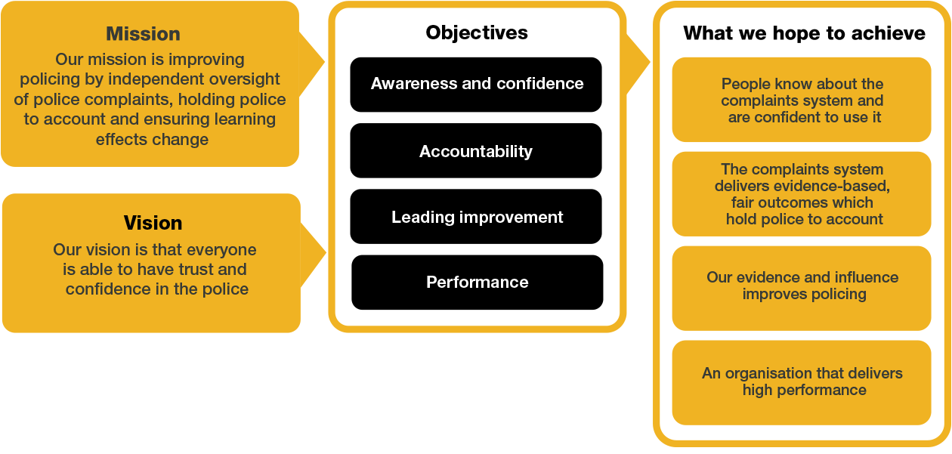

# Organisational context

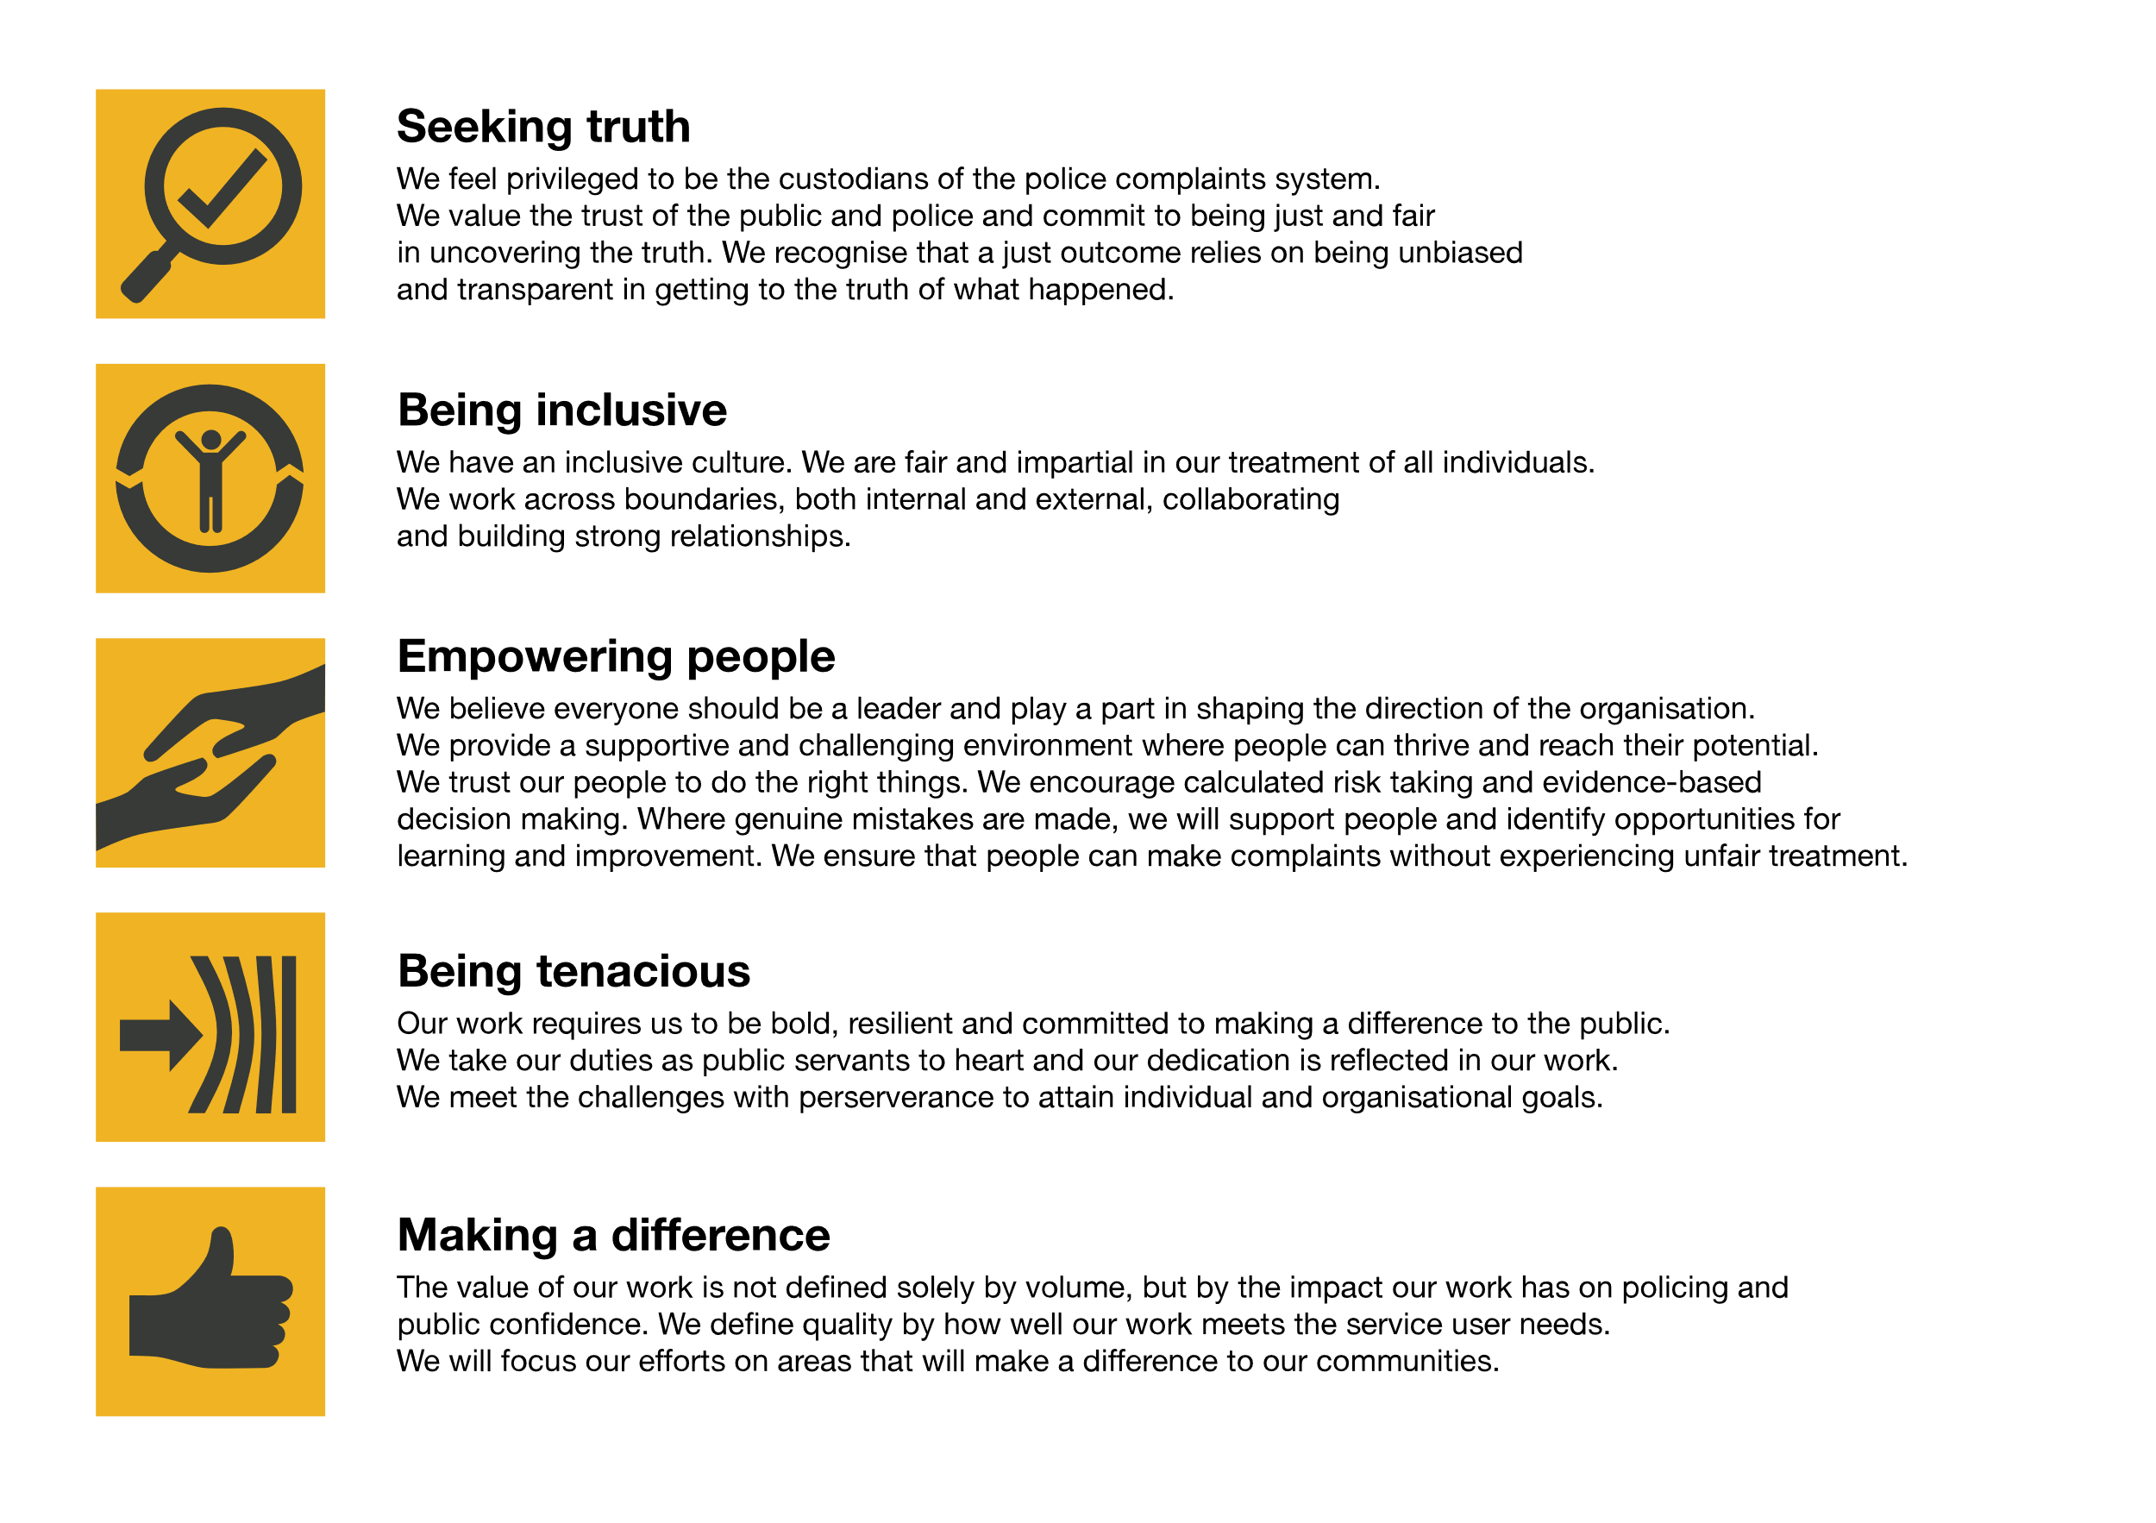We work in the context of our agreed values which inform the way we do things at the IOPC. The Director of Transformation will need to be commited to managing in the context of these values.

The IOPC is committed to **promoting equality and valuing diversity** in everything we do. Our vision is to be, and to be seen as, a leader in inclusive employment and services, demonstrating this ethos in everything that we do.

* As a silver standard Stonewall employer, we continue to commit ourselves to being a LGBTQ+ employer through the work of our Pride LGBTQ+ Staff Network, creating welcoming environments for lesbian, gay, bi and queer people.
* We are pleased to share we are a signatory of the Business in the Community Race at Work Charter. The Charter is composed of five [calls to action](https://race.bitc.org.uk/issues/racecharter) for leaders and organisations across all sectors.
* Being a Disability Confident employer, the IOPC is dedicated to removing the barrier for disabled people to thrive in the workplace.
* Our Staff Networks are constantly working to make the IOPC the leaders of inclusive employment, from our Allyship Programme, to [Welsh Language Standards](https://www.policeconduct.gov.uk/who-we-are/equality-and-diversity/welsh-language-standards) and Know the Line Policy, we are constantly seeking new ways to create an environment for all to develop and thrive.

# Main duties and responsibilities

* Provide leadership of the transformation programme which articulates a clear and compelling vision of change using evidence-based business cases including sound financial analysis and resource implications.
* Lead on the development of our operating model and ensure that it is embedded and understood by staff across the IOPC.
* Develop a range of metrics to measure the success of change and transformation, which should be reported to management board and Unitary Board providing assurance of delivery of expected benefits.
* Provide leadership for the transformation programme through an effective and robust programme and project management culture through the people in our programme and project management teams.
* Oversee all transformation projects such as Improving Operational Delivering and ensure that they are delivered on time, and efficiencies identified are delivered.
* Develop and nurture strong, positive relationships with key stakeholders to ensure high levels of engagement and delivery of change and transformation.
* Ensure excellent and robust governance arrangements across all transformation programmes and projects that support delivery of the IOPC transformation plans.
* Provide effective transformation and change management leadership, and support so that our modernisation plans, and vision of an improved complaint systems is fully realised and delivered using innovative solutions.
* Ensure that the Transformation Programme is resourced effectively through project management colleagues in the Business Development team and the People directorate.
* To provide supportive management to the Business Development and Programme/Project management teams by coaching, developing and motivating team members, empowering them to deliver high quality services and contribute to the achievement of the IOPC business objectives.
* Commit to continually shape an inclusive, compassionate, welcoming, and high performing culture that values, respects and invites different perspectives and focusses on outcomes for people.
* Identify areas across the business where transformation and or change is required in order to achieve efficiency and value for money.

The postholder is required to under any other duties that commensurate with the role of a Director of Transformation

# Person specification

**Qualifications:**

* A management qualification at degree level and / or significant experience in organisational leadership and delivering successful transformation programmes.

**Knowledge:**

* In depth understanding of transformation and change management strategies, techniques, and programmes.
* Detailed working knowledge and understanding of programme and project management methodologies.
* Knowledge of translating operational delivery models into working practices and processes.
* Knowledge and application of risk awareness and management.

Desirable:

* Knowledge of policing, and an understanding of the complaints system.

**Experience:**

* Experience of working at a senior level in a complex environment, managing multiple transformation projects with a range of stakeholders.
* Experience of leading and delivering large scale transformational change and the ability to convey a compelling and engaging vision of change.
* Experience of translating strategy into delivery through plans, programmes, people, and culture.
* Proven track record of strategically aligning financial resources with people resources, ICT, and other assets to achieve desired strategic outcomes.

**Skills:**

* Ability to work within a political environment.
* Ability to deliver major and complex change at pace, through obstacles and a wide range of challenges.
* Ability to work positively with stakeholders to achieve outcomes and deliver change through people.
* Strong leadership credibility to ensure effective performance.
* Ability to drive business and cultural organisational change.
* Highly developed interpersonal, advocacy and communication skills to be able to work effectively with individuals and a range of stakeholders.
* Strong influencing and negotiation skills.
* Highly developed financial acumen to ensure delivery of efficiency and savings targets.
* Ability to provide challenge organisational performance to achieve excellence.
* Ability to simplify and explain complex issues to a range of audiences.
* Ability to identify and implement effective systems to monitor performance.
* Ability to develop and encourage innovative ideas to drive improvement.
* Resilient, tenacious and outcome focussed.
* Ability to respond quickly and innovatively to manage and enhance reputation of transformation and change projects.

# Positive Action

At the IOPC, we are committed to building a workforce which reflects the diversity of the communities in which we serve. A more inclusive workforce enables us to be a more effective and efficient organisation, better understand and respond to the needs of our communities.

Positive action as detailed in the Equality Act 2010, allows us to use measures designed to help improve equality in the workplace, and create a level playing field for all, whilst still employing everyone based on merit. Our workforce profile data shows that people who identify as black, Asian and minority ethnic are under-represented at the IOPC.

For this role – should we have a situation where multiple candidates have achieved the highest score and one identifies as black, Asian or minority ethnic, by using positive action, we can select that candidate for the role, therefore improving this area of under-representation at the IOPC. We will only use positive action in this way where the highest scoring candidates have all scored equally, at the final assessment stage, and above our required threshold.

**Political Restriction**

Please note that this is a politically restricted role and will be subject to limitations set out in the IOPC code of conduct, a relevant extract from which is set out below.

* They act as “spokesperson” for the organisation, or have a significant degree of face-to-face contact with stakeholders, pressure groups, or other bodies or individuals who are seeking to influence the IOPC
* It would appear to the public that the post holder had some influence over the outcome of the organisation’s decisions.

If a post is politically restricted, this means that you should discuss with your line manager before taking on any political activities. Permissions will not be unrIeasonably withheld but consideration will need to be given to the scope and remit of the role and how this may be perceived in the context of your IOPC position. You should discuss with your line manager if you are considering becoming politically active, for example:

* Campaigning for a political party.
* Holding a political office.
* Occupying party political posts.
* Holding a particularly sensitive or high profile unpaid roles in a political party.

# Emotional Consideration

In performing this role, you will have occasional exposure to distressing material which will likely be impactful, traumatic and challenging. Given the nature of the work, it is also possible that you will have contact with individuals who are experiencing extreme distress. The IOPC recognises this and offers all staff a range of wellbeing provisions, including TRiM (Trauma Risk Management) peer-to-peer support, a dedicated Wellbeing Advisor, and access to free confidential counselling. All staff are strongly encouraged to proactively access and engage with the support available. If you would like to speak about this element of the role with somebody already doing similar work at the IOPC, please contact [campaigns@policeconduct.gov.uk](mailto:campaigns@policeconduct.gov.uk) and this can be arranged.

## Reasonable adjustments

The IOPC is a diverse and inclusive workplace and we want to help you demonstrate your full potential whatever type of assessment is used. We are open to providing you with the tools you need to succeed. Whilst this list is not exhaustive, please see potential reasonable adjustments below that we can provide:

* Extra time for presentations or interview questions
* Formatting changes such as colours for text or background on written assignments
* Questions presented in writing during interviews

If you require any reasonable adjustments to our recruitment process, please email campaigns@policeconduct.gov.uk

## Working conditions

The IOPC has a hybrid working arrangement which means staff work in a range of locations including from home. Given the nature of this role, the postholder is expected to spend 2 – 3 days per week office based, which includes attending external meetings and or events.

The post holder will need to travel to all IOPC locations on a regular basis.

Here at the IOPC, maintaining a culture that is accessible and inclusive of gender identity, sexuality, age, disability, race, sex, belief and caring responsibilities is deeply important to us. We believe that a rich, diverse workforce enables us a better understanding of each others needs, and produces more meaningful and trusting relationships, which in turn create more inclusive spaces where we all feel that we can contribute and belong.  We value our diversity, as we believe that our diversity is our strength. It allows us to identify with our communities through shared lived experiences producing better understanding and higher quality results in our work.

# What we offer

* 32.5 days paid annual leave
* Options to carry over, buy or sell annual leave
* Civil Service pension
* Civil Service maternity leave package
* PAM employee assistance programme
* Access to Civil Service Sports Council (CSSC) membership
* Cycle to work scheme
* Opportunity to enjoy the latest home and electronics in a more affordable way provided by Vivup
* Car Leasing Scheme
* Staff networks focused on each of the protected characteristics – run for staff, by staff:
* Age Network
* Enable Network
* Welsh Network
* Pride and LGBTQI+ Network
* Sex and Family Network
* Race, Religion and Belief Network
* Learning and development tailored to your role
* An environment with flexible working options
* A culture encouraging inclusion and diversity behaviours

## Preparation checklist

☐ Review the full job description

☐ Review the behaviours and the descriptors for each behaviour

☐ Review the Strengths dictionary

☐ Review the IOPC values

☐ Consider your Strengths

☐ Consider drafting example answers that cover the specific elements

☐ Prepare some questions to ask the interviewers