**Job description**

**Title: Assessment Analyst**

**Reports to: Senior Assessment Manager**

**Location: Birmingham**

**Grade: 9**

**Salary: £26,665 per annum**

**Contract: Permanent x 2 & 12 month FTC x 1**

# Purpose

As an Assessment Analyst, you will be welcomed into a dynamic and inclusive team working to critically analyse material gathered, preparing reports, and  
effectively communicating decisions and making recommendations as to  
the level of involvement the IOPC will have on cases referred by the Appropriate Authority.

The IOPC is on a journey to develop its culture, perspectives, and ethos to support the organisation’s core outcomes, and this is your opportunity to enter into the varied world of the IOPC, allowing you to develop your mindset and approaches to contribute to improving the police complaints system in England and Wales.

As part of your role as an Assessment Analyst you will be required to make effective, evidence-based recommendations in response to referrals and decisions on  
appeals, reviews and applications made by complainants and Appropriate Authorities (law enforcement agencies), in accordance with legislation and best practice customer service principles. This is achieved by critically analysing material gathered, preparing reports, and effectively communicating decisions and, in the case of referrals, making recommendations as to the level of involvement the IOPC will have on cases referred by the Appropriate Authority.

# Organisational context

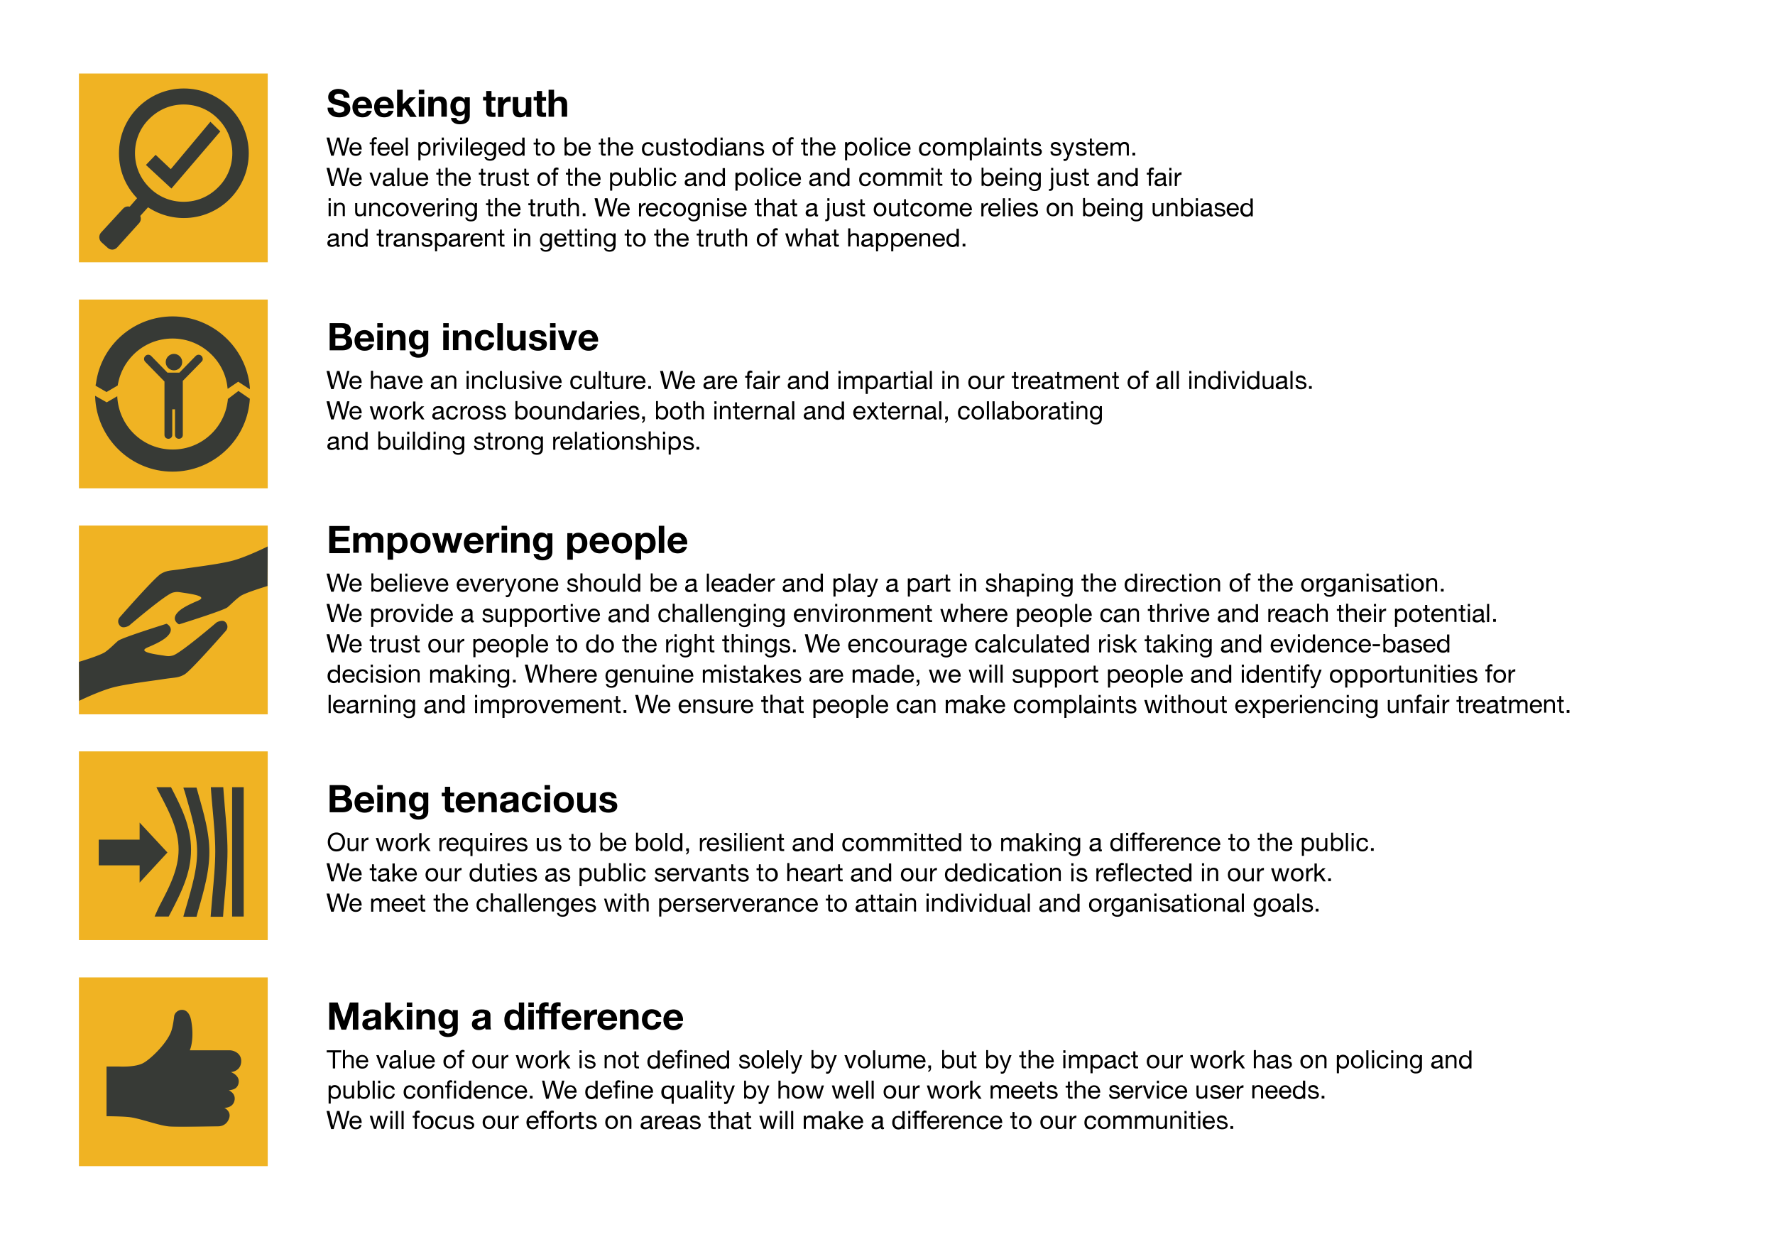We work in the context of our agreed values which inform the way we do things at the IOPC. The Assessment Analyst will need to be commited to managing in the context of these values.

The IOPC is committed to **promoting equality and valuing diversity** in everything we do. Our vision is to be, and to be seen as, a leader in inclusive employment and services, demonstrating this ethos in everything that we do.

* As a silver standard Stonewall employer, we continue to commit ourselves to being a LGBTQ+ employer through the work of our Pride LGBTQ+ Staff Network, creating welcoming environments for lesbian, gay, bi and queer people.
* We are pleased to share we are a signatory of the Business in the Community Race at Work Charter. The Charter is composed of five [calls to action](https://race.bitc.org.uk/issues/racecharter) for leaders and organisations across all sectors.
* Being a Disability Confident employer, the IOPC is dedicated to removing the barrier for disabled people to thrive in the workplace.
* Our Staff Networks are constantly working to make the IOPC the leaders of inclusive employment, from our Allyship Programme to [Operation Hotton](https://www.policeconduct.gov.uk/recommendations/operation-hotton-recommendations-metropolitan-police-service-september-2021), to [Welsh Language Standards](https://www.policeconduct.gov.uk/who-we-are/equality-and-diversity/welsh-language-standards) and Know the Line Policy, we are constantly seeking new ways to create an environment for all to develop and thrive.

# Main duties and responsibilities

The Assessment Function is organised into teams comprising of Senior Assessment Managers and Assessment Analysts. The team works as part of the wider assessments function, which includes administration support for the IOPC and the Customer Contact Centre, which provides advice and guidance to complainants, Appropriate Authorities and other stakeholders. It is often the first contact the public and other agencies have with the IOPC, therefore it is important  
to ensure those parties are provided an appropriate level of service.

Appropriate Authorities have a legal obligation to refer certain matters to the IOPC, regardless of if a complaint is made. Assessment Analysts review the information provided and make a recommendation to the Senior Assessment Manager with regards to the mode of investigation and level of resources to be allocated to independent in investigations. This recommendation may also include proposing relevant lines of enquiry.

Members of the public can appeal to the IOPC under some circumstances where they feel dissatisfied with the Appropriate Authority’s proposed initial handling of their complaint. Assessment Analysts consider these appeals. They record their findings, make determinations about whether the Appropriate Authority has acted appropriately; produce high quality, evidence-based reports to explain their decisions and if necessary can require the Appropriate Authority to record the complaint and investigate in accordance with the relevant legislation.

Assessment Analysts also make decisions on applications from Appropriate Authorities to disapply or discontinue recorded complaints and related appeals from complainants.

When considering referrals, appeals and applications, information may be received through correspondence, via telephone, e-mail, or through interviews with individuals who approach the organisation directly.

Assessment Analysts also provide practical advice and guidance to Appropriate Authorities. All team members will be required to exercise discretion in the course of carrying out these functions

# Person specification

## Essential

* Ensuring customer service principles are met when interacting with complainants, appropriate authorities and other interested parties when providing information or explaining decisions taken by the IOPC.
* Initiating and maintaining liaison relationships with appropriate authorities and providing information to assist them in meeting their statutory referral obligations.
* Processing referrals in writing and over the telephone from appropriate authorities.
* Analysing complaints/cases with relation to allegations of police conduct.
* Critically analysing evidence and information provided to the IOPC.
* Assessing whether the level of information provided by Appropriate Authorities is  
  adequate.
* Obtaining further information from Appropriate Authorities and Complainants as required.
* Producing high quality reports containing analysis and reach evidence based conclusions.
* Ensuring that the IOPC’s decisions are properly documented and effectively  
  communicated as far as possible within the constraints of operational requirements.
* Assisting with the maintenance of information stored on relevant IOPC systems.
* Ensuring that relevant information / intelligence is captured (and considered) when working on specific cases, with a view to identifying patterns / areas of risk.
* Ensuring that each case is dealt with independently and in view of its unique nature.

## Experience

* + Experience of working in an environment where a high level of oral and written  
    communication is required.
  + Experience of dealing with public/people.
  + Evidence of well-developed critical thinking skills, a capacity to conduct enquiries, obtain information and to use sound judgement to reach conclusions.
  + Computer literacy is essential.  
    Successful candidates will be expected to undertake appropriate training and development.

## Reasonable adjustments

The IOPC is a diverse and inclusive workplace and we want to help you demonstrate your full potential whatever type of assessment is used. We are open to providing you with the tools you need to succeed, from extra time to formatting changes, to name a mere few. If you require any reasonable adjustments to our recruitment process, please email [humanresources@policeconduct.gov.uk](mailto:humanresources@policeconduct.gov.uk)

## Working conditions

Making the IOPC a great place to work is one of our key priorities. We are pleased to offer a unique hybrid working model based on business needs, balanced with the needs of our colleagues. Our business need framework guides our decisions about when it is best to work onsite (in our offices or other appropriate locations) to complete tasks most effectively or when to work remotely, offering colleagues flexibility to work where they feel most productive and supporting work-life balance. The model also encourages staff to feel welcome at the IOPC by ensuring we have opportunities to work face-to-face as teams.

## Preparation checklist

☐ Review the full job description

☐ Review the behaviours and the descriptors for each behaviour

☐ Review the Strengths dictionary

☐ Review the IOPC values

☐ Consider your Strengths (if applicable)

☐ Consider drafting example answers that cover the specific elements

☐ Prepare some questions to ask the interviewers