JOB DESCRIPTION
Title: Employee Relations Specialist (Change & Transformation)
Reports to: Director, People
Direct reports: None
Location: Birmingham, Canary Wharf, Cardiff, Croydon, Sale or Wakefield.
Grade: 13a
Salary: £50,970 per annum (plus London Weighting Allowance of £4731 if based in Canary Wharf or Croydon)
Contract: Fixed term (18 months)

Role Purpose

The purpose of the role is to lead on providing expert employee relations on organisational change including, restructures (senior management review and review of support roles), re-organisations, and redundancies. To ensure that effective and productive consultation with staff and trade unions is conducted, as well as supporting leaders and project teams delivering change and transformation.
To be a subject matter expert with in-depth knowledge and expertise in employee relations, employment law and engaging with trade unions. Lead on managing our relationship with our trade union colleagues through change and transformation, including advising on the application of national and local agreements, collective bargaining and local dispute resolution.
To lead on individual consultation meetings with staff, including senior managers, impacted by change, and manage any resulting employee relations issues, including grievances. To work with the People Management and Wellbeing team to ensure that redeployment processes are fully exhausted.

Role and responsibilities

Employee relations:
Provide effective leadership to ensure that:
- Organisational change and transformation projects, such as restructures, realignments, and implementation of new technology and processes are effectively delivered.
- Complex casework, such as grievances raised, because of change and transformation are managed promptly and effectively and seek ways to mitigate financial risk and legal recourse.
- Restructure, redeployment, and realignment activities are managed sensitively and in accordance with IOPC policy and employment legislation.
- Consultation with staff is effectively conducted and proposals offered by colleagues are given full consideration by leaders, and support management with providing a written response.
- Support People Business Partners to ensure that our redeployment and realignment processes are fully exhausted to reduce exit costs.
- The People Directorate is represented through membership of the relevant boards, including IOD, to provide advice and influence decision making, and ensure the impact on people is fully considered.
- Lead on ensuring that any regulatory redundancy notices (if applicable) are lodged with the appropriate government body in a timely manner.
- The People directorate is always represented appropriately.

People policy and communications
- Lead on the creation of new job role profiles for senior managers, following a review of the senior structure, and arrange for job evaluation.
- Ensure regular communication with trade union colleagues so that they are kept up to date with the changes.
- Engage with senior managers and staff impacted by restructures and ensure that they are made aware of their rights and updated on a regular basis.
- Work effectively with change and transformation project teams to ensure that senior managers and staff receive regular communications and updates.
- Develop reports providing updates on organisational change and transformation, for management board and the People & Culture committee.

Decision Making
- Work collaboratively with the People Strategy & Change Implementation Lead, to manage the decision-making process required to agree the proposed changes ensuring that the governance of decision making is above reproach. This will include final decision making presented to the Unitary Board.
- Ensure that the Home Office are suitably briefed (via the Head of Private Office and Director General) and involved where appropriate.

Liaison and project Management
- Work closely with the People Strategy & Change Implementation Lead, to ensure that change and transformation implementation plans are delivered in a timely manner.
- Lead on consultation with the recognised trade union, via the Joint Negotiating Committee.

Implementation
- Work collaboratively with the Director of People and other People Directorate colleagues to ensure that employee relations such as redundancies, redeployment and selection processes comply with HR best practice and employment legislation.
- Ensure that any necessary authorisation for redundancies, recruitment and senior salaries are obtained.
- Ensure that the wellbeing of colleagues is considered at every stage of the managed change.
- Develop and deliver the support required to ensure that colleagues recruited into the new structure are effectively transitioned and trained to understand the corporate requirements of the new roles.

PERSON SPECIFICATION
Qualifications:
- Chartered Institute of Personnel and Development level 7 qualification or equivalent experience.

Knowledge:
- Excellent knowledge of change management and transformation principles. • Excellent knowledge of employment law and its practical application
- Excellent knowledge of HR best practice when managing change.
- Leadership principles and practices.
- Excellent knowledge of redundancy consultation.

Experience:
- Experience of leading and advising senior managers on implementing organisational change and restructures.
- Significant experience of consulting and negotiating with trade unions.
- Significant experience of supporting staff through change.
- Significant experience of leading on providing employee relations advice in relation to redundancies, redeployment and grievances.
- Experience of leading large organisational transformational change.
- Working in a People/HR environment with responsibilities for influencing change.
- Experience of working in the civil service, public, not for profit or charity sectors.
- Developing processes and or policies and procedure to facilitate effective change.
- Working collaboratively with senior managers and leadership teams.
- Experience of working with multiple stakeholders.
- Experience of assessing and evaluating the outcomes of change and transformation.
Skills:
- Excellent influencing and negotiation skills.
- Excellent communication and interpersonal skills.
- Excellent analytical skills.
- Strong decision-making skills.
- The ability to problem-solve and find cost effective solutions.
- Good coaching and mentoring skills.

Other requirements:
Applicants must be willing to travel to regional locations to conduct in person meetings with staff and senior management.

Organisational context
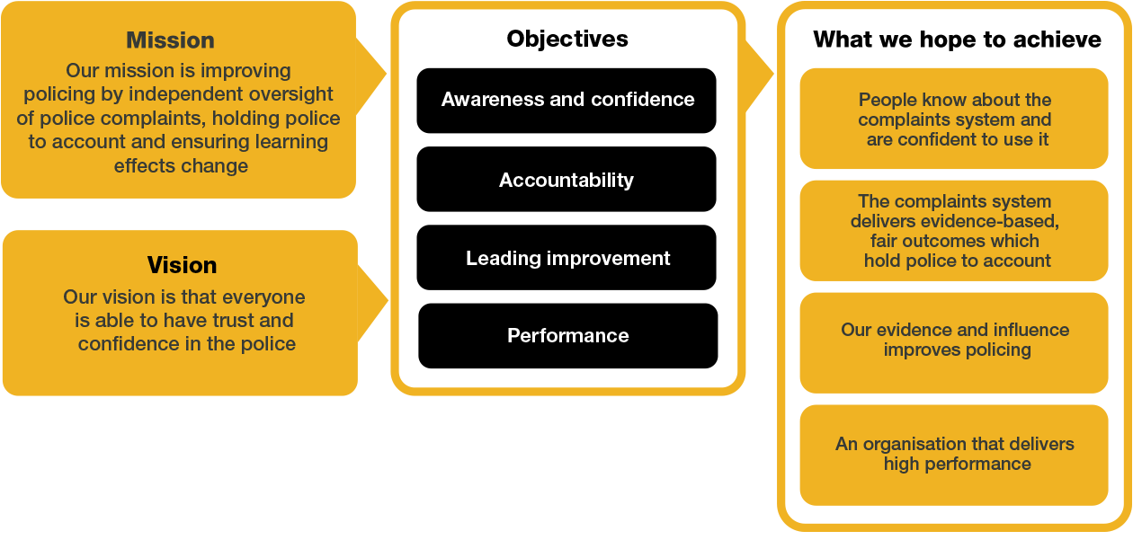
We work in the context of our agreed values which inform the way we do things at the IOPC. The Employee Relations Specialist will need to be committed to working in the context of these values.
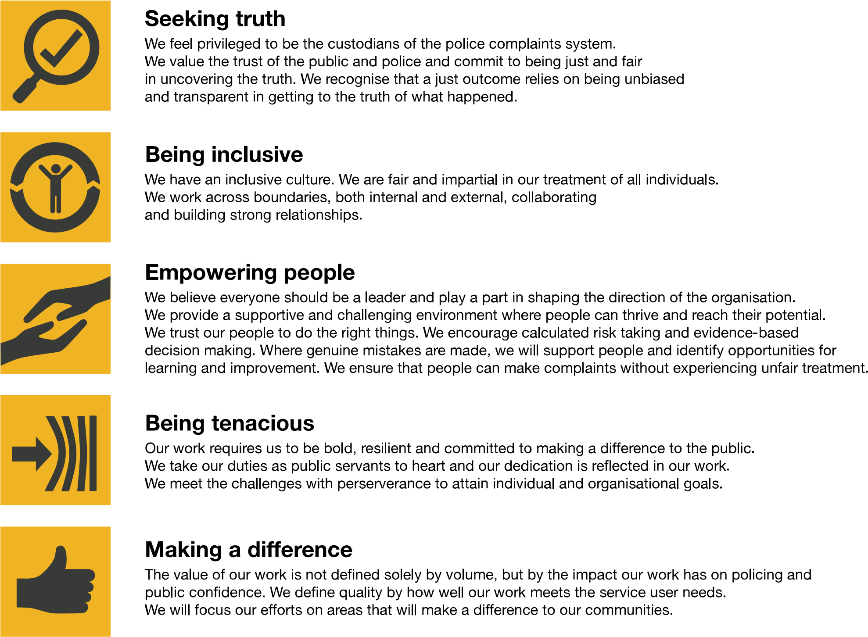

The IOPC is committed to promoting equality and valuing diversity in everything we do. Our vision is to be, and to be seen as, a leader in inclusive employment and services, demonstrating this ethos in everything that we do.
- As a silver standard Stonewall employer, we continue to commit ourselves to being a LGBTQ+ employer through the work of our Pride LGBTQ+ Staff Network, creating welcoming environments for lesbian, gay, bi and queer people.
- We are pleased to share we are a signatory of the Business in the Community Race at Work Charter. The Charter is composed of five calls to action for leaders and organisations across all sectors.
- Being a Disability Confident employer, the IOPC is dedicated to removing the barrier for disabled people to thrive in the workplace.
- Our Staff Networks are constantly working to make the IOPC the leaders of inclusive employment, from our Allyship Programme to Operation Hotton, to Welsh Language Standards and Know the Line Policy, we are constantly seeking new ways to create an environment for all to develop and thrive.

Reasonable adjustments
The IOPC is a diverse and inclusive workplace, and we want to help you demonstrate your full potential whatever type of assessment is used. We are open to providing you with the tools you need to succeed, from extra time to formatting changes, to name a mere few. If you require any reasonable adjustments to our recruitment process, please email campaigns@policeconduct.gov.uk

