**Job description**

**Title:** Interim Regional Director London

**Reports to:** Director of Operations

**Location:** London

**Grade:** RegionalDirector (SC1)

**Salary:** £93,000 plus £4527 London Weightingper annum

**Contract:** Fixed Term - 12 months

# Purpose

The purpose of this senior leadership role is to ensure that investigations of serious and sensitive police complaints, conduct matters and serious incidents are carried out in a timely and consistent way and that case decisions, made on behalf of the Director General, are evidence-based and transparent.

The post holder has an important role in building public confidence in policing by ensuring that our work is explained to complainants, police forces and the wider public and that learning from our work is widely shared.

The post holder is the public face of the Independent Office for Police Conduct (IOPC) at regional level, working with multiple police forces and diverse communities as well as dealing with media issues.

# Organisational context

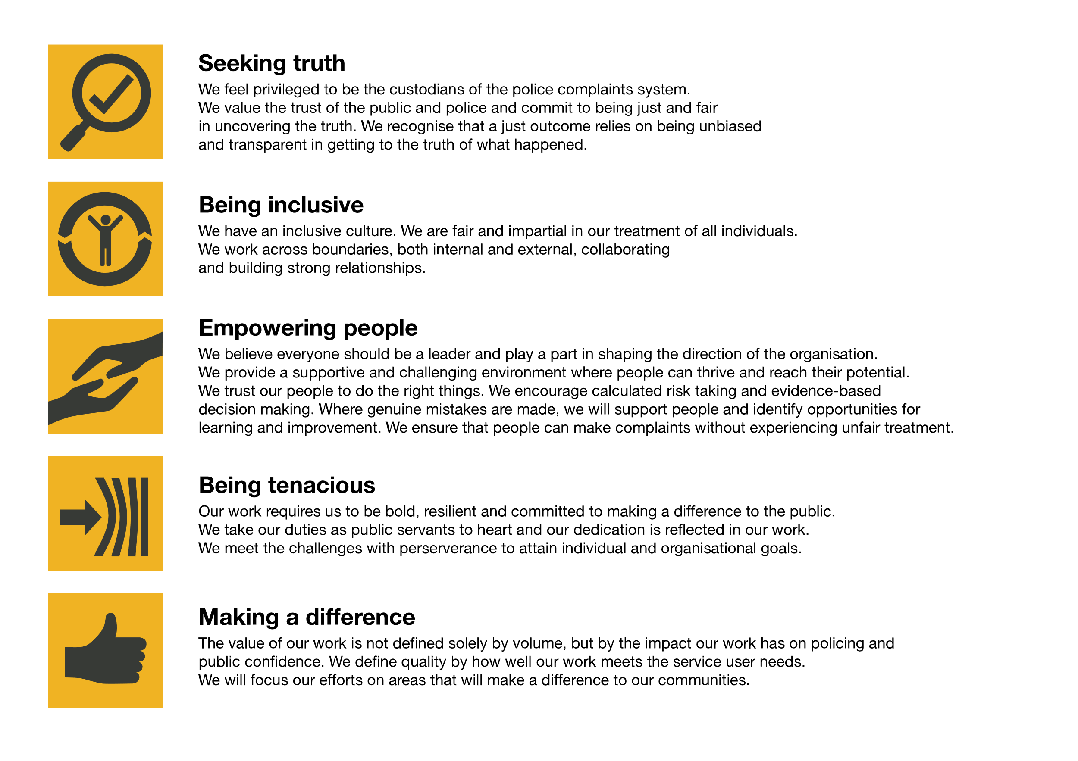We work in the context of our agreed values which inform the way we do things at the IOPC. The Regional Director will need to be commited to managing in the context of these values.

The IOPC is committed to **promoting equality and valuing diversity** in everything we do. Our vision is to be, and to be seen as, a leader in inclusive employment and services, demonstrating this ethos in everything that we do.

* As a silver standard Stonewall employer, we continue to commit ourselves to being a LGBTQ+ employer through the work of our Pride LGBTQ+ Staff Network, creating welcoming environments for lesbian, gay, bi and queer people.
* We are pleased to share we are a signatory of the Business in the Community Race at Work Charter. The Charter is composed of five [calls to action](https://race.bitc.org.uk/issues/racecharter) for leaders and organisations across all sectors.
* Being a Disability Confident employer, the IOPC is dedicated to removing the barrier for disabled people to thrive in the workplace.
* Our Staff Networks are constantly working to make the IOPC the leaders of inclusive employment, from our Allyship Programme to [Operation Hotton](https://www.policeconduct.gov.uk/recommendations/operation-hotton-recommendations-metropolitan-police-service-september-2021), to [Welsh Language Standards](https://www.policeconduct.gov.uk/who-we-are/equality-and-diversity/welsh-language-standards) and Know the Line Policy, we are constantly seeking new ways to create an environment for all to develop and thrive.

# Main duties and responsibilities

**Operational Management**

* Work with colleagues in the Operations Management Board to determine operational policies and practice and ensure consistent investigations and case management standards
* Contribute to the IOPC strategic plan and annual business plan and budget, ensuring that the plan and budget are delivered
* Determine and monitor KPIs and assess the overall performance of Investigations function, agreeing remedial actions if necessary
* Lead business transformation projects

**National /Regional Management**

* Provide effective local leadership, driving efficient and effective delivery of IOPC business in the region to quality standards that are able to withstand detailed scrutiny
* Work with colleagues across the organisation to ensure successful delivery of the IOPC corporate strategy
* Manage a budget and other resources to ensure value for money
* Ensure that regional investigations staff are regularly supervised, effectively managed and have suitable personal development plans in place
* Ensure that the safety and wellbeing of all colleagues is given highest priority
* Be accountable for proactive management of all cases which delivers high quality and timely outcomes and provides assurance to the Directors of Operations
* Undertake the role of IAO for the regional operations teams.
* Maintain an overview of Health and Safety Management in the Canary Wharf office liaising with the central facilities team and Health and Safety Manager as needed

**Decision Making**

* Accountable for and having oversight of routine decision making, providing advice and counsel to direct reports, and ensuring that senior colleagues and relevant teams are briefed about high profile or contentious cases
* Take decisions on complex and/or high-profile cases in accordance with the IOPC’s duties and legislative framework
* Contribute to critical case reviews and have oversight of critical cases within the region, including providing direct leadership when necessary

**External**

* Develop and maintain external relationships, actively engaging with local communities, partner bodies and police forces across the region
* Work with local and national communications teams to respond to media issues and proactively communicate our work
* Deal with the media and press at a national level
* Lead thematic work and act as subject matter expert/ principal spokesperson in relation to a theme

**Other**

* Actively promote the IOPC values
* The role will require participation in an “on call” rota to provide out-of-hours senior leadership for IOPC’s operational work and critical incident management.

**Key Contacts**

* Director General
* Deputy Director General S&I
* Directors of Operations
* Other Regional Directors and the Director of Major Investigations
* Other Directors and Heads (CSC)
* Stakeholders within the forces
* Members of parliament
* Families and complainant representatives
* Community stakeholders
* Press

# Person specification

## Essential, Experience, Skills and Abilities

* Experienced leader and manager of people and budgets with successful track record of developing and delivering strategic plans;
* Experience of working collaboratively as part of a leadership team to build consensus amongst disparate views to achieve effective and mutually agreeable outcomes and deliver corporate priorities;
* Experience of leading investigations and ability to analyse highly complex information, including of a legal nature, and exercise evidence-based decision making;
* Track record of delivery through others, including ability to engage and develop teams to perform at their best and meet stretching goals;
* Evidence of a track record of personal resilience under pressure in order to undertake a role that is subject to significant external scrutiny and where decisions are often challenged;
* Evidence of strong personal credibility, to be able to promote and ensure the independence of the IOPC and its decisions;
* Demonstrably strong relationship development skills and significant experience of engaging with senior level stakeholders;
* Evidence of a track record of success as an influential communicator, including interacting effectively with diverse audiences / experience in a public facing role, including engaging with the media;
* Evidence of sound understanding of, and strong commitment to public service values, to diversity and to the principles of public life

## Reasonable adjustments

The IOPC is a diverse and inclusive workplace and we want to help you demonstrate your full potential whatever type of assessment is used. We are open to providing you with the tools you need to succeed, from extra time to formatting changes, to name a mere few. If you require any reasonable adjustments to our recruitment process, please email [campaigns@policeconduct.gov.uk](mailto:alissia.clarke@policeconduct.gov.uk)

## Working conditions

Making the IOPC a great place to work is one of our key priorities. We are pleased to offer a unique hybrid working model based on business needs, balanced with the needs of our colleagues. Our business need framework guides our decisions about when it is best to work onsite (in our offices or other appropriate locations) to complete tasks most effectively or when to work remotely, offering colleagues flexibility to work where they feel most productive and supporting work-life balance. The model also encourages staff to feel welcome at the IOPC by ensuring we have opportunities to work face-to-face as teams.