**Job description**

**Title:** Assistant People Business Partner

**Reports to:** People Business Partner

**Location:** Birmingham

**Grade:** 10

**Salary:** £32,600 per annum

**Contract:** Permanent

# Purpose

As an Assistant People Business Partner, you will be welcomed into a dynamic and inclusive People Management and Wellbeing team, supporting the work of the People Business Partners. The IOPC is on a journey to develop its culture, perspectives and ethos to support the organisation’s core outcomes and this is your opportunity to enter into the varied world of the IOPC People Directorate, allowing you to develop your mindset and approaches to contribute to improving the police complaints system in England and Wales.

The primary focus of the role is on casework in relation to employee relations and recruitment. Assistant People Business Partners own cases from start to finish. They work closely with line managers providing advice and assistance. They work within organisational policies and agreed practice but also identify policy concerns and contribute to work to develop new policy and guidance. As one of the key links between the business and the People Directorate APBPs will also maintain an excellent knowledge of work being progressed in the wider directorate and provide insights to the OD and Talent and Learning and Development teams to inform their work.

APBPs will tend to focus on employee relations and recruitment casework. It is essential that all APBPs have sufficient knowledge of team activities to be able to assist and guide line managers.

APBPs will work closely with the People Co-ordinator to ensure that the processes for administration are efficient and undertaken in a timely manner. APBPs will also provide advice and guidance to more junior colleagues in the team in the absence of the PBP.

# Organisational context

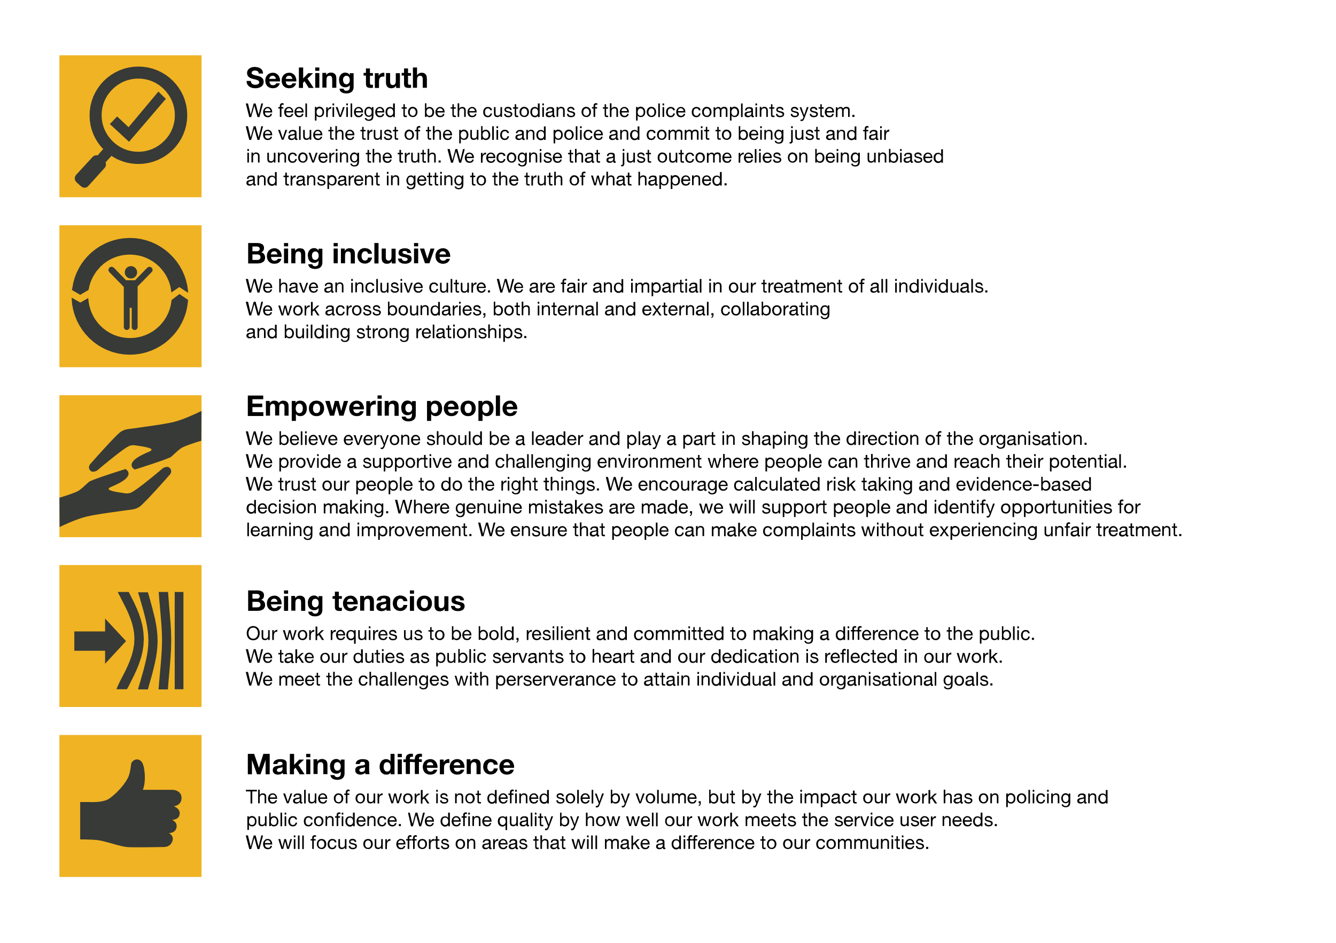We work in the context of our agreed values which inform the way we do things at the IOPC. The Assistant People Business Partner will need to be commited to managing in the context of these values.

The IOPC is committed to **promoting equality and valuing diversity** in everything we do. Our vision is to be, and to be seen as, a leader in inclusive employment and services, demonstrating this ethos in everything that we do.

* As a silver standard Stonewall employer, we continue to commit ourselves to being a LGBTQ+ employer through the work of our Pride LGBTQ+ Staff Network, creating welcoming environments for lesbian, gay, bi and queer people.
* We are pleased to share we are a signatory of the Business in the Community Race at Work Charter. The Charter is composed of five [calls to action](https://race.bitc.org.uk/issues/racecharter) for leaders and organisations across all sectors.
* Being a Disability Confident employer, the IOPC is dedicated to removing the barrier for disabled people to thrive in the workplace.
* Our Staff Networks are constantly working to make the IOPC the leaders of inclusive employment, from our Allyship Programme to [Welsh Language Standards](https://www.policeconduct.gov.uk/who-we-are/equality-and-diversity/welsh-language-standards) and Know the Line Policy, we are constantly seeking new ways to create an environment for all to develop and thrive.

# Main duties and responsibilities

**Employee Relations Focus**

* Maintain an ongoing understanding of the employee relations issues in the client group assigned, engaging regularly with colleagues and line managers to pre-empt issue and solve problems
* Act as a mediator to find solutions to difficulties
* Commission work from the OD and L&D teams to enable local problems to be solved
* Act as a point of contact for colleagues in distress signposting appropriate services
* Advise on ER issues such as long term or regular sickness, disciplinary and grievance matters and performance management and assist managers to find pragmatic solutions to difficulties
* Seek advice from our employment lawyers about complex cases and assist in preparations for ETs
* Support IOPC internal investigations into staff related matters
* Assist the People Business Partner with work force and succession planning
* Develop policy and guidance to first review stage and present to staff council and staff networks for comment
* Providing advice, coaching support and training on people policies and best practice
* assistance on policies, procedures, legislation, and collective agreements
* Ensure that HR record keeping is up to date and of the highest quality
* Operate regular HelpPoint surgeries for colleagues

**Recruitment Focus**

* Maintain an ongoing understanding of the staffing needs of the client group assigned, by engaging regularly with client group managers to establish any potential future or current recruitment requirements
* Advise on job design and undertake job evaluations
* Advise on job evaluation appeals
* Conduct full and detailed job briefings with line managers and establish campaign timelines promoting good practice in the pre-planning of recruitment activity
* Advise hiring managers on policy and process including the use of the New Assessment Framework model
* Draft job advert and job packs for line management approval and ensure that roles are appropriately advertised
* Assess candidate applications and screen them against the job requirements
* Conduct detailed and insightful telephone interviews at initial stages to assess candidate suitability and provide feedback to hiring managers
* Coach managers to consider and select the most appropriate methods of assessment offered from the Assessment Toolkit
* Organise and facilitate assessment centres, including test administration
* Assist on selection panels involving internal candidates
* Provide interview coaching and training to line managers and internal candidates where needed
* Provide candidates with appropriate and constructive feedback
* Make candidate offers and work with the Team Co-ordinator to ensure that pre-employment screening is completed as quickly as possible
* Maintain the HR applicant tracking recruitment system and undertake associated administrative tasks
* Work closely with the Talent Acquisition team to ensure that front line feedback and learning is shared

# Person specification

## Essential

* Experience of providing advice, guidance and coaching to managers
* An excellent knowledge of the law as it relates to recruitment and/or employee relations
* Demonstrable pragmatic problem-solving skills
* Organised, self-motivated and capable of working autonomously.
* Confident communicator with the ability to influence and engage colleagues
* A good understanding of the General Data Protection regulations and experience of working with and protecting personal data
* Knowledge or experience of working with people who may be marginalised, ensuring that they are able to get their voice heard
* Evidence of commitment to continuing professional development

## Desirable

* Membership of the Chartered Institute of Personnel and Development at Level 5 or above.
* Formally accredited mediation skills
* Working knowledge of success profiles

## Reasonable adjustments

The IOPC is a diverse and inclusive workplace and we want to help you demonstrate your full potential whatever type of assessment is used. We are open to providing you with the tools you need to succeed, from extra time to formatting changes, to name a mere few. If you require any reasonable adjustments to our recruitment process, please email [humanresources@policeconduct.gov.uk](mailto:humanresources@policeconduct.gov.uk)

## Working conditions

Making the IOPC a great place to work is one of our key priorities. We are pleased to offer a unique hybrid working model based on business needs, balanced with the needs of our colleagues. Our business need framework guides our decisions about when it is best to work onsite (in our offices or other appropriate locations) to complete tasks most effectively or when to work remotely, offering colleagues flexibility to work where they feel most productive and supporting work-life balance. The model also encourages staff to feel welcome at the IOPC by ensuring we have opportunities to work face-to-face as teams.

## Preparation checklist

☐ Review the full job description

☐ Review the behaviours and the descriptors for each behaviour

☐ Review the Strengths dictionary

☐ Review the IOPC values

☐ Consider your Strengths (if applicable)

☐ Consider drafting example answers that cover the specific elements

☐ Prepare some questions to ask the interviewers