**Title:** Investigation Support Unit Team Member



**J**

**ob**

**d**

**escription**

Trainee Investigator

**Reports to:**  ISU Manager

**Location:** Sale(Greater Manchester)

**Grade:** 7

**Salary:**  £26,765

**Contract:** Fixed-term until 31st March 2026

# Purpose

The postholder will provide administrative support, with the main responsibility being support to Investigations. They will act as a member of the Operations Directorate, providing a full administrative support service to Operations Managers, Operations Team Leaders and Investigators inSalewhilst also providing administrative support nationally as and when required.

The postholder will be responsible for carrying out the document management function of updating and maintaining the case management system in independent investigations. The postholder will maintain local and national spreadsheets as directed. They will also draft correspondence, monitor witness appeal mailboxes and maintain performance management records. Acting as first point of contact to callers for Investigations when appropriate, they will liaise with outside agencies and aggrieved parties whether by telephone, e-mail or post and ensure they are dealt with promptly, efficiently and courteously.

In completing some of these tasks the post holder may view some distressing or sensitive material.

# Organisational context

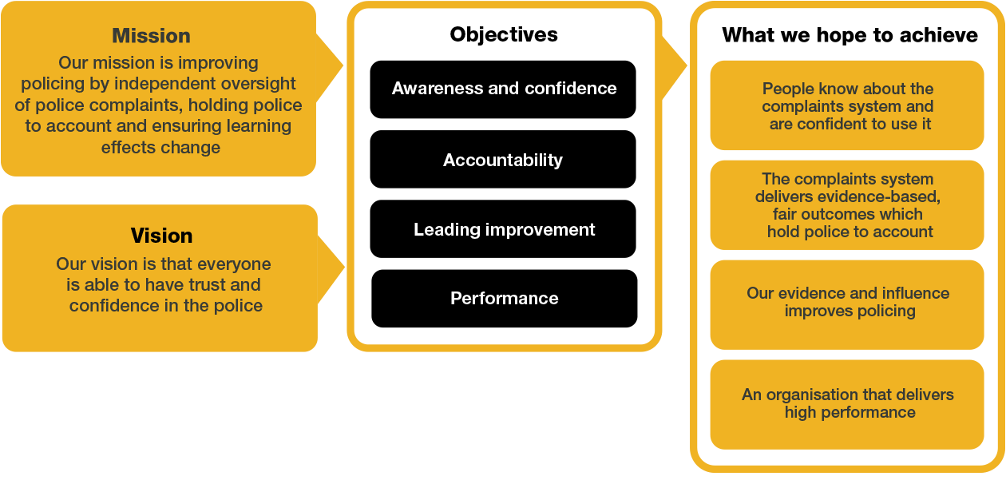

/

We work in the context of our agreed values which inform the way we do things at the IOPC. ISU Team Members will need to be committed to working in the context of these values.

The IOPC is committed to **promoting equality and valuing diversity** in everything we do. Our vision is to be, and to be seen as, a leader in inclusive employment and services, demonstrating this ethos in everything that we do.

* As a silver standard Stonewall employer, we continue to commit ourselves to being a LGBTQ+ employer through the work of our Pride LGBTQ+ Staff Network, creating welcoming environments for lesbian, gay, bi and queer people.
* We are pleased to share we are a signatory of the Business in the Community Race at Work Charter. The Charter is composed of five [calls to action](https://race.bitc.org.uk/issues/racecharter) for leaders and organisations across all sectors.
* Being a Disability Confident employer, the IOPC is dedicated to removing the barrier for disabled people to thrive in the workplace.
* Our Staff Networks are constantly working to make the IOPC the leaders of inclusive employment, from our Allyship Programme to [Operation Hotton,](https://www.policeconduct.gov.uk/recommendations/operation-hotton-recommendations-metropolitan-police-service-september-2021) to [Welsh Language Standards](https://www.policeconduct.gov.uk/who-we-are/equality-and-diversity/welsh-language-standards) and Know the Line Policy, we are constantly seeking new ways to create an environment for all to develop and thrive.



# Main duties and responsibilities

As an ISU Team member, perform the following role with regard to Independent and Managed investigations.

* Ensure that the Operations directorate receive support in relation to the management of all investigations by means of maintaining tasks on the Case Management System (CMS)
* In conjunction with the Lead Investigator, ensure that all ISU functions, in respect of Independent and Managed cases, are completed within the statutory time frames on CMS, in accordance with the IOPC’s legislative requirements, whilst maintaining ongoing liaison with the Lead Investigator in relation to each allocated case throughout its duration.
* Ensure Independent Investigations case files are kept up to date in accordance with guidelines.
* Act as a team member whilst also using initiative in order to build files for Court, Inquests and Disciplinary Hearings, forwarding CPS/Court requests for information, dealing with case queries, disclosing evidence as and when directed by the Lead Investigator to interested parties.
* Prepare evidential documentation relating to court files for submission to the Crown Prosecution Service within the specified guidelines, in accordance with required standards, and on the direction of the Lead Investigator.
* Maintain and update the CMS and securely store such documentation in compliance with IOPC policies.
* Archive investigation material in liaison with the Lead Investigator in closed cases. Ensuring material and exhibits submitted are catalogued prior to submission to off-site Archive.
* Maintain databases to service organisational performance management.
* Attend initial meetings as required at the commencement of new investigations, also attend briefings on more complex cases being run on the HOLMES system
* In relation to Independent investigations copy type statements, proofread and register other documentation as and when required.
* Assist the Operations Directorate with raising purchase orders, using the online requisition system on Business World (in accordance with IOPC procurement processes) and liaising with the Budget Holder when reconciling invoices.
* Maintain fleet vehicle support duties, including the organisation of internal fleet vehicles via the booking system. Ensure vehicles are available for MOT appointments and services, whilst ensuring business needs are met.
* Assist with the arrangement of meetings and other events (both internally and externally), including the booking of video conference facilities and other equipment required. Send out invitations at the request of investigators.
* Book travel arrangements for Operational staff.
* Manage the equipment booking system in respect of the portable audio equipment used for interviews and PPE on call kits.
* Order stationery for the Operations Directorate on a pro rata basis within the agreed budget.
* Take responsibility and maintain an auditable register for all CDs, DVDs and bluebooks in respect of investigations.

The post holder will also perform the following customer service and relationship management duties:

* Issue witness warnings as and when directed and monitor (on a rotational basis) the National Witness Appeal lines.
* Send out update letters on the direction of the Lead Investigator to external parties.
* Deal with enquiries from, and provide assistance to, members of the public, police officers, and any other external agencies when the investigator in the case is not available by taking and passing on the information.
* Assist and liaise with staff members to maintain good communication and relationships, with colleagues in other regional offices and interested parties.
* Act as a point of contact for support to investigation staff e.g. media transfer or sending material to external parties. Acting as a point of contact in advising external parties in relation to material sent and received.

These key duties and responsibilities are intended only as a guide to the main responsibilities of the post and are not intended to restrict the scope of the post holder to perform other duties. Additional responsibilities for the post holder may be agreed on an individual basis and recorded as part of the annual performance review role requirement.

# Person specification

The **essential** requirements are:

* Good level of education
* Ability to work under pressure and prioritise tasks, working to strict and conflicting deadlines
* High level of attention to detail and an ability to work accurately
* Proven experience of working effectively in a team environment
* Experience of dealing with internal parties to complete tasks successfully
* Proficiency in the use of IT, including Microsoft (specifically Word and Excel)

The **desirable** requirements are:

* Familiarisation with the HOLMES 2 computer application.
* Experience or understanding of police forces and criminal justice system
* Typing experience – minimum of 40 to 50 words a minute.

**Skills and Abilities**

* Sound administrative skills, able to organise and prioritise when under pressure and meet or negotiate deadlines.
* Skills appropriate to the role, with the capacity to absorb/organise new information to ensure well briefed on new topics.
* Strong interpersonal communication skills (written and oral).
* Prioritising to ensure key objectives of the role are consistently achieved.
* Comfortable taking decisions within a clear framework of delegation.

**Any move to the IOPC from another employer will mean you can no longer access childcare vouchers. This includes moves between government departments. You may however be eligible for other government schemes, including Tax-Free Childcare. Determine your eligibility at [https://www.childcarechoices.gov.uk/.**](https://www.childcarechoices.gov.uk/.**)

## Reasonable adjustments

The IOPC is a diverse and inclusive workplace, and we want to help you demonstrate your full potential whatever type of assessment is used. We are open to providing you with the tools you need to succeed, from extra time to formatting changes, to name a mere few. If you require any reasonable adjustments to our recruitment process, please email recruitment@policeconduct.gov.uk

## Working conditions

The IOPC are currently consulting with our consultative bodies about proposed changes to our hybrid working policy which will require all staff to work 20% of their contractual hours at their office base (or another office for business reasons) from 1 September 2024 and increased to 40% from April 2025. Office attendance time includes in-person training, meetings with stakeholders and families, and attending events.

### Selection process

This vacancy is using [**Success Profiles**.](https://www.gov.uk/government/publications/success-profiles?_ga=2.156185915.1692943174.1578577916-319911383.1576576754)