**Job description**

**Title:** Transformation Benefits Manager

**Reports to:** PMO Lead

**Location:** Birmingham, Sale, Cardiff, Wakefield, Croydon or Canary Wharf

**Grade:** 13

**Salary:** £47,493 (plus London Weighting allowance of £4,968 if located in Canary Wharf or Croydon)

**Contract:** Fixed-Term until 01st December 2027

# Purpose

As a Transformation Benefits Manager, you will be welcomed into a dynamic and inclusive Strategy Team in the Business Development Department which works to support the implementation of programmes and projects that will deliver our organisation’s strategic objectives. Our organisation is on a transformative journey and this is your opportunity to enter into the varied world of IOPC as we seek to develop the maturity of the way in which we manage and realise benefits of change. The IOPC will be running an exciting Transformation Programme to help us deliver the capability and deliver financial benefits needed to support the deliver towards our strategy. This is a role that will allow you to develop your mindset and approach to contributing towards improving the police complaints system in England and Wales.

The purpose of this role is to embed and maintain the IOPC’s approach to benefits management and to ensure that benefits realisation is optimised from the organisation’s investment in change. The role holder will own and champion the use of our Benefits Management Framework and provide expert advice and guidance to a wide range of stakeholders and functions across the IOPC. The role holder will support the PMO Lead and wider programme/project teams to further develop and sustain benefits management capability across the organisation. The postholder will help teams to identify, quantify, optimise and track the realisation of benefits across the Transformation Programme in accordance with recognised best practice, understanding the need for organisation-wide engagement in benefits realisation.

# Organisational context

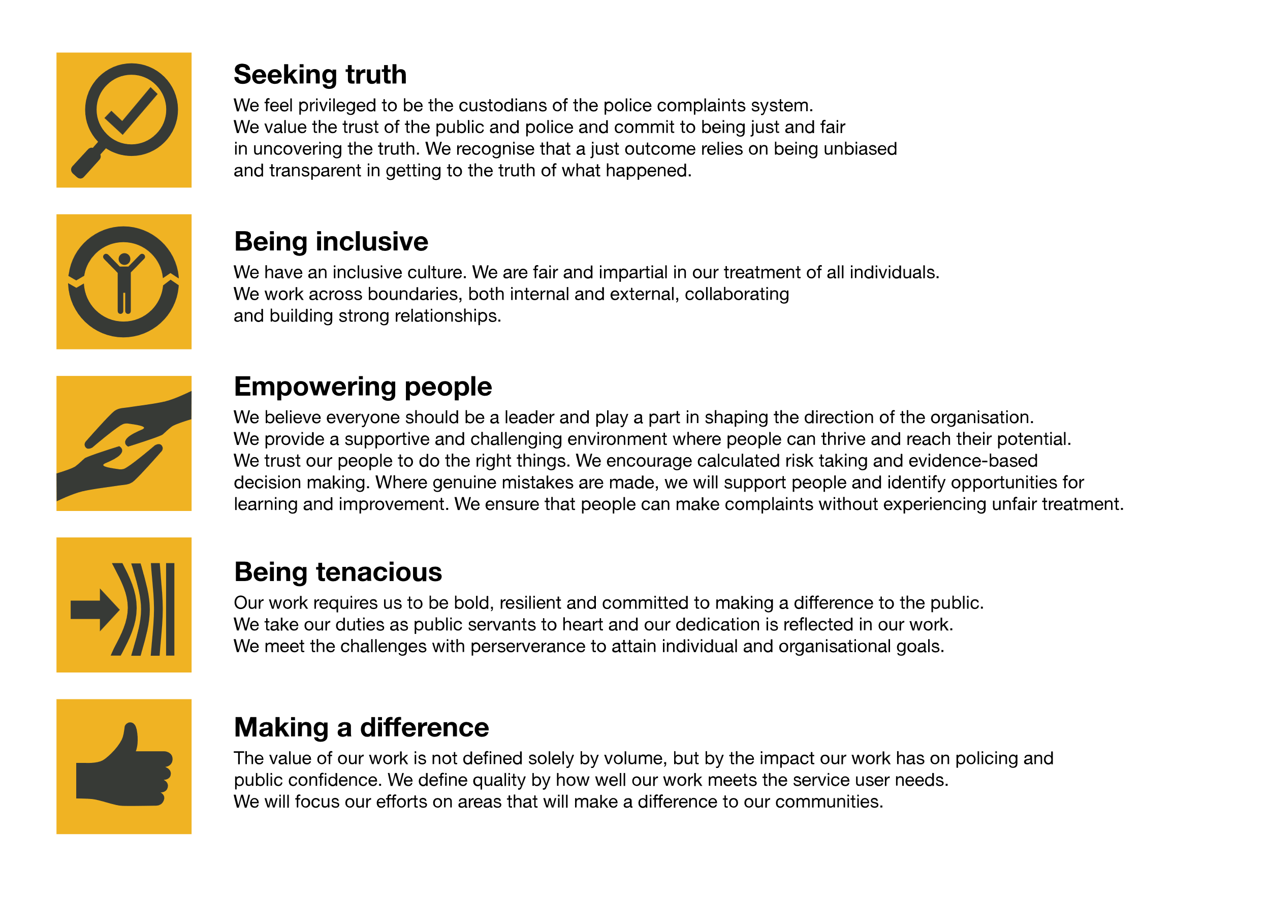We work in the context of our agreed values which inform the way we do things at the IOPC. The Transformation Benefits Manager will need to be commited to managing in the context of these values.

The IOPC is committed to **promoting equality and valuing diversity** in everything we do. Our vision is to be, and to be seen as, a leader in inclusive employment and services, demonstrating this ethos in everything that we do.

* As a silver standard Stonewall employer, we continue to commit ourselves to being a LGBTQ+ employer through the work of our Pride LGBTQ+ Staff Network, creating welcoming environments for lesbian, gay, bi and queer people.
* We are pleased to share we are a signatory of the Business in the Community Race at Work Charter. The Charter is composed of five [calls to action](https://race.bitc.org.uk/issues/racecharter) for leaders and organisations across all sectors.
* Being a Disability Confident employer, the IOPC is dedicated to removing the barrier for disabled people to thrive in the workplace.
* Our Staff Networks are constantly working to make the IOPC the leaders of inclusive employment, from our Allyship Programme to [Operation Hotton](https://www.policeconduct.gov.uk/recommendations/operation-hotton-recommendations-metropolitan-police-service-september-2021), to [Welsh Language Standards](https://www.policeconduct.gov.uk/who-we-are/equality-and-diversity/welsh-language-standards) and Know the Line Policy, we are constantly seeking new ways to create an environment for all to develop and thrive.

# Main duties and responsibilities

* Lead on benefits management activity and work with the project to support delivery of the business case benefits and outcomes. Champion the use of best practice and provide expert advice for team members and project community.

Provide a clear view of how the transformation programme benefits will meet the IOPC’s strategic objectives and ensure these can be reported through the IOPC governance boards.

* Define and shape the benefits management strategy and champion the IOPC Benefits Management Framework.
* Support and provide assurance on all benefits management activity with programmes and workstreams, championing best practice.
* Facilitate workshops, training, map benefits and circulate these for agreement and approval.
* Help SROs and their programme teams to identify, quantify, optimise and actively track the realisation of benefits.
* Support the project manager in preparing and updating the benefits elements of the business case working with specialists as required.
* Work with change management staff to ensure benefits are identified, understood, owned and maximised. Briefs key stakeholders ahead of benefits reviews.
* Identify and engage with other key stakeholders such as Benefits Owners, Programme Managers, Change Managers, Digital Product Owners and key operational stakeholders to support identification of opportunities and to drive forward benefits realisation.
* Work with the Finance Team to understand the financial benefit and recognise the impact this will have on efficiency plan.
* Develop Benefits Profiles and support the maintenance of keeping the profiles relevant, as the programmes progress.
* Ensure that clear measures for tracking and monitoring benefits are defined and agreed with relevant colleagues such as Benefits Owners and operational colleagues.
* Develop a close working relationship with the change network (group to be confirmed) helping to embed benefits realisation.
* Identify and manage risks, issues and dependencies for benefits management and realisation.
* Support development of non-financial benefits best practice including quantification and measurement.
* Support ongoing organisational growth in benefits management capability, helping embed it as part of the ‘the way we do things here’ at the IOPC.

# Person specification

## Essential

* Proven track record and experience of benefits management within a portfolio.
* Experience of actively identifying, quantifying, optimising and tracking the realisation of benefits across a large Portfolio in a complex organisation.
* Experience of working with key benefits management stakeholders to ensure benefits are identified, owned, understood, delivered and maximised.
* Experience of engaging, advising and influencing at all levels of an organisation, including senior managers, whilst projecting credibility and self-assurance.
* Experience of identifying and managing risks, issues and dependencies for benefits management and realisation.
* Experience of preparing complex reports and business submissions and providing sound recommendations.
* Experience of shaping and maintaining a Benefits Management Strategy.
* Experience in reviewing and managing a benefits’ register and benefits reporting.

## Desirable

* Experience of facilitating benefits management workshops.
* Experience of developing of Benefits Profiles

# Skills and Qualifications

## Essential

* APMG Managing Benefits Practitioner level or equivalent experience.

## Desirable

* Related PPM qualifications.
* APM Project Management Qualification
* PRINCE 2 Practitioner
* Managing Successful Programmes Practitioner
* PMI Project Management Professional

**Additional requirements**

* The role will involve occasional travel to other IOPC locations and overnight stays.

## Reasonable adjustments

The IOPC is a diverse and inclusive workplace and we want to help you demonstrate your full potential whatever type of assessment is used. We are open to providing you with the tools you need to succeed, from extra time to formatting changes, to name a mere few. If you require any reasonable adjustments to our recruitment process, please email [recruitment@policeconduct.gov.uk](mailto:recruitment@policeconduct.gov.uk)

## Working conditions

The IOPC are currently consulting with our consultative bodies about proposed changes to our hybrid working policy which will require all staff to work 20% of their contractual hours at their office base (or another office for business reasons) from 1 September and increased to 40% from April next year. Office attendance time includes in-person training, meetings with stakeholders and families, and attending events.

## Preparation checklist

☐ Review the full job description

☐ Review the behaviours and the descriptors for each behaviour

☐ Review the Strengths dictionary

☐ Review the IOPC values

☐ Consider your Strengths (if applicable)

☐ Consider drafting example answers that cover the specific elements

☐ Prepare some questions to ask the interviewers

.