**Job description**

**Title:**  **Proceedings Support Unit Specialist**

**Reports to: Proceedings Support Unit Manager**

**Location: Birmingham, Canary Wharf, Cardiff, Croydon, Sale or Wakefield (**Travel will be required to London and Croydon)**

**Grade: 12**

**Salary: £41,878 plus £4,968 London Weighting Allowance, if based in Canary Wharf or Croydon**

**Contract: Fixed Term until end of September 2025**

# Purpose

As a Proceedings Support Unit Specialist you will be welcomed into a dynamic and inclusive Operations team working to develop the IOPC’s capability to become a front-runner in supporting criminal, coronial and misconduct proceedings. The team will be leading on improving processes relating to proceedings.

The IOPC is on a journey to develop its culture, perspectives and ethos to support the organisation’s core outcomes. This is your opportunity to enter into the varied world of IOPC Operations, allowing you to develop your mindset and approaches to contribute to improving the police complaints system in England and Wales.

# Organisational Context

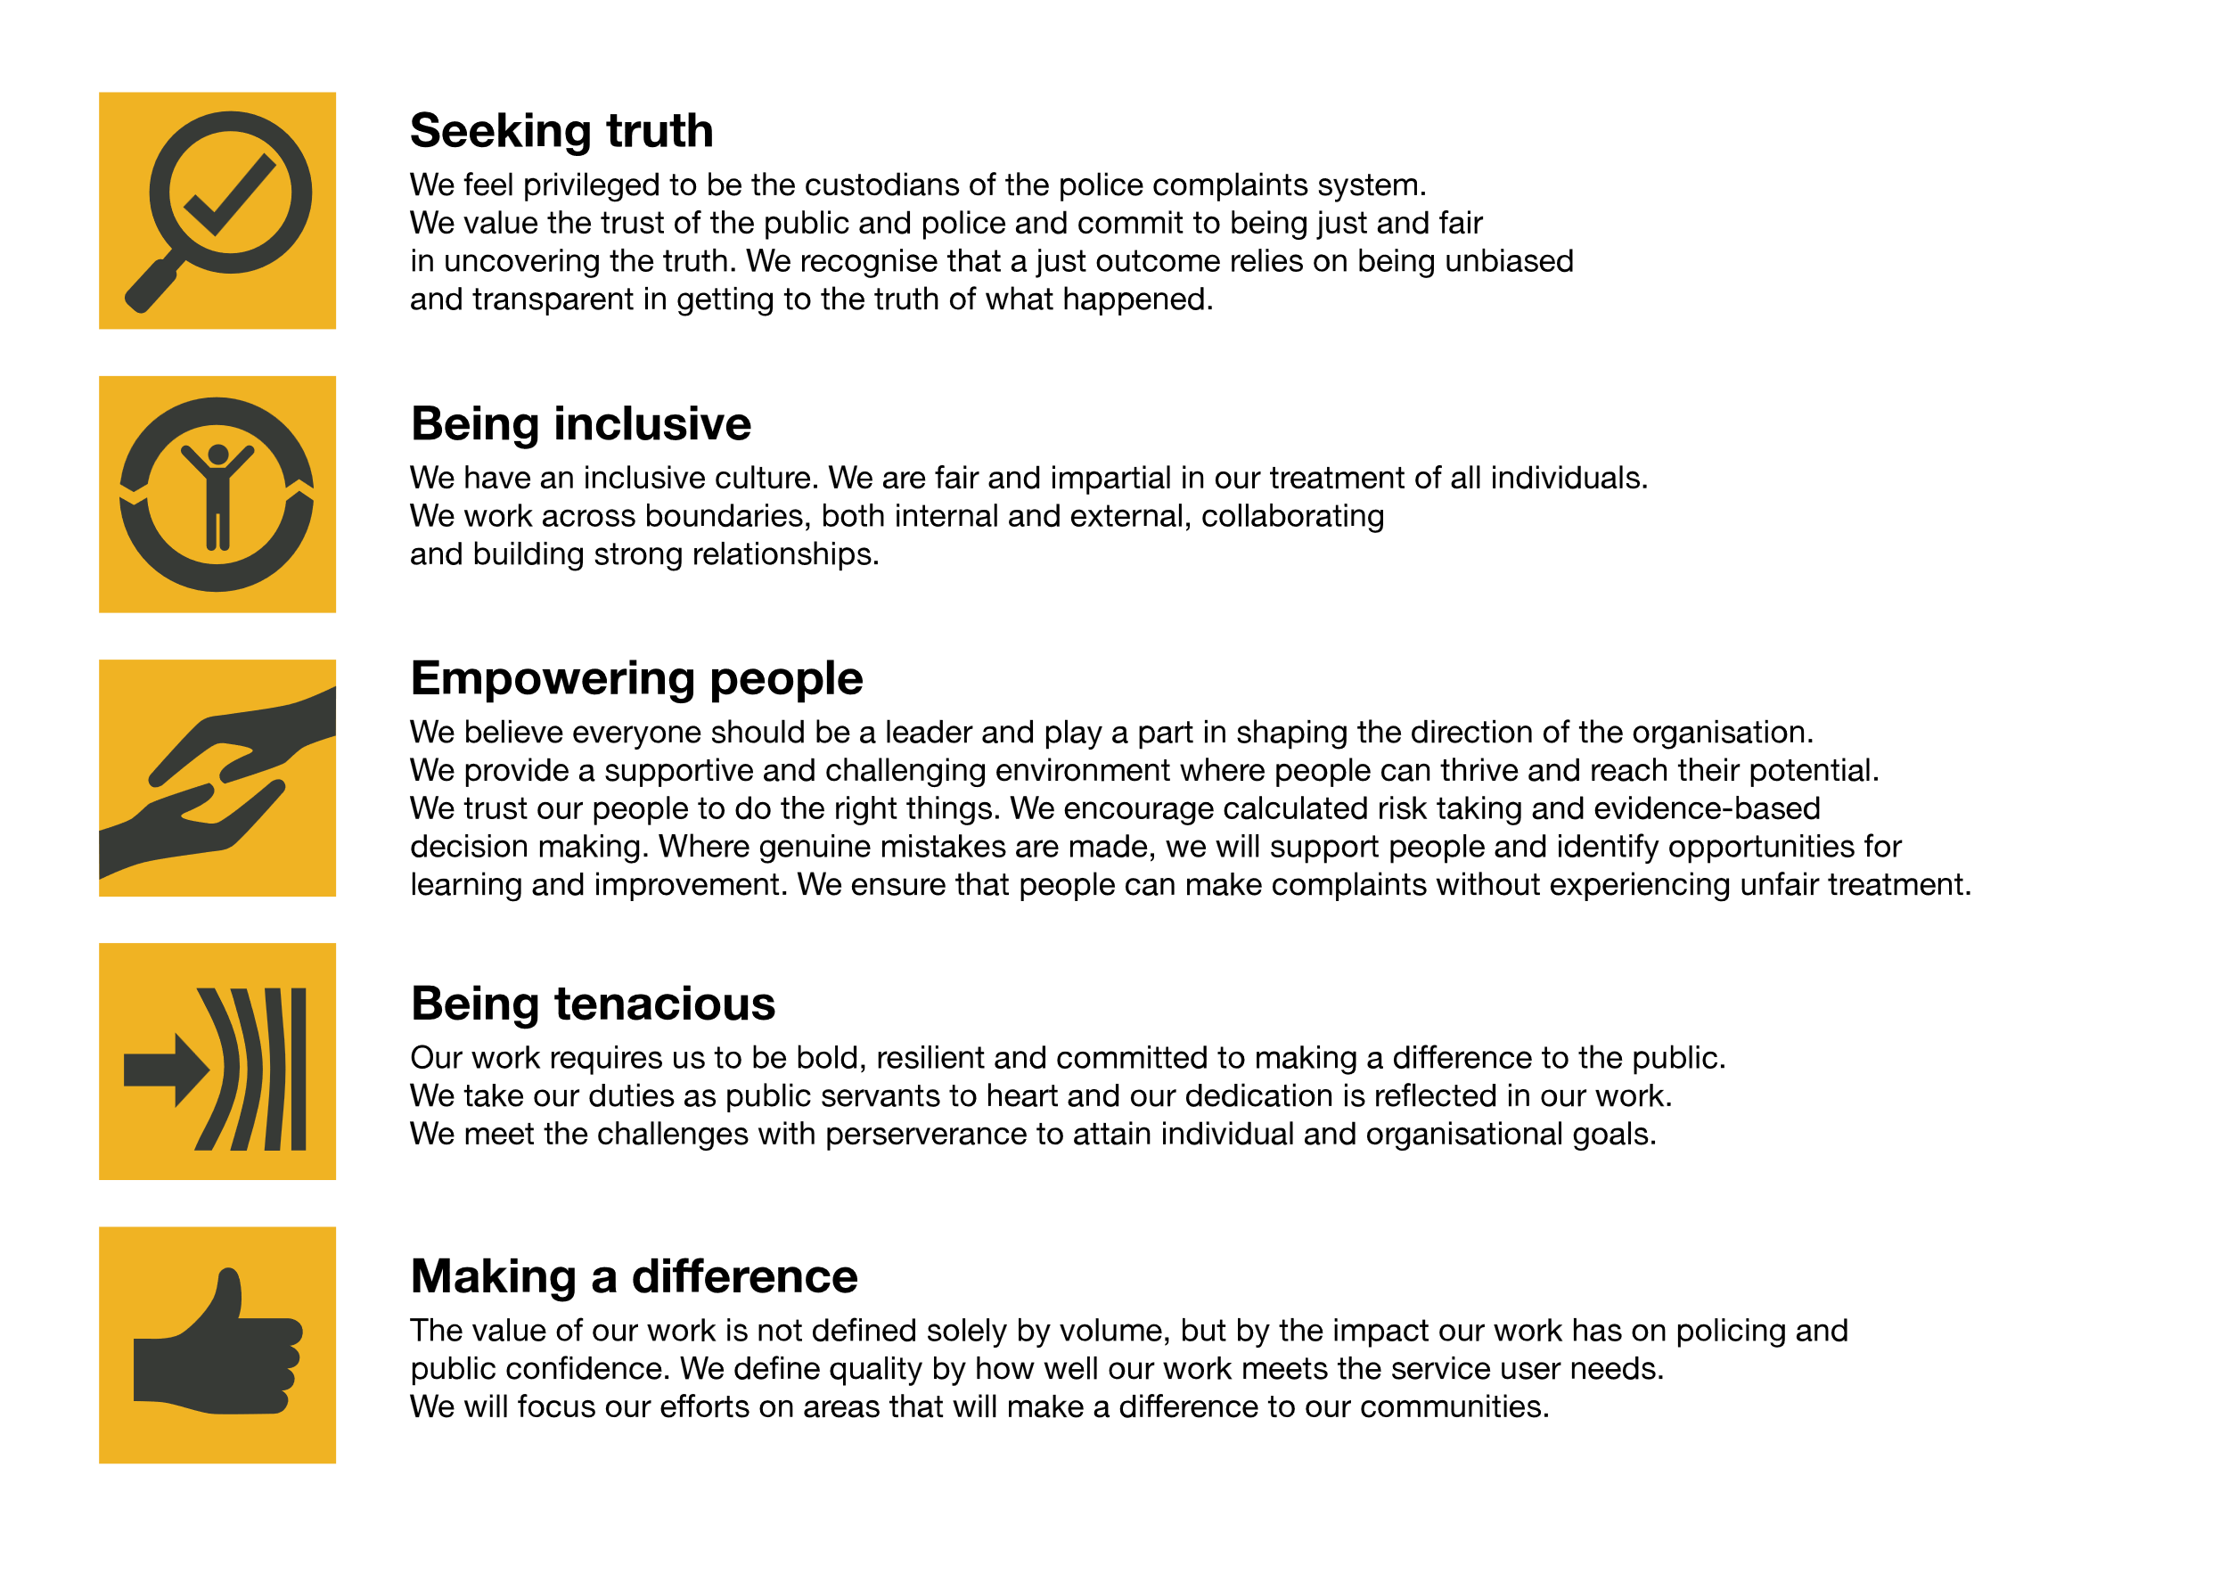We work in the context of our agreed values which inform the way we do things at the IOPC. The Proceedings Support Unit Specialistwill need to be commited to managing in the context of these values.

The IOPC is committed to **promoting equality and valuing diversity** in everything we do. Our vision is to be, and to be seen as, a leader in inclusive employment and services, demonstrating this ethos in everything that we do.

* As a silver standard Stonewall employer, we continue to commit ourselves to being a LGBTQ+ employer through the work of our Pride LGBTQ+ Staff Network, creating welcoming environments for lesbian, gay, bi and queer people.
* We are pleased to share we are a signatory of the Business in the Community Race at Work Charter. The Charter is composed of five [calls to action](https://race.bitc.org.uk/issues/racecharter) for leaders and organisations across all sectors.
* Being a Disability Confident employer, the IOPC is dedicated to removing the barrier for disabled people to thrive in the workplace.
* Our Staff Networks are constantly working to make the IOPC the leaders of inclusive employment, from our Allyship Programme to [Operation Hotton](https://www.policeconduct.gov.uk/recommendations/operation-hotton-recommendations-metropolitan-police-service-september-2021), to [Welsh Language Standards](https://www.policeconduct.gov.uk/who-we-are/equality-and-diversity/welsh-language-standards) and Know the Line Policy, we are constantly seeking new ways to create an environment for all to develop and thrive.

# Main duties and responsibilities

As a Proceedings Support Unit Specialist, you will provide support and specialist knowledge to Operational teams for coronial, criminal, and misconduct proceedings.

**Tasks include:**

* Plan the IOPC response to cases in the proceedings stage.
* Provide expertise, advice, guidance and coaching to operational colleagues to raise standards, improve operational delivery and working practices.
* Examine and assess all material gathered in criminal, misconduct and coronial investigations by applying relevant legislation and IOPC policy and guidelines, and produce schedules.
* Liaise with the Crown Prosecution Service, ensuring the IOPC meets its responsibilities, including requisition and charge, disclosure, possible Public Interest Immunity, and response to defence arguments.
* Lead the effective delivery of all high-risk processes relating to an officer or police member of staff being charged with a criminal offence. This will include requisitions, PNC updates and biometric samples.
* Represent the organisation at coronial, misconduct and criminal proceedings, making quick time decisions to respond to issues/requests in high pressure environments.
* Represent the organisation at CPS briefings, misconduct case conferences and PIRHs.
* Mentor and support operational staff when they are required to attend coronial, misconduct and criminal proceedings to improve operational delivery and colleague welfare.
* Act as a point of contact for complainants, bereaved families, interested parties and other external stakeholders to improve the experiences of service users.
* Lead on improving the standards of the updates we provide to external stakeholders and influence process improvements in relation to witness care.
* Provide regular, meaningful updates on the progress of proceedings to the investigation team, senior managers and external stakeholders.
* Work as part of a multi-disciplinary team with decision makers, lawyers, press officers and others.
* Liaise with Presenting Unit to provide support as required.
* Record decisions and actions on relevant databases.
* Monitor and report the outcome of proceedings to relevant internal stakeholders, external agencies and interested parties to improve joint working.
* Conduct exhibit audit during review of material for disclosure schedules and handle exhibits appropriately for court processes (if no exhibit manager in place)
* In conjunction with the Lead Investigator, manage the closure of the investigation to ensure that the procedural processes and continuity needs are met in accordance with relevant legislation and policies
* Promote and co-ordinate the post-proceedings debrief processes, by liaising with internal and external stakeholders to ensure learning and good practice is identified, shared, and implemented.
* Contribute to organisational quality assurance process by providing feedback on proceedings related tasks, to operational colleagues and promoting the use of existing quality assurance measures.
* Identify to PSU Manager areas of organisational improvements/ gaps in guidance and contribute to identifying solutions.
* Identify areas of risk in coronial, misconduct and criminal proceedings to operational staff and provide advice on how risks can be mitigated.
* Problem solve and be accountable for making decisions in respect to proceedings related issues and stakeholder requests

These main duties and responsibilities are intended only as a guide and are not intended to restrict the scope of the post holder to perform other duties. Additional responsibilities for the post holder may be agreed and recorded.

# Person specification

## Essential

* A sound knowledge and understanding of the Police (Conduct) Regulations 2020; Home Office Guidance; Criminal Procedures Investigations Act 1996 and relevant amendments to disclosure requirements.
* The post-holder will need to be an accredited IOPC investigator, or have equivalent experience, with knowledge and technical ability gained through extensive experience in relation to misconduct, criminal and coronial investigations
* Experience of undertaking the role of Disclosure Manager and building case files in criminal investigations.
* Experience of creating schedules for criminal, coronial, and misconduct disclosure.
* Experience of criminal, misconduct, and coronial procedures, including attendance and participation.
* Experience of, or the necessary knowledge to lead IOPC quality assurance processes in respect to proceedings work.
* Experience of persuading and negotiating with internal and external parties to complete tasks successfully and deal with problems as they arise.
* Experience of engagement to understand service user needs and issues and to build effective working partnerships.
* Proven experience of making decisions and problem solving in challenging, time pressured circumstances.
* Proven experience of having worked with multiple time demands and deadlines, exercising judgment on time management.
* Analytical skills with the capacity to absorb/organise new information to represent the IOPC.
* Ability to work to high level of detail and an ability to work accurately.
* Ability to identify and mitigate operational and organisational risk.

## Desirable

* Knowledge of Common Law Disclosure Guidelines.

## Reasonable adjustments

The IOPC is a diverse and inclusive workplace and we want to help you demonstrate your full potential whatever type of assessment is used. We are open to providing you with the tools you need to succeed, from extra time to formatting changes, to name a mere few. If you require any reasonable adjustments to our recruitment process, please email [campaigns@policeconduct.gov.uk](mailto:campaigns@policeconduct.gov.uk)

## Working conditions

Making the IOPC a great place to work is one of our key priorities. We are pleased to offer a unique hybrid working model based on business needs, balanced with the needs of our colleagues. Our business need framework guides our decisions about when it is best to work onsite (in our offices or other appropriate locations) to complete tasks most effectively or when to work remotely, offering colleagues flexibility to work where they feel most productive and supporting work-life balance. The model also encourages staff to feel welcome at the IOPC by ensuring we have opportunities to work face-to-face as teams.

## Preparation checklist

☐ Review the full job description

☐ Review the behaviours and the descriptors for each behaviour

☐ Review the Strengths dictionary

☐ Review the IOPC values

☐ Consider your Strengths

☐ Consider drafting example answers that cover the specific elements

☐ Prepare some questions to ask the interviewers