Job description
Title: Quality and Service Improvement Officer
(cross-deployable within the wider Quality team to include handling complaints and feedback from service users)
Reports to: Quality Team Leader
Location: Any IOPC office
Grade: 11
Salary: £33,783 (plus London Weighting Allowance of £4203 if based in Canary Wharf or Croydon)
Contract: Fixed-term – 12 months with the possibility of extension or being made permanent

Purpose
As a Quality and Service Improvement Officer, you will be welcomed into a dynamic and inclusive Strategy and Corporate Services directorate. The IOPC is on a journey to develop its culture, perspectives and ethos to support the organisation’s core outcomes and this is your opportunity to enter into the varied world of IOPC Quality and Service Improvement, allowing you to develop your mindset and approaches to contribute to improving the police complaints system in England and Wales.
This position will form part of the Quality & Service Improvement team which works at the forefront of the IOPC’s drive to deliver exceptional quality and value for money in the service that we provide to all our stakeholders and service users.
This position will be within the service improvement team within the wider Quality & Service Improvement team but will be expected to work flexibly across all areas of delivery. This includes working to respond as required, to complaints from service users.

The post holder will lead the organisation through the annual Customer Service Excellence® accreditation. They will also take a key role in the learning work as this is developed to the wider organisation.
The post holder can expect to work in a progressive and dynamic organisation with declared and strong core values. The work will be fulfilling and offer considerable opportunities for personal growth, challenge and satisfaction.
Please note: There will be a need to travel to other IOPC offices. There will also be a need to travel to other locations to meet with stakeholders and service users.
The purpose of this role is:
- To work as part of the quality team to provide support, as required, to colleagues handling, and responding to complaints from service users
- To drive improvements in delivery through engagement and collaboration with service users and stakeholders, using feedback to improve
- To lead improvement projects in line with organisational priorities
- To provide advice and guidance on IOPC ways of working, good practice and technical areas of expertise
- Contribute to improved organisational learning and disseminate learning and best practice across the IOPC
- To support colleagues in driving and sustaining improvements in IOPC delivery

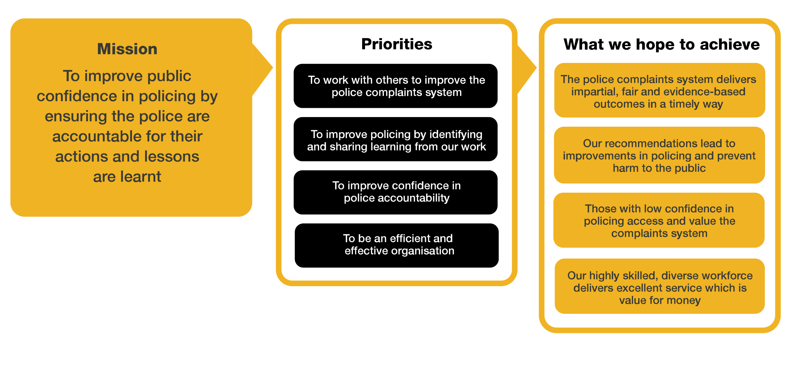
Organisational context

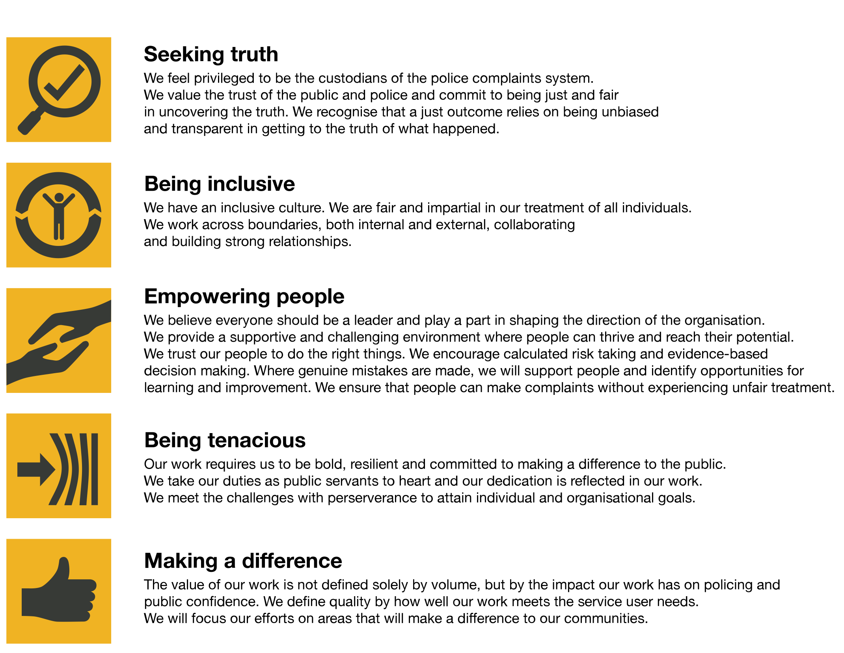
We work in the context of our agreed values which inform the way we do things at the IOPC. The Quality and Service Improvement Officer will need to be commited to managing in the context of these values.
The IOPC is committed to promoting equality and valuing diversity in everything we do. Our vision is to be, and to be seen as, a leader in inclusive employment and services, demonstrating this ethos in everything that we do.
- As a silver standard Stonewall employer, we continue to commit ourselves to being a LGBTQ+ employer through the work of our Pride LGBTQ+ Staff Network, creating welcoming environments for lesbian, gay, bi and queer people.
- We are pleased to share we are a signatory of the Business in the Community Race at Work Charter. The Charter is composed of five calls to action for leaders and organisations across all sectors.
- Being a Disability Confident employer, the IOPC is dedicated to removing the barrier for disabled people to thrive in the workplace.
- Our Staff Networks are constantly working to make the IOPC the leaders of inclusive employment, from our Allyship Programme to Welsh Language Standards and Know the Line Policy, we are constantly seeking new ways to create an environment for all to develop and thrive.

We particularly welcome applications from black and minority ethnic candidates as they are under-represented within the IOPC at this level.
The IOPC is proud to have been awarded Customer Service Excellence® accreditation. This independently assessed award demonstrates our commitment to put the service user at the heart of our work.

Main duties and responsibilities
Our Organisation
- Consider IOPC strategic intent when carrying out work, i.e. learning and accountability
- Identify and cycle learning and improvement from cases into the wider organisation in order to embed a ‘learning culture’
- Challenge work that doesn’t add value
- Represent the organisation as specified. This could include representing the IOPC at external events and meetings
- Attend and contribute to organisational improvement activities / events that seek to embed organisational learning and drive improvements throughout the organisation
- Champion and promote a service user focus across the IOPC

Our People
- Take responsibility for personal and professional learning and development
- Be able to give constructive feedback to colleagues, including peers and managers. Expect feedback and be able to reflect on it
- Maintain your professional expertise and keep up to date with relevant legislation, policy and good practice in order to strive for operational improvement
- If assigned, act as a buddy for new or junior staff
- Work with other teams across the IOPC to support them to define their own quality measures

Our Delivery
- Plan and lead strands of the quality improvement framework, including working with others to deliver:
  - Quality standards for teams across the IOPC
  - An audit / dip sampling regime to provide assurance about the quality of our work
  - Debriefs and after-action reviews with internal and external service users to identify learning for the IOPC and other organisations where necessary
  - Information and presentations for external stakeholders and service users as required
  - Collection, analysis, decision making and response to complaints and feedback about our work
  - An effective process for learning and improving our delivery in response to the identification of best practice, mistakes and service user / stakeholder feedback
  - Thematic, learning reviews of IOPC end to end processes
- Liaise with colleagues and external partners to recover and improve service delivery, identify and implement organisational learning
- Convert raw data (from a variety of sources) to useful management information, produce reports and present findings to senior managers as required
- Work collaboratively with colleagues across the Quality team to deliver the team’s objectives

Person specification

Essential Experience
Experience that would enable you to lead in one or more of the following areas and a working knowledge of at least one other area:
- Delivering improvement projects to drive quality, using an evidence based and service user focussed approach
- Responding to and resolution of complaints from service users and stakeholders.
- Experience of communicating verbally or in writing with challenging stakeholders

Desirable Experience
- Carrying out audits and reviews of areas of work – including setting parameters for the audit, engaging with stakeholders, conducting the audit and presenting findings and opportunities to senior managers, both in person and in writing
- Working with service users and stakeholders to understand their needs and ensure that these are fed into improvement activities
- Experience of gathering and analysing evidence against policy, guidance and legislation to inform decisions and recommendations

Knowledge
- Understanding of the police complaints system and the statutory framework within which the IOPC operates
- Understanding of the relevance of the Human Rights Act 1998; IOPC obligations under the Equality Act 2010, including the Public Sector Equality Duty, and other relevant legislation to the work of the IOPC
- Understanding of the IPCC (Staff Conduct) Regulations 2004 (desirable)
- Understanding of the IOPC’s staff code of conduct and the disciplinary and dismissal policy (desirable)
- Knowledge of safeguarding policy

Skills and Abilities
- Skilled and confident communicator, verbally and in writing, who is motivated by delivering high quality service directly to service users (both internal and external) and is driven to improve service wherever possible
- Able to persuade and influence others
- Self-motivated with the proven ability to plan and prioritise their own workload
- Able to prioritise and manage tasks effectively to deliver quality outcomes within challenging timescales
- Able to review the work of others, identify opportunities for learning and share learning across a wider team / organisation
- Skilled in giving constructive feedback to colleagues
- Promotes a culture which values diversity of experience and background and embeds team behaviours
- Provide expertise and guidance in key operational areas including investigations, appeals and referrals
- Proactively identifies and resolves issues and risks, including written risk assessments, and escalates where appropriate
- Able to work flexibly and remotely, including national travel, working independently and as part of a national team based in separate locations
- Confident to present information to senior managers, and work collaboratively across the IOPC to ensure learning drives improvements

Reasonable adjustments
The IOPC is a diverse and inclusive workplace and we want to help you demonstrate your full potential whatever type of assessment is used. We are open to providing you with the tools you need to succeed, from extra time to formatting changes, to name a mere few. If you require any reasonable adjustments to our recruitment process, please email humanresources@policeconduct.gov.uk

Working conditions
Making the IOPC a great place to work is one of our key priorities. We are pleased to offer a unique hybrid working model based on business needs, balanced with the needs of our colleagues. Our business need framework guides our decisions about when it is best to work onsite (in our offices or other appropriate locations) to complete tasks most effectively or when to work remotely, offering colleagues flexibility to work where they feel most productive and supporting work-life balance. The model also encourages staff to feel welcome at the IOPC by ensuring we have opportunities to work face-to-face as teams.

Preparation checklist
☐ Review the full job description
☐ Review the behaviours and the descriptors for each behaviour
☐ Review the Strengths dictionary
☐ Review the IOPC values
☐ Consider your Strengths (if applicable)
☐ Consider drafting example answers that cover the specific elements
☐ Prepare some questions to ask the interviewers

