**Job description**

**Title:**  **Organisational Development Lead**

**Reports to: Director, People**

**Location: Based in any IOPC office, hybrid working**

**Grade:** **13**

**Salary:**  **£44,340 per annum (plus London Weighting if applicable)**

**Contract:** **Permanent**

# Purpose

The IOPC was established in 2018, taking on many colleagues from a predecessor body the Independent Police Complaints Commission. In our first three year plan the focus was on modernisation and improvement. We were delighted that the Home Affairs Select Committee recognised the progress we have made. Our people survey results continue to improve, and our colleagues now judge us to be amongst the higher performing organisations in the civil service group.

Embarking on our second strategic plan will call for further, sometimes radical change. As OD lead you will be at the heart of this programme of work. As a highly experienced OD practitioner you will problem solve with teams and deliver light touch interventions, that improve team dynamics, deliver on our Leadership Charter and assist us in managing process and structural change.

You will develop cultural measures and collaborate across the People team to continue to deliver the change in culture that prepares colleagues for our future.

You will work in the context of our visible commitment to equality, diversity and inclusion.

You will need to be an effective collaborator, comfortable with matrix management and leading project workstreams. You will directly manage a small team.

# Our five year corporate strategy



**Awareness and confidence**: we want people to know about the complaints system and be confident to use it

**Accountability**: the complaints system delivers evidence based, fair outcomes which hold police to account

**Leading improvements**: our evidence and influence improves policing

**Performance**: An organisation that delivers high performance

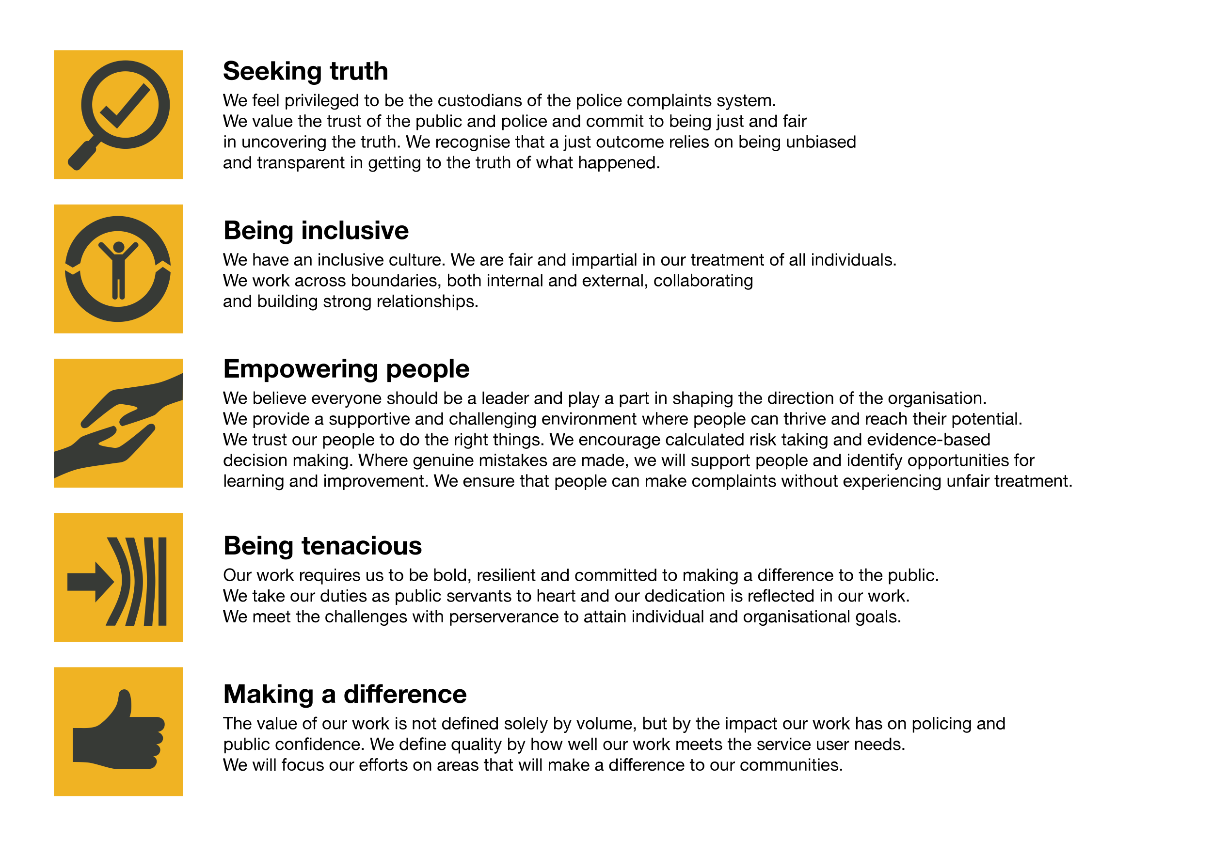We work in the context of our values which inform the way we do things at the IOPC.

The IOPC is committed to **promoting equality and valuing diversity** in everything we do. Our vision is to be, and to be seen as, a leader in inclusive employment and services, demonstrating this ethos in everything that we do.

* As a silver standard Stonewall employer, we continue to commit ourselves to being a LGBTQ+ employer through the work of our Pride LGBTQ+ Staff Network, creating welcoming environments for lesbian, gay, bi and queer people.
* We are pleased to share we are a signatory of the Business in the Community Race at Work Charter. The Charter is composed of five [calls to action](https://race.bitc.org.uk/issues/racecharter) for leaders and organisations across all sectors.
* Being a Disability Confident employer, the IOPC is dedicated to removing the barrier for disabled people to thrive in the workplace.
* Our Staff Networks are constantly working to make the IOPC the leaders of inclusive employment, from our Allyship Programme to our operational work to [Welsh Language Standards](https://www.policeconduct.gov.uk/who-we-are/equality-and-diversity/welsh-language-standards) we are constantly seeking new ways to create an environment for all to develop and thrive.

# Our Leadership Charter

# Main duties and responsibilities

**OD interventions**

* To develop the IOPC model of OD, coaching and encouraging colleagues to deliver OD interventions
* To work with People Business Partners to diagnose team and organisational issues and develop effective solutions
* To commission internal and external OD interventions to achieve effective change
* To personally lead development workshops
* To work with restorative practice techniques to enable change
* To maintain an up-to-date knowledge of best practice in OD and implement new approaches where appropriate

**Leadership Charter**

* To develop a plan to embed the IOPC leadership charter
* To develop an IOPC leadership plan following on from our recent Leadership Development Centres
* To commission leadership interventions and evaluate the outcomes
* To collaborate with People Management & Wellbeing Business Partners to identify struggling leaders and plan interventions to develop their skills

**Management Development**

* To work with the Talent Manager and Learning & Talent Development team to ensure there is a seamless process of development for managers and leaders
* To formulate a management development plan for existing managers to embed value driven management

**Culture**

* To raise the profile of the importance of cultural change to achieving our long-term objectives
* To define the change required in the IOPC culture and develop a culture change plan
* To work closely with the Equality Delivery Manger and Staff Networks to ensure that the culture change plan is inclusive and contributes to the IOPC EDI strategy
* To formulate measures to act as a “cultural barometer”
* To ensure regular measurement takes place and amend the culture change plan in response to results

**Organisation Design**

* To advise on effective structures based on an understanding of job roles
* To work with People Business Partners and LEAN practitioners to introduce and embed new structures and ways of working
* To work with the Learning & Talent Development team to identify and embed the necessary skills to implement new ways of working successfully
* To contribute to change teams that design and implement effective systems and structures to improve productivity and efficiency

**Evaluation**

* To embed evaluation into all planned work and share learning from mistakes and successes
* To contribute to after action reviews and produce occasional evaluation reports

**General**

* To ensure that OD and personal data is processed in line with UK GDPR
* To prepare and present papers for the Management Board and People and Culture Committee
* To manage and motivate a small team
* To manage contracts with external suppliers effectively and ensure procurement is compliant with internal policy and Cabinet Office controls.
* Contribute to departmental decision making through the People Senior Management team
* To identify opportunities for continuous improvement.
* Any other reasonable tasks relevant to the objectives of the role and appropriate to the grade

# Person specification

## **Experience**

1. Demonstrable experience of leading an OD workstream of a significant change project to a successful conclusion
2. Demonstrable experience of leading or making a significant contribution to an organisational culture change project
3. Proven ability to run workshops and OD interventions that define problems, generate solutions and enable change
4. Experience of collaborating with a wide range of stakeholders to deliver multi-disciplinary projects and promoting inclusive working.

**Skills and Abilities**

1. Thorough understanding of the issues that impact on organisational culture, values and performance and emerging trends and new practices
2. Effective project management skills including analytical skills, problem solving and decision making
3. Organised, self-motivated and capable of working autonomously within a rapidly changing environment.
4. Confident communication with the ability to influence and engage staff at all levels.
5. Evidence of commitment to continuing professional development for self and others.

**Technical**

1. Chartered Institute of Personnel and Development (CIPD) qualification at Level 5 or above or other specialist OD qualification such as Civil Service OD Practitioner Course.

**Reasonable adjustments**

The IOPC is a diverse and inclusive workplace and we want to help you demonstrate your full potential whatever type of assessment is used. We are open to providing you with the tools you need to succeed, from extra time to formatting changes, to name a mere few. If you require any reasonable adjustments to our recruitment process, please email [humanresources@policeconduct.gov.uk](mailto:humanresources@policeconduct.gov.uk)

**Working conditions**

Making the IOPC a great place to work is one of our key priorities. We are pleased to offer a unique hybrid working model based on business needs, balanced with the needs of our colleagues. Our business need framework guides our decisions about when it is best to work onsite (in our offices or other appropriate locations) to complete tasks most effectively or when to work remotely, offering colleagues flexibility to work where they feel most productive and supporting work-life balance. The model also encourages staff to feel welcome at the IOPC by ensuring we have opportunities to work face-to-face as teams.

## Preparation checklist

☐ Review the full job description

☐ Review the behaviours and the descriptors for each behaviour

☐ Review the Strengths dictionary

☐ Review the IOPC values

☐ Consider your Strengths (if applicable)

☐ Consider drafting example answers that cover the specific elements

☐ Prepare some questions to ask the interviewers