**Job description**

**Title: Senior Media Officer**

**Reports to: Media Relations Manager**

**Location: Birmingham or Cardiff**

**Grade: 13**

**Salary: £47,493**

**Contract: Permanent**

# Purpose

As a senior media officer, you will be welcomed into a dynamic and inclusive Communications team, working to provide advice on media and communications matters to IOPC staff at all levels up to and including the Director General and wider executive team. You will devise and deliver media handling plans, leading and managing a regional media operation. The IOPC is on a journey to develop its culture, perspectives and ethos to support the organisation’s core outcomes and this is your opportunity to enter into the varied and fast-paced world of IOPC Communications, allowing you to develop your mindset to contribute to improving public confidence in the police complaints system in England and Wales.

Reporting to the media relations manager, you will manage and develop a media officer to manage the reputation of the IOPC through proactive and reactive media relations including social media. The post holder will be security cleared to at least BS level, and this role is politically restricted.

# A screenshot of a computer screen Description automatically generatedOrganisational context

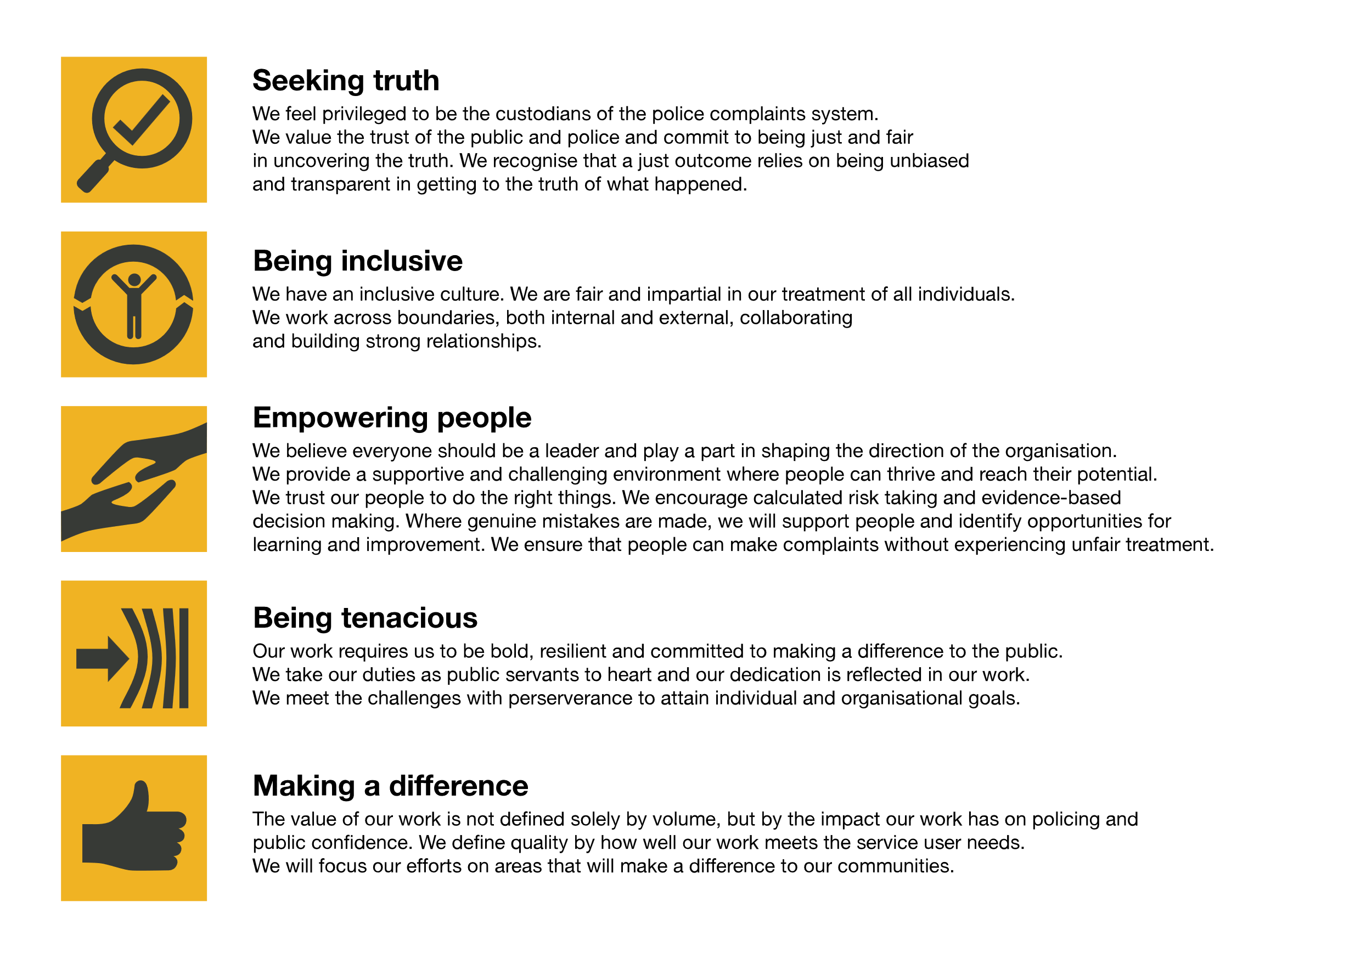We work in the context of our agreed values which inform the way we do things at the IOPC. The Senior Media Officer will need to be commited to managing in the context of these values.

The IOPC is committed to **promoting equality and valuing diversity** in everything we do. Our vision is to be, and to be seen as, a leader in inclusive employment and services, demonstrating this ethos in everything that we do.

* As a silver standard Stonewall employer, we continue to commit ourselves to being a LGBTQ+ employer through the work of our Pride LGBTQ+ Staff Network, creating welcoming environments for lesbian, gay, bi and queer people.
* We are pleased to share we are a signatory of the Business in the Community Race at Work Charter. The Charter is composed of five [calls to action](https://race.bitc.org.uk/issues/racecharter) for leaders and organisations across all sectors.
* Being a Disability Confident employer, the IOPC is dedicated to removing the barrier for disabled people to thrive in the workplace.
* Our Staff Networks are constantly working to make the IOPC the leaders of inclusive employment, from our Allyship Programme to [Operation Hotton](https://www.policeconduct.gov.uk/recommendations/operation-hotton-recommendations-metropolitan-police-service-september-2021), to [Welsh Language Standards](https://www.policeconduct.gov.uk/who-we-are/equality-and-diversity/welsh-language-standards) and Know the Line Policy, we are constantly seeking new ways to create an environment for all to develop and thrive.

# Main duties and responsibilities

* Deputising for the media relations manager as required
* Managing and developing two media officers between 2 locations.
* Supporting the media relations manager in managing the reputation of the IOPC through proactive and reactive media relations
* Providing a proactive and reactive social media service in line with our digital media strategy
* Supporting the media relations manager in providing leadership and strategic direction for media relations across the IOPC
* Providing expert advice to the IOPC executive team, senior managers and other colleagues on media relations and reputation management
* Developing and managing the implementation of media handling plans supporting IOPC investigations, reports, policy areas and key announcements
* Working with digital communications colleagues, assisting in the development of digital media plans
* Contributing to corporate projects and initiatives with a significant media impact or dimension
* Lead on key thematic areas by developing specific expertise in that area
* Working closely with members of the wider Communications team and other Strategy Communications and Engagement directorate teams to ensure communications are joined-up and consistent
* Proactively promoting the services and role of the media team within the IOPC
* Proactively engaging with external stakeholders to promote the role and remit of the IOPC and the media team, in particular the protocols and guidelines under which it operates
* Take part in the out of hours duty rota for the media team
* Any other duties as required by the post.
* Some travel may be required between the two offices

# Person specification

* Demonstrable experience of working in a media relations role in a high-profile organisation, and/or senior and relevant experience as a journalist
* Ability and resilience to manage competing priorities and multi-task on a daily basis
* Excellent written and verbal communicating and influencing skills
* Experience of working in corporate or strategic teams and contributing to major corporate initiatives
* Good interpersonal skills and the ability to deal confidently with people at all levels
* An understanding of how to manage and developing, a geographically dispersed, media relations team
* A flexible, proactive and creative approach

## Reasonable adjustments

The IOPC is a diverse and inclusive workplace and we want to help you demonstrate your full potential whatever type of assessment is used. We are open to providing you with the tools you need to succeed, from extra time to formatting changes, to name a mere few. If you require any reasonable adjustments to our recruitment process, please email [recruitment@policeconduct.gov.uk](mailto:recruitment@policeconduct.gov.uk)

## Working conditions

The IOPC are currently consulting with our consultative bodies about proposed changes to our hybrid working policy which will require all staff to work 20% of their contractual hours at their office base (or another office for business reasons) from 1 September and increased to 40% from April 2025. Office attendance time includes in-person training, meetings with stakeholders and families, and attending events.

## Preparation checklist

☐ Review the full job description

☐ Review the behaviours and the descriptors for each behaviour

☐ Review the Strengths dictionary

☐ Review the IOPC values

☐ Consider your Strengths (if applicable)

☐ Consider drafting example answers that cover the specific elements

☐ Prepare some questions to ask the interviewers