**Job description**

**Title: Data Quality Manager**

**Reports to: Data Governance Lead**

**Location: Birmingham, Canary Wharf, Cardiff, Croydon**

**Grade:** **12**

**Salary: £41,878, plus London Weighting Allowance of £4968, if based in**

**Canary Wharf or Croydon**

**Contract: Permanent**

# Purpose

As a Data Quality Manager, you will be welcomed into our Digital, Data and Technology function within Finance and Corporate Services. The IOPC is on a journey to develop its culture, perspectives, and ethos to support the organisation’s core outcomes, and this is your opportunity to enter into the varied world of IOPC Strategy and Impact, allowing you to develop your mindset and approaches to contribute to improving the police complaints system in England and Wales.

The Data Governance Team is part of the Digital, Data and Technology function within Data & Information department. These areas bring together teams responsible for Data Governance, Data Quality, Data Design & Architecture, Records Management, Insight and Analytics, as well as our technical ICT Teams. We operate nationally with team members across seven sites

The Data Quality Manager is the operational lead for data quality in the IOPC and responsible for supporting the Data Governance Lead with the delivery of data quality priorities within data governance framework as set out in the data strategy.

# Organisational context

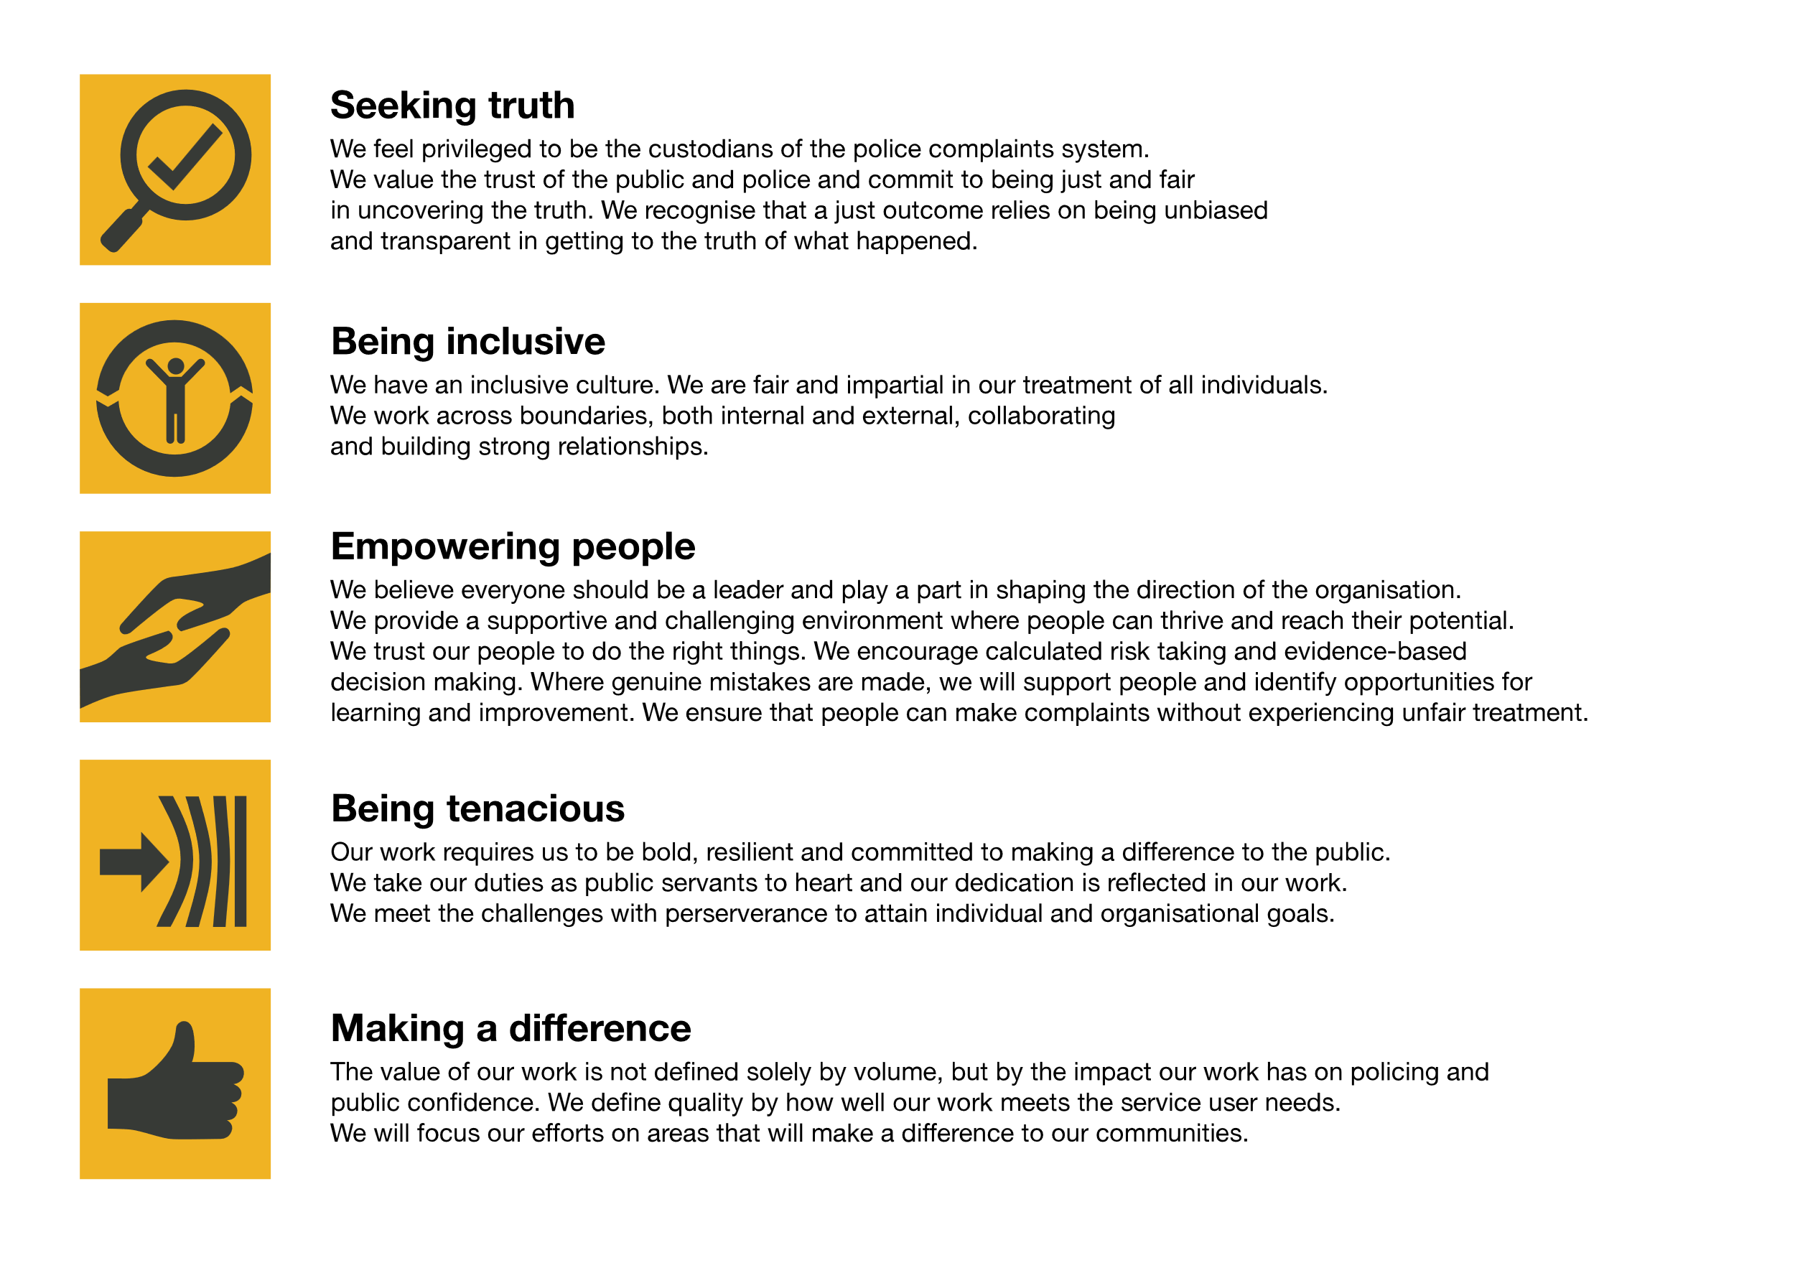We work in the context of our agreed values which inform the way we do things at the IOPC. The Data Quality Manager will need to be commited to managing in the context of these values.

The IOPC is committed to **promoting equality and valuing diversity** in everything we do. Our vision is to be, and to be seen as, a leader in inclusive employment and services, demonstrating this ethos in everything that we do.

* As a silver standard Stonewall employer, we continue to commit ourselves to being a LGBTQ+ employer through the work of our Pride LGBTQ+ Staff Network, creating welcoming environments for lesbian, gay, bi and queer people.
* We are pleased to share we are a signatory of the Business in the Community Race at Work Charter. The Charter is composed of five [calls to action](https://race.bitc.org.uk/issues/racecharter) for leaders and organisations across all sectors.
* Being a Disability Confident employer, the IOPC is dedicated to removing the barrier for disabled people to thrive in the workplace.
* Our Staff Networks are constantly working to make the IOPC the leaders of inclusive employment, from our Allyship Programme to [Operation Hotton](https://www.policeconduct.gov.uk/recommendations/operation-hotton-recommendations-metropolitan-police-service-september-2021), to [Welsh Language Standards](https://www.policeconduct.gov.uk/who-we-are/equality-and-diversity/welsh-language-standards) and Know the Line Policy, we are constantly seeking new ways to create an environment for all to develop and thrive.

# Main duties and responsibilities

* Leading on Data Quality improvement workstreams across the IOPC
* Supporting the design and development of the IOPC’s methodology for monitoring data quality, including development of data quality management processes
* Identify data that is of critical/significant importance to the IOPC, alongside other Information Management Teams, and support the design of processes to help manage that data
* Designing and developing new organisational data quality processes
* Driving forward the data quality elements of the IOPC’s Data Strategy
* Monitoring organisation performance against data quality standards and policies, rectifying issues, identifying risk, and maximising value.
* Provide support to the Data Governance Lead in establishing responsibilities and roles for data quality across the organisation
* Work with Learning and Development to develop formal training for IOPC’s information management systems to maintain our data quality standards
* Ensure that the business are provided with appropriate support, guidance, and training in relation to agreed data quality principles and processes
* Work with the Data Governance team to develop an organisational data catalogue, and associated glossaries and dictionaries for the IOPC
* Provide management supervision to the Data Quality Officer roles to evaluate the quality of the data in the IOPC’s information management systems, analysing it for errors, inconsistencies, and other defects.
* Be an ambassador, leading conversations, and continuous improvement in data capabilities as part of our Data Strategy and improving our data literacy/culture

# Person specification

## Essential

* Expert level of understanding of data quality and the government data quality dimensions
* Excellent understanding of industry best practice in methodology of managing enterprise data quality across a complex data estate
* A passion for data and the desire to create a data led culture and understanding how this can improve business performance.
* You are committed, independent, reliable, problem focused and pragmatic.
* You are a superb communicator, networker and influencer who can challenge how things are done where necessary
* Knowledge of data quality tooling
* Knowledge of undertaking data quality assessment to prepare data for use with artificial intelligence and automation
* Excellent understanding of data quality metrics and the assessment of the usefulness/quality of data.
* Able to work flexibly and independently, including national travel, as part of a team based in separate locations
* A detailed understanding of data quality reporting and data analytics/BI tools and techniques

## Experience

* A track record in managing, monitoring and analysing data quality against the Government Data Quality Framework A qualification in a relevant data/analytical field or a minimum of 2 years’ experience working directly on data quality
* Holding or working towards CDMP Data Management Qualification, or similar
* Experience of designing and developing data quality processes
* Experience of data quality reporting and analysis
* Knowledge of basic concepts of law and regulatory guidance/standards regarding data management and trends in data policy.
* Experience of supporting business change.
* Experience of leading a team or project with positive outcomes

## Skills and Abilities

* Practical, and operational understanding of data quality and the ability to reconcile with a complex public sector environment and a varied data estate.
* Develop strategies to drive behavioural changes across teams with data being valued and handled as a strategic asset.
* Ability to lead a team that can support non-data colleagues to deliver data quality related outcomes
* Effective communication skills
* Competent in the use of MS Office, advanced MS Excel skills
* Power BI reporting and analytics skills
* Combining and comparing multiple data sources including those in enterprise data warehouses

## Reasonable adjustments

The IOPC is a diverse and inclusive workplace, and we want to help you demonstrate your full potential whatever type of assessment is used. We are open to providing you with the tools you need to succeed, from extra time to formatting changes, to name a mere few. If you require any reasonable adjustments to our recruitment process, please email [recruitment@policeconduct.gov.uk](mailto:recruitment@policeconduct.gov.uk)

## Working conditions

## Making the IOPC a great place to work is one of our key priorities. We are pleased to offer a hybrid working model. The IOPC requires all staff to work 20% of their contractual hours at their office base (or another office for business reasons) from September 2024, increasing to 40% from April 2025. Office attendance time includes in-person training, meetings with stakeholders and families, as well as attending events.

## Preparation checklist

☐ Review the full job description

☐ Review the behaviours and the descriptors for each behaviour

☐ Review the Strengths dictionary

☐ Review the IOPC values

☐ Consider your Strengths

☐ Consider drafting example answers that cover the specific elements

☐ Prepare some questions to ask the interviewers