**Job description**

**Title: Legal Assistant**

**Reports to: Legal Services Practice Manager**

**Location: Birmingham or Cardiff**

**Grade: 7**

**Salary: £26,765**

**Contract: Permanent**

# Purpose

As a Legal Assistant, you will be welcomed into a dynamic and inclusive Legal team working to provide administrative support across the IOPC. The IOPC is on a journey to develop its culture, perspectives and ethos to support the organisation’s core outcomes and this is your opportunity to enter into the varied world of IOPC Legal, allowing you to develop your mindset and approaches to contribute to improving the police complaints system in England and Wales.

The Legal Assistant role acts as a member of the Legal Services Practice Management Team, providing a high quality administrative support service to the General Counsel, Senior Lawyers and Lawyers across the IOPC offices.

# Organisational context

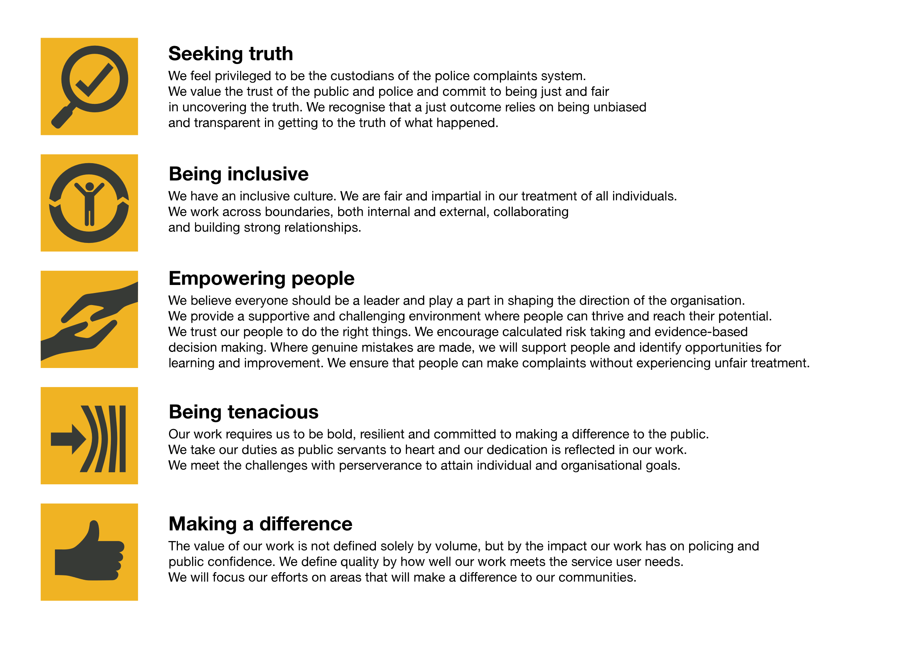We work in the context of our agreed values which inform the way we do things at the IOPC. The Legal Assistant will need to be commited to managing in the context of these values.

The IOPC is committed to **promoting equality and valuing diversity** in everything we do. Our vision is to be, and to be seen as, a leader in inclusive employment and services, demonstrating this ethos in everything that we do.

* As a silver standard Stonewall employer, we continue to commit ourselves to being a LGBTQ+ employer through the work of our Pride LGBTQ+ Staff Network, creating welcoming environments for lesbian, gay, bi and queer people.
* We are pleased to share we are a signatory of the Business in the Community Race at Work Charter. The Charter is composed of five [calls to action](https://race.bitc.org.uk/issues/racecharter) for leaders and organisations across all sectors.
* Being a Disability Confident employer, the IOPC is dedicated to removing the barrier for disabled people to thrive in the workplace.
* Our Staff Networks are constantly working to make the IOPC the leaders of inclusive employment, from our Allyship Programme to [Operation Hotton](https://www.policeconduct.gov.uk/recommendations/operation-hotton-recommendations-metropolitan-police-service-september-2021), to [Welsh Language Standards](https://www.policeconduct.gov.uk/who-we-are/equality-and-diversity/welsh-language-standards) and Know the Line Policy, we are constantly seeking new ways to create an environment for all to develop and thrive.

# Main duties and responsibilities

* To provide high quality support services which support Legal Services as a whole and meet the needs of individual lawyers.
* To undertake archiving of the Legal paper files.
* To implement new systems, processes and ways of working and to contribute to the development and implementation of service plans, initiatives and projects.
* To maintain the Legal Services case management system, Tricostar, including the production of performance reports.
* To accurately collate and index bundles of documents, both in hard copy and electronically including for Court hearings and Misconduct Hearings
* Diary management for staff in Legal Services to include arranging meetings, booking venues, arranging catering, booking travel and accommodation etc.
* To deliver documents to Courts, Chambers and other offices.
* To create agenda’s for monthly team meetings and take the minutes of these meetings.
* To maintain and update where necessary the Legal Library and loose leaf books and manuals.
* To undertake basic financial tasks such as processing invoices and purchase orders, expenses for payment and cheque requests.
* Any other duties commensurate with the duties and grade of the post that may from time to time be directed.

# Person specification

## Essential Experience

* + A good range of general administrative experience.
  + High degree of organisational ability and attention to detail
  + Self-starter, able to work unsupervised and on own initiative with the ability to prioritise and multi-task
  + Excellent written and oral communication skills
  + Excellent interpersonal skills, including tact, discretion and liaising with representatives from external organisations
  + Good time management with the ability to evaluate competing priorities
  + Demonstrable experience of team working ability
  + Good IT skills, especially in relation to Microsoft Office products
  + Ability to interrogate existing databases to produce management statistics.
  + Able to travel to other IOPC venues and external organisations when required including occasional overnight stays.

## Desirable Experience

* + A good knowledge of legal processes either through training or practical experience.

## Reasonable adjustments

The IOPC is a diverse and inclusive workplace and we want to help you demonstrate your full potential whatever type of assessment is used. We are open to providing you with the tools you need to succeed, from extra time to formatting changes, to name a mere few. If you require any reasonable adjustments to our recruitment process, please email [recruitment@policeconduct.gov.uk](mailto:recruitment@policeconduct.gov.uk)

## Working conditions

The IOPC are currently consulting with our consultative bodies about proposed changes to our hybrid working policy which will require all staff to work 20% of their contractual hours at their office base (or another office for business reasons) from 1 September and increased to 40% from April 2025. Office attendance time includes in-person training, meetings with stakeholders and families, and attending events.

## Preparation checklist

☐ Review the full job description

☐ Review the behaviours and the descriptors for each behaviour

☐ Review the Strengths dictionary

☐ Review the IOPC values

☐ Consider your Strengths (if applicable)

☐ Consider drafting example answers that cover the specific elements

☐ Prepare some questions to ask the interviewers