**Job description**

**Title: Financial Accountant**

**Reports to: Senior Accountant**

**Location: Cardiff**

**Grade: 12**

**Salary: £40,075 (pay award pending)**

**Contract: Permanent**

# Purpose

As a Financial Accountant, you will be welcomed into a dynamic and inclusive Finance team working on a range of financial accounting activities including providing advice, ensuring compliance with accounting standards and tax regulations. As well as supporting the preparation of the IOPC statutory accounts. The IOPC is on a journey to develop its culture, perspectives and ethos to support the organisation’s core outcomes, and this is your opportunity to enter the varied world of IOPC finance, allowing you to develop your mindset and approaches to contribute to improving the police complaints system in England and Wales.

# A screenshot of a computer screen Description automatically generatedOrganisational Context

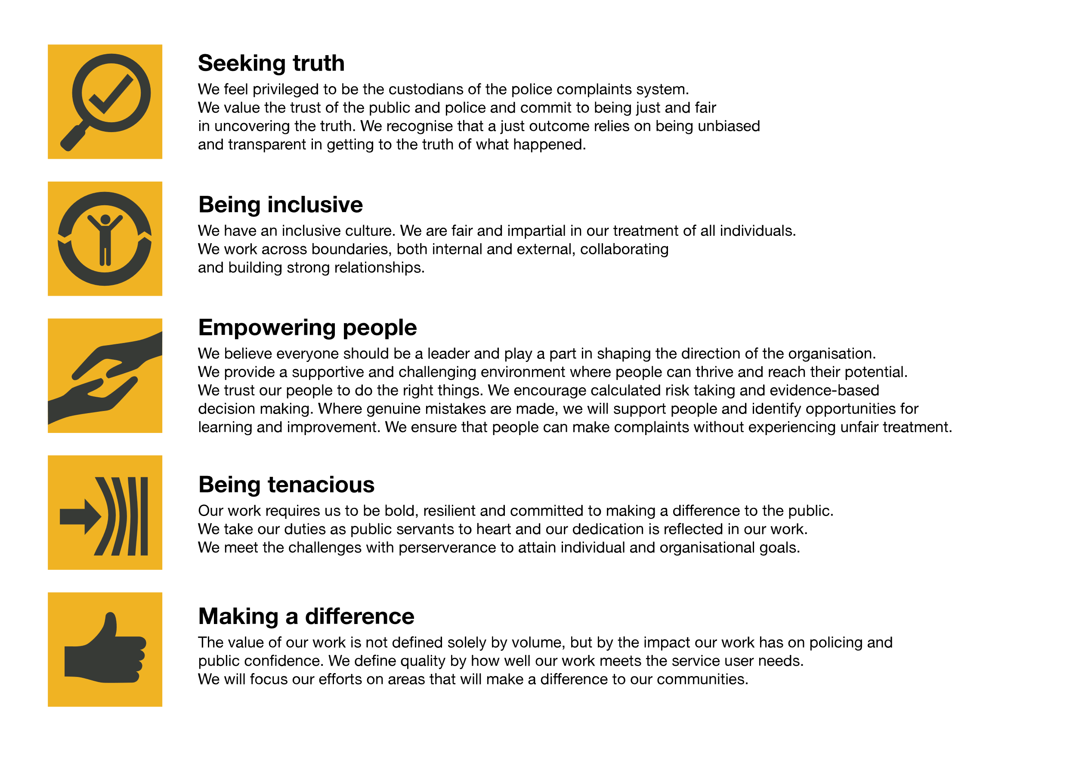We work in the context of our agreed values which inform the way we do things at the IOPC. The Financial Accountant will need to be commited to managing in the context of these values.

The IOPC is committed to **promoting equality and valuing diversity** in everything we do. Our vision is to be, and to be seen as, a leader in inclusive employment and services, demonstrating this ethos in everything that we do.

* As a silver standard Stonewall employer, we continue to commit ourselves to being a LGBTQ+ employer through the work of our Pride LGBTQ+ Staff Network, creating welcoming environments for lesbian, gay, bi, and queer people.
* We are pleased to share we are a signatory of the Business in the Community Race at Work Charter. The Charter is composed of five [calls to action](https://race.bitc.org.uk/issues/racecharter) for leaders and organisations across all sectors.
* Being a Disability Confident employer, the IOPC is dedicated to removing the barrier for disabled people to thrive in the workplace.
* Our Staff Networks are constantly working to make the IOPC the leaders of inclusive employment, from our Allyship Programme to [Operation Hotton](https://www.policeconduct.gov.uk/recommendations/operation-hotton-recommendations-metropolitan-police-service-september-2021), to [Welsh Language Standards](https://www.policeconduct.gov.uk/who-we-are/equality-and-diversity/welsh-language-standards) and Know the Line Policy, we are constantly seeking new ways to create an environment for all to develop and thrive.

# Main duties and responsibilities

* Maintain the asset register, ensuring correct treatment of disposals, additions, and depreciation for capital transactions. Maintain record of assets under construction to support the asset register.
* Maintain integrity of the trial balance through regular review of transactions. Prepare and/or review working papers and associated journal postings.
* Ensure all balance sheet account reconciliations are completed, actively investigating any discrepancies and coordinating with stakeholders for resolutions. Undertake bank reconciliation on rotation with Senior Finance Officer.
* Accounting for VAT and PSA tax, including preparation of returns for approval and submission to HMRC by deadline.
* Prepare budget and regular forecasting for all non-cash transactions including depreciation.
* Provide support to People Directorate on payroll processing and problem solving. Undertake validation of monthly payroll for BACS processing and HMRC submissions.
* Administer same day bank payments and BACS authorisations on rota and

ad hoc when necessary.

* Prepare timely regulatory and stakeholder reporting in relation to responsibilities of the financial accounting team, including preparation of Home Office quarterly consolidation pack and workforce management information returns.
* Prepare compliance reporting in line with corporate policies and regulatory requirements.
* Support the Senior Accountant in preparation of the IOPC statutory financial accounts. To include gathering evidence and preparing accounting disclosures.
* Support the external audit process by being the contact point for information sharing and attendance at audit planning meetings.
* Support the Senior Accountant to ensure Government Financial Reporting Manual and National Audit Office Disclosure Checklist requirements are understood and incorporated into the statutory financial accounts.
* Support IOPC financial system administration and contribute to system development.
* Build strong professional relationships with internal and external stakeholders while acting as a guide, providing technical accounting advice in line with IFRS and the financial reporting manual (FReM) and other relevant Government guidance documents. Ensuring financial transparency of IOPC operations and demonstrating adherence to best practice.
* Support Senior Accountant with other Financial Accounts projects and activities including review of current processes to identify and implement improvements for efficiency.
* Maintain relevant task instructions to ensure resilience of the team during periods of absence.

# Person specification

## Essential Experience

* Experience of financial accounting activities and liaising with auditors.
* Experience of analysing and accurately interpreting data from various sources to support decisions, demonstrating attention to detail, problem-solving and analytical skills.
* Understanding of an effective financial control environment.
* Experience of working independently, managing a busy workload to deliver deadlines and priorities.

## Desirable Experience

* + Preparation of statutory financial statements and notes for the Annual Report and Accounts.
* Experience of effectively communicating complex financial information and decisions to a range of stakeholders.
* Experience of developing policies and procedures to ensure compliance with accounting standards.

## Essential Technical

* Qualified accountant with current membership to CCAB (ACA, ACCA, CIMA, CIPFA).
* Up-to-date knowledge of accounting standards and best practice.
* High level of IT literacy, particularly MS Excel.

## Desirable Technical

* An understanding of Finance systems administration and experience of working with finance systems, ideally Unit 4 Business World.
* Knowledge of the HM Treasury Financial Reporting Manual (FreM)

## Reasonable adjustments

The IOPC is a diverse and inclusive workplace, and we want to help you demonstrate your full potential whatever type of assessment is used. We are open to providing you with the tools you need to succeed, from extra time to formatting changes, to name a mere few. If you require any reasonable adjustments to our recruitment process, please email [recruitment@policeconduct.gov.uk](mailto:recruitment@policeconduct.gov.uk)

## Working conditions

The IOPC are currently consulting with our consultative bodies about proposed changes to our hybrid working policy which will require all staff to work 20% of their contractual hours at their office base (or another office for business reasons) from 1 September and increased to 40% from April next year. Office attendance time includes in-person training, meetings with stakeholders and families, and attending events.

## Preparation checklist

☐ Review the full job description

☐ Review the IOPC values

☐ Consider your Strengths (if applicable)

☐ Consider drafting example answers that cover the specific elements

☐ Prepare questions to ask the interviewers