**2**

**Job description**

**Title: System Data Governance Lead – Microsoft 365 (M365)**

**Reports to: Head of Data and Information**

**Location: Birmingham, Canary Wharf, Cardiff, Croydon, Sale or Wakefield**

**Grade:** **14**

**Salary: £57,864, plus London Weighting Allowance of £4968, if based in**

**Canary Wharf or Croydon**

**Contract: Permanent**

# Purpose

As a M365 Data Governance Lead, you will be welcomed into our Digital, Data and Technology function within Finance and Corporate Services. We are looking for an experienced Product Owner with a proven track record of programme level data management of M365 Suite capabilities. Our ideal candidate will have a minimum of 12 months experience of delivering strategic needs with a strength in stakeholder engagement. This is a **data post** with a focus on the onboarding of M365 solutions and data lifecycle management of the M365 environment including data retention, access control and data literacy and how the M365 technology assists good record and document management.

The System Governance Team is part of the Digital, Data and Technology function within Data & Information department. DDaT brings together teams responsible for Data & System Governance, Data Quality, Data Design & Architecture, Data and Records Management, Insight and Analytics, as well as our technical ICT Teams. We operate nationally with team members across seven sites

You will support the Head of Data and Information Lead with the delivery of organisational priorities within the IOPC Data Strategy and driving the Data evolution of our M365 technology. We want you to embed a culture of excellent data management into the organisation, we are looking for someone who is passionate about M365 and data to contribute to improving the police complaints system in England and Wales.

# Organisational context

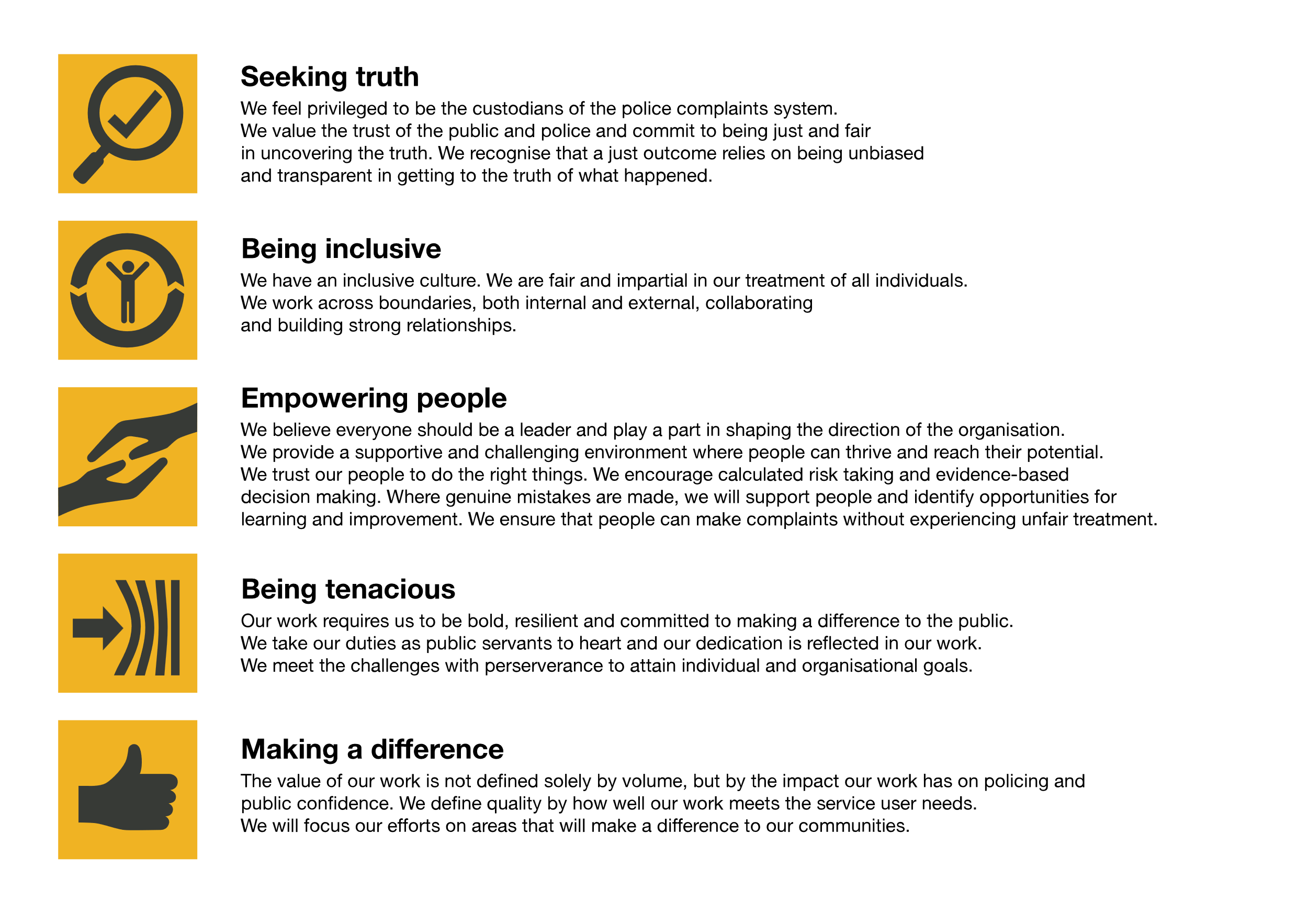We work in the context of our agreed values which inform the way we do things at the IOPC. The Data Governance Officer will need to be commited to managing in the context of these values.

The IOPC is committed to **promoting equality and valuing diversity** in everything we do. Our vision is to be a leader in inclusive employment and services, demonstrating this ethos in everything that we do.

* As a silver standard Stonewall employer, we continue to commit ourselves to being a LGBTQ+ employer through the work of our Pride LGBTQ+ Staff Network, creating welcoming environments for lesbian, gay, bi, and queer people.
* We are pleased to share we are a signatory of the Business in the Community Race at Work Charter. The Charter is composed of five [calls to action](https://race.bitc.org.uk/issues/racecharter) for leaders and organisations across all sectors.
* Being a Disability Confident employer, the IOPC is dedicated to removing the barrier for disabled people to thrive in the workplace.
* Our Staff Networks are constantly working to make the IOPC the leaders of inclusive employment, from our Allyship Programme to [Operation Hotton](https://www.policeconduct.gov.uk/recommendations/operation-hotton-recommendations-metropolitan-police-service-september-2021), to [Welsh Language Standards](https://www.policeconduct.gov.uk/who-we-are/equality-and-diversity/welsh-language-standards) and Know the Line Policy, we are constantly seeking new ways to create an environment for all to develop and thrive.

# 

# Main duties and responsibilities

* Primary responsibility for M365 Productivity tools and services, as a Product Owner. Responsible for M365 Data governance, quality and management through effective and innovative development and implementation of the M365 roadmap.
* Create and deliver the M365 Data roadmap including Purview and CoPilot M365 technical capabilities to enhance our M365 usage.
* To lead the M365 Data Project – with key stakeholders and IT, providing expert advice and policy / process creation and guidance on M365 use and data.
* To lead and coordinate/support M365 testing and problems solving for development in M365 and connection within our system infrastructure, including AI evolution opportunities.
* Engage suppliers and external bodies, to ensure our systems are upgraded as necessary to maintain our data integrity and that our interests are appropriately represented
* To identify and coordinate change through the IOPC DDaT governance structure and manage the change request processes, including the organisation’s expectations for change.
* Lead the Data literacy for M365 and work with Learning and Development, to ensure training materials/sessions are in place and that these are communicated to staff with the support of Corporate Communications.
* Ensure Data compliance with DPA and UK GDPR and Record and Information Management in the M365 environment.
* Lead and own the development and introduction of appropriate auditing processes and scheduled M365 data management audits across IOPC Data & Information, including M365 access permission requests in line with policy.
* Responsible for overseeing the management of the System Data audit and assurance team, and day-to-day auditing and assurance.
* Develop & Oversee delivery of the system audit schedule across the IOPC’s digital and data estate to test the efficacy and offer assurance around our data governance processes
* Support the wider Data & Information Teams the design and implementation of the Data Strategy, driving the ambition to be data driven and enabled.
* Support IOPC Data Owners with their roles and responsibilities, providing assurance of their activities and feeding back to appropriate groups across the organisation. Chair any associated user groups and other meetings, where necessary
* Provide assurance to the Information Assurance Group on risk and compliance matters associated with M365 Data.

# Person specification

## Essential Skills & Experience

* Min of 12 months experience of ownership of M365 **Data** ownership at a organisational cross departmental strategic level.
* Experience of process improvement and development, including system audit processes, access permissions and Purview
* Experience of data audit associated with cross verification of multiple system platforms. (Case/Record Management / SharePoint / M365)
* Understanding of industry best practice of System Data Assurance, standards and methodologies
* An understanding of the stages of the data lifecycle and how they relate to M365 business processes, organisational/legislative compliance and analysis.
* Support the creation of M365 supported data insight and create assurance summary reports and findings to improve M365 Data Capture and Usage.
* Strategic Project change experience to identify and lead prioritisation of M365 development and deliver on time and efficiently.
* Experience of staff line management and cross departmental / organisational working.
* Experience in identifying opportunities for innovation, applying critical thinking to identify solutions to problems in line with evidence-based practice
* Building strong working relationships with internal stakeholders and end users.
* Experience of ownership of meetings and engagement with commercial providers to evolve and development the relationship around product development.
* Experience of leading strategic needs at National, Regional and Local level to enable maximisation of the development of system assurance and utilisation.
* Demonstrable evidence of strong analytical and communication skills both written and verbal.
* Knowledge of basic concepts of data legislation and regulatory guidance/standards regarding data management and policy.
* Competent in the use of Microsoft Office and M365 teams / SharePoint / Forms / Bookings and Apps
* Able to prioritise and manage own tasks effectively.
* You are committed, independent, reliable, problem focused and pragmatic.
* Able to work flexibly and independently, including national travel, as part of a team based in separate locations

## Desirable Criteria

* Experience in Police data
* A qualification in M365 Administration.

## Reasonable adjustments

The IOPC is a diverse and inclusive workplace, and we want to help you demonstrate your full potential whatever type of assessment is used. We are open to providing you with the tools you need to succeed, from extra time to formatting changes, to name a mere few. If you require any reasonable adjustments to our recruitment process, please email [recruitment@policeconduct.gov.uk](mailto:recruitment@policeconduct.gov.uk)

## Working conditions

Making the IOPC a great place to work is one of our key priorities. We are pleased to offer a hybrid working model. The IOPC requires all staff to work 20% of their contractual hours at their office base (or another office for business reasons) from September 2024, increasing to 40% from April 2025. Office attendance time includes in-person training, meetings with stakeholders and families, as well as attending events.

Here at the IOPC, maintaining a culture that is accessible and inclusive of gender identity, sexuality, age, disability, race, sex, belief and caring responsibilities is deeply important to us. We believe that a rich, diverse workforce enables us a better understanding of each others needs, and produces more meaningful and trusting relationships, which in turn create more inclusive spaces where we all feel that we can contribute and belong.  We value our diversity, as we believe that our diversity is our strength. It allows us to identify with our communities through shared lived experiences producing better understanding and higher quality results in our work.

## Preparation checklist

☐ Review the full job description

☐ Review the behaviours and the descriptors for each behaviour

☐ Review the Strengths dictionary

☐ Review the IOPC values

☐ Consider your Strengths

☐ Consider drafting example answers that cover the specific elements

☐ Prepare questions to ask the interviewers