**Job description**

**Title:** Transformation Assurance Manager

**Reports to:** PMO Lead

**Location: IOPC Offices:** Birmingham, Sale, Cardiff, Wakefield, Croydon or Canary Wharf

**Grade:** 13

**Salary:** £47,493 (plus London Weighting allowance of £4,968 if located in Canary Wharf or Croydon)

**Contract:** Fixed-Term until 31st December 2025

# Purpose

As a Transformation Assurance Manager, you will be welcomed into a dynamic and inclusive Strategy Unit in the Business Development Department which works to support the implementation of programmes and projects that will deliver our organisation’s strategic objectives. The IOPC will be running an exciting Transformation Programme to help us deliver the capability and deliver financial benefits needed to support the deliver towards our strategy. The Transformation Assurance Manager will be essential to ensuring we achieve the benefits we need to from our Transformation programme and succeed in being the organisation we aspire to be.

A fundamental component of IOPC’s change management process is the independent assurance of delivery of projects at pre-defined stages throughout the change lifecycle. The Assurance Manager will be responsible for working with the PMO Lead to ensure the IOPC has confidence in the overall health of its projects.

The Transformation Assurance Manager role is to ensure that the right level of assurance is undertaken at the right time in a project’s lifecycle. This includes ensuring reviews are scheduled and delivered to enable scrutiny of the achievability of the project to meet its objectives and benefits as stated within the projects business case.

The Transformation Assurance Manager will involve attendance at ongoing monthly programme/project boards to provide advice, support and feedback from assurance reviews, including assistance with how programmes/projects can meet review recommendations. The postholder should seek to identify good practice from outside the organisation and bring the learning back into the organisation so that it can be used to improve the way in which the IOPC implements change activities.

# Organisational context

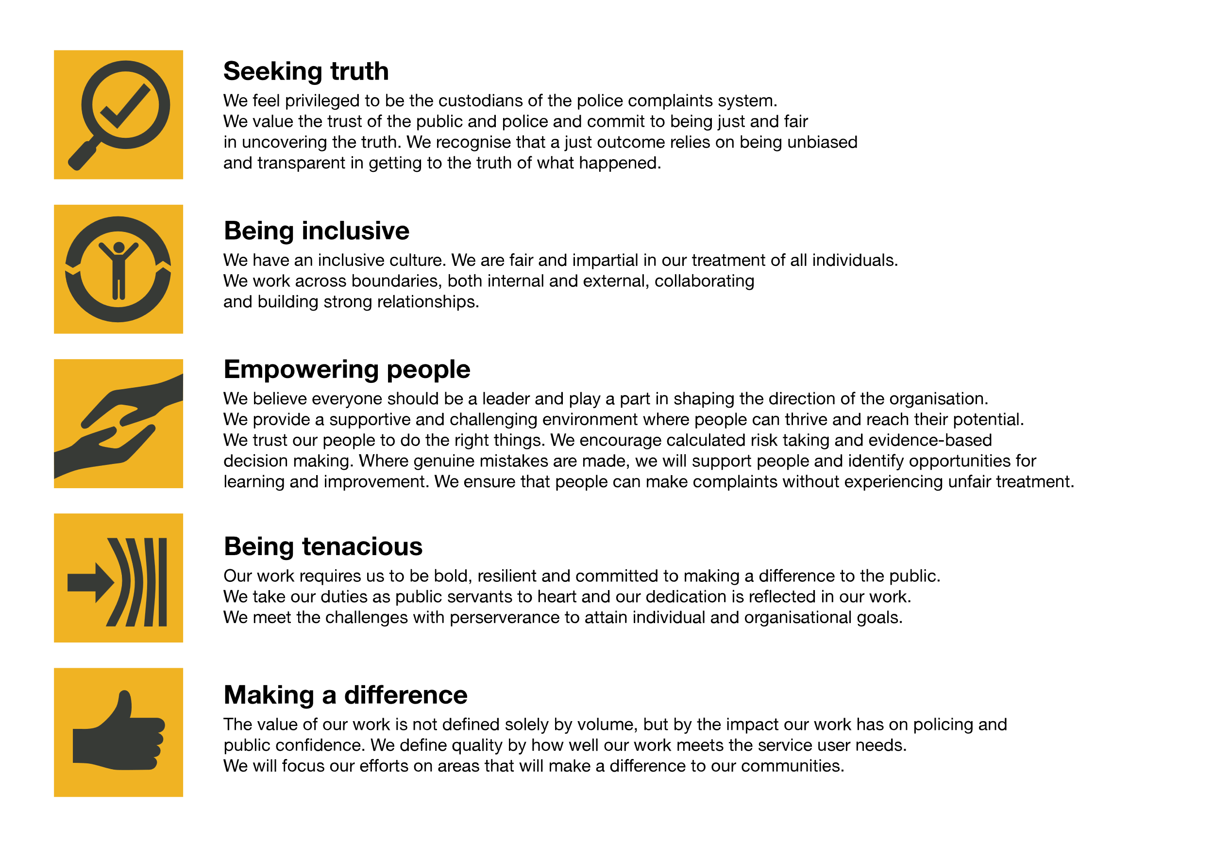We work in the context of our agreed values which inform the way we do things at the IOPC. The Transformation Assurance Manager will need to be commited to managing in the context of these values.

The IOPC is committed to **promoting equality and valuing diversity** in everything we do. Our vision is to be, and to be seen as, a leader in inclusive employment and services, demonstrating this ethos in everything that we do.

* As a silver standard Stonewall employer, we continue to commit ourselves to being a LGBTQ+ employer through the work of our Pride LGBTQ+ Staff Network, creating welcoming environments for lesbian, gay, bi and queer people.
* We are pleased to share we are a signatory of the Business in the Community Race at Work Charter. The Charter is composed of five [calls to action](https://race.bitc.org.uk/issues/racecharter) for leaders and organisations across all sectors.
* Being a Disability Confident employer, the IOPC is dedicated to removing the barrier for disabled people to thrive in the workplace.
* Our Staff Networks are constantly working to make the IOPC the leaders of inclusive employment, from our Allyship Programme to [Operation Hotton](https://www.policeconduct.gov.uk/recommendations/operation-hotton-recommendations-metropolitan-police-service-september-2021), to [Welsh Language Standards](https://www.policeconduct.gov.uk/who-we-are/equality-and-diversity/welsh-language-standards) and Know the Line Policy, we are constantly seeking new ways to create an environment for all to develop and thrive.

# Main duties and responsibilities

* Lead on the development and maintenance of the programme’s proactive assurance plan. Develop a robust and efficient assurance schedule working with the PMO Lead Programme/Project SRO’s to plan and co ordinate assurance reviews which align with the change activity lifecycle and approval stages to ensure that no delays occur.
* Ensure appropriate reviews are carried out at key milestones in line with the programme’s assurance plan.
* Work with Project Managers / SRO’s across a portfolio or department to ensure they implement appropriate levels of assurance as part of baseline and future planning activities.
* Working alongside a Project Manager to integrate planned assurance activities throughout the lifecycle of a project.
* Participate as an assurance reviewer at the appointed time.
* Write and provide relevent and appropriate internal template documentation, supporting advice, guidance, strategy and approach for reviews.
* Cultivate valuable working contacts with internal and external stakeholders in the implementation of the programme’s assurance plan.
* Develop and continuously improve processes to ensure that assurance activities provide consistent standards, accurate decisions and value for money.
* Responsible for collating outcomes or recommendations from reviews and feeding back to the Project Manager to collectively implement identified solutions to overcome any shortfalls. Provide analysis to relevant governance boards about the outcomes from assurance reviews from across a department
* Work with the PMO Lead, the review team, SRO and senior stakeholders to ensure that all recommendations are well founded and based on factual evidence.
* Ensure that the recommendations from assurance reviews are logged, tracked and completed in a timely manner, bringing overdue recommendations to the PMO Lead’s attention and appropriate governance board(s).
* Contribute to PMO activities in order to ensure consistency of process and customer service for our stakeholders.

# Person specification

## Essential

* Experience and thorough knowledge of portfolio/programme management through the full lifecycle is a pre-requisite of this role.
* Must have worked in a programme/project/change environment previously.
* Experience of working with assurance frameworks in relation to programmes/projects.
* Facilitation of meetings and the ability to challenge and hold constructive conversations with senior leaders.
* Recent experience of complex risk and issue management.

## Desirable

* Experience of IPA gateway (or equivalent) reviews on low-risk projects.
* Management of Risk (MoR) Foundation.

# Skills and Abilities

## Essential

* Experience and thorough knowledge of portfolio/programme management through the full lifecycle is a pre-requisite of this role. Must have worked in a programme/project/change environment previously.
* Experience of working with assurance frameworks in relation to programmes/projects.
* Facilitation of meetings and the ability to challenge and hold constructive conversations with senior leaders.
* Recent experience of complex risk and issue management.

## Desirable

* APM Project Fundamentals
* APM Project Management Qualification
* PRINCE 2 Foundation and/or Practitioner
* Managing Successful Programmes Foundation
* Managing Successful Programmes Practitioner
* APMG International Project Planning and Control Foundation
* PMI Certificate in Associate Project Management

**Additional requirements**

* The role will involve occasional travel to other IOPC locations and overnight stays.

## Reasonable adjustments

The IOPC is a diverse and inclusive workplace and we want to help you demonstrate your full potential whatever type of assessment is used. We are open to providing you with the tools you need to succeed, from extra time to formatting changes, to name a mere few. If you require any reasonable adjustments to our recruitment process, please email [recruitment@policeconduct.gov.uk](mailto:recruitment@policeconduct.gov.uk)

## Working conditions

The IOPC are currently consulting with our consultative bodies about proposed changes to our hybrid working policy which will require all staff to work 20% of their contractual hours at their office base (or another office for business reasons) from 1 September and increased to 40% from April next year. Office attendance time includes in-person training, meetings with stakeholders and families, and attending events.

## Preparation checklist

☐ Review the full job description

☐ Review the behaviours and the descriptors for each behaviour

☐ Review the Strengths dictionary

☐ Review the IOPC values

☐ Consider your Strengths (if applicable)

☐ Consider drafting example answers that cover the specific elements

☐ Prepare some questions to ask the interviewers

.