**Job description**

**Title:** Discrimination Operational Lead

**Reports to:** Operations Manager

**Location:** Any IOPC Office - Hybrid

**Grade:** 13

**Salary:** £46,335 (plus London Weighting Allowance of £4,731 if located in Croydon or Canary Wharf)

**Contract:** 12 month Fixed-Term Contact

# Purpose

The primary purpose of this role is to support the IOPC to fulfil its Public Sector Equality Duty (PSED) by embedding a consistent and effective approach to handling issues of discrimination in our operational work.

The successful candidate will have an in-depth understanding of the Equality Act 2010 and the IOPC Guidelines for Handling Allegations of Discrimination including their application across IOPC investigations and reviews.

Discrimination in policing is a serious issue that can erode public trust and confidence. The way in which these allegations are handled is crucial for restoring public confidence in the police and the police complaints system.

Working with various teams across the organisation, the candidate will embed learning to ensure we meet our minimum standard on handling discrimination cases. Supporting improvements to our Operations manual, informing learning and development and being tenacious and confident to advise on cases - offering evidence-based challenge including to senior staff. You will be expected to attend key meetings related to internal and external handling of discrimination cases.

The post holder will receive support from the Strategic Lead for discrimination, the delivery and policy lead and discrimination technical advisors.

# A screenshot of a computer screen Description automatically generatedOrganisational Context

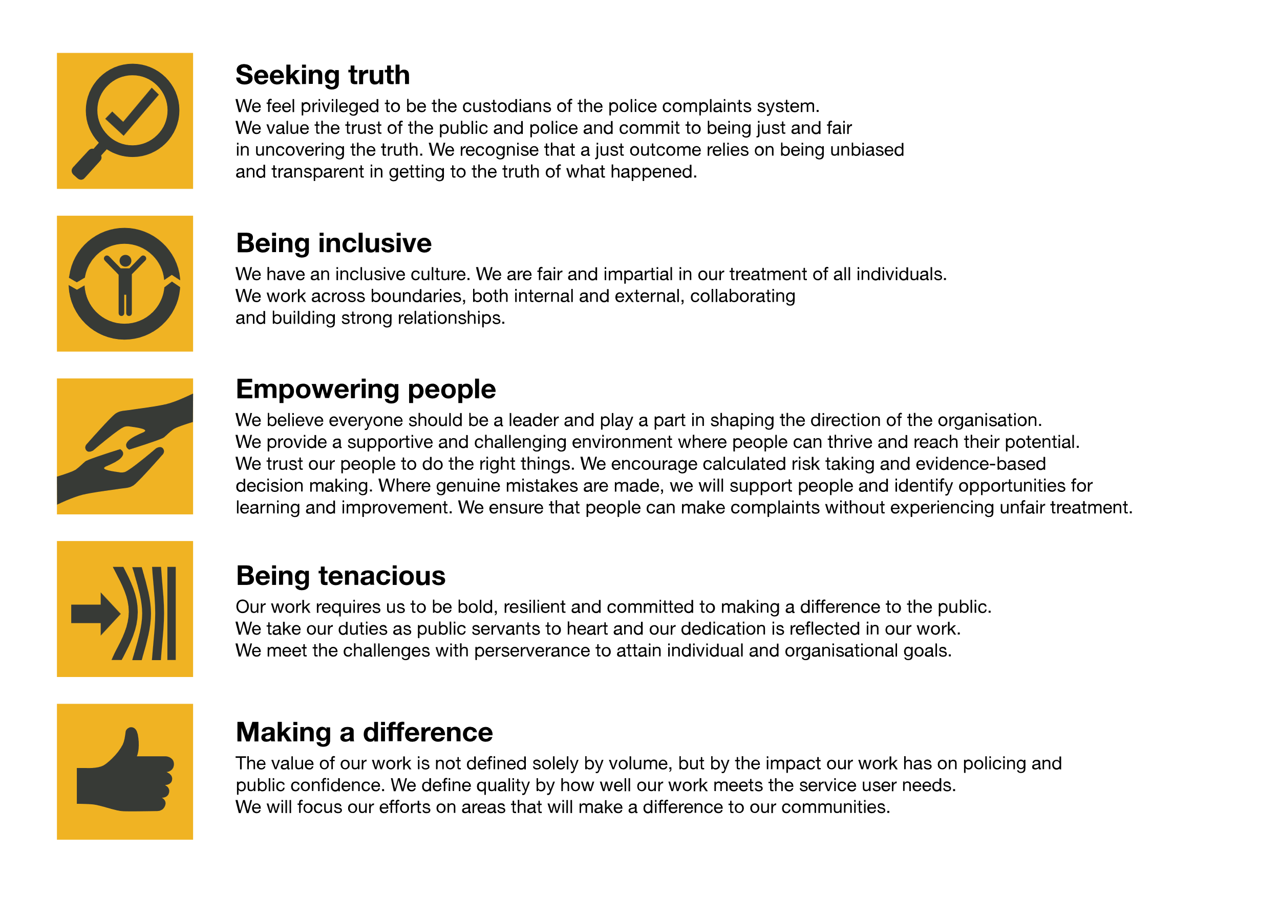We work in the context of our agreed values which inform the way we do things at the IOPC. The Discrimination Operational Lead will need to be commited to managing in the context of these values.

The IOPC is committed to **promoting equality and valuing diversity** in everything we do. Our vision is to be, and to be seen as, a leader in inclusive employment and services, demonstrating this ethos in everything that we do.

* As a silver standard Stonewall employer, we continue to commit ourselves to being a LGBTQ+ employer through the work of our Pride LGBTQ+ Staff Network, creating welcoming environments for lesbian, gay, bi and queer people.
* We are pleased to share we are a signatory of the Business in the Community Race at Work Charter. The Charter is composed of five [calls to action](https://race.bitc.org.uk/issues/racecharter) for leaders and organisations across all sectors.
* Being a Disability Confident employer, the IOPC is dedicated to removing the barrier for disabled people to thrive in the workplace.
* Our Staff Networks are constantly working to make the IOPC the leaders of inclusive employment, from our Allyship Programme to [Operation Hotton](https://www.policeconduct.gov.uk/recommendations/operation-hotton-recommendations-metropolitan-police-service-september-2021), to [Welsh Language Standards](https://www.policeconduct.gov.uk/who-we-are/equality-and-diversity/welsh-language-standards) and Know the Line Policy, we are constantly seeking new ways to create an environment for all to develop and thrive.

# Main duties and responsibilities

* Leading and shaping delivery of the IOPC’s Discrimination technical advice and support to Investigators, Assessment Analysts and Casework Managers. Managing escalation of concerns to the Strategic lead for Discrimination.
* Overseeing, co-ordinating and quality-assuring the development of internal advice and guidance – embedding learning from relevant teams.
* Advising and developing content for the Operations manual to deliver consistent and effective handling. Collaborating with relevant teams to ensure a co-ordinated approach.
* Supporting and advising on the development of IOPC Discrimination learning and development events, learning resources and Professionalising Investigation Programme Level 2 (PIP2) accreditation materials.
* Supporting and advisiong on the identification and development of individual and organisational learning recommendations – working with the Discrimination Policy lead.
* Analysing trends and patterns in investigations and reviews to identify areas for improvement.
* Developing and maintaining relationships with relevant internal and external stakeholders representing the IOPC where appropriate.
* Supporting senior staff in their engagement with key stakeholders and providing issue-specific advice.
* Building and maintaining understanding of discrimination including the wider context. Keeping abreast of developments by taking responsibility for professional development and that of the Discrimination technical advisors – ensuring learning is disseminated. Actively seeking out opportunities to work with stakeholders to co-create learning and guidance products.
* This role will require some travel to other IOPC offices and external meetings.

# Person specification

## Experience

* Specialist knowledge of discrimination and the Equality Act 2010, and experience of dealing with allegations of discrimination.
* Providing specialist support, advice and guidance to colleagues, including at a senior level.
* Building and maintaining effective working relationships with a wide range of internal and external stakeholders.
* Excellent analytical and report writing skills.
* Quality assuring others’ work and providing constructive feedback.
* Ability to manage own learning and professional development.
* Presenting to a range of audiences with confidence.
* Strong attention to detail.
* Self-motivated with a track record of delivering to planned timescales.
* Strong and up-to-date understanding of the police complaints and discipline system.
* Leading work to deliver through others.

**Desirable:**

* Line management experience

## Reasonable adjustments

The IOPC is a diverse and inclusive workplace and we want to help you demonstrate your full potential whatever type of assessment is used. We are open to providing you with the tools you need to succeed, from extra time to formatting changes, to name a mere few. If you require any reasonable adjustments to our recruitment process, please email [recruitment@policeconduct.gov.uk](mailto:recruitment@policeconduct.gov.uk)

## Working conditions

The IOPC are currently consulting with our consultative bodies about proposed changes to our hybrid working policy which will require all staff to work 20% of their contractual hours at their office base (or another office for business reasons) from 1 September and increased to 40% from April next year. Office attendance time includes in-person training, meetings with stakeholders and families, and attending events.

## Preparation checklist

☐ Review the full job description

☐ Review the behaviours and the descriptors for each behaviour

☐ Review the Strengths dictionary

☐ Review the IOPC values

☐ Consider your Strengths (if applicable)

☐ Consider drafting example answers that cover the specific elements

☐ Prepare some questions to ask the interviewers